DOCUMENTATION
JABULANI NDEBELE

import zipfile

with zipfile.ZipFile("apps.csv.zip", 'r') as zip_ref:
zip_ref.extractall(".")

import os
print(os.listdir("."))

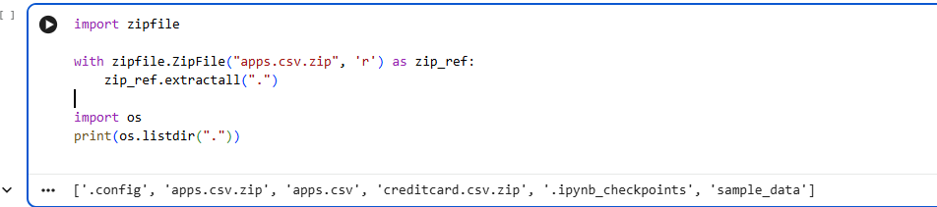

import zipfile Loads Python’s built-in zipfile module, which lets you work with compressed .zip files.
with zipfile.ZipFile("apps.csv.zip", 'r") as zip_ref:
Opens the file apps.csv.zip in read mode ('r').
- zip_ref is a reference to the opened zip file.
zip_ref.extractall(".") Extracts all contents of the zip file into the current directory (".").
- This unpacks apps.csv so you can use it directly with Pandas.
import os Loads the os module, which lets you interact with the operating system (like listing files).
print(os.listdir(".")) Lists all files and folders in the current working directory.
- Useful for confirming that the extraction worked.
The output shows the files present in your working directory after extraction:
- apps.csv.zip → the original compressed file.
- apps.csv → the extracted dataset (ready to load with Pandas).
- creditcard.csv.zip → another compressed dataset.
- .config, .ipynb_checkpoints, sample_data → system and notebook-related folders.
Confirmation: The file apps.csv is now available and ready for analysis.

import pandas as pd

df = pd.read_csv("apps.csv")
df.info()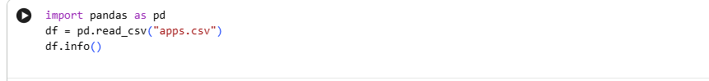
import pandas as pd Loads the Pandas library, the standard tool for handling tabular data in Python.
pd.read_csv("apps.csv") Reads the file apps.csv into a DataFrame called df. Each row = one app, each column = app attributes.
df.info() Prints a concise summary of the DataFrame:
- Number of entries (rows).
- Column names.
- Non-null counts (missing values check).
- Data types (numeric, string/object).
- Memory usage.
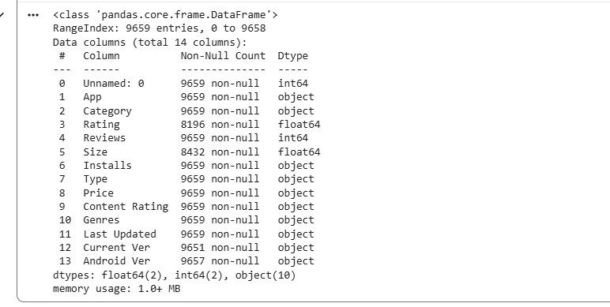
Entries: 9659 rows → dataset contains nearly 10,000 apps.
Columns (13 total):
- Unnamed: 0 → index column (can be dropped).
- App → app name.
- Category → app category (e.g., Tools, Games, Education).
- Rating → user rating (float).
- Reviews → number of reviews (int).
- Size → app size (object, often needs cleaning like "20M").
- Installs → number of installs (object, often formatted with commas or "+").
- Type → Free or Paid.
- Price → app price (string, needs conversion to numeric).
- Content Rating → age suitability (e.g., Everyone, Teen).
- Genres → app genres (sometimes multiple per app).
- Last Updated → date of last update.
- Current Ver → current version string.
- Android Ver → minimum Android version required.
Data types:
- int64 → numeric columns like Reviews.
- float64 → numeric columns like Rating.
- object → text/string columns like App, Category, Size.

import matplotlib.pyplot as plt

df['Category'].value_counts().plot(kind='bar', figsize=(12,6))
plt.title("App Distribution by Category")
plt.show()
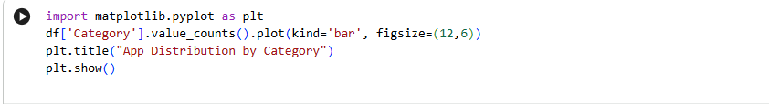

df['Category'].value_counts() Counts how many apps belong to each category (e.g., Tools, Games, Education). Returns a Series with categories as the index and counts as values.
.plot(kind='bar', figsize=(12,6)) Creates a bar chart of the category counts.
- kind='bar' → vertical bars.
- figsize=(12,6) → sets the plot size for readability.
plt.title("App Distribution by Category") Adds a descriptive title to the chart.
plt.show() Displays the plot

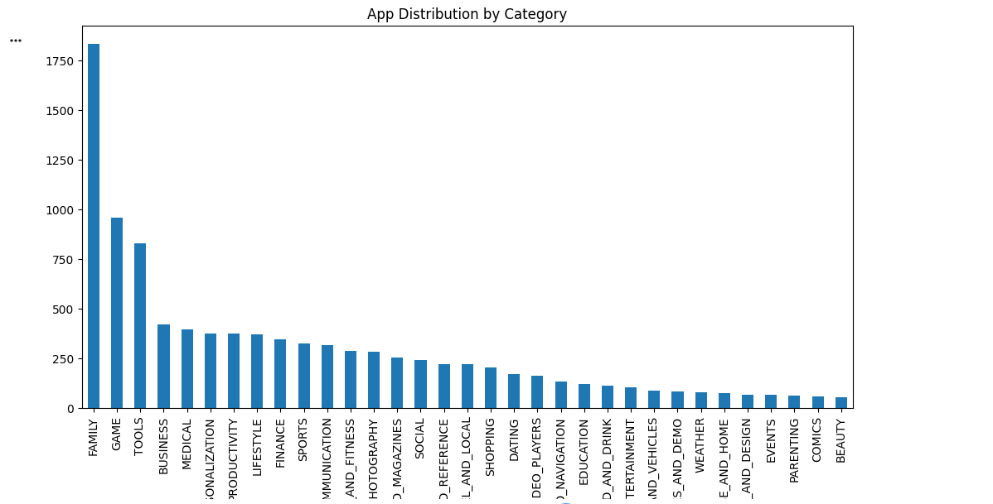

The bar chart shows the distribution of apps across categories in the dataset.
Key observations:
- FAMILY → largest category, with over 1800 apps.
- GAME → second largest, around 950 apps.
- TOOLS → third, around 850 apps.
- Other categories like Business, Medical, Personalization, Productivity, Lifestyle, and Finance have moderate representation.
- Niche categories (e.g., Beauty) have very few apps, under 100.

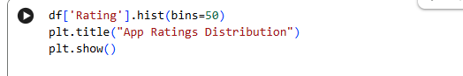

df['Rating'].hist(bins=50)
plt.title("App Ratings Distribution")
plt.show()

df['Rating'].hist(bins=50)
- Creates a histogram of the Rating column.
- Splits the rating values into 50 bins (intervals).
- Shows how frequently apps fall into each rating range.
plt.title("App Ratings Distribution")
- Adds a descriptive title to the plot.
plt.show()
- Displays the histogram
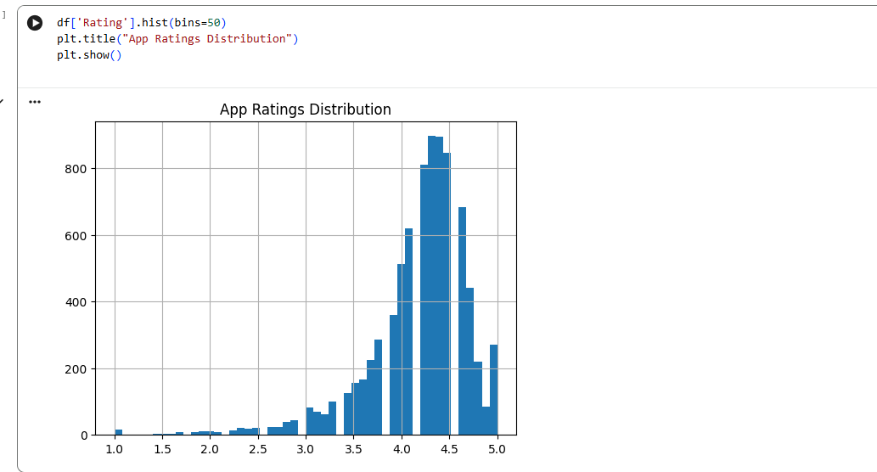
- The histogram shows the distribution of app ratings across the dataset.
- Key observations:
  - Ratings range from 1.0 to 5.0.
  - Most apps cluster between 3.5 and 4.5, with a peak around 4.2.
  - Very few apps have ratings below 3.0.
  - This suggests that most apps on Google Play tend to have high ratings, possibly due to user bias (people often rate apps they like, while uninstalling apps they dislike without rating).

- from textblob import TextBlob Imports the TextBlob library, which is used for natural language processing (NLP) tasks like sentiment analysis.
- df['Reviews'].apply(...) Applies a function to every entry in the Reviews column.
  - Each review text is converted to a string (str(x)).
  - TextBlob(str(x)).sentiment.polarity calculates the sentiment polarity of the text.
- Sentiment polarity values:
  - Range: -1.0 to +1.0
  - -1.0 → very negative sentiment.
  - 0.0 → neutral sentiment.
  - +1.0 → very positive sentiment.
- df['Sentiment'] Creates a new column in the DataFrame called Sentiment, storing the polarity score for each review.

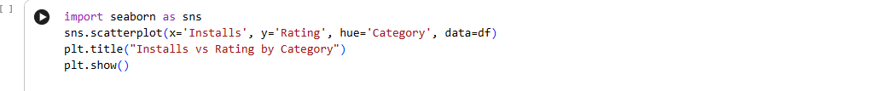
sns.scatterplot(...) Creates a scatter plot using Seaborn.
- x='Installs' → horizontal axis shows number of installs.
- y='Rating' → vertical axis shows app ratings.
- hue='Category' → colors each point by app category (Games, Tools, Education, etc.).
- data=df → uses the apps dataset.
plt.title("Installs vs Rating by Category") Adds a descriptive title to the plot.
plt.show() Displays the scatter plot.

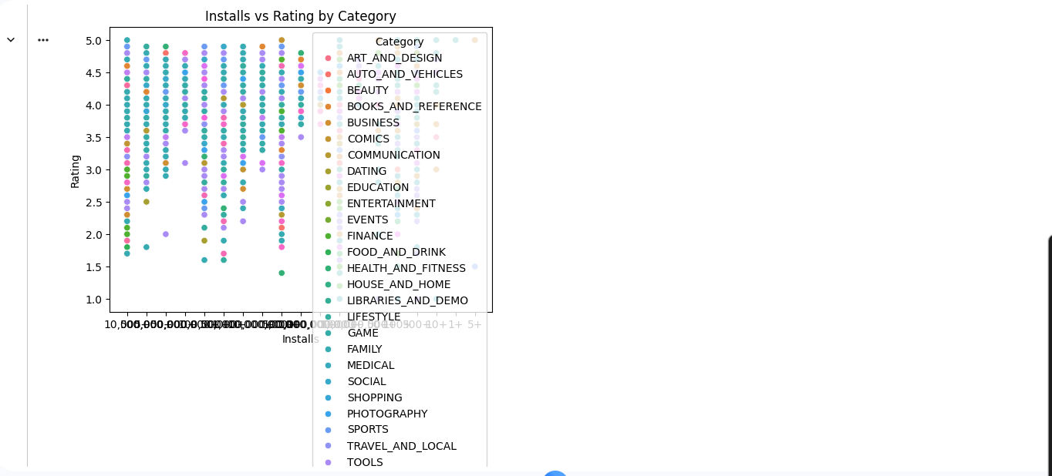

The scatter plot shows the relationship between installs (popularity) and ratings (user satisfaction), broken down by category.
Key observations:
- Apps with millions of installs are spread across categories like GAME, FAMILY, COMMUNICATION, SOCIAL.
- Ratings cluster mostly between 3.5 and 4.5, regardless of installs.
- Some categories (e.g., Education, Books, Health) show fewer installs but relatively high ratings.
- Popular categories like Games have wide variation — some highly rated, others poorly rated despite high installs.

📱 Unveiling the Android App Market
📖 Overview
This project explores the Google Play Store apps dataset, uncovering trends in app categories, ratings, installs, pricing, and user sentiment. By combining data cleaning, exploratory analysis, visualization, and sentiment analysis, the project reveals how popularity and user satisfaction vary across the Android ecosystem.
📂 Dataset
- File: apps.csv
- Size: 9,659 rows × 13 columns
- Features include:
  - App metadata: App, Category, Genres, Last Updated, Current Ver, Android Ver
  - User metrics: Rating, Reviews, Installs
  - App attributes: Size, Type, Price, Content Rating
🛠 Tools & Libraries
- Python
- Pandas, NumPy → Data cleaning & manipulation
- Matplotlib, Seaborn → Visualization
- TextBlob → Sentiment analysis of user reviews
- Jupyter Notebook → Interactive exploration
🪜 Methodology
- Data preparation
  - Extracted apps.csv from zip archive.
  - Inspected dataset with df.info().
  - Cleaned messy columns (Size, Installs, Price).
  - Checked for missing values and duplicates.
- Exploratory analysis
  - Distribution of apps by category.
  - Histogram of ratings.
  - Installs vs ratings scatter plot by category.
- Sentiment analysis
  - Applied TextBlob to user reviews.
  - Created sentiment polarity scores (-1 to +1).
  - Compared sentiment across categories.
- Visualization
  - Bar plots for category distribution.
  - Histograms for rating distribution.
  - Scatter plots for installs vs ratings.
  - Sentiment distribution plots.
- Insights
  - Identified dominant categories (Family, Games, Tools).
  - Ratings skewed toward 4.0–4.5.
  - High installs don’t always mean high ratings.
  - Sentiment analysis adds nuance beyond numeric ratings.
📊 Results
- Category dominance:
  - FAMILY apps lead with ~1,800 entries.
  - GAME and TOOLS follow with ~950 and ~850 apps.
- Ratings:
  - Most apps rated between 3.5–4.5.
  - Peak around 4.2, suggesting positive bias in ratings.
- Installs vs Ratings:
  - Popular apps (millions of installs) spread across categories.
  - Niche categories (Education, Books) show fewer installs but strong ratings.
- Sentiment:
  - Positive sentiment dominates reviews.
  - Some categories (e.g., Communication, Social) show mixed sentiment despite high installs.
🎯 Learning Outcomes
- Hands-on experience with EDA and visualization for categorical and numerical data.
- Practical application of sentiment analysis to textual reviews.
- Ability to interpret popularity vs satisfaction trends in app markets.
- Strengthened skills in data cleaning, feature engineering, and storytelling with data.

