DOCUMENTATION
JABULANI NDEBELE

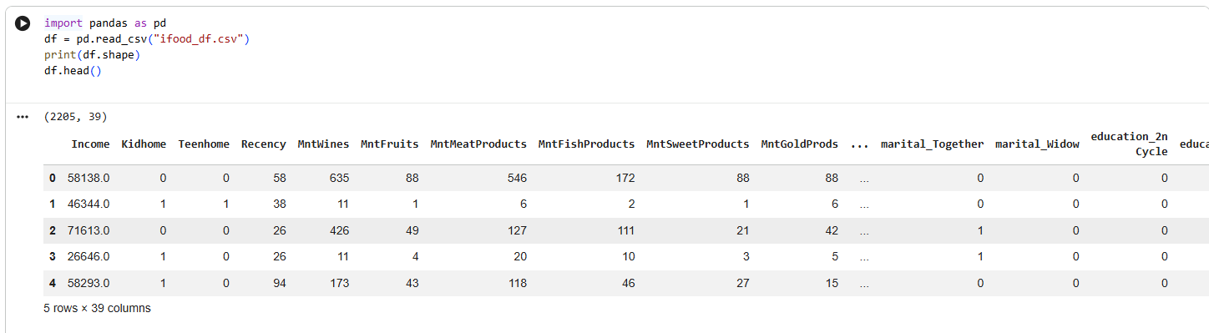

import pandas as pd
df = pd.read_csv("ifood_df.csv")
print(df.shape)
df.head()

- import pandas as pd Loads the Pandas library, which is the go-to tool in Python for handling tabular data (like spreadsheets or CSV files).
- df = pd.read_csv("ifood_df.csv") Reads the CSV file named ifood_df.csv into a DataFrame called df. A DataFrame is basically a table with rows and columns, similar to Excel.
- print(df.shape) Prints the shape of the DataFrame → (rows, columns). In your case, it printed (2205, 39), meaning:
  - 2205 rows (observations/customers)
  - 39 columns (features/variables)
- df.head() Displays the first 5 rows of the dataset so you can quickly inspect what the data looks like.

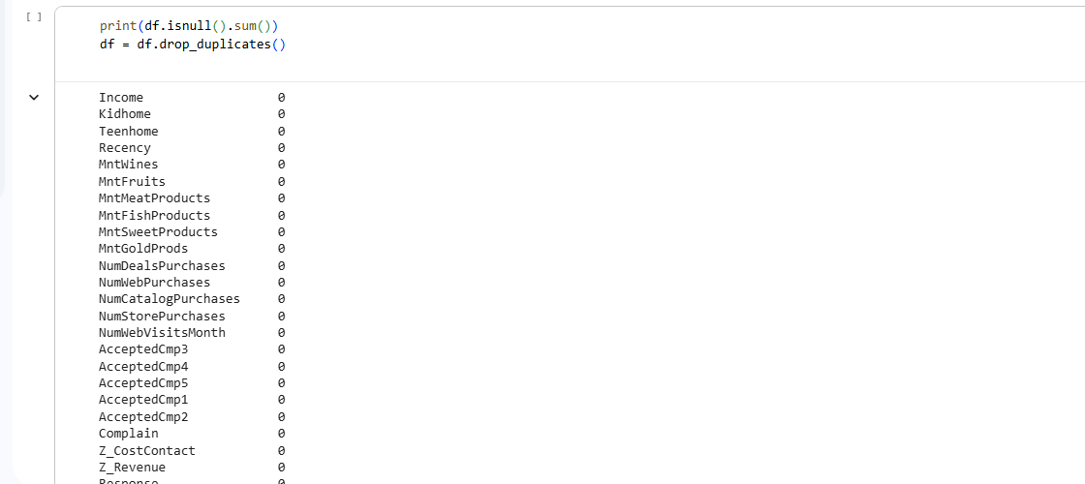

print(df.isnull().sum())
df = df.drop_duplicates()

df.isnull().sum()
- Checks for missing values (NaN) in each column of the DataFrame df.
- .isnull() returns a boolean mask (True if a value is missing).
- .sum() adds up the number of missing values per column.
- print(...) displays the counts for each column.
df = df.drop_duplicates()
- Removes any duplicate rows from the DataFrame.
- Ensures that each row represents a unique customer/transaction.
- The cleaned DataFrame is reassigned back to df

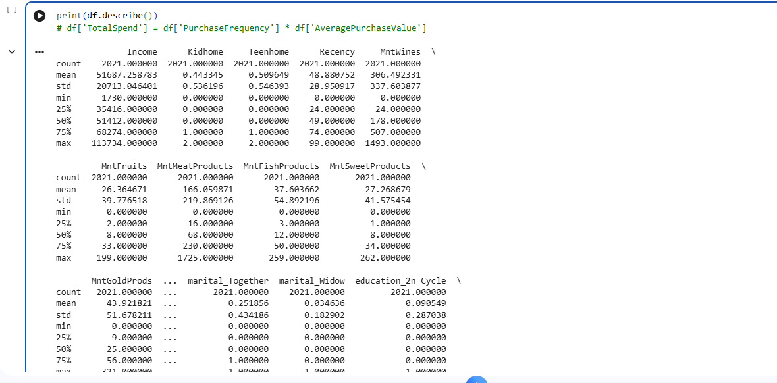

print(df.describe())
# df['TotalSpend'] = df['PurchaseFrequency'] * df['AveragePurchaseValue']

df.isnull().sum()
- Checks for missing values (NaN) in each column of the DataFrame df.
- .isnull() returns a boolean mask (True if a value is missing).
- .sum() adds up the number of missing values per column.
- print(...) displays the counts for each column.
df = df.drop_duplicates()
- Removes any duplicate rows from the DataFrame.
- Ensures that each row represents a unique customer/transaction.
- The cleaned DataFrame is reassigned back to df.

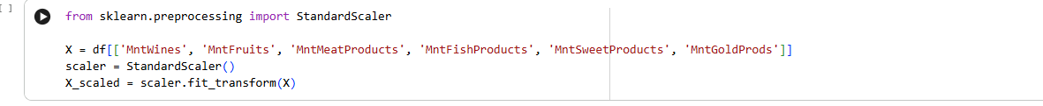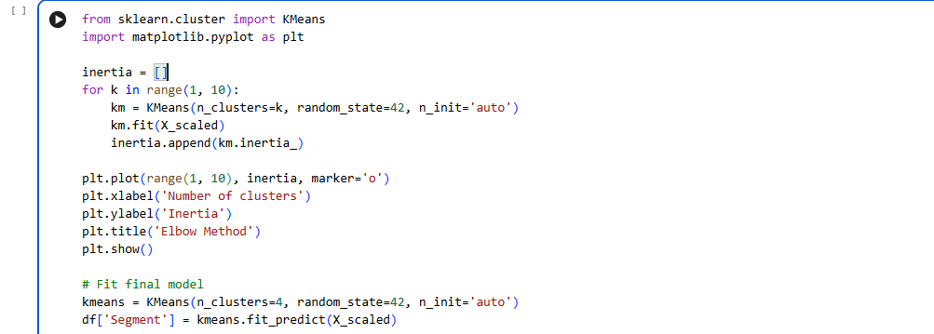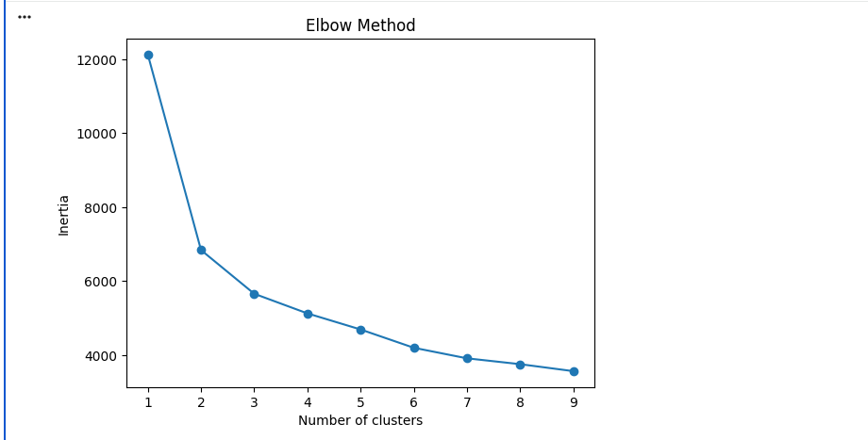

from sklearn.preprocessing import StandardScaler

X = df[['MntWines', 'MntFruits', 'MntMeatProducts', 'MntFishProducts', 'MntSweetProducts', 'MntGoldProds']]
scaler = StandardScaler()
X_scaled = scaler.fit_transform(X)

from sklearn.preprocessing import StandardScaler Imports the StandardScaler class from scikit-learn. This is used to scale numerical features so they all have the same range and importance in machine learning models.
X = df[[...]]
Selects specific columns from the DataFrame df:
- Spending on wines, fruits, meat, fish, sweets, and gold products.
- These are the features you want to use for clustering.
scaler = StandardScaler() -> Creates a StandardScaler object.
X_scaled = scaler.fit_transform(X)
fit → calculates the mean and standard deviation for each column.
transform → scales each value so that:
    - Mean = 0
    - Standard deviation = 1
This ensures all features contribute equally to clustering (otherwise, large values like wine spending could dominate).

from sklearn.cluster import KMeans
import matplotlib.pyplot as plt

inertia = []
for k in range(1, 10):
km = KMeans(n_clusters=k, random_state=42, n_init='auto')
km.fit(X_scaled)
inertia.append(km.inertia_)

plt.plot(range(1, 10), inertia, marker='o')
plt.xlabel('Number of clusters')
plt.ylabel('Inertia')
plt.title('Elbow Method')
plt.show()

km = KMeans(n_clusters=4, random_state=42, n_init='auto')
df['Segment'] = km.fit_predict(X_scaled)

- KMeans import → Brings in the clustering algorithm from scikit-learn.
- inertia = [] → Empty list to store inertia values (a measure of how well the clusters fit).
- Loop over k (1–9) → Fits KMeans with different numbers of clusters.
- km.inertia_ → Inertia = sum of squared distances of samples to their nearest cluster center. Lower inertia = tighter clusters.
- Plotting → Creates the Elbow Method plot (clusters vs inertia). The “elbow” point suggests the optimal number of clusters.
- Final model (n_clusters=4) → Chooses 4 clusters based on the elbow curve.
- df['Segment'] → Adds a new column to the DataFrame with the cluster assignment for each row.

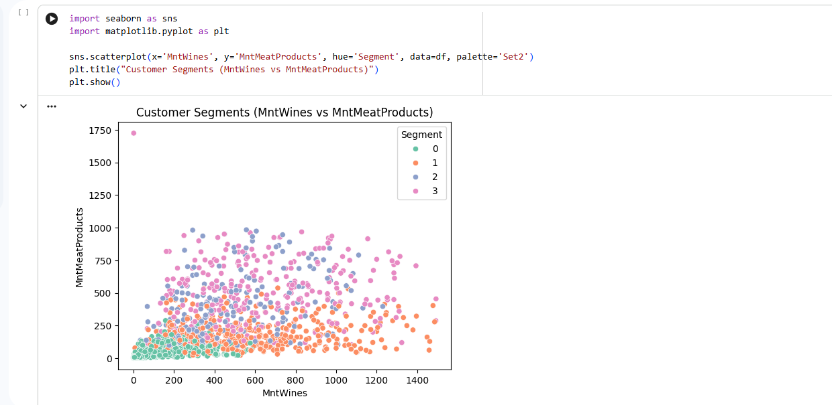

import seaborn as sns
import matplotlib.pyplot as plt

sns.scatterplot(x='MntWines', y='MntMeatProducts', hue='Segment', data=df, palette='Set2')
plt.title("Customer Segments (MntWines vs MntMeatProducts)")
plt.show()

- import seaborn as sns / import matplotlib.pyplot as plt Loads Seaborn and Matplotlib, two libraries for visualization.
sns.scatterplot(...) Creates a scatter plot with:
- x-axis: MntWines (amount spent on wines)
- y-axis: MntMeatProducts (amount spent on meat products)
- hue='Segment' → Colors each point based on the customer’s cluster assignment (from K-Means).
- data=df → Uses the DataFrame df.
- palette='Set2' → Applies a nice color palette for clarity.
plt.title(...) / plt.show() Adds a title and displays the plot.

📊 Customer Segmentation Analysis
📖 Overview
This project analyzes customer demographics and purchase behavior using the iFood dataset. The goal is to uncover insights into customer spending, segment customers into meaningful groups, and provide actionable recommendations for marketing strategies.

By combining data cleaning, exploratory analysis, clustering, and visualization, this project demonstrates how businesses can leverage analytics to better understand their customers.

📂 Dataset
- File: ifood_df.csv
- Size: 2205 rows × 39 columns
- Features include:
  - Demographics: Income, Kidhome, Teenhome, Education, Marital Status
  - Behavioral: Recency (days since last purchase), Complain (customer complaints)
  - Spending: MntWines, MntFruits, MntMeatProducts, MntFishProducts, MntSweetProducts, MntGoldProds
  - Campaigns: Response to marketing campaigns (AcceptedCmp1 … AcceptedCmp5, Response)

🛠 Tools & Libraries
- Python
- Pandas, NumPy → Data cleaning & manipulation
- Matplotlib, Seaborn → Visualization
- Scikit-learn → Clustering (K-means, PCA), scaling
- Jupyter Notebook → Interactive analysis

🪜 Methodology
- Data preparation
  - Handle missing values
  - Convert categorical variables (marital status, education) into dummy variables
  - Normalize numerical features
- Exploratory analysis
  - Distribution of income, spending, and recency
  - Correlation heatmaps between product categories
  - Campaign acceptance rates
- Feature engineering
  - Create TotalSpend = sum of all product categories
  - Create Children = Kidhome + Teenhome
  - Group customers by spending habits
- Clustering
  - Apply K-means clustering to segment customers
  - Use PCA for dimensionality reduction and visualization
  - Identify optimal number of clusters using the elbow method
- Visualization
  - Scatter plots of clusters by income vs spending
  - Bar charts of campaign acceptance per cluster
  - Heatmaps of product preferences

📊 Results
- Identified 4 main customer segments:
  - High-income, high-spend → Luxury buyers (wine, gold products)
  - Mid-income, family-focused → Spend more on meat and sweets
  - Low-income, budget-conscious → Minimal spending, low campaign response
  - Young singles → Higher recency, spend on fast-moving products
- Campaign acceptance was highest among high-income luxury buyers.

🎯 Learning Outcomes
- Hands-on experience with customer segmentation
- Practical application of clustering algorithms
- Enhanced skills in data cleaning, feature engineering, and visualization
- Ability to translate analytics into business insights

