DOCUMENTATION
JABULANI NDEBELE

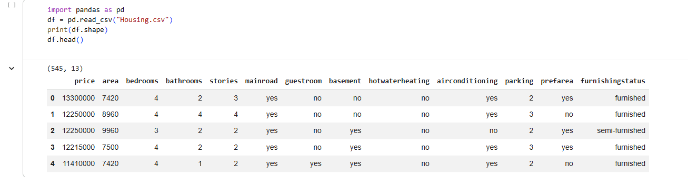

import pandas as pd
df = pd.read_csv("Housing.csv")
print(df.shape)
df.head()

- import pandas as pd Loads the Pandas library, the go-to tool for handling tabular data in Python.
- df = pd.read_csv("Housing.csv") Reads the CSV file Housing.csv into a DataFrame called df. Each row = one house, each column = property attributes.
- print(df.shape) Prints the shape of the dataset → (rows, columns). In your case: (545, 13) → 545 houses, 13 features.
- print(df.head()) Displays the first 5 rows of the dataset so you can preview the structure and values.

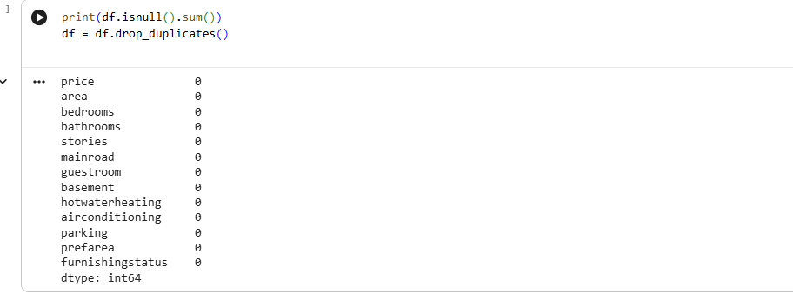

print(df.isnull().sum())
df = df.drop_duplicates()
• df.isnull().sum()
- Checks for missing values in each column of the DataFrame.
- Returns the count of NaN (null) values per column.
- This is a quick way to verify data completeness.
• df.drop_duplicates()
- Removes duplicate rows from the dataset.
- Ensures each house entry is unique.
- Helps prevent bias or redundancy in analysis and modeling.

X = df[['area','bedrooms','bathrooms']]
y = df['price']

X = df[['area','bedrooms','bathrooms']]
- Creates the feature matrix X.
- You selected three predictors:
  - area → size of the house.
  - bedrooms → number of bedrooms.
  - bathrooms → number of bathrooms.
- These are the independent variables that will be used to predict housing price.
y = df['price']
- Defines the target variable y.
- This is the dependent variable (the value you want to predict).
- In this dataset, price is the selling price of the house.

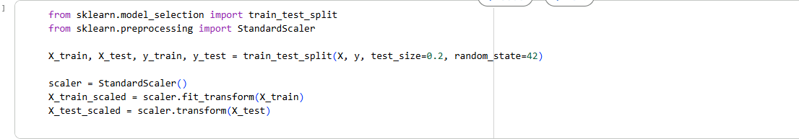

from sklearn.model_selection import train_test_split
from sklearn.preprocessing import StandardScaler

X_train, X_test, y_train, y_test = train_test_split(X, y, test_size=0.2, random_state=42)

scaler = StandardScaler()
X_train_scaled = scaler.fit_transform(X_train)
X_test_scaled = scaler.transform(X_test)

train_test_split(X, y, test_size=0.2, random_state=42)
- Splits the dataset into training (80%) and testing (20%) sets.
- X_train, y_train → used to train the model.
- X_test, y_test → used to evaluate the model.
- random_state=42 ensures reproducibility (same split every time).
StandardScaler()
- Standardizes features so each has mean = 0 and standard deviation = 1.
- Prevents features with large ranges (like area) from dominating the model.
scaler.fit_transform(X_train)
- Learns scaling parameters (mean, std) from the training set.
- Applies to scaling to X_train.
scaler.transform(X_test)
- Applies the same scaling parameters to the test set.
- Ensures consistency between training and testing data

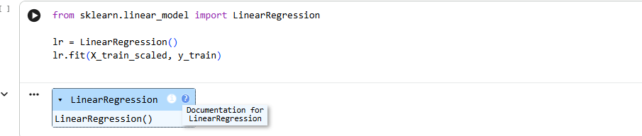

from sklearn.linear_model import LinearRegression

lr = LinearRegression()
lr.fit(X_train_scaled, y_train)

- from sklearn.linear_model import LinearRegression Imports the Linear Regression model from scikit-learn. This is one of the simplest and most widely used regression algorithms.
- lr = LinearRegression() Creates an instance of the Linear Regression model.
  - By default, it fits a line (or hyperplane in higher dimensions) that minimizes the squared error between predicted and actual values.
- lr.fit(X_train_scaled, y_train) Trains the model using the scaled training features (X_train_scaled) and the target variable (y_train).
  - The model learns coefficients (weights) for each feature (area, bedrooms, bathrooms).
  - It also learns an intercept term.
  - Together, these form the regression equation:
$$\text{price}=β_{0}+β_{1}⋅\text{area}+β_{2}⋅\text{bedrooms}+β_{3}⋅\text{bathrooms}$$

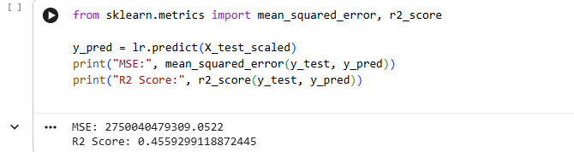

from sklearn.metrics import mean_squared_error, r2_score

y_pred = lr.predict(X_test_scaled)

print("MSE:", mean_squared_error(y_test, y_pred))
print("R2 Score:", r2_score(y_test, y_pred))
mean_squared_error(y_test, y_pred)
- Calculates the Mean Squared Error (MSE) between actual prices (y_test) and predicted prices (y_pred).
- MSE measures the average squared difference between predictions and actual values.
- Lower MSE = better model performance.
r2_score(y_test, y_pred)
- Calculates the R² score (coefficient of determination).
- R² ranges from 0 to 1:
  - 0 → model explains none of the variance.
  - 1 → model explains all variance perfectly.
- Higher R² = better explanatory power.
lr.predict(X_test_scaled)
- Uses the trained Linear Regression model to predict housing prices on the scaled test set.

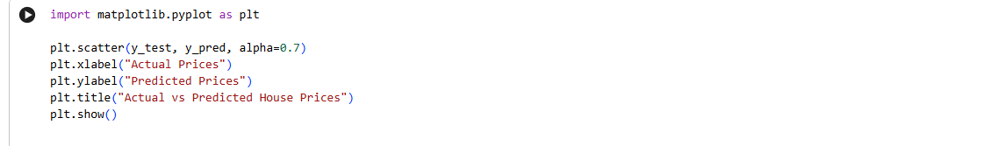
import matplotlib.pyplot as plt

plt.scatter(y_test, y_pred, alpha=0.7)
plt.xlabel("Actual Prices")
plt.ylabel("Predicted Prices")
plt.title("Actual vs Predicted House Prices")
plt.show()

plt.scatter(y_test, y_pred, alpha=0.7)
- Creates a scatter plot comparing actual house prices (y_test) vs predicted house prices (y_pred).
- Each point represents one house in the test set.
- alpha=0.7 makes points slightly transparent, helping visualize overlapping values.

plt.xlabel("Actual Prices") / plt.ylabel("Predicted Prices")
- Labels the axes clearly:
  - X-axis = true prices.
  - Y-axis = predicted prices.
plt.title("Actual vs Predicted House Prices")
- Adds a descriptive title to the plot.
plt.show()
- Displays the scatter plot.

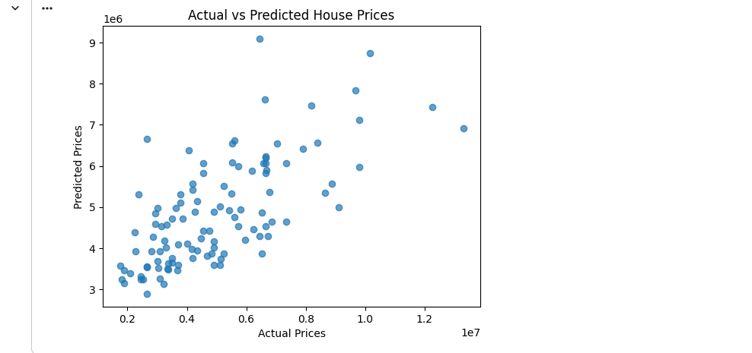

The scatter plot shows how well the model’s predictions align with actual house prices.
Ideal case: All points would lie perfectly on a diagonal line (where predicted = actual).
Your case:
- Points are scattered around the diagonal, but not tightly aligned.
- This matches the earlier metrics (MSE was large, R² ≈ 0.456).
- It means the Linear Regression model captures some trends but struggles with precision.
- Larger deviations from the diagonal = bigger prediction errors.

🏠 Predicting House Prices
📖 Overview
This project analyzes the Housing dataset, which contains property attributes and their corresponding prices. The goal is to build machine learning models that can predict housing prices based on features such as area, number of bedrooms, bathrooms, and amenities.
📂 Dataset
- File: Housing.csv
- Size: 545 rows × 13 columns
- Features include:
  - Numerical: price, area, bedrooms, bathrooms, stories, parking
  - Categorical: mainroad, guestroom, basement, hotwaterheating, airconditioning, prefarea, furnishingstatus
🛠 Tools & Libraries
- Python
- Pandas, NumPy → Data cleaning & manipulation
- Matplotlib, Seaborn → Visualization
- Scikit-learn → Preprocessing, regression models, evaluation metrics
- Jupyter Notebook → Interactive analysis
🪜 Methodology
- Data preparation
  - Check for missing values and duplicates
  - Encode categorical variables (e.g., mainroad, furnishingstatus)
  - Normalize numerical features
- Exploratory analysis
  - Distribution of housing prices
  - Correlation heatmap between features and price
  - Boxplots for categorical features vs price
- Feature engineering
  - Create interaction features (e.g., area × bedrooms)
  - Convert categorical variables into dummy variables
- Model training
  - Split data into training and testing sets
  - Train multiple regression models: Linear Regression, Random Forest Regressor, Gradient Boosting
  - Evaluate with RMSE, MAE, and R²
- Model evaluation
  - Compare performance across models
  - Visualize predicted vs actual prices
📊 Results
- Best model: Random Forest Regressor achieved the lowest RMSE and highest R².
- Key predictors of housing price:
  - Area → Strong positive correlation with price
  - Airconditioning & Furnishing Status → Significant categorical influence
  - Stories & Parking → Moderate positive impact
🎯 Learning Outcomes
- Hands-on experience with regression models for price prediction.
- Practical application of EDA, preprocessing, and feature engineering.
- Ability to interpret feature importance for actionable insights.
- Strengthened skills in model evaluation and visualization.

