

Republic of the Philippines
Western Mindanao State University
College of Computing Studies
Department of Information Technology
Zamboanga City

In partial fulfillment of the requirements in
IT 313 – Elective 3

WMSU ILS-Elementary Department: Automated Grades Portal and Students Attendance using QR Code

Submitted by:

Banalo, Josie O.
Cuento, Collen B.
Pardillo, John Carlo A.
Vega, Ashley Faye M.
Villanueva, Ashley Nicole N.
Submitted to:

Mr. Sherard Chris B. Banquerigo
Ms. Justine Ann Albay-Arip
Instructors
Date of Submission:

November 6, 2025

Table of Contents
Chapter 1 - Project Overview 1
1.1. Product Overview 1
1.2. Project Site 1
1.3. Background of the Client 1
1.4. Proposed Solution 2
1.4.1. Product Summary 2
1.4.2. List of Features 2
Chapter 2 – The Company 3
2.1. Company Profile 3
2.2. Company Logo 3
2.3. Company Vision 4
2.4. Company Mission 4
2.5. Company Goals 4
2.6. Company Organizational Structure 4
2.6.1. Overall Team Structure 4
2.6.2. Management Team 4
2.6.3. Analysis and Design Team 5
2.6.4. Development Team 5
2.6.5. Testing Team 5
2.6.6. Training Team 5
2.7. Company Policies 6
2.7.1. Meetings 6
2.7.2. Fundings 6
2.7.3. Penalties 6
2.8. Company Agreement 7
2.9 Client Agreement…………………………………………………………………………………………………….8
Chapter 3- Project Plan and Schedule………………………………………………………………………………...9
3.1.Action Plan…………………………………………………………………………………………………………….9-14
3.2. Work Breakdown Structure……………………………………………………………………………….…...…15
3.3.Network Diagram……………………..……………………………………………………………….…...……16-19
3.4.Milestones and Deliverables……………………………………………………………..……………………20-22
3.5. Gantt chart………………………………………………………………………………………………………….…..23
Chapter 4- Project cost………………………………………………………………………………………………..….24
4.1.Cost of Project Resources……………………………………………………………………………………..24
4.1.1. Effort Cost………………………………………………………………………………………………..…..…24
4.1.2. Hardware Cost……………………………………………………………………..………………….…24-25
4.1.3. Software Cost…………………………………………………………………………………….……………25
4.1.4. Miscellaneous Cost………………………………………………………………………..…………………25
4.1.5. Overall Cost……………………………………………………………………………..……………………..26
4.2. Return-On-Investment…………………………………………………………………………………….26-27
4.3. Intangible Benefits……………………………………………………………………….……………………..27
Chapter 5- Project Feasibility………………………………………………………………….……………………….28
5.1. Candidate Solution Matrix………………………………………………………………..……………………….28
5.2. Technology Gap Analysis …………………………………………………………….………………………….28
5.3. Feasibility Study………………………………………………………………………………….…………………..29
5.3.1. Operational Feasibility ……………………………………………………………….………………..…29 5.3.2. Technical Feasibility ………………………………………………………………………...………………….29
5.3.3. Schedule Feasibility ……………………………………………………………………..…………..30-32
5.3.4. Economic Feasibility…………………………………………………………………….…………….33-35
5.3.5. Cultural Feasibility……………………………………………………………………………………..35-36
5.3.6. Legal Feasibility …………………………………………………………………………...……………….36
5.4. Feasibility Analysis Matrix…………………………………………………………………………………………37
5.5 Function and Non- Function requirements gathered………………………………………………………..41
5..1Requirements 1…………………………………………………………………………………………………………………41
5.2Requirements2…………………………………………………………………………………………………………………..41
5.3Requirements 3………………………………………………………………………………………………………………41-42
5.4 Requirements 4…………………………………………………………………………………………………………………42
5.5 Requirements5………………………………………………………………………………………………………..………..42
5.6 Requirements6………………………………………………………………………………………………………………. ..43
5.7 Requirements7……………………………………………………………………………………………………………… ..43
5.8 Requirements8……………………………………………………………………………………………………………. 43-44
5.9 Requirements9…………………………………………………………………………………………………………… …...44
5.10 Requirements10……………………………………………………………………………………………………… .……44
5.11 Requirements11……………………………………………………………………………………………………..………45
5.12 Requirements12……………………………………………………………………………………………………………..45
5.13. Requirements13……………………………………………………………………………………………………….45-46
5.14 Requirements 14……………………………………………………………………………………………………………..46
5.15 Requirements15……………………………………………………………………………………………………………..46
5.16. Requirements16………………………………………………………………………………………………………..46-47
5.17 Requirements17……………………………………………………………………………………………………………..47
5.18 Requirements18………………………………………………………………………………………………………..…….47
5.19 Requirements19…………………………………………………………………………………………………………..…48
5.20 Requirements20…………………………………………………………………………………………………………….48
5.21 Requirements20………………………………………………………………………………………………………..……48
5.22 Requirements22……………………………………………………………………………………………………..………48
5.23 Requirements23…………………………………………………………………………………………………..…………49
5.24 Requirement24…………………………………………………………………………………………………..…………..50
5.25 Requirements25………………………………………………………………………………………………..…………..50
5.26 Requirements26……………………………………………………………………………………………………………..51
5.27 Requirements27………………………………………………………………………………………………..…………..51
5.28 Requirements28…………………………………………………………………………………………………………….51
5.29 Requirements29……………………………………………………………………………………………………………..52
5.30 Requirements30……………………………………………………………………………………………………………..52
5.31 Requirement31……………………………………………………………………………………………………………….52
5.32 Requirement32……………………………………………………………………………………………………………….53
5.33 Requirements33………………………………………………………………………………………………………………53
5.34 Requirements34……………………………………………………………………………………………………………..54
5.35 Requirements35……………………………………………………………………………………………………………..54
5.36 Requirements36……………………………………………………………………………………………………………..54
5.37 Requirements37……………………………………………………………………………………………………..………55
5.38 Requirements38……………………………………………………………………………………………………………..55
5.39 Requirements39………………………………………………………………………………………………………..55-56
5.40 Requirements40……………………………………………………………………………………………………………..56
5.41 Requirements41……………………………………………………………………………………………………………..56
5.42 Requirements42…………………………………………………………………………………………………………….56
5.43 Requirements43…………………………………………………………………………………………………..…….….57
5.44 Requirements44………………………………………………………………………………………………….…..……57
5.45 Requirements45……………………………………………………………………………………………………….…..59
6.1 High Case Diagram…………………………………………………………………………………………………………...59
6.2 Use Case Diagram………………………………………………………………………………………………………….…60
6.2.1 Create Student Account……………………………………………………………………………..………..60
6.2.2 Create Teacher Account ……………………………………………………………………………………….61
6.2.3. Record Student Attendance…………………………………………………………………………….…62-63
6.2.4 View and Sort Ranked Grades…………………………………………………………………………………64
6.2.5 Generate Qr code for Student…………………………………………………………………………….65-66

List of Figures
Figure I: StudTech Logo 3
Figure II: StudTech Overall Team Structure 4
Figure III: StudTech Management Team 4
Figure IV: StudTech Analysis and Design Team 5
Figure V: StudTech Programming Team 5
Figure VI: StudTech Testing Team 5
Figure VII: StudTech Training Team 5

Chapter 1 - Project Overview

Product Overview
This system is a student portal designed to make the management of WMSU ILS Elementary school records easier and more organized. Instead of using manual or paper-based processes, all important information, such as grades and attendance will be stored digitally.
This helps not only the teachers but also the students and the admin since retrieving and updating records becomes much faster and more reliable. The main objective of the system is to provide easy access to student records. This means there is no need to spend time searching through papers as the information can be accessed. It also ensures data accuracy and reduces errors since everything is computerized and well-organized.
The system covers the essential functions needed in a school portal. First, it has a grade computing feature that allows teachers to compute grades easily and input students’ grades quickly and accurately. Also, it includes student attendance using generated barcodes to easily keep track of students who is present or absent in class.

Project Site
The Western Mindanao State University - School (WMSU ILS) is situated within the main campus, specifically in Campus A along Normal Road. Serving as the basic education unit of the university, the ILS accommodates students from kindergarten up to senior high school. As part of a well-established academic institution, the school plays a vital role in shaping the foundational education of its students while also serving as a training ground for future educators. The campus is equipped with essential facilities for learning; however, despite its academic reputation, some of its administrative processes remain outdated.
One of the major issues observed at the project site is the continued use of manual methods in computing and recording student grades. Teachers still calculate grades by hand and then manually input them into each student's Form 137, a process that is not only time-consuming but also prone to human error. This method creates inefficiencies, particularly during grading periods, and adds unnecessary workload to the faculty. Given the number of students enrolled from different levels, this traditional approach affects the school's ability to manage student records efficiently. As such, the site clearly presents a need for a more streamlined and automated grading system to enhance accuracy, save time, and improve overall administrative productivity.

Background of the Client
Dr. Lilibeth S. Eyo is the Assistant Principal of WMSU ILS – Elementary Department. She was a Grade 6 adviser before becoming the Asst. Principal. She also studied at WMSU with a course of BEED and graduated in 2004. And taken Master’s and Doctoral degrees.
Dr. Lilibeth S. Eyo requested an automated grading system that automatically computes student's grades and easier reporting tools for teachers.

Proposed Solution

1.4.1. Product Summary

To address the the current manual system at WMSU ILS, we propose the development and implementation of a Student Information and Monitoring System designed specifically for the school's needs. This system will serve as a centralized digital platform that automates grade computation, streamlines student and teacher monitoring, and enhances administrative operations. One of the key features is class scheduling system, which will allow administrators to assign and adjust class timetables easily, while giving students and teachers real-time access to their daily schedules through their accounts.

The system will also include a QR code-based attendance monitoring feature, integrated with the student ID. By scanning their QR codes upon entering the classroom, students can be automatically marked present when the qr code in their id was scanned by the teacher, while absences are logged and stored in the database. When a student is marked absent, the system will send a notification alert, which will be sent to the parent or guardian through SMS or email, keeping them informed in real-time status of their child.

Additionally, the system will include a school calendar that highlights events and class schedules, and displays teacher absences to ensure transparency for students and administration. To support academic monitoring, the system will automatically compute and rank students based on their grades, sorting them from highest to lowest to easily determine the top performers in each class or grade level. This comprehensive solution aims to modernize WMSU ILS operations, reduce manual workload, and create a more efficient and transparent academic environment for both staff and students.

1.4.2. List of Features
Automated ILS Grades Portal Student/Faculty ID with QR Code for Attendance
- Provides a centralized online system for recording, managing, and accessing student grades.
- Reduces errors from manual computation and speeds up grade processing.
Class Scheduling Management System
- Allows administrators to add and assign subjects for each grade level.
- Prevents schedule conflicts and ensures subjects are aligned with the curriculum.
Student ID with QR Code for Attendance
- Each student/faculty ID is embedded with a QR code containing their information.
- QR codes can be scanned to automatically log attendance.
- Stickers with QR codes will be pasted onto IDs for easy use.
Automatic Ranking or Sorting the Student’s Grade
- Automatically ranks students based on computed grades.
- Helps teachers identify top-performing students per class.
- Provides an overview of academic performance trends.
Printable and Downloadable Report Card
- Students can download their finalized report card as a PDF.
- Reduces paperwork for admin staff and ensures accurate record-keeping.
Editing Grades Accessible for Teachers
- Authorized teachers can edit or update grades, schedules, and attendance when needed.
- Changes are logged to maintain accountability and transparency.
Data Privacy
- Implements role-based access control to protect sensitive student data.

- Ensures compliance with data protection standards (e.g., securing grades and personal info).
Customer Service
- Built-in help desk or support feature where faculty can submit inquiries.
- Provides faster resolution to issues regarding grades, scheduling, or attendance.
Notifications and Alerts (e.g., absences, schedules, updates)
- Sends automated alerts to students and faculty about absences, class schedules, or updates.
- Keeps everyone informed in real-time to avoid miscommunication.
Student Report Card Portal (View Only)
- A student Portal that can view by the student only.
- Can Monitor the Grades and Attendance

Chapter 2 – The Company

Company Profile
The StudTech company is established by five members who strive to exceed the expectations of their clients. It was founded within Western Mindanao State University to accommodate clients according to their standards and demands.
StudTech (pronounced “Stad-Tek”) combines “Student” and “Technology”, representing the vision of aspiring students who aim to build their own programming company. The name reflects the perspective of students in developing innovative and useful technology.
The company, StudTech embodies determination of student innovators who strive the deliver quality and practical technology solutions. StudTech serves as a proof to how students can transform ideas into impactful solutions which can set the future into excellence, especially in the field of technology.

Company Logo

Figure I: StudTech Logo

Our company logo represents the spirit of technology and teamwork. The gear at the center reflects our determination as students to create and innovate, just like the gear that keeps on working in a machine. The whole circle of the logo itself represents unity and collaboration within the group members to achieve success. Lastly, the bold STUDTECH name symbolizes our tenacity, strength, and pride as a group of student innovators. Overall, the logo reflects the team members as students that are united by technology, working hand in hand to deliver projects with excellence and purpose.

Company Vision
StudTech aims to be a high-quality company recognized in the IT industry for its competitiveness, consistency, and commitment to delivering modern, innovative technology solutions to clients.

Company Mission
StudTech create high-quality websites designed to our clients’ needs and preferences, ensuring an accessible, user-friendly, and flexible user experience.

Company Goals
- To provide quality product that resolves the needs of our clients.
- To ensure customer / client satisfaction remains our highest priority.
- To deliver and finish our projects on time.
- To maintain clear and professional communication with our clients.
- To create user-friendly and accessible digital solutions.
- To build a good relationship within our members based on trust and reliability.
- To strive hard during the process of building the project based on client’s preferences.

Company Organizational Structure

2.6.1. Overall Team Structure
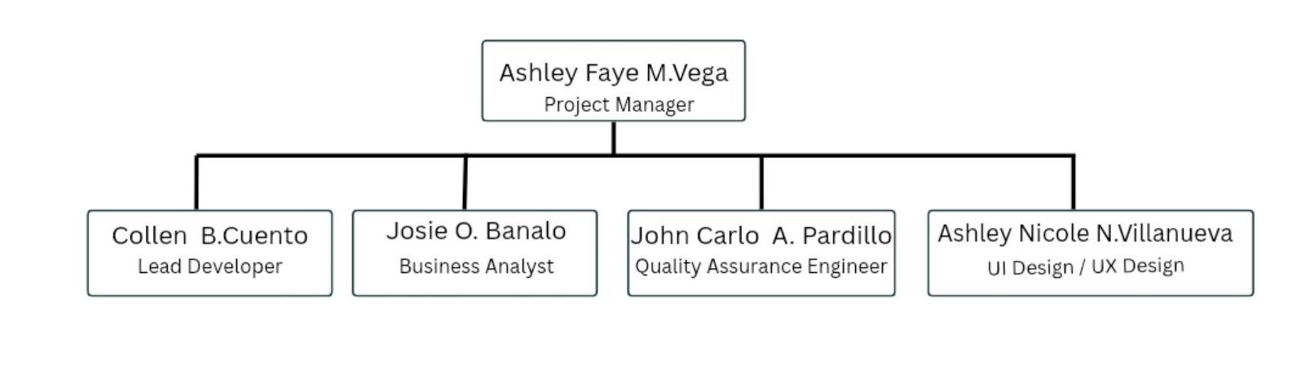
Figure II: StudTech Overall Team Structure

2.6.2. Management Team
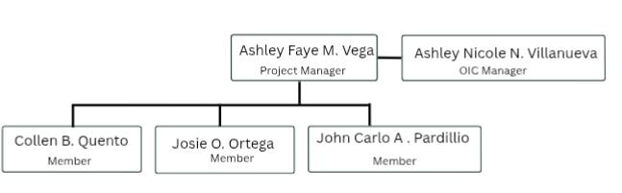

Figure III: StudTech Management Team

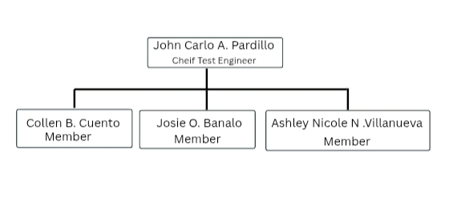
2.6.3. Analysis and Design Team

Figure IV: StudTech Analysis and Design Team

2.6.4. Development Team
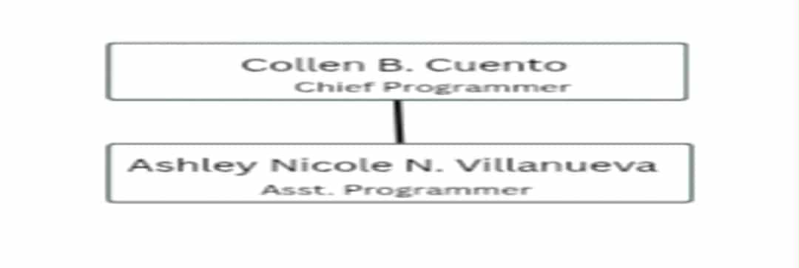
Figure V: StudTech Programming Team

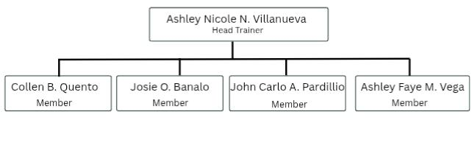
2.6.5. Testing Team
Figure VI: StudTech Testing Team

2.6.6. Training Team
Figure VII: StudTech Training Team
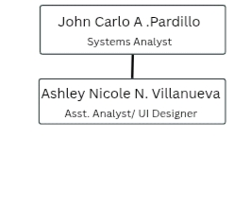

Company Policies

2.7.1. Meetings
- StudTech company’s meeting will be held at the agreed time and place.
- StudTech company will meet every Wednesday from 3:00 PM to 5:00 PM and every Thursday from 1:00 PM to 4:00 PM. If the meeting will not push through within the set date and time, we will do a virtual or online meeting instead using Discord or Google Meet. The virtual meeting will be held on Saturday night on the agreed time by the members. Overall, the members will still have to meet during break time on school days for a short meeting.
- Any member’s absence must have a valid reason; otherwise, a penalty of ₱50.00 will be required.
- The use of mobile phones is permitted only for related activities, such as providing updates or searching for relevant information.

2.7.2. Fundings
- An amount of ₱50.00 will be collected on every Friday.
- For transparency, the money must be collected and documented daily, and it will be used to fund the company’s project.
- The funding is estimated to range from ₱3,000.00 to ₱5,000.00 for StudTech’s projects, particularly for system hosting and deployment.

2.7.3. Penalties
- If a member is late in submitting any company activities, he/she shall pay a fine of ₱20.00.
- Absence of a member shall incur a fine of ₱50.00 per absence, which will be collected as part of the funds for StudTech company project.
- There will be removal or expulsion of any member from StudTech company.
- If a member is late during the said date and time of a group meeting, he/she shall pay ₱10.00.

  - Company Agreement

CONTRACT OF AGREEMENT

We, the undersigned, hereby understood and abide the rules and regulations, policies, and penalties set by the StudTech Company. Signed this September 04, 2025 at the College of Computing Studies, Western Mindanao State University, Normal Road, Baliwasan, Zamboanga City, Philippines, 7000.

Ashley Faye M. Vega
Project Manager
Josie O. Banalo
Business Analyst
Collen B. Cuento
Lead Developer
John Carlo A. Pardillo
Quality Assurance Engineer
Ashley Nicole N. Villanueva
UI/UX Designer

Ms. Justine Ann Albay-Arip
Instructor

Noted by:

Mr. Sherard Chris B. Banquerigo
Instructor

2.9 Client Agreement
Client Agreement Form

Organization Name: | WESTERN MINDANAO STATE UNIVERSITY ILS- ELEMENTARY
Organization Address: | Normal Road,Baliwasan Zamboanga City
Project Working Title: | WMSU ILS-Elementary Department: Automated Grades Portal and Students Attendance using QR Code
Project Description: | This system is a student portal designed to make the management of WMSU ILS Elementary school records easier and more organized. Instead of using manual or paper-based processes, all important information, such as grades and attendance will be stored digitally.
Developer (Students)
- Banalo, Josie O.
- Cuento, Collen B.
- Pardillo, John Carlo A.
- Vega, Ashley Faye M.
- Villanueva, Ashley Nicole N.

The undersigned hereby agreed to be their client and provide the necessary information and support to the above students to carry out an information system development project for our organization from the 1st Semester S.Y 2021 – 2022 to 2nd Semester S.Y. 2021 – 2022 following the academic year of Western Mindanao State University.

The Client (Top-Management Member of the Organization):

Signature:
Name of the Client: | Dr. Lilibeth S. Eyo
Designation: | Assistant Principal
Office: | Western Mindanao State University ILS- elementary
Email: | Eyo.lilibeth@wmsu.edu.ph
Contact Number: | 09088670978

The Contact Person (Top-Management Member or Employee of the Organization):
Signature:
Name of the Person: | Ashley Faye Vega
Designation: | Project Manager
Office: | Western Mindanao State University(Student)
Email: | Vegaashleyfaye@gmail.com
Contact Number: | 09912428924
Note: Upon successful completion of the project, the client should be able to issue a letter certifying the suitability and acceptance of the developed software for the organization
Chapter 3-Project Plan and Schedule
3.1. Action Plan
Group Name: StudTech Company

[WMSU-ILS (ED): Automated Grades Portal and QR-Based Attendance Management System] Action Plan

Activity |  | Time Estimates |  |  | Required Resources | Dependencies | Person-in-Charge
# |  | Duration | Start | End
Phase 1 – Planning
1.1 | Create a company | 1 Day | Aug. 12, 2025 | Aug. 12, 2025 | Internet, laptop | - | All
1.2 | Design a company logo | 1 Day | Aug. 12, 2025 | Aug. 12, 2025 | Internet, laptop, phone | 1.1 | Villanueva
1.3 | Define company mission, vision, and goals | 1 Day | Aug. 12, 2025 | Aug. 12, 2025 | Internet, laptop, phone | 1.1 | All
1.4 | Define company organizational structure | 1 Day | Aug. 12, 2025 | Aug. 12, 2025 | Internet, phone | 1.1 | Vega
1.5 | Define company policies and penalties | 1 Day | Aug. 12, 2025 | Aug. 12, 2025 | Internet, laptop, phone | 1.4 | All
1.6 | Establish and promote company | 1 Day | Aug. 12, 2025 | Aug. 12, 2025 | Internet, laptop | 1.5 | All
1.7 | Close a deal with a client | 3 Days | Aug. 13, 2025 | Aug. 15, 2025 | Internet, phone | 1.6 | All
1.8 | Create project action plan | 7 Days | Sep. 09, 2025 | Sep. 15, 2025 | Internet, laptop | 1.7 | All
1.9 | Determine project milestones and deliverables | 7 Days | Sep. 09, 2025 | Sep. 15, 2025 | Internet, laptop | 1.7 | All
1.10 | Create work breakdown structure | 1 Day | Sep. 16, 2025 | Sep. 27, 2025 | Internet, laptop | 1.8, 1.9 | All
1.11 | Create an online project board | 2 Days | Sep,. 16, 2025 | Sep. 27, 2025 | Internet, laptop, phone, Excel | 1.8 | All
1.12 | Create an online Gantt Chart | 1 Day | Sep. 16, 2025 | Sep. 27, 2025 | Internet, laptop | 1.9 | All
1.13 | Create Activity Network Diagram | 1 Day | Sep. 16, 2025 | Sep.27, 2025 | Internet, laptop | 1.9 | All
1.14 | Determine project critical path and slack time | 1 Day | Sep. 16, 2025 | Sep 27, 2025 | Internet, laptop, phone | 1.9, 1.13 | All
1.15 | Collate project documentation for Phase 1 | 3 Days | Oct. 6, 2025 | Oct. 8, 2025 | Internet, laptop, phone | 1.14 | All
Phase 2 – Analysis
2.1 | Identify data collection method | 1 Day | Oct. 27, 2025 | Oct. 28, 2025 | Internet, laptop, phone | 1.15 | All
2.2 | Conduct initial data gathering | 3 Days | Oct. 29, 2025 | Oct. 31, 2025 | Internet, laptop, phones | 2.1 | All
2.3 | Transcribe and analyze collected data | 1 Day | Nov. 3, 2025 | Nov. 4, 2025 | Internet, laptop | 2.2 | All
2.4 | Propose initial solution for the project | 1 Day | Nov. 3, 2025 | Nov. 4, 2025 | Laptop, internet | 2.3 | All
2.5 | Determine project cost | 1 Day | Nov. 3, 2025 | Nov. 4, 2025 | Laptop, phone | 2.4 | All
2.6 | Conduct feasibility study | 1 Day | Sep. 30 ,2025 | Sep. 30, 2025 | Laptop, internet | 2.5 | All
2.7 | List initial project requirements | 3 Days | Nov. 5, 2025 | Nov. 7, 2025 | Laptop, internet, phone | 2.6 | All
2.8 | Determine hardware requirements | 1 Day | Nov. 8, 2025 | Nov. 10, 2025 | Laptop, phone, internet | 2.7 | All
2.9 | Determine software requirements | 1 Day | Nov. 11, 2025 | Nov. 12, 2025 | Laptop, phone, internet | 2.7 | All
2.10 | Determine network requirements | 1 Day | Nov. 11, 2025 | Nov. 12, 2025 | Laptop, phone, internet | 2.7 | All
2.11 | Determine database requirements | 1 Day | Nov. 11, 2025 | Nov. 12, 2025 | Laptop, phone, internet | 2.7 | All
2.12 | Identify software specifications | 1 Day | Nov. 11, 2025 | Nov. 12, 2025 | Laptop, phone, internet | 2.7 | All
2.13 | List product features | 2 Days | Nov. 13, 2025 | Nov. 14, 2025 | Laptop, phone, internet | 2.7 | All
2.14 | List product attributes | 2 Days | Nov. 13, 2025 | Nov. 14, 2025 | Laptop, phone, internet | 2.7 | All
2.15 | Create product mockups | 3 Days | Nov.17, 2025 | Nov. 19, 2025 | Laptop, phone, internet | 2.7 | All
2.16 | Finalize documentation for Phase II | 4 Days | Nov. 20, 2025 | Nov. 25, 2025 | Laptop, phone, internet | 2.15 | All
Phase 3 – Design
3.1 | Determine system architecture | 5 Days | Nov.26, 2025 | Dec. 1, 2025 | Laptop, internet | 2.16 | All
3.2 | Create business use case | 3 Days | Dec. 2, 2025 | Dec. 4, 2025 | Laptop, internet | 2.16 | All
3.3 | Create context and data flow diagram | 3 Days | Dec. 2, 2025 | Dec. 4, 2025 | Laptop, internet | 2.16 | All
3.4 | Design system models | 3 Days | Dec. 2, 2025 | Dec .4,2025 | Laptop, internet | 2.16 | Villanueva
3.5 | Design user interface | 7 Days | Dec. 5 2025 | Dec. 10, 2025 | Laptop, internet | 3.4 | Villanueva
3.6 | Create product prototype | 7 Days | Dec. 5, 2025 | Dec. 10, 2025 | Laptop, internet | 3.5 | Cuento, Villanueva
3.7 | Finalize documentation for Phase III | 5 Days | Dec .11, 2025 | Dec. 16, 2025 | Laptop, internet | 3.6 | All
Phase 4 – Coding
4.1 | Write System Module 1 – [User/Admin Login using WMSU account] | 5 Days | Jan. 5, 2026 | Jan. 9, 2026 | Laptop, internet, IDE | 3.7 | Cuento, Villanueva
4.2 | Write System Module 2 – [System Dashboard] | 5 Days | Jan. 5, 2026 | Jan. 9, 2026 | Laptop, internet, IDE | 4.1 | Cuento, Villanueva
4.3 | Get feedback from a consultant 1 | 1 Day | Jan. 10, 2026 | Jan. 12, 2026 | Laptop, phone | 4.2 | All
4.4 | Debug, fix bugs, and update modules | 7 Days | Jan. 13, 2026 | Jan. 20, 2026 | Laptop, internet, IDE | 4.3 | Cuento, Villanueva
4.5 | Write System Module 3 – [Automated Grades Portal Section] | 7 Days | Jan. 13, 2026 | Jan. 20, 2026 | Laptop, IDE | 4.4 | Cuento, Villanueva
4.6 | Write System Module 4 – [Class Schedules Data Input for all grade levels] | 7 Days | Jan. 13, 2026 | Jan. 20, 2026 | Laptop, IDE | 4.5 | Cuento, Villanueva
4.7 | Write System Module 5 – [Gathering Students Records and Students Attendance Management using QR Code] | 7 Days | Jan. 13, 2026 | Jan.20, 2026 | Laptop, IDE, phone | 4.6 | Cuento, Villanueva
4.8 | Integrate System Modules | 7 Days | Jan. 13, 2026 | Jan. 20, 2026 | Laptop, internet, IDE | 4.7 | Cuento, Villanueva
4.9 | Get feedback from a consultant 2 | 2 Days | Jan.21 , 2026 | Jan. 23, 2026 | Laptop, phone | 4.8 | All
4.10 | Debug, fix bugs, and update modules | 7 Days | Jan. 24, 2026 | Feb.3, 2026 | Laptop, internet | 4.9 | Cuento, Villanueva
4.11 | Conduct unit testing | 3 Days | Feb. 4, 2026 | Feb. 7, 2026 | Laptop, phone, School PCs, internet | 4.10 | Cuento, Pardillo, Villanueva
4.12 | Finalize product design and coding | 7 Days | Feb. 9, 2026 | Feb. 16, 2026 | Laptop, internet | 4.11 | Cuento, Villanueva
Phase 5 – Testing
5.1 | Create testing plan | 2 Days | Feb .17 , 2026 | Feb. 19, 2026 | Laptop, internet | 4.12 | Cuento
5.2 | Create test cases | 2 Days | Feb 17, 2026 | Feb. 19, 2026 | Laptop, internet | 5.1 | Cuento
5.3 | Conduct alpha testing | 4 Days | Feb. 20, 2026 | Feb. 24, 2026 | Laptop, internet | 5.2 | Cuento, Pardillo
5.4 | Conduct beta testing | 3 Days | Feb. 25, 2026 | Feb. 28, 2026 | Laptop, internet | 5.3 | Cuento, Pardillo
5.5 | Fix system errors | 4 Days | March.2, 2026 | March.5,2026 | Laptop, internet | 5.4 | Cuento, Villanueva
5.6 | Conduct software/product attributes testing | 2 Days | March.6, 2026 | March. 7, 2026 | Laptop, internet | 5.5 | Pardillo
5.7 | Conduct user acceptance testing | 2 Days | March. 6, 2026 | March. 7, 2026 | Laptop, internet | 5.6 | Cuento, Villanueva
5.8 | Create migration plan | 2 Days | March 6,2026 | March.7,2026 | Laptop, internet | 5.7 | All
5.9 | Deploy system/product to client’s site | 5 Days | March. 8, 2026 | March.13,2026 | Laptop, internet | 5.8 | Cuento, Villanueva
Phase 6 – Maintenance
6.1 | Create product manual | 2 Days | March.14,2026 | March.16,2026 | Laptop, internet | 5.9 | All
6.2 | Gather and analyze customer feedback | 1 Day | March.17,2026 | March.18,2026 | Laptop, internet | 5.9 | All
6.3 | Perform corrective maintenance | 3 Days | March 19,2026 | March 21,2026 | Laptop, internet | 6.2 | Cuento, Villanueva
6.4 | Perform perfective maintenance | 3 Days | March.19 2026 | March.21,2026 | Laptop, internet | 6.2 | Cuento, Villanueva
6.5 | Perform adaptive maintenance | 3 Days | March.19,2026 | March 21,2026 | Laptop, internet | 6.2 | Cuento, Villanueva
6.6 | Finalize project documentation | 2 Days | March.23,2026 | March 24,2026 | Laptop, internet | 6.3, 6.4, 6.5 | All
6.7 | Turn-over project to client and close the project | 1 Day | March.25,2026 | March.26,2026 | Laptop, internet | 6.6 | All

3.2. Work Breakdown Structure

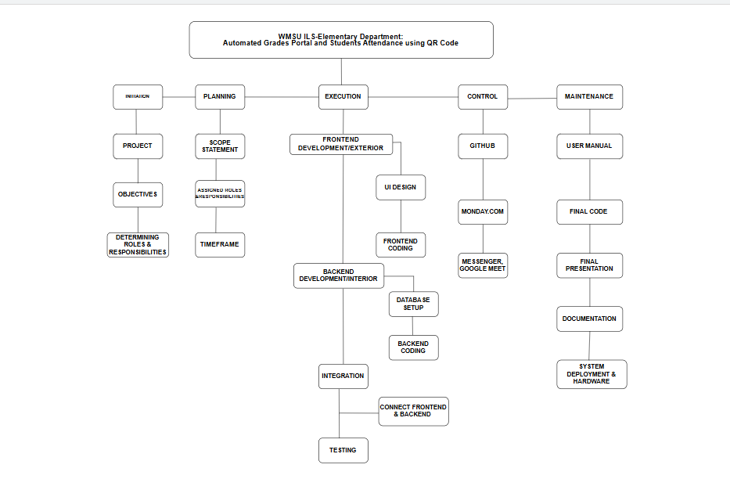

3.3.Network Diagram

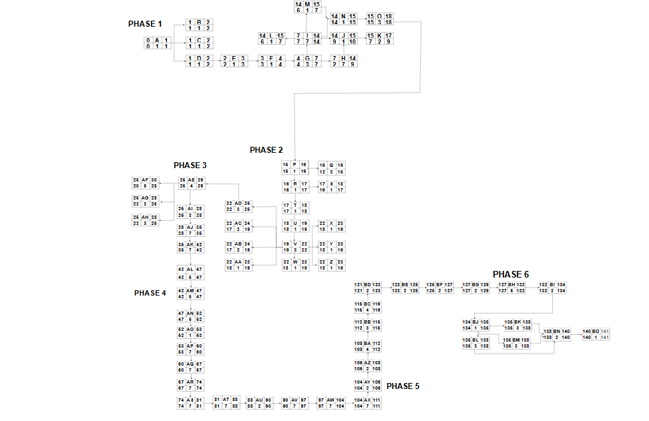

PHASE 1 : PLANNING
ACTIVITIES | DEPENDENCY | DURATION( TIME)
1.1 A | - | 1
1.2 B | A | 1
1.3 C | A | 1
1.4 D | A | 1
1.5 E | D | 1
1.6 F | E | 1
1.7 G | F | 3
1.8 H | G | 7
1.9 I | G | 7
1.10 J | H,I | 1
1.11 K | J | 2
1.12 L | I | 1
1.13 M | I | 1
1.14 N | I ,M | 1
1.15 O | N | 3
Critical Path : A,B,C,D,E,F,G,I,N
Activity slack: H,J,K,L,M,O

PHASE 2 : ANALYSIS
ACTIVITIES | DEPENDENCY | DURATION(TIME)
2.1 P | 0 1.5 | 1
2.2 Q | P | 3
- R | P | 1
2.4 S | R | 1
2.5 T | R | 1
2.6 U | T | 1
2.7 V | U | 3
2.8 W | V | 1
2.9 X | V | 1
2.10 Y | V | 1
2.11 Z | V | 1
2.12 AA | V | 1
2.13 AB | V | 2
2.15 AC | V | 2
2.16 AD | V | 3
2.17 AE | AD | 4
Critical Path : P,R,T,U,V,AD,AE
Activity Slack :Q,S,W,X,Y,Z,AA,AB,AC

PHASE 3: DESIGN
ACTIVITIES | DEPENDENCY | DURATION(TIME)
3.1 AF | AD 2.16 | 5
3.2 AG | AD 2.16 | 3
3.3 AH | AD 2.16 | 3
3.4 AI | AH | 7
3.5 AJ | AI | 7
3.6 AK | AJ | 7
3.7 AL | AK | 5
Critical Path: AF,AG,AH,AI,AJ,AK,AL
Activity Slack: AF,AG,AH

ACTIVITIES | DEPENDENCY | DURATION(TIME)
4.1 AM | 3.7 AK | 5
4.2 AN | AN | 5
4.3 AO | AO | 1
4.5 AP | AP | 7
4.6 AQ | AQ | 7
4.7 AR | AR | 7
4.8 AS | AS | 7
4.9 AT | AT | 7
4.10 AU | AU | 2
4.11 AV | AV | 7
4.12 AW | AW | 3
4.13 AX | AX | 7
PHASE 4: CODING
Critical Path: AM,,AN,AO,AP,AQ,AR,AS,AT,AU,AV,AW,AX
Activity Slack: NONE
PHASE 5: TESTING
ACTIVITIES | DEPENDENCY | DURATION(TIME)
5.1 AJ | 4.12 AW | 2
5.3 AL | AK | 4
5.4 AM | AL | 3
5.5 AN | AM | 4
5.6 AO | AN | 2
5.7 AP | AO | 2
5.8 AQ | AP | 2
5.9 AR | AQ | 5
Critical Path : AY,AZ,BA,BC,BD,BE,BF,BG
Activity Slack : NONE
PHASE 6 : MAINTENANCE
ACTIVITIES | DEPENDENCY | DURATION(TIME)
6.1 AS | 5.9 AR | 2
6.2 AT | 5.9 AR | 1
6.3 AU | AT | 3
6.4 AV | AT | 3
6.5 AW | AT | 3
6.6 AX | AV,AW | 2
6.7 AY | AX | 1

Critical Path : BH,BI,BJ,BL,BK,BM,BN,BO
Activity Slack : NONE

3.4 Milestones and Deliverables
PHASE 1: PLANNING
Milestone | Deliverables
1.1 Create a company | Company profile document
1.2 Design company logo | Company Official logo
1.3 Define company mission, vision and goals | Company mission, vision, and goals aimed
1.4 Define company organization structure | Organization role on Company
1.5 Define company policies and penalties | Company policies and penalties document
1.6 Establish and promote company | Company project proposal document
1.7 Close a deal with a client | Client agreement document
1.8 Create project action plan | Project action plan document
1.9 Determine project milestone and deliverables | Milestone and Deliverable list
1.10 Create work breakdown structure | WBS chart/ Document
1.11 Create an online project board | Trello online project tracking board
1.12 Create an Gantt chart | Gantt chart schedule
1.13 Create Activity Network Diagram | Activity Network Diagram
1.14 Determine project critical path and slack time | Critical path Analysis Report
1.15 Collate project documentation for Phase 1 | Phase 1 Documentation file

PHASE 2 : ANALYSIS
Milestone | Deliverables
2.1 Identify data collection method | Data Collection Plan
2.2 Conduct initial data gathering | Raw data collected
2.3 Transcribe and analyze collected data | Data Analysis Report
2.4 Propose Initial solution for the project | Initial Solution Documentation
2.5 Determine project cost | Cost Estimation Report
2.6 Conduct Feasibility study | Feasibility Study Report
2.7 List initial project requirements | Initial Requirements list
2.8Determine hardware requirements | Hardware Requirement list
2.9 Determine software requirements | Software Requirement list
2.10 Determine network requirements | Network Requirement list
2.11 Determine database requirements | Database Requirements list
2.12 Identify software specification | Software Specification Document
2.13 list product features | Product Feature list
2.14 list product attributes | Product attributes list
2.15 Create product mockups | Product Mockup Designs
2.16 Finalize documentation for Phase II | Phase 2 Documentation file
PHASE 3: DESIGN
` Milestone | Deliverables
3.1 Determine system architecture | System architecture document
3.2 Create business use case | Business use Case document
3.3 Create context and data flow diagram | Context Diagram and Data flow Diagram
3.4 Design system model | System Model Diagram
3.5 Design user interface | UI Designs/ Mockups
3.6 Create product prototype | Product Prototype
3.7 Finalize documentation for Phase III | Phase 3 Documentation file

PHASE 4 : CODING
Milestone | Deliverables
S4.1 Write System Module 1-[User/admin login using WMSU account] | Module source code [User/login using WMSU account]
4.2 Write System Module 2- [ System Dashboard] | Module source code [ System dashboard]
4.3 Get Feedback from a consultant 1 | Consultant feedback Report
4.4 Debug, fix bugs, and update modules | Debugs and update report
4.5 Write System Module 3 – [Automated Grades Portal Section ] | Module source code [Automated Grades Portal Section]
4.6 Write System Module 4-[ Class Schedules Data Input for all grade levels | Module source code [Class Schedules Data input for all grade levels
4.7 Write System Module 5-[ Gathering students Records and Student attendance Management using QR Code] | Module source code [Gathering students records and student attendance Management using QR code]
4.8 Integrate System Modules | Integrated system build
4.9 Get feedback from a consultant 2 | Consultant Feedback Report
4.10 Debug, fix bugs and update modules | Debugs and Update report
4.11 Conducting unit Testing | Unit testing result
4.12 Finalize product designing and coding | Finalize designed and code source
PHASE 5: TESTING
Milestone | Deliverables
5.1 Create testing plan | Testing plan document
5.2 Create test cases | Test care Document
5.3 Conduct alpha testing | Alpha test report
5.4 Conduct beta testing | Beta test report
5.5 Fix system errors | Fix bug error
5.6 Conduct software/product attributes testing | Attributes Test Report
5.7 Conduct user acceptance testing | User approve and report
5.8 Create migration plan |  | Migration plan Document
5.9 Deploy system/ product to client |  | Deployed system and client site
PHASE 6 : MAINTENANCE
Milestone |  | Deliverables
6.1 Create product manual |  | User manual/ Customer Guide
6.2 Gather and analyze customer feedback |  | Customer feedback report
6.3 Perform corrective, maintenance |  | Corrective maintenance report
6.4 Perform perfective maintenance |  | Perfective maintenance report
6.5 Perform adaptive maintenance |  | Adoptive maintenance
6.6 Finalize project documentation |  | Finalize project documentation
6.7 turn-over project to client and close the project |  | Project handover package

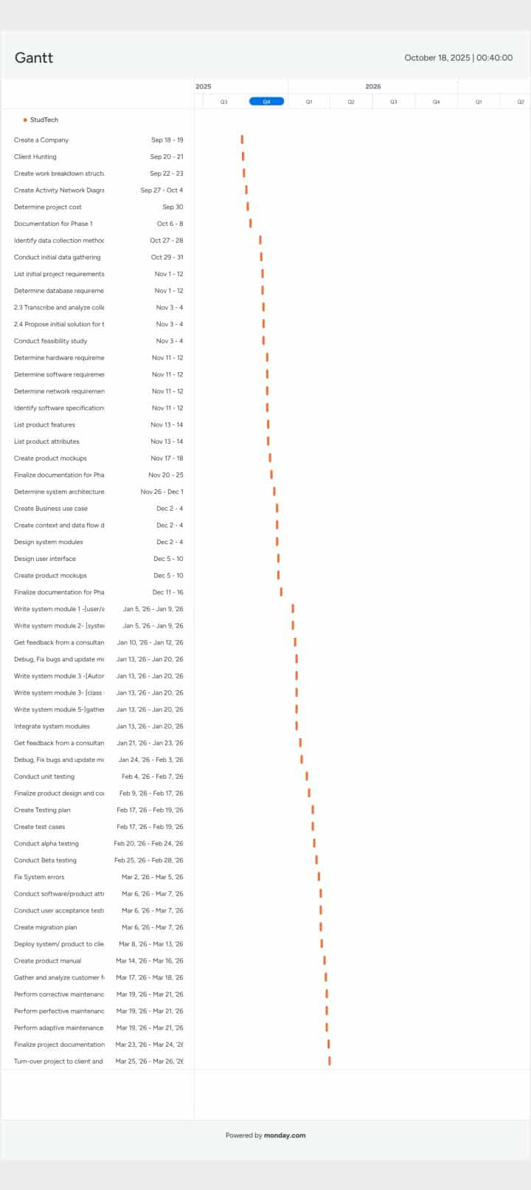
3.5 Gannt Chart

Chapter 4 – Project Cost

4.1. Cost of Project Resources
Project Costing
4.1.1. Effort Cost
Project: Learning Management System

Effort Cost
Member | Hours/Day | Rate/Hour |  | Total Working Days | Total
Josie Banalo | 4 | PHP 50 |  | 300 | PHP 60,000
Collen Cuento | 4 | PHP 100 |  | 300 | PHP 120,000
John Carlo Pardillo | 4 | PHP 50 |  | 300 | PHP 60,000
Ashley Faye Vega | 4 | PHP 50 |  | 300 | PHP 60,000
Ashley Nicole Villanueva | 4 | PHP 100 |  | 300 | PHP 120,000
Total |  |  | PHP 420,000
4.1.2 Hardware Cost
Hardware Cost
Item | Unit | Price/Unit |  | Quantity | Total
Laptop | Set | PHP 39, 000  PHP 19,000  PHP 30,000 |  | 4 | PHP 88,000
Hard drive | 8GB/pc  8GB/pc  4GB/pc | PHP 500 |  | 3 | PHP 1,500
QR CODE STICKER |  | 100 |  | 60 | PHP 6,000
Total |  |  | PHP 95,000

4.1.3 Hardware Cost
Hardware Cost
Item | Unit | Price/Unit |  | Quantity | Total
Laptop | Set | PHP 39, 000  PHP 19,000  PHP 30,000 |  | 4 | PHP 88,000
Hard drive | 8GB/pc  8GB/pc  4GB/pc | PHP 500 |  | 3 | PHP 1,500
QR CODE STICKER |  | 100 |  | 60 | PHP 6,000
Total |  |  | PHP 95,000

4.1.4Miscellaneous

Miscellaneous
Item | Total
Food Allowance | PHP 20,000
Transportation | PHP 10,000
Documentation | PHP 20,000
Cloud Server Subscription for a year | PHP 5,000
Utility | PHP 25,000
Total | PHP 80,000
Overall Cost
Expenses |  | Total
Effort Cost |  | PHP 420,000
Hardware Cost |  | PHP 95,000
Software Cost |  | PHP 5,000
Miscellaneous |  | PHP 80,000
Total: PHP 600,000

4.1.5 Overall Cost
Overall Cost
Expenses | Total
Effort Cost | PHP 420,000
Hardware Cost | PHP 95,000
Software Cost | PHP 5,000
Miscellaneous | PHP 80,000
Total: PHP 600,000

4.2. Return-on-Investment (ROI)

DEVELOPMENT COST
TYPE OF COST | YEAR  2025 2026 2027 2028 | TOTAL

Salary | PHP 420,000 |  |  |  | PHP 420,000
Hardware | PHP 95,000 |  |  |  | PHP 95,000
Software | PHP 5,000 |  |  |  | PHP 5,000
Miscellaneous | PHP 80,000 |  |  |  | PHP 80,000
Total: |  |  |  |  | PHP 600,000

OPERATIONAL COST
TYPE OF COST | YEAR  2025 2026 2027 2028 | TOTAL

Maintenance | PHP 5,000 | PHP 5,000 | PHP 5,000 | PHP 5,000 | PHP 20,000
Upgrades | PHP 5,000 | PHP 5,000 | PHP 5,000 | PHP 5,000 | PHP 20,000
Repairs | PHP 10,000 | PHP 10,000 | PHP 10,000 | PHP 10,000 | PHP 40,000
Utility | PHP 10,000 | PHP 10,000 | PHP 10,000 | PHP 10,000 | PHP 40,000
Total: |  |  |  |  | PHP 120,000

BENEFITS
TYPE OF COST | YEAR  2025 2026 2027 2028 | TOTAL

Reduce Office Supplies | PHP 20,000 | PHP 20,000 | PHP 20,000 | PHP 20,000 | PHP 80,000
Increase Productivity | PHP 30,000 | PHP 50,000 | PHP 70,000 | PHP 100,000 | PHP 250,000
Reduce Wages | PHP 5,000 | PHP 5,000 | PHP 5,000 | PHP 5,000 | PHP 20,000
Total: | PHP 55,000 | PHP 75,000 | PHP 95,000 | PHP 125,000 | PHP 350,000

ROI = \frac{\text{Benefits – Total Cost}}{\text{Total Cost}} \times 100
ROI = \frac{350,000 – 120,000}{120,000} \times 100
ROI = \frac{230,000}{120,000} \times 100
ROI = 191.67\% Positive ROI
4.3. Intangible benefits
- Faster grading process – automatic checking of quizzes and assignments.
- Improved productivity – teachers and students save time, can focus more on learning.
- Computer-aided learning – students access lessons anytime, anywhere.
- Reduced paperwork – less printing, less storage needed.
- Increased student engagement – interactive modules and online discussions.
- Better communication – easy announcements, updates, and feedback between teachers and students.
- Academic transparency – students can track grades and progress in real time.
- Support for blended/online learning – flexible for both face-to-face and remote classes.
- Skill development – students gain digital literacy and adaptability.
- Reduced academic dishonesty – system logs and monitoring help track activities.

Chapter 5- Project Feasibility
5.1 Candidate Solution Matrix

5.2 Technology Gap Analysis
Characteristic | Open-Source (Management Information system) | New Development | Paid/Subscription
Portion of the System computerized | Self hosted and customizable system | Self hosted and customizable system | fully customizable for School to control
Benefits | Takes a Month | Customized system development | Quick Implementation
Servers and Workstations | Dedicated and Scalable server | Dedicated and Scalable  server | NOT Cloud-based, Vendor dependent
Software Tools Needed | Lates coded MySQL | CCS,PHP,MySQL,REACT.JS, Node.JS with API | NOT APPLICABLE
Application Software | Open Source and Customized Solution | Customized solution | Customized solution
Method of Data Processing | Online, remote and Real time | Online, remote and Real time | Online, remote and Real time
Output Devices and Implications | Monitors, Laptops, Printers | Monitors ,Laptops, Printers | Monitors, Laptops, Printers
Input Devices and Implications | Mouse, Keyboard | Mouse, Keyboard | Mouse, Keyboard
Storage Devices and Implications | MySQL and storage scalable meet to user needs | MySQL and storage scalable meet to user needs | NOT Cloud-based, Vendor dependent

Top Features or Characteristics | WMSU ILS Elementary Department: Automated Grades Portal, and Student Attendance using QR code (Management Information System) | WMSU.Edu.ph | Samal Island City College  Student QR Attendance tracker (SQAT)
Ease of Use | Expert | Easy | Easy
Performance | 4/5 | 5/5 | 5/5
Customizable | Yes | Yes | Yes
Participants | Individual | Individual | Individual
Grades | Advance and Generated Grades | Fix and simple | NONE
Attendance | Automatic Notified in Portal Attendance and Parents | NONE | Notified to Parent or Guardians
Security | Self-Hosted | Self- Hosted | Self-Hosted
Reliability | Self-Hosted | Self-Hosted | Self-Hosted
Office Integration | NO | NO | NO

  - Feasibility Study
5.3.1. Operational Feasibility

- The implementation of the self-hosted WMSU ILS Elementary Department Automated Grades Portal and student attendance using QR codes for our elementary students to manage the attendance by QR code to notify the parents, input and records grade generate automatic ranking of students, class schedule, and teacher assigned in a portal of a student. The QR codes help for fast transaction of checking attendance by scanning and monitoring the safety of students inside and outside the classroom. The portal of a student can show grades, attendance, class schedule, and teacher assignments. This new system implementation will help the teachers monitor the students’ performance and ensure the safety inside of the schools.

Success Factors :
a. Requires series of Training for Non-IT teachers.
b. Need to established IT support or helpdesk
c. Phase-based Implementation/ Pilot Testing for Accessibility
d. Usability of the System. Should be easy to navigate but requires repetitive used of System familiarized it.

5.3.2.Technical Feasibility
Hardware Resources
- Development
Laptop
- Deployment
Physical deployment manage by the Client with A largely amount of users.
Software Resources
- Apache – Local Web Server
- MySQL 5.7- Database
- PHP 8.2- Version improved security, compatible and security.
- PHP Extension- Extension needed install and Complete.
- SMTP Mail Server – sending ,notifications, and Updates.
- Cronjobs- For automation input Attendance and notified the Parents in System.
- JS.QR code or other Open source - for attendance scanned
- CSS- Custom code
- REACT.JS- For frontend development
- NODE.JS- for Backend development
- People Resource

Member | Functions
Ashley Faye M. Vega  MIS Project Manager | - Prepared and documents the process procedures and Protocols for MIS Platform.  - Develop Technical solution and Security tools to help.  - Set MIS Guidelines and Policies and ensure its implementation in the School.  - Set security requirements in MIS Platform.  - Ensure the compliance platform to the Data Privacy Act 2012 (RA 10173)
Collen Q. Cuento  MIS Lead developer | - The responsible of the development of the team in the design, development, coding, testing, and debugging of customized MIS platform remote learning in school.  - Assigned of the development of system.  - The leader of development of the team.  - Ensure the development phase of the system complete.
Josie O. Banalo  MIS Business Analysis | - Ensure the business documents for development phase.  - Helps the Pm to understand the client needs and user want a friendly system.
John Carlo A. Pardillo  MIS Quality Assurance Engineering | - To ensure the system function and error free.  - Help the lead developer to develop the system.  - Check the system bugs and to ensure the Quality of the system.
Ashley Nicole N. Villanueva  MIS UX design/ UI design | - The responsibility of the design team.  - Help the lead developer for the system.  - Create a Prototype for visual of the system development
5.3.3. Schedule Feasibility

A long-term approach implementation WMSU ILS: Elementary Department Automated Grades Portal and student attendance using QR codes.

WMSU ILS : Elementary Department Automated Grades ,Portal and student attendance using QR codes
Stage 3: Integration
Stage 2: Migration
Stage 1: Development

1. Planning and Preparation of Installation Requirements
1.Planning integration
1.Preparation of dedication MIS server
2. Installation of on-site and off-site data on school system
2. Installation of server, MIS and dependencies
2. Create a Portal of MIS
3. Develop customized APIs
3. Complementation of student and faculty records
3. Customization and Administration

4. Integration of MIS students Portal
4. Coding and Module Development
4. Production Migration and Testing
5. Integration of MIS student attendance
5. Records Migration and lunching
5. System Testing
6. Deployment and Adoption of MIS

3. Stage of Implementation of WMSU ILS: Elementary Department Automated Grades Portal and student Attendance using QR code.
Stage 1: Development
In this stage, the team will develop the customized WMSU ILS : Elementary Department Automated Grades Portal and student Attendance using QR code, conduct testing and Prepare deployment of the system in Elementary department.
1. Phase I - Planning and Preparation of Installation requirements.
2. Phase II - Installation of server, MIS and dependencies.
3. Phase III - Customization and Administration.
4. Phase IV - Coding and Module Development.
5. Phase V - System Testing
6. Phase VI- Deployment and Adoption of MIS

Stage 2: Migration
In this stage, the team will prepare the MIS server that provide a service to the Elementary Department.
The Team will continue monitoring and maintaining the system the used of MIS in the Elementary Department during the Phase 1.
1. Preparation of dedication MIS server
2. Installation of on-site and off-site data on school system
3. Complementation of Student and faculty records.
4. Production migration and Testing
5. Records migration and lunching
Stage 3: Integration
In this stage, the team will propose the MIS to develop on the Automated Grades, Portal and students using QR code in a system protocols.
1. Planning integration
2. Create a Portal of MIS
3. Create a customize APIs
4. Integration of MIS students portal
5. Integration MIS students attendance
Project Duration: 300 days or 10 months
Note: Refers Action plan detailed project schedule.
Success Factors:
a. On- time procurement of hardware resource
b. On time schedule of training and scheduling of MIS

5.3.5. Economics
Project Costing
Project: Learning Management System
5.3.6 Effort Cost
Effort Cost
Member | Hours/Day | Rate/Hour |  | Total Working Days | Total
Josie Banalo | 4 | PHP 50 |  | 300 | PHP 60,000
Collen Cuento | 4 | PHP 100 |  | 300 | PHP 120,000
John Carlo Pardillo | 4 | PHP 50 |  | 300 | PHP 60,000
Ashley Faye Vega | 4 | PHP 50 |  | 300 | PHP 60,000
Ashley Nicole Villanueva | 4 | PHP 100 |  | 300 | PHP 120,000
Total |  |  | PHP 420,000

5.3.7 Hardware Cost
Hardware Cost
Item | Unit | Price/Unit |  | Quantity | Total
Laptop | Set | PHP 39, 000  PHP 19,000  PHP 30,000 |  | 4 | PHP 88,000
Hard drive | 8GB/pc  8GB/pc  4GB/pc | PHP 500 |  | 3 | PHP 1,500
QR CODE STICKER |  | 100 |  | 60 | PHP 6,000
Total |  |  | PHP 95,000

5.3.8 Software Cost

Software Cost
Item | Unit | Price/Unit | Quantity | Total
Software for Development  (CSS, PHP, MySQL, REACT.JS NODE.JS) | License | FREE | 5 | FREE
API | LICENSE | PHP 500-2,000 | 2 | PHP 1,000  PHP 4,000
 | TOTAL: |  |  | PHP 5,000

5.3.9 Miscellaneous
Miscellaneous
Item | Total
Food Allowance | PHP 20,000
Transportation | PHP 10,000
Documentation | PHP 20,000
Cloud Server Subscription for a year | PHP 5,000
Utility | PHP 25,000
Total | PHP 80,000

Overall Cost
Expenses | Total
Effort Cost | PHP 420,000
Hardware Cost | PHP 95,000
Software Cost | PHP 5,000
Miscellaneous | PHP 80,000
Total: PHP 600,000

5.3.10 Return-on-Investment (ROI)
DEVELOPMENT COST
TYPE OF COST | YEAR  2025 2026 2027 2028 | TOTAL

Salary | PHP 420,000 |  |  |  | PHP 420,000
Hardware | PHP 95,000 |  |  |  | PHP 95,000
Software | PHP 5,000 |  |  |  | PHP 5,000
Miscellaneous | PHP 80,000 |  |  |  | PHP 80,000
Total: |  |  |  |  | PHP 600,000

OPERATIONAL COST
TYPE OF COST | YEAR  2025 2026 2027 2028 | TOTAL

Maintenance | PHP 5,000 | PHP 5,000 | PHP 5,000 | PHP 5,000 | PHP 20,000
Upgrades | PHP 5,000 | PHP 5,000 | PHP 5,000 | PHP 5,000 | PHP 20,000
Repairs | PHP 10,000 | PHP 10,000 | PHP 10,000 | PHP 10,000 | PHP 40,000
Utility | PHP 10,000 | PHP 10,000 | PHP 10,000 | PHP 10,000 | PHP 40,000
Total: |  |  |  |  | PHP 120,000

BENEFITS
TYPE OF COST | YEAR  2025 2026 2027 2028 | TOTAL

Reduce Office Supplies | PHP 20,000 | PHP 20,000 | PHP 20,000 | PHP 20,000 | PHP 80,000
Increase Productivity | PHP 30,000 | PHP 50,000 | PHP 70,000 | PHP 100,000 | PHP 250,000
Reduce Wages | PHP 5,000 | PHP 5,000 | PHP 5,000 | PHP 5,000 | PHP 20,000
Total: | PHP 55,000 | PHP 75,000 | PHP 95,000 | PHP 125,000 | PHP 350,000

ROI = \frac{\text{Benefits – Total Cost}}{\text{Total Cost}} \times 100
ROI = \frac{350,000 – 120,000}{120,000} \times 100
ROI = \frac{230,000}{120,000} \times 100
ROI = 191.67\% Positive ROI

Intangible benefits

- Faster grading process – automatic checking of quizzes and assignments.
- Improved productivity – teachers and students save time, can focus more on learning.
- Computer-aided learning – students access lessons anytime, anywhere.
- Reduced paperwork – less printing, less storage needed.
- Increased student engagement – interactive modules and online discussions.
- Better communication – easy announcements, updates, and feedback between teachers and students.
- Academic transparency – students can track grades and progress in real time.
- Support for blended/online learning – flexible for both face-to-face and remote classes.
- Skill development – students gain digital literacy and adaptability.
- Reduced academic dishonesty – system logs and monitoring help track activities.

5.4.1. Cultural Feasibility
The proposed WMSU ILS-Elementary Department: Automated Grades Portal , and Students Attendance using QR code will be helpful the Elementary department of WMSU-ILS to monitor the students attendance, class schedule , direct notified the parents, Student record and a student Portal.

Success Factors:
a. Requires extensive training for faculty.
b. Awareness program for end-users (Faculty and Teachers)
c. Establish a support system to help teachers and faculty to less the manual works to monitor the students .
d. Support for other users may find it difficult in using the system need to practice and Familiarize all the system functions to adopt the new system implement.

5.4.2. Legal Feasibility
One of the primary concerns is data privacy. The implementation of the self-hosted WMSU ILS-Elementary Department: Automated Grades Portal , and Students Attendance using QR code both management and the technical team to address the problem.
Most of the tools to be used in the implementation are open source or free of use.
Success Factors:
a. Security configuration of the server where the WMSU ILS-Elementary Department: Automated Grades Portal , and Students Attendance using QR code will be deployed.
b. Requires expertise in IT security
c. Compliance with the University Academic Guidelines
d. Compliance with the applicable law of the Republic of the Philippines.

5.4.3 Feasibility Analysis Matrix
Feasibility Criteria | Weight | MIS -WMSU ILS-Elementary Department: Automated Grades Portal , and Students Attendance using QR code | New Development | Paid/ Subscription Based
Operational | 30% | Fully Support MIS requirements | Fully support of MIS requirements | Most Features MIS requirements
 |  | 100 | 100 | 80
Technical | 10% | Comfortable in setting up from scratch | Comfortable in setting up from scratch | Vendor dependent
 |  | 100 | 100 | 100
Economic | 30% | Cost for own server, domain, storage | Cost for own server, domain, storage | Expensive, cost per user
 |  | 80 | 70 | 30
Schedule | 30% | Need asap, less than 5 month | Take several of 10 months | Weeks to 1 month
 |  | 85 | 60 | 100
Ranking | 100% | 89.5 | 79 | 83

5.5 Function and Non- Function requirements gathered
5.1 .Requirement #1
Requirement Type: Functional Requirement
Event/Use Case: Student Registration (Grade 3 -Grade 6)
Description: The system shall allow administrators to register new students with unique Qr code ,IDs and personal details.
Rationale: To ensure proper identification and record-keeping for all students.
Source (Originator): Administrator
Fit Criterion: Each registered student must appear in the database with a unique Qr code and ID.
Customer Satisfaction: 5
Customer Dissatisfaction: 5
5.2 Requirement #2
Requirement Type: Functional Requirement
Event/Use Case: Teacher Account Management
Description: The system shall allow administrators to create and manage teacher accounts.
Rationale: To ensure that only verified instructors can access and update class information.
Source (Originator): Administrator
Fit Criterion: Each teacher must be assigned to at least one subject before they can access grading.
Customer Satisfaction: 5
Customer Dissatisfaction: 5
5.3 Requirement #3
Requirement Type: Functional Requirement
Event/Use Case: Subject Encoding
Description: The system shall allow administrators and teachers to encode subject details such as code, description, and units.
Rationale: To standardize subjects across all departments.
Source (Originator): Admin/Teacher
Fit Criterion: Each subject entry must contain complete details before it can be saved.
Customer Satisfaction: 4
Customer Dissatisfaction: 5

5.4 Requirement #4
Requirement Type: Functional Requirement
Event/Use Case: Automatic computed Attendance
Description: This function attendance daily
Rationale: To avoid manual input.
Source (Originator): System Administrator
Fit Criterion: To avoid time consuming .
Customer Satisfaction: 5
Customer Dissatisfaction: 4

5.5 Requirement #5
Requirement Type: Functional Requirement
Event/Use Case: Grade Input
Description: The system shall allow teachers to encode student grades per subject and term.
Rationale: To simplify the grading process and reduce manual errors.
Source (Originator): Teacher
Fit Criterion: All grades must follow the official WMSU grading format.
Customer Satisfaction: 5
Customer Dissatisfaction: 4

5.6 Requirement #6
Requirement Type: Functional Requirement
Event/Use Case: Grade Computation
Description: The system shall compute final grades automatically based on encoded scores and weights.
Rationale: To ensure accurate and efficient grade computation.
Source (Originator): Teacher
Fit Criterion: The system must calculate results consistent with the WMSU formula.
Customer Satisfaction: 5
Customer Dissatisfaction: 5

5.7 Requirement #7
Requirement Type: Functional Requirement
Event/Use Case: Grade Approval
Description: The system shall allow administrators to review and approve submitted grades before publishing.
Rationale: To maintain data integrity and prevent unauthorized grade changes.
Source (Originator): Admin
Fit Criterion: Grades must show as “Pending” until approved by an administrator.
Customer Satisfaction: 5
Customer Dissatisfaction: 4

5.8 Requirement #8
Requirement Type: Functional Requirement
Event/Use Case: Grade Viewing
Description: The system shall allow students to view their final grades through their portal accounts.
Rationale: To give students quick access to academic performance records.
Source (Originator): Student
Fit Criterion: Students can access grades only for completed subjects.
Customer Satisfaction: 5
Customer Dissatisfaction: 5

5.9 Requirement #9
Requirement Type: Functional Requirement
Event/Use Case: Attendance Scanning
Description: The system shall record student attendance through scanning of ID QR codes.
Rationale: To automate attendance checking and avoid manual errors.
Source (Originator): Teacher
Fit Criterion: Each scan must record date, time, and student ID in the database.
Customer Satisfaction: 5
Customer Dissatisfaction: 5

5.10 Requirement #10
Requirement Type: Functional Requirement
Event/Use Case: Attendance Report Generation
Description: The system shall generate attendance reports for each subject per month.
Rationale: To monitor attendance patterns.
Source (Originator): Admin
Fit Criterion: Reports must include date, student name, and attendance status.
Customer Satisfaction: 5
Customer Dissatisfaction: 4

5.11 Requirement #11
Requirement Type: Functional Requirement
Event/Use Case: Role-Based Access Control
Description: The system shall provide role-based access control for Admins, Teachers, and Students.
Rationale: To ensure data confidentiality and prevent unauthorized access.
Source (Originator): Admin
Fit Criterion: Users can only access functions related to their roles.
Customer Satisfaction: 5
Customer Dissatisfaction: 5

5.12 Requirement #12
Requirement Type: Functional Requirement
Event/Use Case: Audit Trail Logging
Description: The system shall record a history of all changes made to student grades or schedules.
Rationale: To maintain transparency and traceability.
Source (Originator): Admin
Fit Criterion: Audit trail must show user, action, timestamp, and old/new data.
Customer Satisfaction: 5
Customer Dissatisfaction: 5

5.13 Requirement #13
Requirement Type: Functional Requirement
Event/Use Case: Printable Class Record
Description: The system shall allow teachers to print class records for backup.
Rationale: To maintain hard copy references when needed.
Source (Originator): Teacher
Fit Criterion: Printout must include subject name, student list, and grades.
Customer Satisfaction: 4
Customer Dissatisfaction: 4

5.14 Requirement #14
Requirement Type: Functional Requirement
Event/Use Case: Report Card Download
Description: The system shall let students download a PDF version of their report card.
Rationale: To simplify access to academic documents.
Source (Originator): Student
Fit Criterion: File must include official format and school logo.
Customer Satisfaction: 5
Customer Dissatisfaction: 5

5.15 Requirement #15
Requirement Type: Functional Requirement
Event/Use Case: Attendance Override
Description: The system shall allow admins to manually correct attendance errors.
Rationale: To handle missed scans or excused absences.
Source (Originator): Admin
Fit Criterion: Override must be logged in audit trail with reason.
Customer Satisfaction: 4
Customer Dissatisfaction: 4
Due to message limits, I will continue the

5.16 Requirement #16
Requirement Type: Functional Requirement
Event/Use Case: QR Student ID Generation
Description: The system shall generate a digital and printable student ID with a unique QR code.
Rationale: To support quick and secure attendance scanning.
Source: Administrator
Fit Criterion: ID must correctly decode student identity when scanned.
Customer Satisfaction: 5
Customer Dissatisfaction: 5

5.17 Requirement #17
Requirement Type: Functional Requirement
Event/Use Case: Student Profile Management
Description: Students shall be able to update their personal information except restricted fields like ID number.
Rationale: To ensure updated student records.
Source: Student
Fit Criterion: System validates and logs all changes.
Customer Satisfaction: 4
Customer Dissatisfaction: 4

5.18 Requirement #18
Requirement Type: Functional Requirement
Event/Use Case: Teacher Dashboard
Description: The system shall provide teachers an overview of assigned subjects, students, and pending grades.
Rationale: To simplify navigation and task management.
Source: Teacher
Fit Criterion: Dashboard updates dynamically based on teacher role.
Customer Satisfaction: 5
Customer Dissatisfaction: 4

5.19 Requirement #19
Requirement Type: Functional Requirement
Event/Use Case: Student Dashboard
Description: Students shall view enrolled subjects, attendance stats, and published grades.
Rationale: To quickly access academic data.
Source: Student
Fit Criterion: All dashboard info must be correct and up-to-date.
Customer Satisfaction: 5
Customer Dissatisfaction: 5

5.20 Requirement #20
Requirement Type: Functional Requirement
Event/Use Case: Search Function
Description: The system shall allow search for subjects, teachers, or students using keywords.
Rationale: To speed up data retrieval.
Source: All roles
Fit Criterion: Search results must match entered keywords.
Customer Satisfaction: 4
Customer Dissatisfaction: 4

5.21 Requirement #21
Requirement Type: Functional Requirement
Event/Use Case: Notification Alerts
Description: The system shall notify users of new grades, schedule updates, or attendance concerns.
Rationale: To ensure timely communication.
Source: System
Fit Criterion: Notifications display within 5 seconds of event trigger.
Customer Satisfaction: 5
Customer Dissatisfaction: 4

5.22 Requirement #22
Requirement Type: Functional Requirement
Event/Use Case: Login Authentication
Description: All users shall log in using secure credentials.
Rationale: Protect system access.
Source: System Administrator
Fit Criterion: Incorrect passwords must deny system entry.
Customer Satisfaction: 5
Customer Dissatisfaction: 5

5.23 Requirement #23
Requirement Type: Functional Requirement
Event/Use Case: Password Reset
Description: The system shall allow users to reset passwords through secure verification.
Rationale: To recover accounts when credentials are forgotten.
Source: All Users
Fit Criterion: Password must be successfully updated & logged.
Customer Satisfaction: 5
Customer Dissatisfaction: 4

5.24 Requirement #24
Requirement Type: Functional Requirement
Event/Use Case: Class List Viewing
Description: Teachers shall view a list of students enrolled in each assigned class.
Rationale: Supports attendance and grade input.
Source: Teacher
Fit Criterion: Class list matches enrollment records.
Customer Satisfaction: 5
Customer Dissatisfaction: 5

5.25 Requirement #25
Requirement Type: Functional Requirement
Event/Use Case: Enrollment Management
Description: Administrators shall enroll or remove students from subjects.
Rationale: Maintains accurate class composition.
Source: Admin
Fit Criterion: Changes must reflect immediately in class lists.
Customer Satisfaction: 5
Customer Dissatisfaction: 5

5.26 Requirement #26
Requirement Type: Functional Requirement
Event/Use Case: Attendance Status Tag
Description: Attendance must be tagged as Present, Absent, or Excused.
Rationale: Standardizes attendance classification.
Source: Teacher
Fit Criterion: Tags must appear correctly in attendance logs.
Customer Satisfaction: 4
Customer Dissatisfaction: 4

5.27 Requirement #27
Requirement Type: Functional Requirement
Event/Use Case: Event/Use Case: Conflict Detection
Description: To view the error in grades detection in the system
Rationale: Avoids error on grades.
Source: System
Fit Criterion: System must display conflict warnings before saving.
Customer Satisfaction: 5
Customer Dissatisfaction: conflict Detection
Description: To view the error in grades detection in the system Rationale: Avoids error on grades.
Source: System Fit Criterion: System must display conflict warnings before saving.
Customer Satisfaction: 5
Customer Dissatisfaction: 5

5.28 Requirement #28
Requirement Type: Functional Requirement
Event/Use Case: Conflict Detection
Description: To view the error in grades detection in the system
Rationale: Avoids error on grades.
Source: System
Fit Criterion: System must display conflict warnings before saving.
Customer Satisfaction: 5
Customer Dissatisfaction: 5

5.29 Requirement #29
Requirement Type: Functional Requirement
Event/Use Case: Export Reports
Description: Admins and teachers shall export attendance & grade reports to PDF.
Rationale: Provides offline access.
Source: Teacher/Admin
Fit Criterion: Downloaded reports must match on-screen data.
Customer Satisfaction: 5
Customer Dissatisfaction: 4

5.30 Requirement #30
Requirement Type: Functional Requirement
Event/Use Case: Data Backup
Description: The system shall automatically back up data daily.
Rationale: Prevents loss of school records.
Source: System Admin
Fit Criterion: Backup logs must show successful operations daily.
Customer Satisfaction: 5
Customer Dissatisfaction: 5

5.31 Requirement #31
Requirement Type: Functional Requirement
Event/Use Case: Log-out
Description: The system shall log out inactive users after a set period.
Rationale: Security compliance.
Source: System
Fit Criterion: Auto-logout after inactivity timeout.
Customer Satisfaction: 5
Customer Dissatisfaction: 3

5.32 Requirement #32
Requirement Type: Functional Requirement
Event/Use Case: Grade Change Request
Description: Teachers may request changes to approved grades for admin validation.
Rationale: Corrects grading errors.
Source: Teacher
Fit Criterion: Request history must be logged.
Customer Satisfaction: 5
Customer Dissatisfaction: 4

5.33 Requirement #33
Requirement Type: Functional Requirement
Event/Use Case: Print Attendance Sheet
Description: Teachers shall print blank attendance sheets if scanning system is unavailable.
Rationale: Provides manual backup.
Source: Teacher
Fit Criterion: Printable sheet includes subject and roster.
Customer Satisfaction: 4
Customer Dissatisfaction: 3

5.34 Requirement #34
Requirement Type: Functional Requirement
Event/Use Case: Multi-term Grade Records
Description: The system shall store and track grade records per semester and academic year.
Rationale: Historical academic tracking.
Source: Admin
Fit Criterion: Students can view past grades anytime.
Customer Satisfaction: 5
Customer Dissatisfaction: 5

5.35 Requirement #35
Requirement Type: Functional Requirement
Event/Use Case: Announcement
Description: The event updates the system .
Rationale: Ensure proper class timing.
Source: Admin
Fit Criterion: For the system for Announcement happened it school.
Customer Satisfaction: 5
Customer Dissatisfaction: 4

5.36 Requirement #36
Requirement Type: Functional Requirement
Event/Use Case: Student Suspension/Restriction
Description: The system shall restrict suspended students from accessing features like attendance and scheduling.
Rationale: Enforces school policies.
Source: Admin
Fit Criterion: Restricted users see limited menu access.
Customer Satisfaction: 4
Customer Dissatisfaction: 3

5.37Requirement #37
Requirement Type: Functional Requirement
Event/Use Case: Teacher access
Description: Teachers can edit and input data of students in the class .
Rationale: To easy access.
Source: Teacher
Fit Criterion: System prevents assigning classes outside availability.
Customer Satisfaction: 4
Customer Dissatisfaction: 4

5.38 Requirement #38
Requirement Type: Functional Requirement
Event/Use Case: Section Assignment
Description: Admins shall assign students to specific class sections.
Rationale: Organizes academic groups.
Source: Administrator
Fit Criterion: Section lists show assigned students only.
Customer Satisfaction: 5
Customer Dissatisfaction: 4

5.39 Requirement #39
Requirement Type: Functional Requirement
Event/Use Case: Real-time Attendance Update
Description: Attendance scan results must show in real-time on teacher screens.
Rationale: Accurate monitoring during class.
Source: Teacher
Fit Criterion: Updates appear within 1–3 seconds.
Customer Satisfaction: 5
Customer Dissatisfaction: 5

5.40 Requirement #40
Requirement Type: Functional Requirement
Event/Use Case: System Logs Dashboard
Description: Admins shall view logs of system usage activities.
Rationale: Security and diagnostics.
Source: Admin
Fit Criterion: Logs must include user ID, time, and action.
Customer Satisfaction: 5
Customer Dissatisfaction: 4

5.41 Requirement #41
Requirement Type: Functional Requirement
Event/Use Case: Grading Template Customization
Description: Admins shall configure grading components and weight percentages.
Rationale: Support department-specific grading systems.
Source: Admin
Fit Criterion: Changes must apply instantly in grade computation.
Customer Satisfaction: 5
Customer Dissatisfaction: 5

5.42 Requirement #42
Requirement Type: Functional Requirement
Event/Use Case: Report Filtering
Description: Users shall filter attendance and grades by date, subject, or student.
Rationale: Improve data navigation.
Source: All
Fit Criterion: Filter outputs must match selected criteria.
Customer Satisfaction: 4
Customer Dissatisfaction: 4

5.43 Requirement #43
Requirement Type: Functional Requirement
Event/Use Case: Student Status Tracking
Description: The system shall reflect status such as Active, Graduated, Dropped.
Rationale: Maintain correct enrollment records.
Source: Admin
Fit Criterion: Status changes update related permissions.
Customer Satisfaction: 5
Customer Dissatisfaction: 4

5.44 Requirement #44
Requirement Type: Functional Requirement
Event/Use Case: Error Feedback
Description: The system shall display meaningful feedback messages when actions fail.
Rationale: Improves usability and error recovery.
Source: System
Fit Criterion: Messages must specify issue and solution hints.
Customer Satisfaction: 4
Customer Dissatisfaction: 3

5.45 Requirement #45 Feature Name: Student QR Code Viewing Portal
Requirement Type: Functional Requirement Event/Use Case: QR Code Scanning and Viewing Description: The administrator can quickly access and view each student’s QR code through a dedicated viewing portal.
Rationale: To make QR code access and attendance verification faster and more convenient. Source: Administrator
Fit Criterion: When selected, the system should display a pop-up window showing the student’s QR code clearly.
Customer Satisfaction: 5
Customer Dissatisfaction: 5

5. 1High Case Diagram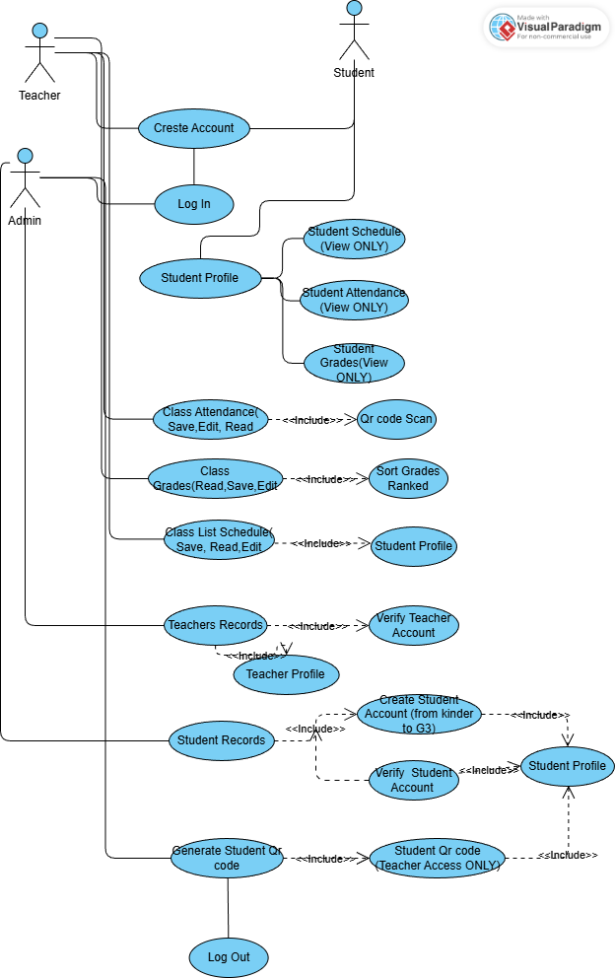

5.2 Use Case Diagram

5.2.1Use Case 1: Create Student Account
Field | Description
Use case name: | Create student account
Scenario: | Create a new student account in the WMSU ILS.
Triggering event: | A new student enrolls and needs access to the WMSU ILS.
Brief description: | The student or administrator creates a student account by entering personal and academic information. The system validates the data, generates a student profile, and assigns a unique student ID.
Actors: | Student, Administrator
Related use cases: | Log in to system, Generate Qr code student
Stakeholders: | Students, Office, Faculty, Administration
Preconditions: | System is online and accessible, Student is officially enrolled
Postconditions: | Student account is created and saved, Unique student Qr code is generated, Student profile is stored in the system

5.2.2 Use Case 2: Create Teacher Account
Field | Description
Use case name: | Create Teacher account
Scenario: | Create a new Teacher account in the WMSU ILS.
Triggering event: | A Teacher must have and needs access to the WMSU ILS system to Monitor the Students Attendance, Grades and Schedule.
Brief description: | The Teacher or administrator creates a Teacher account by entering personal and academic information. The system validates the data.
Actors: | Teacher , Administrator
Related use cases: | Log in to system, Used the system to monitor the students attendance using Qr Code Generate by the system.
Stakeholders: | Teacher, Office, Faculty, Administration
Preconditions: | System is online and accessible, Teacher is officially enrolled
Postconditions: | Teacher account is created and can Access Student profile is stored in the system

Flow of activities
Actor | System
1. Teacher/admin requests to create a Teacher account. | 1.1 System displays student registration form.
2. Teacher /admin enters personal and academic information. | 2.1 System validates entered information.
3. Teacher/admin submits the form. | 3.1 System creates Teacher account.  3.3 System stores account in database.
| Exception conditions: | Missing or invalid student information, Student already exists in the system |

5.2.3 Use Case 3: Record Student Attendance
Field | Description
Use case name: | Record attendance
Scenario: | Record student attendance using the student Qr code.
Triggering event: | A class session starts from Morning and Afternoon.
Brief description: | The instructor records attendance by scanning or entering student Qr code numbers. The system Scan the Qr code and records attendance for the scheduled class.
Actors: | Teacher
Related use cases: | Generate student Qr code, View class schedule
Stakeholders: | Students, Faculty, Administration
Preconditions: | Teacher is logged in, Class schedule exists, Student Qr codes are generated
Postconditions: | Attendance is recorded, Attendance data is saved and linked to the class

Flow of activities
Actor | System
1. Teacher record students attendance. | 1.1 System displays class list.
2. Teacher scans student Qr code. | 2.1 System verifies student Qr code.
3. Teacher confirms attendance. | 3.1 System records attendance.  3.2 System updates attendance records.
| Exception conditions: | Invalid or unrecognized student ID, Class schedule not found |

5.2.4 Use Case 4: View and Sort Ranked Grades
Field | Description
Use case name: | View and Sort ranked grades
Scenario: | Student views academic grades online and also the teacher directly see the final grades base on their ranked.
Triggering event: | The teacher have access and also the admin ONLY.
Brief description: | The Teacher accesses the grades portal to view posted grades per subject for the current or previous Quarter and Sort by ranking.
Actors: | Teachers
Related use cases: | Log in to system
Stakeholders: | Students, Faculty, Registrar
Preconditions: | The Grades sort by ranked per Quarter , Grades are already posted
Postconditions: | Grades are displayed on screen

Flow of activities
Actor | System
1. Student selects “View Grades.” | 1.1 System retrieves student grade records.  1.2 System displays grades by subject.
| Exception conditions: | Grades not yet posted, Student not authorized |

5.2.5 Use Case 5: Generate Qr code for Student
Field | Description
Use case name: | Generate Qr code for Student
Scenario: | The system Generate a Unique Qr code individual to students based on their Lrn.
Triggering event: | Start of Quarter.
Brief description: | The administrator creates Qr code and used it to scanned for Automatic Attendance record.
Actors: | Teacher
Related use cases: | Attendance
Stakeholders: | Students, Faculty, Administration
Preconditions: | Administrator is logged in, Academic term is defined
Postconditions: | Qr code scanned and Automatic Update in the attendance portal

Flow of activities
Actor | System
1. Administrator requests to manage schedules. | 1.1 System displays sc.
2. Administrator enters class details. | 2.1 System validates schedule data.
3. Administrator saves schedule. | 3.1 System stores and publishes schedule.
| Exception conditions: Generate Qr code for Student , Invalid instructor assignment |

