|  |  |
| --- | --- |
| **Exp no: 1** | **Calculating values of random data using NumPy for mathematical formulas 1)Euclidean distance between two points 2) Dot Product of two Vectors 3)Solving a System of Linear Equations** |

## AIM:

To calculate the values for the mathematical formulas using NumPy library

## INTEGRATED DEVELOPMENT ENVIRONMENT (IDE) REQUIRED:

JUPYTER NOTEBOOK

## REQUIRED LIBRARIES FOR PYTHON:

* Numpy

## PROCEDURE:

1. **Euclidean distance**

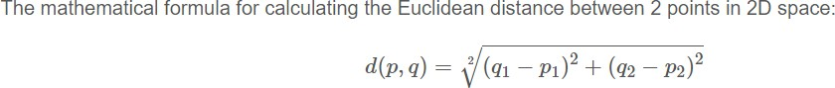

## Dot Product

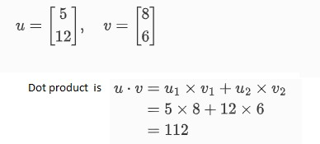

1. **Solving a System of Linear Equations**

A system of linear equations can be represented in matrix form as AX=B, whereA is the matrix of coefficients, X is the column vector of variables, and B is the column vector of solutions. To solve for **X,** we can use: X=A-1 B assuming A is invertible.

## PROGRAM:

**Calculating the Euclidean Distance Between Two Points**

**Calculating the Dot Product of Two Vectors**

**Solving a System of Linear Equations**

## Result:

Exercise 1 -Output for Calculating the Euclidean Distance between Two Points is:

Exercise 2 –Output for dot product of two vectors A and B is

Exercise 3 -Output solution of System of Linear Equations is