**Introduction**

1. This project provides a **step-by-step guide to creating an Amazon EC2 (Elastic Compute Cloud) instance** using the AWS Management Console. It walks you through each stage of the process so that anyone — even without prior AWS experience — can follow along and successfully launch their own virtual server in the cloud.
2. You’ll learn how to set up a web-server development environment on AWS, configure key settings, and understand the deliverables involved. The guide also includes **troubleshooting tips for common issues**, ensuring a smooth and repeatable experience when creating EC2 instances.
3. By the end, you’ll have a fully functional **cloud-based virtual server** ready for development and testing.

Step 1

If this is your first time using AWS you must first create an account, verify your email by signing and then go to your AWS management console.

Sign into AWS management console, click on “sign into console”. This will bring you to your **IAM user sign in** page. Fill in your account ID, IAM username and password and press enter.

Second sign in option

You can also sign in using your root user email. On the AWS sign-in page, click the option “Sign in using root user email” — this will display two sign-in options: Root user and IAM user. Select the appropriate option for your account, click Next, and then enter your credentials to sign in.

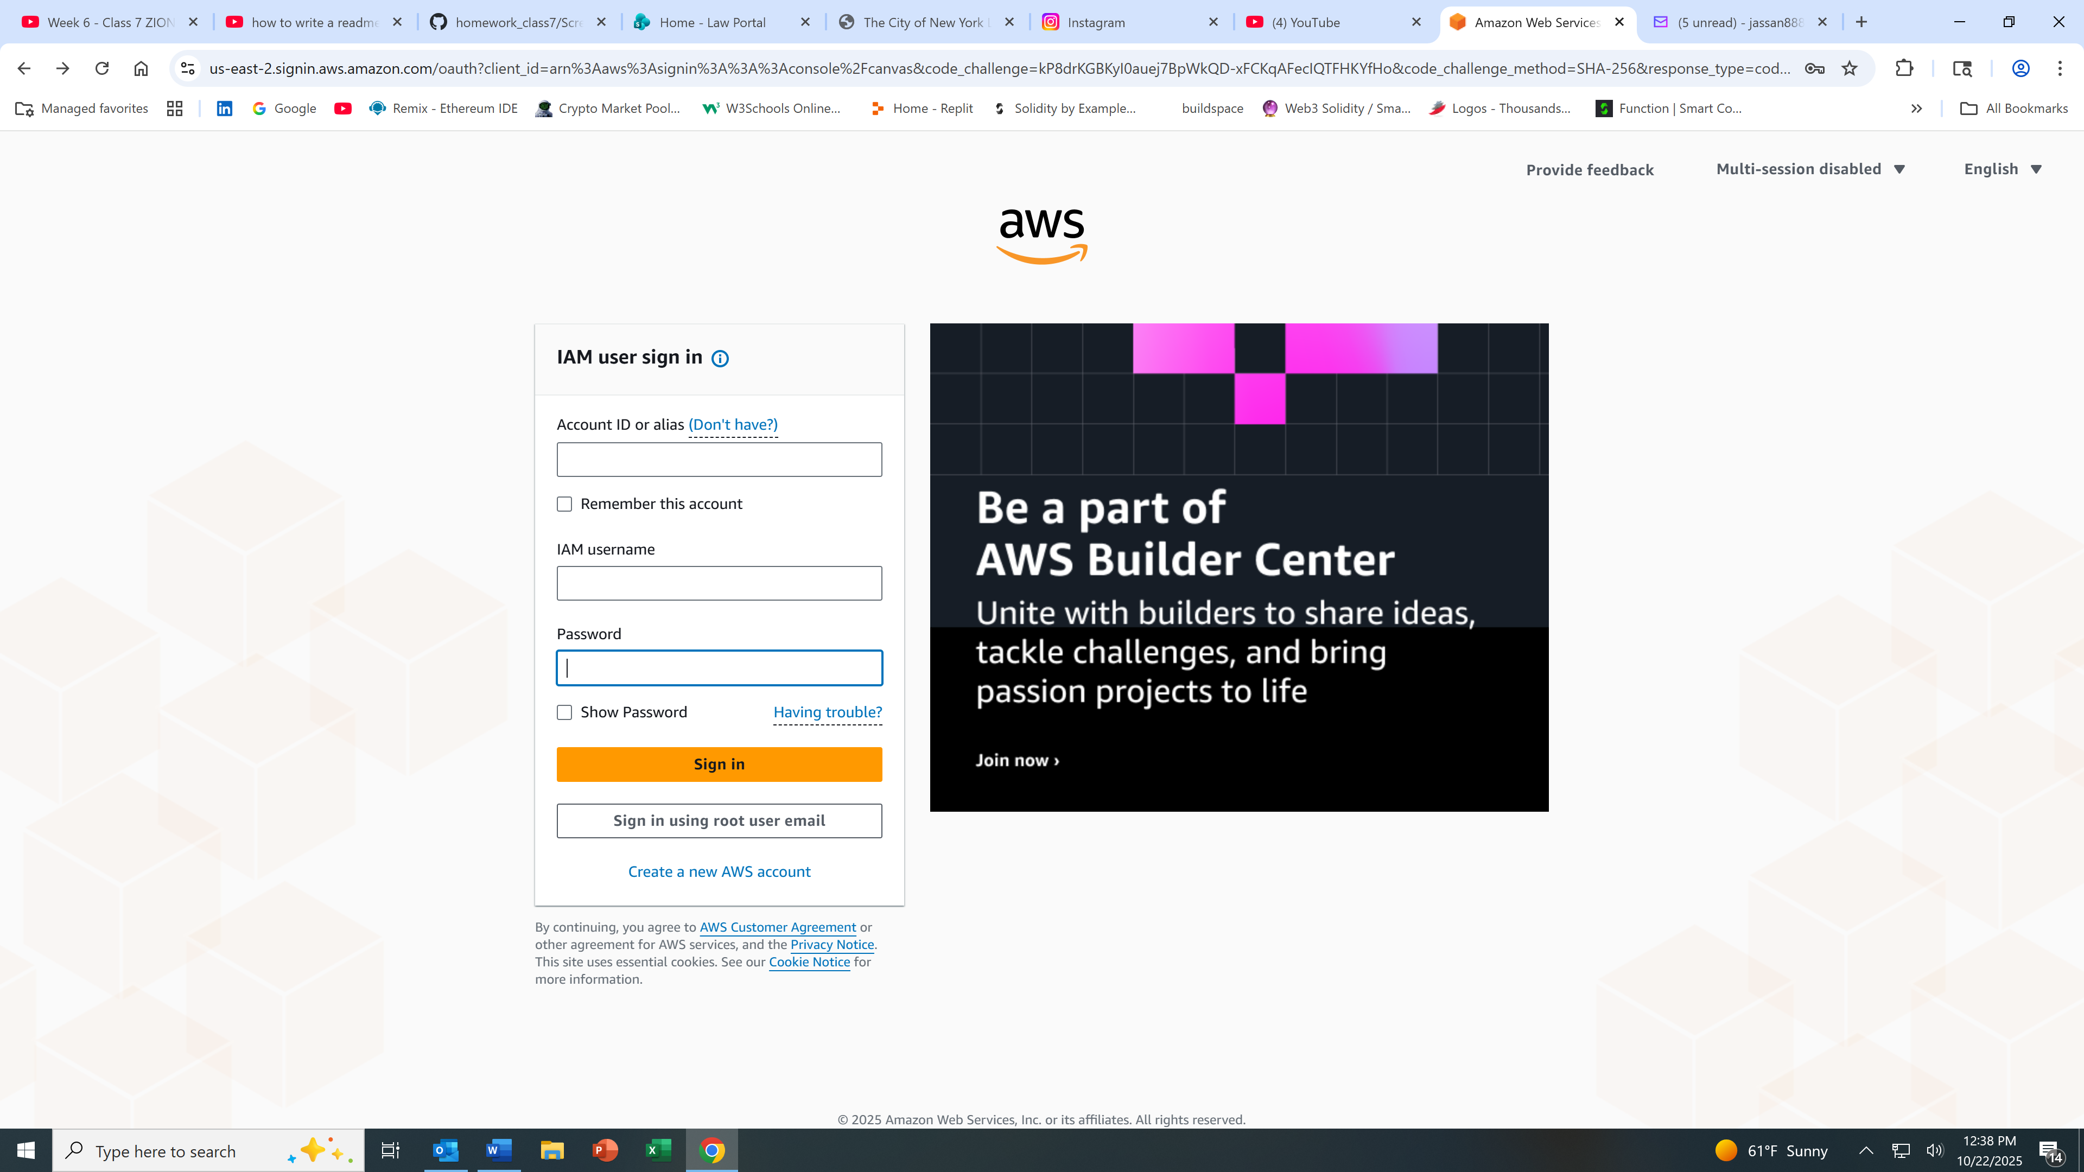

Step 2

With sign in completed you should be on the AWS console home page, to make sure you did

look for your credentials that should be on your upper right hand side.

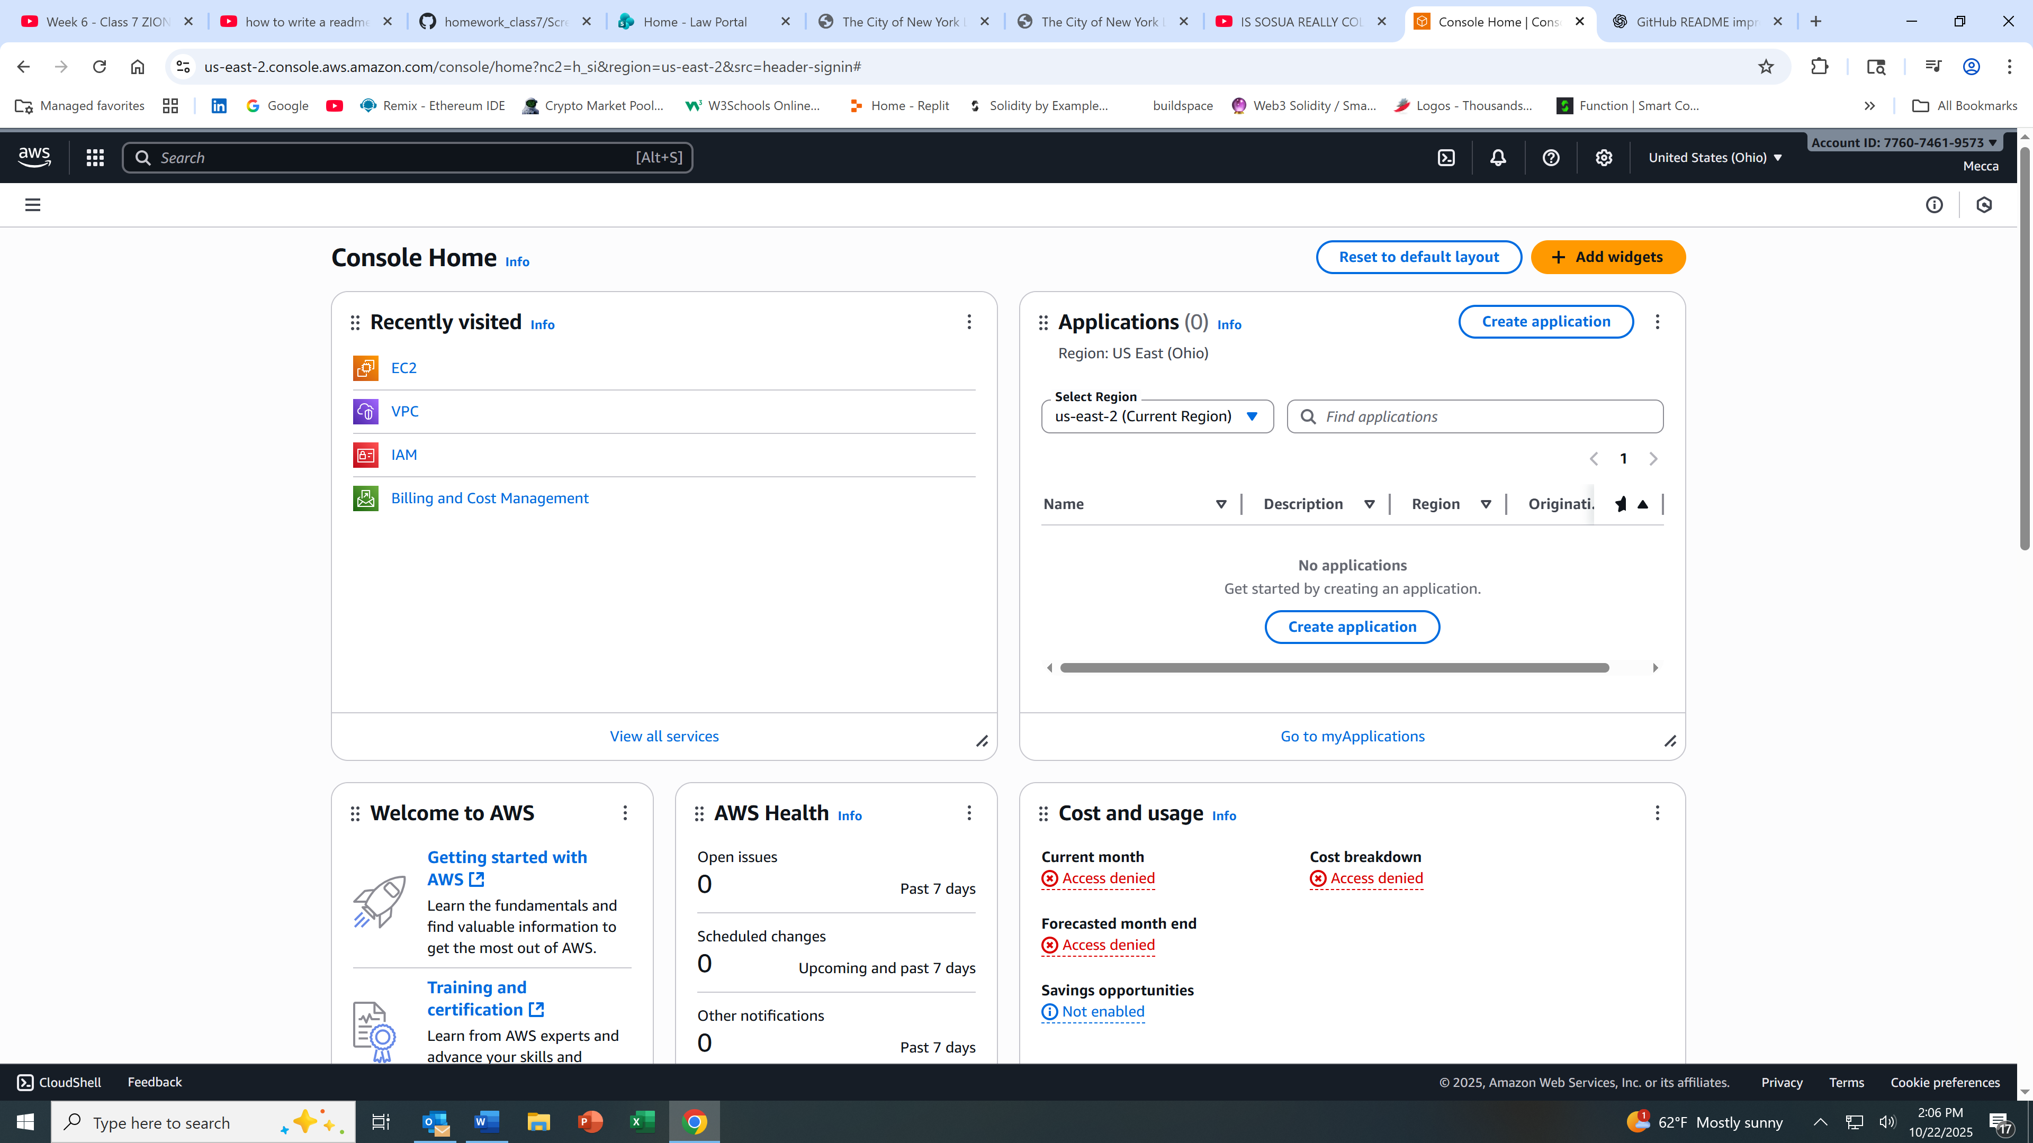

Step 3

In the search box on your left hand side type in EC2 and pick (EC2 virtual servers in cloud).

From the EC2 page look at the bar menu on your left hand side, scroll down to Network &

Security and click on security groups.

On the security group page , select “create security group” which you will see on your right hand side. Fill in the basic details (name, description). Select inbounds HTTP, Anywhere IPv4.

So the same for SSH for inbounds