Inclusive Communication and Shared Decision-Making
How can we involve all school members in realizing our vision?

Purpose: This activity helps define communication and decision-making processes involving all school members.

Audience: School leadership team (ideally with a representative from all school members: administrators, community school, after-school staff, teachers, parents, students)

Time: 2-3 hours (This could be done over multiple sessions)

Outcome(s): As a result of this activity, we will have:
- A visual representation of a communication and/or decision-making process involving all school members

Materials:
- A Comparison of Classical Leadership and Shared Responsibility handout
- Inclusive Communication and Shared Responsibility Decision-Making Directions handout
- Flip chart paper and markers for each team

Introduction (45-60 minutes)
- Ask participants to use A Comparison of Classical Leadership and Shared Responsibility handout to share some of the benefits and drawbacks of a shared responsibility model.
Some benefits might include:
- Ownership and buy-in and thus increased commitment by all members
- Increased trust between school members and likelihood that all adults are communicating consistent messages to students and collectively finding strategies to meet the needs of all students
- Necessary that teachers have voice if students are to have voice

Some drawbacks of shared responsibility might include:
- Collaboration takes time and coordination
- It can be difficult to come to consensus, particularly with large groups
- Emphasis on process can be frustrating for those who are results-oriented and can cause the group to lose sight of the purpose or focus

- Key frame: Not all school decisions can be made using consensus or shared responsibility, however, if shared responsibility processes are used in a few identified areas, it can greatly increase school member commitment, cohesion, consistency, and investment in collectively carrying out the vision. Clear/frequent communication and transparent decision-making processes clarify how and when they can be involved in informing or shaping the school vision. (By consensus, we mean that all members can live with and support the final decision.)
- For both decision-making and communication—Brainstorm the different school members and existing groups that might currently organize/represent these groups (These might include existing teacher groups such as grade level or departments, parent groups, student council or other student groups, etc.).
- For decision-making—Brainstorm the types of decisions that might be made though a shared responsibility process versus those that must be decided by the district or principal alone, such as personnel decisions or issues of compliance (Alternatively, the principal could provide decisions s/he is comfortable opening to a shared responsibility process). Categorize these into major themes such as climate policies, instructional policies, safety policies, etc.
- For communication—Look at the categories of decisions and decide whether there is any additional vision-related information that might need to be communicated to school members or might require input from school members. Add these categories.
- Go over the Inclusive Communication and Shared Responsibility Decision-Making Directions
- Divide the leadership team in half. Ask one half to focus on communication and the other on decision-making.

Activity (30-45 minutes)
- Ask participants to design decision-making and communication processes in separate groups
- Participants should draw this process on flip chart paper and be prepared to explain the process

Closing (1 hour to 1 hour 15 minutes)
- Ask each group to share their proposed process and hear feedback from the other group using the following round robin process. Ask each member to share:
- One thing they like about the proposed process
- Any questions or concerns they have about the proposed process.
- Summarize benefits and concerns heard from the group
- Ask the group for proposed modifications to the proposed process to address concerns
- Check for group consensus on the process
- Decide on next steps for implementing the proposed processes and clear assignments of responsibility for these next steps

Facilitator Tips:

We had difficulties arriving at this activity. We found that school members were particularly attached to their existing structures and processes and had difficulty thinking about how to consolidate, streamline, or connect existing communication structures.

We found it more effective to have participants think about the different school members and the existing groups they might be currently organized into that could be connected to a process and how these groups might be involved in either communication or decision-making as separate processes.

As such, we suggest either tackling communication and decision-making in separate meetings or splitting up the group to focus on these separately.

A Comparison of Classical Leadership and Shared Responsibility

Classical leadership | Shared responsibility
- Leadership determined by a person’s position or title in a group | - Leadership determined by the quality of people’s interactions rather than their position within the group
- Leadership evaluated by whether the leader solves problems | - Leadership evaluated by how people are working together toward a common vision
- Leaders provide solutions and answers | - All members of the group work to enhance the collaborative process and to make it more fulfilling
- Distinct differences between leaders and followers: character, skill, etc. | - People are interdependent—all are active participants in the process of leadership
- Communication is often formal | - Communication is crucial with an emphasis on conversation
- Can often rely on secrecy, deception and payoffs of various kinds to garner the support of others within the organization | - Values democratic processes, honesty and shared ethics—seeks a common good
Drawing from material in Gloria Nemerowicz and Eugene Rosi (1997) Education for Leadership and Social Responsibility, London: Falmer Press. Page 16.

Inclusive Communication and
Shared Responsibility Decision-Making Facilitator Directions
How can we involve all school members in realizing our vision?

Purpose:
- To define some communication and decision-making processes involving all school members.

Audience: School leadership team (ideally with a representative from all school members: administrators, community school, after-school staff, teachers, parents, students)

Activity Directions (30-45 minutes)
- Identify the type of process you are designing (communication or decision-making)
(See examples on subsequent pages).
- Thinking about the kinds of communication or decisions the whole group brainstormed, identify the core focus or goal of the process you are designing.
Examples:
  - If it’s a communication flow chart, the ultimate goal might be to communicate decisions-made/lessons learned to all school members
  - If it’s a decision-making flow chart, the ultimate goal might be to make decisions on new school policies
- Thinking about the different school member groups that the whole group brainstormed (e.g., departments, classified staff, PTA, student council), discuss how each group will be represented in giving input on decisions or receiving and sharing information with others in their team.
- Discuss and diagram a process for making a decision or communicating information to and from the school as it relates to the identified goal of the process. Use as few words as possible in your diagram. Detailed descriptions of the process should be completed separately from the visual.
- On the decision-making chart, be sure to clearly delineate where input is asked for versus where decisions are actually made. Some additional questions to consider:
  - How will the decision-making body ensure parent and student input informs decisions affecting these school members?
  - How will decisions be made? (Consensus is recommended for greater commitment from school members and to truly encourage consideration of all perspectives. If consensus is used, those who cannot live with and support a decision are given the opportunity to voice concerns and propose alternative solutions they can live with before a final decision is made.)

Sample Decision-Making Process #1

Purpose: This flow chart shows the process for making decisions about new school-wide policies.
Evaluation
Proposed Problem/Issue
Leadership Team
Policy Implemented
Policy Designed
All School Members Informed/ Trained
No

Sample Decision-Making Process #1 Explanation

- Every school member has a representative on the leadership team.
- Based on evaluation or other data sources, any school member can raise an issue to the attention of the leadership team through their representative.
- The leadership representative brings these issues to the Leadership Team who uses criteria (e.g., alignment with the school vision, feasibility of addressing with available resources, level of priority, relevant existing structures that could be leveraged, etc.) to decide if the issue is one that needs to be addressed or not and how it should be addressed.
- The proposer is given feedback on their proposed issue on whether to go forward or not and with whom (they may be given criteria to follow and directed to work with an existing committee or to pull together representatives of appropriate school members, to gather additional data etc.).
- Once the policy is designed, it is brought to the Leadership Team again who reviews it and provides feedback for revision.
- One the policy is revised to something the Leadership Team members all agree to support, it is implemented and communicated to all school members who are affected by the policy. If training is required that is also provided.
- The policy is assessed for effectiveness and may bring up new issues that would then be directed through the process.

Sample Decision-Making Process #2

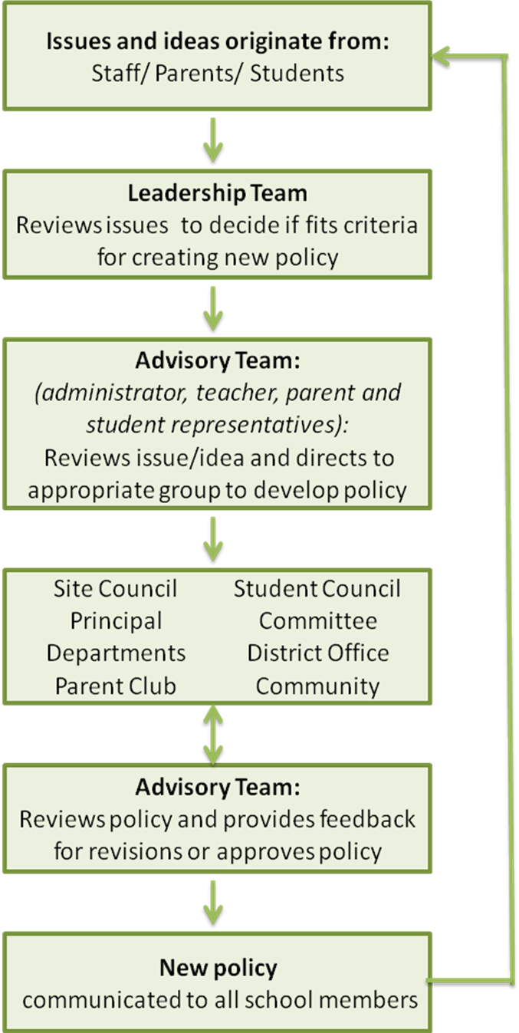

Sample Communication Process #1

Purpose: To gather input from all school members on important school policies and to share information on the results of this input with all school members.

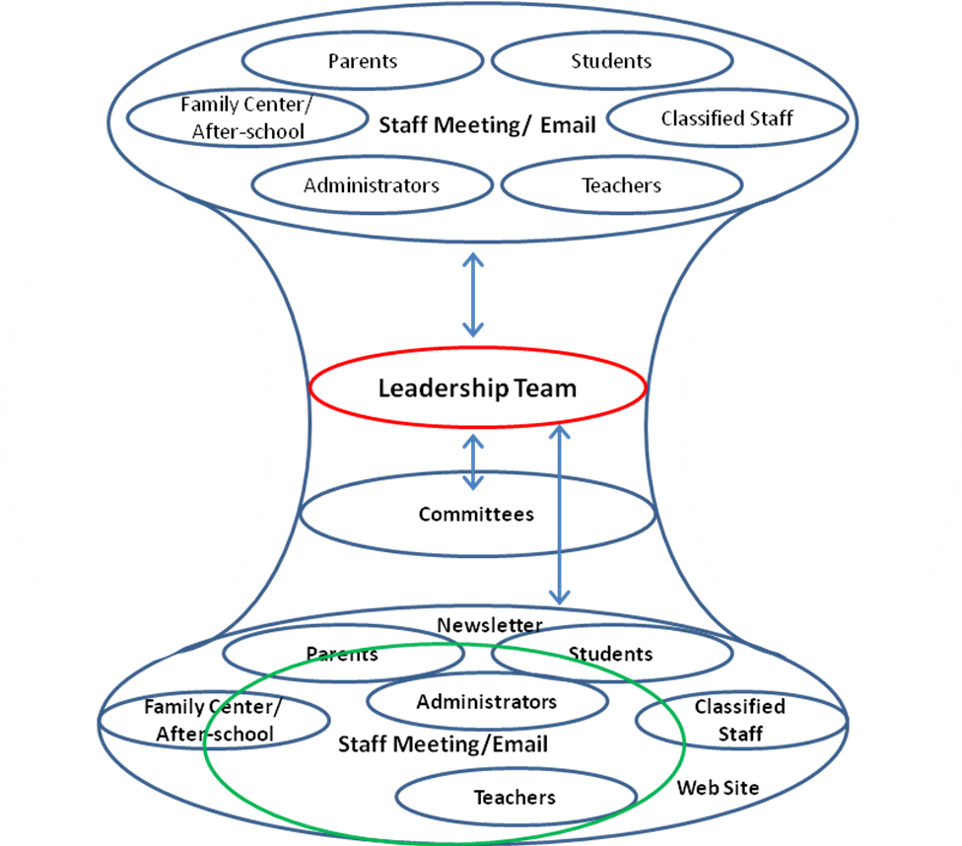

Sample Communication Process #1 Explanation

- Every staff member belongs to a group.
- Parents and students have representatives on parent and student committees.
- Every group has a representative on the Leadership Team and at staff meetings. Representatives are expected to communicate with all members of the group for which they are representing.

- The Leadership Team initiates the need for a new or revised policy based on issues raised by representatives.
- The Leadership Team either delegates the working of the policy to a committee or works on it within the Leadership Team.
- Input for ideas is invited from all school members (or representatives of school member groups) at staff meeting, group meetings, or via email.
- The Leadership Team (or committee) uses input to design the new policy.
- Feedback on the proposed policy is invited through email, team meetings, or staff meeting.
- New policy is shared with all school members at staff meeting, via email, and on the Web site.

Sample Communication Process #2

Purpose: To gather input from all school members on new structures/processes and to share information on these structures as they develop with all school members.

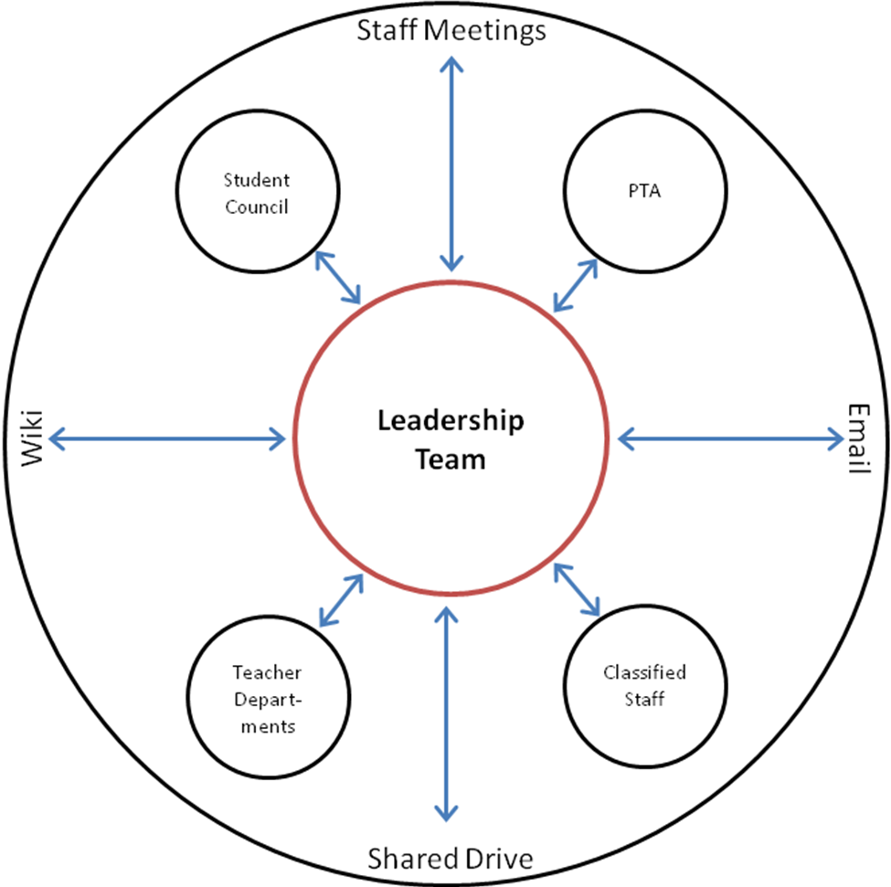

Sample Communication Process #2 Explanation

- Every school member belongs to a group.
- Every group has a representative on the Leadership Team

- Leadership Team representatives raise issues heard from groups at Leadership Team meetings.
- Leadership Team members rotate facilitation of staff meetings focused on a particular issue/problem to gather staff ideas.
- Leadership Team members take ideas and work on a proposed solution.
- Leadership Team members bring proposed solution to their groups for input (or by email or on the Wiki).
- The Leadership Team revises solutions, posts them on the Shared Drive and emails staff.

The green circle above represents the group of people who would be part of the staff meeting/email – ALL administrators/teachers, some staff, parents, and students

