Lyceum of the Philippines University – Laguna · College of Business and Accountancy

Session 8 — DAX Measures and Filter Context
Milestone B5 · Asynchronous activity · BDAT04 Fundamentals of Data Warehousing · Term 1, AY 2026–2027
Released | Thursday, 15 October 2026
Due | 12:00 noon, Friday 16 October 2026 — the §IX-C late cap applies after this.
Submit to | b5-dax-measures/ in your folder of the class repository
Marked on | Rubric D (printed on the last page), out of 100
Prerequisite | Your finished B4 model. If your relationships or dimDate are not right, nothing in this activity will work.
Platform | Power BI Service in the browser, My workspace. Model view and DAX query view.
Effort | About three hours. Six measures and one calculated column — the writing is the short part.

The AI rule for this activity — read it twice
DAX written by an assistant is Tier 3 and needs my written approval in advance. That includes Copilot. If the Fabric trial is active on your account, Copilot will offer to write measures for you. Decline it. For this activity the answer is no — there is no approval on file, and a measure you did not write is a measure you cannot defend in the oral.
What is allowed (Tier 2, log it): asking an assistant to explain what CALCULATE does, or to explain an error message you are already looking at. Asking it what a function means is learning. Asking it for the expression is not.
If Copilot writes something before you can stop it, do not delete the evidence. Say so in your AI Use Log, say what you did about it, and keep going. An honest log is never penalized. This one will be read carefully.
What you are building, and why it matters
In B4 you built the model. It holds no answers yet — a star schema with no measures is a filing cabinet. This week you write the measures that turn it into something a branch manager can ask questions of.
There is one idea underneath everything in this activity, and if you leave with only this, the week has done its job: a measure has no value of its own. It has a value in a context. The same expression gives you a whole year of company revenue in one cell and a single branch’s worst Tuesday in the cell beside it, and nothing about the expression changed. Part B is three items long because this is the idea students most often carry a wrong version of into their capstone.
You are not writing time intelligence this week — no year-to-date, no same-period-last-year. That is Week 10, and it will rest on the dimDate you built in B4.
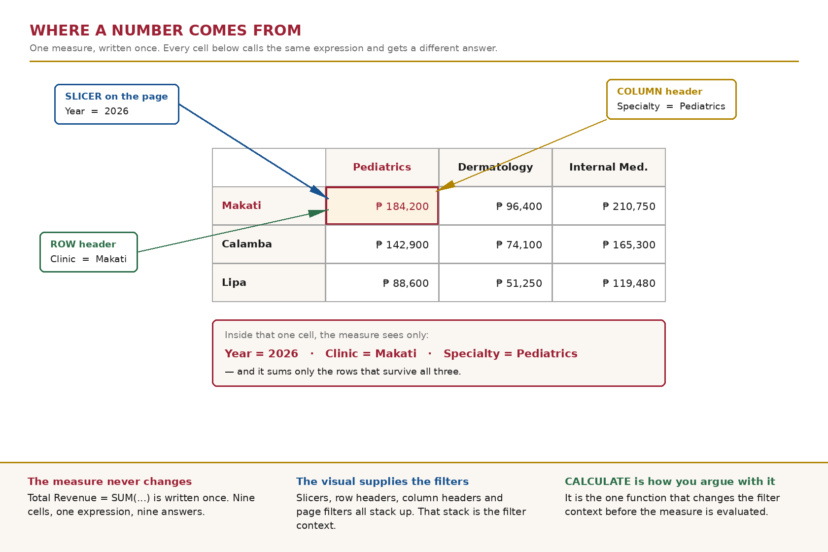
Figure 1. Where a number comes from. Drawn on a clinic example so that it teaches the reading rather than handing you your own matrix.
Part A — Measures, and what makes them different (about 50 minutes)
ITEM 1 Write the three base measures, then prove one of them 30 min
Create these as measures, not calculated columns. Put them in the sales table.
Total Revenue = SUM ( tblSales[Amount] )
Total Units = SUM ( tblSales[Quantity] )
Transaction Count = DISTINCTCOUNT ( tblSales[SaleID] )

1.1 Put Total Revenue on a card visual with no filters anywhere on the page.
1.2 Compare that number against the known total you recorded in B4, Item 7.1. They must match exactly. If they do not, stop and find out why before going further — something in your model changed.
1.3 Now put Transaction Count beside a second measure defined as COUNTROWS ( tblSales ). Record both numbers. Are they the same, or different?
Analysis — what you found
The Total Revenue card visual shows 2.69M or $2,694,600.80 it matches my answer from the b4 item 7.1
Transaction count(DISTINCTCOUNT): 11,167 then COUNTROWS(tblSales): 11,167, So both numbers are the same.

Reflection prompt. Explain what you found, using the grain statement you wrote in B4 Item 2. Then think back to Week 4, when you removed 23 duplicate SaleIDs: what would these two measures have shown if you had not removed them? Finish by saying what that makes this pair of measures useful for, every time new data lands.
Reflection — what it means
So in b4 item 2 my grain statement of tblSales is one row of tblSales represents a single sale transaction of a particular product, of a single customer, in a particular branch, in a specific date; using the SaleID as an identifier. So because each row is one transaction, COUNTROWS and DISTINCTCOUNT both shows the 11,167.
So thinking back to week 4 if the 23 duplicate SaleIDs had not been removed, then the countrows will add it up 11,167 + 23 = 11,190 and this will be shown, and then the the distinctcount would still be showing the 11,167 as it is basing in the SaleID as the distinct count didn’t change. So comparing both these measure serves as an immediate data integrity audit every time new data lands; so whenever the countrows is greater than distinctcount then those duplicate transaction keys have breached the fact table.
ITEM 2 Safe division, and what a manager sees when it is not 20 min
2.1 Create Average Transaction Value using DIVIDE:
Average Transaction Value = DIVIDE ( [Total Revenue], [Transaction Count] )

2.2 Now create a second, deliberately wrong version using the division operator:
ATV Unsafe = [Total Revenue] / [Transaction Count]

2.3 Put both in a table by Branch, then filter the page to a date on which one branch sold nothing. Record what each measure returns in that row.
2.4 Delete ATV Unsafe when you are done. Keep the screenshot.
Analysis — what you found
When I filtered the date to Wednesday, January 1, 2025 branch B07 completely disappeared from the table. Even when “show items with no data” was turned on, B07 did not show up because both Average Transaction Value and ATV Unsafe shows blank empty cells as b07 had zero sales and zero transactions on that day.

Reflection prompt. One of those two results appears on a branch scorecard in front of the owner. Describe what she would conclude from it, and say why that is worse than a blank cell.
Reflection — what it means
Well the owner might think that it is not collecting the payments of the customers. So a blank cell makes sense because it shows that the branch did not have any sale transactions at all on that date.

Part B — Filter context (about 80 minutes)
This is the part of the activity that carries the most marks. Work slowly. Every item here is a different way of asking the same question: what can this measure see?
ITEM 3 One measure, nine answers 25 min
3.1 Build a matrix visual: Branch on rows, Category on columns, Total Revenue in values.
3.2 Add a slicer for Customer Tier and leave it unselected for now.
3.3 Pick one cell — any cell that is not a total. Write down its exact value, its row, and its column.
3.4 Now list every filter acting on that one cell. There are more than two. Include anything coming from the visual itself, from the page, and from the relationships you built in B4.
3.5 Screenshot the matrix. Name it matrix.png — it is part of your submission.
Analysis — what you found
Cell: Row = B01, Column = Espresso Drinks, Exact Value: 285,630.92
The filters acting on this one cell: Row header: tblBranches[BranchID] = “B01”, Column header: tblProducts[Category] = “Espresso Drinks”, Visual grid: the matrix visual intersection of row B01 and column Espresso Drinks, slicer: Tier slicer(unselected), relationships: Active one to many relationships from tblBranches and tblProducts filtering into tblSales.

Reflection prompt. You wrote Total Revenue once. It appears in that matrix a dozen times and returns a different number nearly every time, without being edited. Explain, in your own words, where the difference comes from.
Reflection — what it means
So the formula total revenue = SUM(tblSales[Amount]) didn’t change but the number changes because of the filter context. So in the grand total cell(2,694,600.80) the formula sees all the sales across the company. While in the cell that I picked, the row header limits the data to branch B01, and the column header limits it to the product Espresso Drinks. So the measure returns different answers simply because each of the cell forces it to calculate over a different filtered slice of the table.
ITEM 4 Argue with the filter context 30 min
CALCULATE is the only function that changes the filter context before a measure is evaluated. This item is the smallest honest demonstration of it.
4.1 Create these two measures:
Revenue All Branches = CALCULATE ( [Total Revenue], REMOVEFILTERS ( tblBranches ) )

Branch Share of Revenue = DIVIDE ( [Total Revenue], [Revenue All Branches] )

4.2 Put Branch on rows with all three measures. Format the share as a percentage.
4.3 Does the share column add up to 100%? Record the actual total, not the one you expect.
4.4 Now set the Customer Tier slicer to a single tier. Watch Revenue All Branches carefully and record whether it changes.
Analysis — what you found
Branch share of Revenue sums to 100.00% and the Revenue All Branches sums at 2,694,600.80 across all rows.
As I set the Customer Tier slicer to a Gold Tier, Revenue All Branches changes as it drops from 2,694,600.80 to 102,125.19 across every single row.

Reflection prompt. That measure is called “all branches”, and yet it moved when you touched a slicer that has nothing to do with branches. Explain why — precisely, naming what REMOVEFILTERS did and did not do. Then say what you would have to change if you wanted a true grand total that ignores everything.
Reflection — what it means
The measure changed because of the REMOVEFILTERS(tblBranches) and it only ignores the filters on branches. So it does not stop filters coming from the other tables, like the customer tier slicer. So when I clicked “Gold”, the formula ignored the branch rows but it still filtered to only Gold customer sales across all stores.
So if I wanted a true grand total that ignores everything, then I have to remove all filters by writing REMOVEFILTERS() with nothing inside the parentheses, or use ALL().
ITEM 5 When a calculated column is the right answer 25 min
You have been told measures are usually right. “Usually” is doing work in that sentence. This item is where you find the line.
5.1 Create a calculated column in the sales table:
LineCost = tblSales[Quantity] * RELATED ( tblProducts[UnitCost] )

5.2 Then create two measures:
Total Cost = SUM ( tblSales[LineCost] )
Gross Margin % = DIVIDE ( [Total Revenue] - [Total Cost], [Total Revenue] )

5.3 Now do the wrong thing on purpose. Create a calculated column as well:
Margin Pct Column =
DIVIDE ( tblSales[Amount] - tblSales[LineCost], tblSales[Amount] )

5.4 Put Branch on rows. Add Gross Margin % and the average of Margin Pct Column. Record both numbers for every branch.
5.5 Delete Margin Pct Column when you have your screenshot. Keep LineCost — it is correct and you will use it again.
Analysis — what you found
So the measure Gross Margin % and the average of Margin Pct Column returned different values for every single branch: Blank row(B07): Gross Margin % = 50.3%, average of Margin Pct Column = 56.19%, B01: Gross Margin % = 58.6%, average of Margin Pct Column = 60.48%, B02: Gross Margin % = 58.8%, average of Margin Pct Column = 60.58%, B03: Gross Margin % = 59.3%, average of Margin Pct Column = 60.65%, B04: Gross Margin % = 58.7%, average of Margin Pct Column = 60.41%, B05: Gross Margin % = 58.7%, average of Margin Pct Column = 60.53%, B06: Gross Margin % = 58.2%, average of Margin Pct Column = 60.27%, Total: Gross Margin % = 58.7%, average of Margin Pct Column = 60.50%

Reflection prompt. LineCost is a column and it is right. Margin Pct Column is a column and it is wrong. State the rule that separates them in one sentence, then apply your rule to a case I have not given you: should “days since the customer joined” be a column or a measure?
Reflection — what it means
So the rule is use a calculated column for row by row math but always use a measure for percentages and ratios so we don’t calculate an “average of averages”.
LineCost works as a column because every receipt row needs to multiply its own quantity by its own unit cost but margin is a percentage. If we just average the percentages in a column, a small 100 pesos order gets the exact same weight as a bit 10k pesos order, so which gives the wrong profit number. The measure is correct because it adds up all the money and all the costs first before dividing.
So for the “days since the customer joined” I think this should be a calculated column in tblCustomers because it gives each customer a fixed number that we can put into the slicer to group customers like 0-30 days or 1+ year which a measure cannot do.

Part C — Make it survive contact (about 50 minutes)
ITEM 6 Name it, format it, explain it 20 min
A measure nobody can read is a measure nobody will trust. This is the cheapest mark on the sheet and the one most often skipped.
6.1 Put every measure in a display folder. Delete any stray measure you created while experimenting.
6.2 Set the format on each one: peso and no decimals for money, one decimal and a percent sign for rates, thousands separators throughout.
6.3 Write a one-line description on each measure, in the model, in business language. Not “sums the Amount column” — say what the number is.
6.4 Record all of it in a table: measure name, what it answers, format applied.
Analysis — what you found
Measure Name | Display Folder | Format Applied | Business Question It Answers
Total Revenue | Financials | Currency PhP | How much total money did the business generate before deducting any costs?
Total Cost | Financials | Currency PhP | How much did it cost to buy or produce the items that were sold (COGS)?
Gross Margin % | Financials | Percentage | What percentage of our sales do we keep as profit after covering ingredient/product costs?
Total Units | Operations | Whole Number with commas | How many individual items, cups, or pastries did we physically sell?
Transaction Count | Operations | Whole Number with commas | How many separate checkout receipts were issued to customers?
Average Transaction Value | Operations | Currency PhP | On average, how much does a customer spend per visit or checkout receipt?
Revenue All Branches | Benchmarking | Currency PhP | What are the total sales across all branches combined for baseline benchmarking?
Branch Share of Revenue | Benchmarking | Percentage | What percentage of total company sales did a specific branch contribute?

Reflection prompt. Name one measure whose name you changed while doing this, and say what was dangerous about the first name. If you changed none, say why your first names were already safe — and be honest.
Reflection — what it means
So I didn’t changed any names of the measures as they should use clear business language instead of formula names so we don’t misinterpret the numbers. For example calling it total units instead of sum of quality makes it immediately obvious that it counts physical items sold rather than the number of visiting customers. So this clear naming prevents store managers and executives from making poor business decisions based on misunderstood figures.
ITEM 7 Break them on purpose 30 min
Rubric B's “Developing” level describes measures that “return correct totals but break under filtering.” This item is how you find out which of yours do.
7.1 Filter the page to a branch and a category that branch has never sold. Record what every measure returns.
7.2 Filter to a date outside the range of your data. Record every measure again.
7.3 Filter to the blank customer — the one you found on the dimension side in B4 Item 7. Record every measure a third time.
7.4 Build a small grid of your results: three scenarios down, your measures across.
Analysis — what you found
For item 7.1 filtering to an inactive date with zero transactions such as Monday, Dec 28, 2026 cleared the visual safely, showing no rows.
For item 7.2 filtering the report down to only Branch B01 kept the Branch Share of Revenue at its true company-wide contribution of 23.7% It did not jump to 100%.
For item 7.3 selecting (Blank) in the Tier slicer successfully isolated the walk-in sales without registered membership accounts, totaling Php1,226,559.26 across 5,047 transactions. All operational and financial measures calculated smoothly across every branch row without encountering errors.
For item 7.4 so when clicking a payment method in the slicer, the Transaction Count card updated immediatedly because the measure resides directly inside the sales fact table. However, the table visual containing the Branches Name remained completely static and showed all branches.

Reflection prompt. Which measure behaved worst, and what did it return? Then answer the question that actually matters: when there is genuinely nothing to count, is a blank cell or a zero the more honest thing to show a manager? Pick one and defend it — there is a defensible case for either, and I am marking the defense, not the choice.
Reflection — what it means
So for a data model, relationships act like a one-way street: filters only travel from the dimension; the 1 side down to the fact table: the many side, never backward. So this design protects our report. If Power BI allowed filters to travel backward from tblSAles up into the tblBranches that filter could accidentally spill into other tables like tblCustomers and dimDate. That confusion creates calculation errors, produces wrong grand totals, and slows down your dashboard. So always use dimension tables like branch names, customer tiers or dates to filter the data and keep the fact tables strictly for holding raw transactions and calculations.

What to submit
Everything into b5-dax-measures/ in your own folder of the class repository, by 12:00 noon on Friday 16 October.
- B5_DAX_Measures_<SURNAME>.docx — this sheet, with every Analysis and Reflection box filled in.
- model_2026-10-16.tmdl — the TMDL export of the finished model, in your backups folder. It contains every measure expression you wrote. I will read it against your sheet.
- matrix.png — the Item 3 matrix, with the slicer visible.
- ai-use-log.md — updated for this milestone. If Copilot appeared and you declined it, that is a log entry and a good one.

If you get stuck
Post in the group chat, not a private message. DAX errors are almost always one of four things, and whichever one is biting you is probably biting someone else.
Before you ask, check: is the measure in the right table, are the square brackets and quote marks right, does the column you referenced still exist under that name, and is your B4 relationship actually there? That last one accounts for more “my measure returns blank” messages than the other three combined.
How this is marked — Rubric D
The course rubric for build milestones B3 to B7. Each criterion is scored on a four-point scale and weighted; your mark is the sum of (level × weight) ÷ 4.
Criterion | Weight | What I am looking for
Technical correctness | 35 | Measures return correct values and hold up under filtering. DIVIDE used. The column-versus-measure decision in Item 5 is right and is justified.
Business justification | 25 | Every measure answers a business question you can state. Filter-context explanations are in your own words, not a definition copied from somewhere.
Documentation and readability | 20 | Measures named, formatted, foldered and described in the model. No stray experiments left behind. matrix.png present.
Response to prior feedback | 15 | What your B4 letter asked for, visibly acted on. The TMDL export is checked here — it carries every measure you wrote, verbatim.
Timeliness and integrity | 5 | In the right folder by noon. AI Use Log complete and specific. The DAX in your model is DAX you wrote.

Name and signature | Date and time submitted

Jerald B. Bongalos · Course Facilitator, BDAT04 Fundamentals of Data Warehousing · College of Business and Accountancy, LPU – Laguna

