LYCEUM OF THE PHILIPPINES UNIVERSITY – LAGUNA
College of Business and Accountancy
SESSION 6 — DIMENSIONAL MODEL DESIGN
Milestone B3 · Grain, facts and dimensions, schema on paper
BDAT04 Fundamentals of Data Warehousing · Saturday 26 September 2026 · Three hours
How this activity works
- Eight items, in three parts. Work them in order — each one uses what the one before it produced.
- Every item has the same two boxes. ANALYSIS is what you found or built. REFLECTION is what it means. Both are marked, and the reflection is worth more than you expect.
- You may use Power BI, your notes, your earlier queries and your feedback letters. Part C is done on paper.
- This activity IS milestone B3. There is no separate submission.
A reflection is not a summary.
Do not tell me what you did — the analysis box already says that. Tell me what it cost, what it would have broken, or what you now see that you did not see before. Two or three honest sentences beat a paragraph of restatement.
Dataset: Kape Tayo, as it stands in your own Power BI workspace. Nothing new is issued today.

PART A — GRAIN
Grain is the single sentence that says what one row of a fact table means. It is the first thing a designer declares and the most expensive thing to get wrong.
ITEM 1 · What is one row of tblSales?
about 20 minutes
What to do
- Load tblSales. Count the total rows.
- Count the DISTINCT values of SaleID.
- Compare the two numbers. If they are equal, each SaleID appears once. If they differ, some appear more than once.
- Look at three actual rows. What does each one describe — a whole sale? a single product within a sale? a day of sales?
ANALYSIS
State the grain in ONE sentence, beginning exactly: “One row of tblSales is …” Then give the two counts you used.
There are 11,167 rows and 9 columns in tblSales, there are 3 distinct values of SaleID, Cash,Gcash, Card , One row of tblSales is a single sale transaction of a particular product, of a single customer, in a particular branch, in a specific date. There are 4 distinct values of SaleID. So it is a day of sales. _______________________________________________________________________________________________
_______________________________________________________________________________________________
REFLECTION
If your grain sentence is wrong, every number built on this table is wrong and nothing warns you. Which of the two counts would have exposed the error — and what would you have concluded if you had only looked at the rows?
_If didn’t look at the tblproducts I would have put the unit price in my grain but its already stated in the tblprducts. Also if I only look at the rows its would not give me the duplicate SalesID and would artificially inflate the revenue of the business._______________________________________________________________________________________________

ITEM 2 · What is one row of tblInventory?
about 20 minutes
What to do
- Load tblInventory. Count the rows.
- List the distinct values of MovementType and count the rows in each.
- Decide what a single row records. Is it a stock level, or a stock movement? Those are not the same thing.
- Check whether any column could serve as a unique identifier for the row.
ANALYSIS
State the grain in ONE sentence, beginning “One row of tblInventory is …” List the MovementType values with their counts.
There are a total of 1514 rows for tblInventory, the distinct values of MovementType are 4 which are Delivery 1476 rows, Wastage 23 rows, Adjustment 23 row, and Transfer out 19 rows. One row of tblInventory is a movement of a particular product, in a particular branch in a specific date. So it is a stock movement. We can use the MovementType as a unique identifier for the row. __________________________________________________________________________________________
REFLECTION
tblSales and tblInventory are both fact tables, and their grains are different. Write one sentence explaining why you cannot put them in the same table, even though both are about products at branches over time.
_We can’t put the same table as tblSales talks about the sales of the product in the specific branch made while the tblInventory answers the stock movement of the product in that specific branch._______________________________________________________________________________________________
_______________________________________________________________________________________________

ITEM 3 · The grain test
about 25 minutes
What to do
- Take this business question: “How much revenue did each branch earn in March 2026?” Using only your declared grain for tblSales, decide whether the table can answer it. Show the grouping you would use.
- Now take this one: “What was the average number of items per customer visit?” Decide whether your declared grain can answer it.
- Do not build the answer. Decide whether the grain permits it, and show why.
ANALYSIS
For each question: ANSWERABLE or NOT ANSWERABLE, and the one-line reason that follows from your grain statement.
_Using only the grain that I declared for tblSales it cant answer the total revenue of the branch earned in March 2026, as it is not stated in the grain the quantity the customer bought. _______________________________________________________________________________________________
REFLECTION
One of these two questions is blocked by the grain, not by missing data. Explain the difference between “we do not have that data” and “the grain of this table cannot express that” — and say which one a business user would find harder to accept.
_We do have the data for the quantity of each row on how many items where sold but the grain of this table cannot express that at it would be unique to each single row. _______________________________________________________________________________________________

PART B — FACTS AND DIMENSIONS
A fact table holds the things you measure. A dimension table holds the things you slice by. Most modelling errors are really classification errors made early and never revisited.
ITEM 4 · Classify every column in tblSales
about 25 minutes
What to do
- List every column in tblSales.
- Put each one into exactly one of three buckets: MEASURE (something you would sum or average), KEY (something that points at another table), DESCRIPTIVE ATTRIBUTE (something you would filter or group by, but never sum).
- Two columns will be arguable. Decide anyway, and mark them with an asterisk.
ANALYSIS
A three-column table: Column | Bucket | Why. Every column in the table must appear exactly once.
SaleID |KEY|Can point to other table , Date|ATTRIBUTE|It can be used as a filter, BranchID|KEY| points to another table, ProductID|KEY| points to another table, CustomerID|KEY|points another table, Quantity|MEASURE|can be sum and average, UnitPrice*|MEASURE|can be sum and average but should not be, Amount*|MEASURE|can be sum and average but should not be, PaymentMethod|ATTRIBUTE|It can be used as a filter ________________________________________________________________________________________________
REFLECTION
Find a column you could technically sum but never should. Name it and say what the sum would mean — and why producing that number would mislead a reader.
We could technically sum the Unit Price and Amount but should not be as it would not mean anything as it is distinct a a certain product and the amount is relative to the quantity of items sold. It can be misleading as it would show unuseful data of the sum of the unitprice.________________________________________________________________________________________________

ITEM 5 · Classify the seven tables
about 25 minutes
What to do
- List the seven Kape Tayo tables.
- Classify each as FACT, DIMENSION, or NEITHER.
- For each FACT, write its grain in one line (you already have two of them).
- For each DIMENSION, name the column that joins it to a fact table.
ANALYSIS
A four-column table: Table | Fact / Dimension / Neither | Grain (facts only) | Join key (dimensions only).
tblSales|FACT| One row of tblSales is a single sale transaction of a particular product, of a single customer, in a particular branch, in a specific date, tblCustomers|Dimension| CustomersID. tblBranches|Dimension|BranchID . tblInventory|FACT| One row of tblInventory is a movement of a particular product, in a particular branch in a specific date. tblCalendar|Dimension|Date, tblProducts|Dimension|ProductsID, tblEmployees|Neither.
REFLECTION
Name the table you found hardest to classify and say what made it hard. A hard case is not a failure — it usually means the business itself has not decided something.
I found that the tblEmployees to be the hardest to classify as it doesn’t point another fact table which is the tblSales, it can connect through branches only.
ITEM 6 · The hard case — tblEmployees
about 20 minutes
What to do
- Open tblEmployees. Read its columns.
- Ask: which fact table has a column that points at an employee? Check tblSales and tblInventory.
- Decide: is tblEmployees a dimension in THIS model, or is it a table that belongs to a different model entirely?
- If it is a dimension, name the fact table it would serve and the key it would use. If it is not, say what it would take to make it one.
ANALYSIS
Your decision, in writing, with the evidence you checked.
EmployeeID doesn’t appear in both tblSales and tblInventory. I think it belongs to a different model. To make the tblEmployee to be a dimension it can be use in the tblSales using the EmployeeID in which the particular Employee is the one who serves the customer or in the tblInventory is the Employee who facilitate the Movement of the inventory.
REFLECTION
A dimension nobody joins to is not a dimension — it is a table sitting in your file. What would you say to a manager who insists it belongs in the model because “we have the data”?
If it joins to nothing, then it is not useful for the current model and can only be useful if another model or something needs to be added in the current one and it will require the tbEmployees.

PART C — SCHEMA ON PAPER
You draw the schema before you build it, because paper forces you to decide what the software would quietly decide for you.
ITEM 7 · Draw the schema on paper
about 30 minutes
What to do
- On PAPER — not in Power BI — draw your model.
- Put your fact table or tables in the centre. Put the dimensions around them.
- Draw a line for every relationship. Write the key name on each line.
- Mark the SIDE of each relationship: which table is ONE, which is MANY. Use a 1 and a *.
- Label your diagram with your name and photograph it.
ANALYSIS
A photograph of your drawing, inserted below or submitted alongside this sheet.
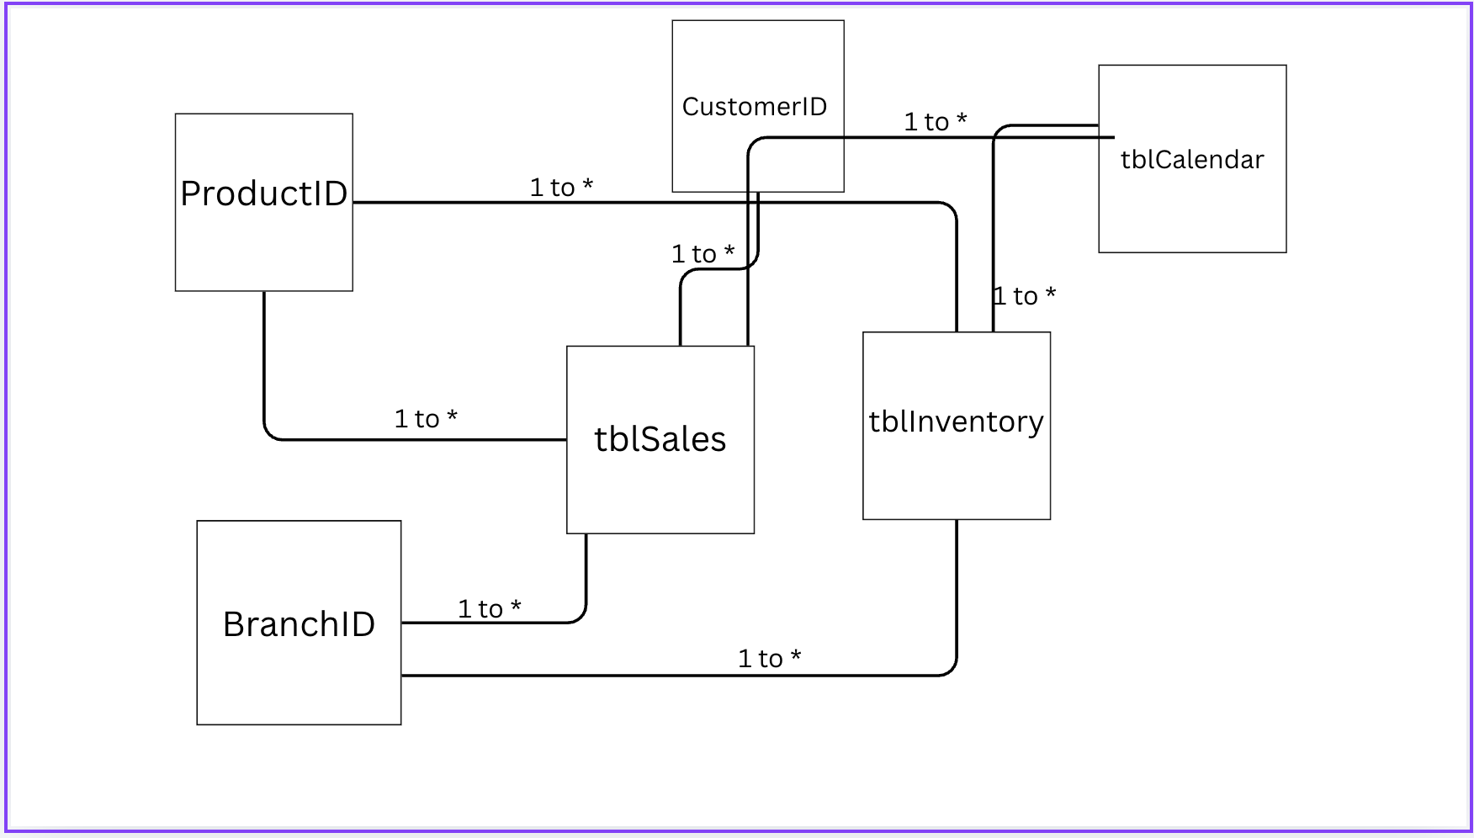________________________________________________________________________________________________
REFLECTION
You drew this before building it. Why does the syllabus ask for paper first? Answer from what happened while you were drawing — something you had to decide on paper that the software would have decided for you.
I was able to see and distinguish the fact tables and the dimesions of the model. The tblCalendar should also be used as a dimension in both fact tables while I wast able to use the tblEmployees for the 2 fact tables.

ITEM 8 · The dimension that serves both
about 15 minutes
What to do
- Look at your drawing. Find the dimension or dimensions that connect to BOTH fact tables.
- Name them.
- Now imagine you had built two separate copies — one for Sales, one for Inventory.
ANALYSIS
The name of the shared dimension, and the two fact tables it serves.
ProductID, BranchID, CustomerID, Date having two separate copies would be redundant for the data.
REFLECTION
Describe one specific report that would go wrong if Sales and Inventory each had their own private copy of that dimension. Be concrete: name the report, and say what number would be wrong.
It would be unnecessary to have the same dataset in which both are identical in data, as it would be more work to model it separately instead of having one model because they just serves the same purpose.

B3 — FORMAL SUBMISSION BLOCK
Copy your final answers here. This is the page marked against the syllabus milestone. Everything in it should already exist somewhere in Items 1 to 8 — if it does not, go back.
1 · Grain statement, one per fact table
Written as a full sentence. “One row of … is …”
One row of tblSales is a single sale transaction of a particular product, of a single customer, in a particular branch, in a specific date.
One row of tblInventory is a movement of a particular product, in a particular branch in a specific date.
2 · Fact tables, with their measures
________________________________________________________________________________________________
________________________________________________________________________________________________
________________________________________________________________________________________________
3 · Dimension tables, with the key each one joins on
________________________________________________________________________________________________
________________________________________________________________________________________________
________________________________________________________________________________________________
________________________________________________________________________________________________
________________________________________________________________________________________________
4 · Relationships — one line each, in the form DIMENSION 1 — * FACT (key)
________________________________________________________________________________________________
________________________________________________________________________________________________
________________________________________________________________________________________________
________________________________________________________________________________________________
________________________________________________________________________________________________
5 · One design decision you are not certain about, and what you would need to resolve it
________________________________________________________________________________________________
________________________________________________________________________________________________
________________________________________________________________________________________________
Schema drawing attached / photographed: YES · NO Name: ______________________________

How this is marked
Criterion | Weight
Grain statements are correct, complete and written as sentences | 25
Facts, dimensions and keys classified correctly, with the hard cases defended | 25
Schema drawing — complete, keyed, sides marked | 20
Reflections — honest, specific, and about consequence rather than restatement | 25
Submitted complete and on time | 5
An item with a correct analysis and an empty or restating reflection earns roughly half of what it could. That is deliberate. The analysis shows you can operate the tool; the reflection shows you understand what you just did.
— Sir JB

