Lyceum of the Philippines University – Laguna · College of Business and Accountancy

Session 7 — Star Schema, Relationships and the Date Table
Milestone B4 · Asynchronous activity · BDAT04 Fundamentals of Data Warehousing · Term 1, AY 2026–2027
Released | Thursday, 8 October 2026
Due | 12:00 noon, Friday 9 October 2026 — the §IX-C late cap applies after this.
Submit to | b4-star-schema/ in your folder of the class repository
Marked on | Rubric D (printed on the last page), out of 100
Platform | Power BI Service in the browser, My workspace. No Desktop, no Pro features.
Effort | About three hours. It is not a three-hour reading task — almost all of it is in the model view.

Read this before you open anything
Back up first. Open your B2 semantic model, go to TMDL view, copy the whole script and save it as model_2026-10-08_before.tmdl in your backups folder. If this activity goes wrong, that file is how you get back. You are changing the model today, not a report built on it.
You will not be able to finish Item 5 if you skip Item 3. The items are in this order on purpose.
AI use. Tier 2 applies — you may use an assistant to explain a concept or an error message, and you must log it. The M expression in Item 5 is given to you by me; that is not AI use and does not go in your log. Writing M or DAX with an assistant is Tier 3 and needs written approval first.
What you are building, and why it matters
In Session 6 you designed a dimensional model on paper. Today you build it. By noon tomorrow your model should have one fact table in the middle, dimensions around it, every relationship declared deliberately rather than guessed by the software, and a date table that Power BI itself has accepted as a date table.
There is one thing in your model that will not survive today, and I am not going to tell you what it is. Item 3 and Item 4 are designed so that you find it and so that Power BI tells you about it in its own words. When it does, do not work around it. Read the message and write it down — it is worth marks.
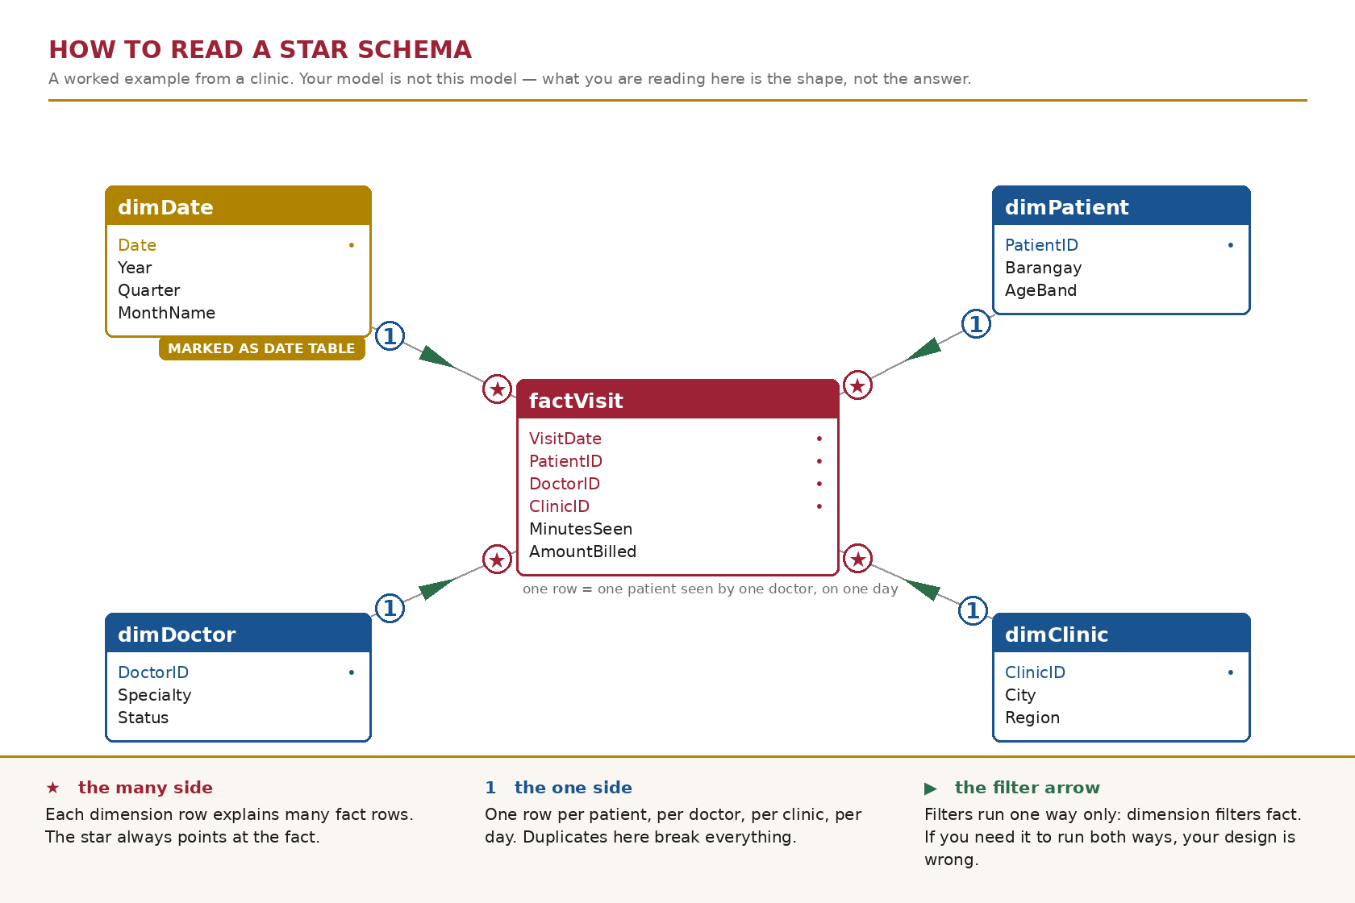
Figure 1. The shape you are aiming for, drawn on a clinic example so that it teaches the reading without handing you your own answer.
Part A — Read the model you already have (about 40 minutes)
ITEM 1 Open the model and write down what is already there 15 min
1.1 Go to app.powerbi.com → My workspace → your cleaned semantic model from B2 → Open data model.
1.2 Save the TMDL backup described on page 1 before you touch anything.
1.3 Take a screenshot of the Model view exactly as you find it. Name it before.png and keep it — it is part of your submission.
1.4 List every relationship that already exists. For each one: the table it goes from, the table it goes to, the two columns, the cardinality, the cross-filter direction, and whether it is active.
If there are none, write “none” and then explain in one sentence why that is the state you would expect after B2.
ANALYSIS — WHAT YOU FOUND
From table and column | To table and column | Cardinality | Cross-filter direction | Status
tblCustomers[City] | tblBranches[City] | Many-to-one | Both | Active
tblEmployees[BranchID] | tblBranches[BranchID] | Many-to-one | Both | Active
tblInventory[BranchID] | tblBranches[BranchID] | Many-to-one | Both | Active
tblInventory[ProductID] | tblProducts[ProductID] | Many-to-one | Single | Active
tblSales[BranchID] | tblBranches[BranchID] | Many-to-one | Single | Active
tblSales[CustomerID] | tblCustomers[CustomerID] | Many-to-one | Single | Inactive
tblSales[ProductID] | tblProducts[ProductID] | Many-to-one | Both | Active
Also there is currently no relationships connecting tblCalendar and tblSalesJul2026 to any table.
Reflection prompt. Power BI can detect relationships for you. It does that by matching column names, not by understanding your business. Name one relationship you would not want it to create on its own, and say what damage it would do to a branch manager's numbers if it did.
Reflection — what it means
I don’t want Power BI to create automatically is the relationship between tblCustomers[City] and tblBranches[City] because the KapeTayo business has many branch and a customer from a certain city can go into different KapeTape tayo branches and buy coffee from it. So if this relationship is automatically put by Power BI and the manager try to filter sales by branch then it filter the customers, and would affect the renevue of the business or the certain branch performance.
ITEM 2 Restate the grain against the real tables 25 min
2.1 Write the grain of each fact table in exactly this form: “One row of <table> represents …”.
2.2 Open each fact table and find one row that proves your statement. Record its key values.
2.3 Do the same for every dimension: one row represents one what?
Then compare all of it against the schema you drew for B3. Three of you drew that schema in software rather than on paper; if you were one of them, this is where you find out what the paper would have caught.
Analysis — what you found
Fact table: tblSales: One row of tblSales represents a single sale transaction of a particular product, of a single customer, in a particular branch, in a specific date; SaleID: "S00001”, Date: 2025-01-01, BranchID: "B01”, ProductID: "P01”, CustomerID: "C0001”, Quantity: 2, UnitPrice: 120.0, Amount: 240.0, PaymentMethod: "GCash"
Fact table: tblInventory: One row of tblInventory represents a single movement of a particular product, in a particular branch in a specific date; MovementID: "M00001”, Date: 2025-01-02, BranchID: "B01”, ProductID: "P01”, MovementType: "Restock", QuantityMoved: 50
one row of tblProducts represents one unique product; primary key is ProductID, one row of tblCustomers represents one customer; primary key is CustomerID, One row of tblBranches represents one unique branch; primary key is BranchID, one row of tblEmployees represents one employee; primary key is EmployeeID and one row of tblCalendar represents one calendar date; primary key is Date.
TblCalendar is an isolated table in the model view and also the tblSalesJul2026 even though I already appended it into the tblSales.
In B3 the tblCalendar I connect it to both tblSales and tblInventory, but in the model view the tblCalendar is not linked to the both fact table.

Reflection prompt. What did you have to change once you saw the real tables, and why did the paper design not show it to you?
Reflection — what it means
So in the picture that we did it didn’t show if the relationship is active. So in the model view tblCalendar was not linked into the tblSales and tblInventory and tblSalesJul2026 even though this salesjul2026 was already appended to the tblSales.

Part B — The date table (about 75 minutes)
This is the part of the activity that carries the most marks, and the part that will decide whether Week 10 time intelligence works for you or quietly produces wrong answers.
ITEM 3 Audit the calendar you were given 25 min
Power Query Online has no Column quality or Column profile pane — you already know this. Use Group By and Count Rows, which produce harder evidence anyway.
3.1 Measure your calendar table and record four numbers: total rows, distinct dates, earliest date, latest date.
3.2 Now do arithmetic the software will not do for you. Count the number of days from the earliest date to the latest date inclusive. Compare that to the number of rows.
3.3 If the two numbers differ, the table has gaps. Find them and list every missing date.
3.4 Separately: what is the latest date anywhere in your sales table, after the July append? Is it inside the calendar's range?
Analysis — what you found
Total Rows: 537 rows, MonthNo; 1: 60 rows, 2: 56 rows, 3: 60 rows, 4: 58 rows, 5: 62 rows, 6: 59 rows, 7: 31 rows, 8: 31 rows, 9: 29 rows, 10: 30 rows, 11: 30 rows, 12: 31 rows. Distinct dates: 537 distinct dates. Earliest date: 2025-01-01, Latest date: 2026-6-30.
2025 = 365 days, 2026 = 31+28+31+30+31+30 = 181 days , 365 + 181 = 546 days , So 546 – 537 = 9 days.
There are missing 9 dates: Jan 15, 2025 and Jan 29, 2026, March 9, 2026 and March 11, 2026, April 13, 2026 and April 25, 2026, June 11, 2025, Sept 1, 2025, Oct 13, 2025.
The latest date in tblSales is July 31, 2026 , No it is not inside the calendar’s range as tblCalendar ends on June 30, 2026, so the July 2026 is not in the tblCalendar.

Reflection prompt. A gap in a date table throws no error anywhere. Explain, in one sentence a branch manager would understand, what a monthly sales trend chart does with a day that has no calendar row.
Reflection — what it means
So the sales that is not in the calendar or missing in it will not show in the visual chart or not be included, So it will not show the actual monthly revenue of a branch on the trende chart without showing any error.
ITEM 4 Let Power BI tell you the table is not a date table 15 min
4.1 In Model view, select your calendar table. Open its menu and choose Mark as date table. Pick your date column.
4.2 Record what happens, word for word. If it refuses, transcribe the message exactly.
4.3 From that message, write down the conditions Power BI enforces before it will accept a table as a date table.
Analysis — what you found
When I toggle the “on” for the Mark as a date table and then I select the Date column, it didn’t execute and showed an error message and it says: “The date column can’t have gaps in dates.”
The conditions Power BI enforces before it will accept a table as a date table as written in the Learn more link is that it contains unique values so meaning no duplicates, it contains no null values so no blank or empty, contiguous date values(from beginning to end) so as I look for that meaning it says that the column must not contain gaps or missing calendar days between its minimum and maximum date. Then valid date data type the column data type must be set to Date or Date/Time.

Reflection prompt. You have been using this calendar table since Week 2 and nothing has broken. Why not? Name the specific kind of calculation that would have exposed it, and say why you have not written one yet.
Reflection — what it means
I think because I wasn’t using the calendar yet like I use sum or group by the attributes like PaymentMethod or IDs but not really digging deep into looking at the calendar.
ITEM 5 Build a date table that will survive the rest of the course 35 min
Your sales now run into July 2026. Your date table is going to cover whole calendar years — 1 January 2025 through 31 December 2026 — not just the span of the data you happen to hold today.
5.1 In Power Query, create a Blank query. Open the Advanced editor and paste the expression below exactly.
let
Start = #date(2025, 1, 1),
Finish = #date(2026, 12, 31),
Days = Duration.Days(Finish - Start) + 1,
Dates = List.Dates(Start, Days, #duration(1, 0, 0, 0)),
Source = Table.FromList(Dates, Splitter.SplitByNothing(), {"Date"}),
Typed = Table.TransformColumnTypes(Source, {{"Date", type date}})
in
Typed

5.2 Rename the query dimDate.
5.3 Using the Add column → Date menu — not typed formulas — add Year, Quarter, Month number, Month name, Day, and Day of week name. Rename every applied step so the list reads as documentation.
5.4 Close and apply. In Model view, mark dimDate as the date table.
5.5 Record the row count of dimDate, its earliest and latest date, and confirm that marking succeeded this time.
One more thing, and it is a marked one: explain in your own words what each of the three arguments of List.Dates does. You were given this expression; you still have to be able to read it.
Analysis — what you found
Row count: 730 rows, Earliest Date: January 1, 2025 , Latest Date: December 31, 2026 , and it succeeded without errors as Power BI accepted dimDate[Date] as a verified contiguous date table.
List.Dates(Start, Days, #duration(1, 0, 0, 0)) , Start(#date(2025, 1, 1)) Where the calendar begins, Days(Duration.Days(Finish – Start) + 1) the total count of dates to generate from start to finish which is the 730 days, #duration(1, 0, 0, 0) The step size or interval added to each date (1 day, 0 hours, 0 minutes, 0 seconds), making sure that the list steps forward one day at a time with zero gaps.

Reflection prompt. Your sales stop on 31 July 2026, but I asked for a table that runs to 31 December 2026. Give me a reason that is about next month, not about this activity.
Reflection — what it means
Well me make a table until December 31, 2026 making it the whole calendar year so we don’t have to build it every time that a new month comes in. So once a new sales data drop it can easily look for in the dimDates without missing date keys.

Part C — Wire the star, then prove it (about 55 minutes)
ITEM 6 Create every relationship your design calls for 30 min
6.1 Delete any relationship that points at the old calendar table, then connect each fact table to dimDate instead.
6.2 Create the remaining relationships your B3 design calls for. There are at least six in this model.
6.3 For every one of them, set cardinality and cross-filter direction deliberately. Do not accept the defaults without looking at them.
6.4 Record them all in a table: from, to, the two columns, cardinality, cross-filter direction, active or inactive.
6.5 Arrange the Model view so the fact table sits in the middle and the dimensions around it. Screenshot it as after.png.
ANALYSIS — WHAT YOU FOUND
From table and column | To table and column | Cardinality | Cross-filter direction | Status
tblEmployees[BranchID] | tblBranches[BranchID] | Many-to-one | Single | Active
tblInventory[BranchID] | tblBranches[BranchID] | Many-to-one | Single | Active
tblInventory[ProductID] | tblProducts[ProductID] | Many-to-one | Single | Active
tblInventory[Date] | dimDate[Date] | Many-to-one | Single | Active
tblSales[CustomerID] | tblCustomers[CustomerD] | Many-to-one | Single | Active
tblSales[BranchID] | tblBranches[BranchID] | Many-to-one | Single | Active
tblSales[ProductID] | tblProducts[ProductID] | Many-to-one | Single | Active
tblSales[Date] | dimDate[Date] | Many-to-one | Single | Active

Reflection prompt. Name one relationship where you were tempted to set the cross-filter direction to Both. Say what you did instead, and what question you would have to be asked before Both became the right answer.
Reflection — what it means
I was tempted to set the cross-filter direction to Both for the tblSales and tblProducts. But I kept it in Single to maintain the star schema. Before Both became the right answer I would have to be asked if a product in the tblProducts has zero sales so we can check both.
ITEM 7 Validate, then count what fell off the edge 25 min
A model that returns a number is not a model that returns the right number. This is how you tell the difference.
7.1 Record the total of Amount across your whole sales table. This is your known total. Write it down before you go any further.
7.2 For each relationship, count the fact rows that match no row in the dimension — the left anti join technique from Week 4. Record one count per relationship.
7.3 Compare every count against the orphan numbers you reported in W4.
7.4 Where a number changed, explain why. Where a number did not change but you expected it to, say so — that is worth more than a silent correction.
Analysis — what you found
The total of Amount is $2,694,600.80
tblSales – dimDate has 12 rows blanks, in W4 there is 771 orphan rows from the tblCalendar. SaleIDs 108185, 101452, 101890, 110339, 105363, 102447, 105736, 103627, 102013, 104516, 108658, 109125.
tblSales – tblProducts same with W4 9 orphan rows because of the ProductID p99.
tblSales – tblBranches no orphan rows while in W4 66 orphan rows due to typos then new branch B07 was incorporated in the tblBranches so no active orphans.
tblSales – tblCustomers has 5,039 blanks + 8 orphan rows and in W4 there is 0 orphans, so the 5,039 was like those walk ins then the 8 orphans was not in the tblCustomers and there are C0182, C0183, C0184
tblInventory – dimDate has 0 rows while in W4 it has 82 orphan rows because of those missing date from the tblCalendar that the dimDate has resolved.
TblEmployees – tblBranches has 0 rows in the W4 has 1 row thas is a 1 staff record that is in the branch B07.

Reflection prompt. The blank CustomerID rows. In W3 you called them a limitation rather than a defect. Now that a relationship exists, those rows land somewhere specific. Find out where, say what it is called, and tell me whether building the relationship changes your W3 answer. Yes or no, then defend it.
Reflection — what it means
Well it will land in the blank row and it will not change my answer. Because it is still the same it is a fact of the business and not a defect. Like what I said in the previous weeks that not every customer will put their info when they just want to buy a coffee or in any business as they are just walk ins and remember that deleting those blank rows will remove the actual revenue of the business.

What to submit
Everything goes into b4-star-schema/ in your own folder of the class repository, by 12:00 noon on Friday 9 October.
- B4_Star_Schema_<SURNAME>.docx — this sheet, with every Analysis and Reflection box filled in.
- model_2026-10-09.tmdl — the TMDL export of the finished model, in your backups folder. Nobody in this class submitted one for the midterm. It is a marked requirement this time.
- before.png and after.png — Model view at the start and at the end.
- ai-use-log.md — updated for this milestone, even if the entry is “none used”.

If you get stuck
Message the group chat, not me privately — if one of you is stuck on Item 4, all four of you are. I will be reading the chat through the evening.
If the model will not open or the workspace will not load, say so in the chat immediately and keep working on paper. A connectivity failure is not a missed deadline; silence is.
How this is marked — Rubric D
The course rubric for build milestones B3 to B7. Each criterion is scored on a four-point scale and weighted; your mark is the sum of (level × weight) ÷ 4.
Criterion | Weight | What I am looking for
Technical correctness | 35 | Relationships correct and deliberate. The date table is continuous, covers the range, and is marked. Validation performed and shown.
Business justification | 25 | Grain stated in business terms. Filter direction defended. Orphans explained as business facts, not as error counts.
Documentation and readability | 20 | Applied steps renamed. Queries named. Both screenshots present. The sheet is filled in, not gestured at.
Response to prior feedback | 15 | What your B3 and midterm feedback asked for, visibly acted on. This is where the TMDL export and the paper-first instruction are checked.
Timeliness and integrity | 5 | In the right folder by noon. AI Use Log complete: tool, date, purpose, what it produced, how you verified it.

Name and signature | Date and time submitted

Jerald B. Bongalos · Course Facilitator, BDAT04 Fundamentals of Data Warehousing · College of Business and Accountancy, LPU – Laguna

