Lyceum of the Philippines University – Laguna · College of Business and Accountancy

Session 7 — Star Schema, Relationships and the Date Table
Milestone B4 · Asynchronous activity · BDAT04 Fundamentals of Data Warehousing · Term 1, AY 2026–2027
Released | Thursday, 8 October 2026
Due | 12:00 noon, Friday 9 October 2026 — the §IX-C late cap applies after this.
Submit to | b4-star-schema/ in your folder of the class repository
Marked on | Rubric D (printed on the last page), out of 100
Platform | Power BI Service in the browser, My workspace. No Desktop, no Pro features.
Effort | About three hours. It is not a three-hour reading task — almost all of it is in the model view.

Read this before you open anything
Back up first. Open your B2 semantic model, go to TMDL view, copy the whole script and save it as model_2026-10-08_before.tmdl in your backups folder. If this activity goes wrong, that file is how you get back. You are changing the model today, not a report built on it.
You will not be able to finish Item 5 if you skip Item 3. The items are in this order on purpose.
AI use. Tier 2 applies — you may use an assistant to explain a concept or an error message, and you must log it. The M expression in Item 5 is given to you by me; that is not AI use and does not go in your log. Writing M or DAX with an assistant is Tier 3 and needs written approval first.
What you are building, and why it matters
In Session 6 you designed a dimensional model on paper. Today you build it. By noon tomorrow your model should have one fact table in the middle, dimensions around it, every relationship declared deliberately rather than guessed by the software, and a date table that Power BI itself has accepted as a date table.
There is one thing in your model that will not survive today, and I am not going to tell you what it is. Item 3 and Item 4 are designed so that you find it and so that Power BI tells you about it in its own words. When it does, do not work around it. Read the message and write it down — it is worth marks.
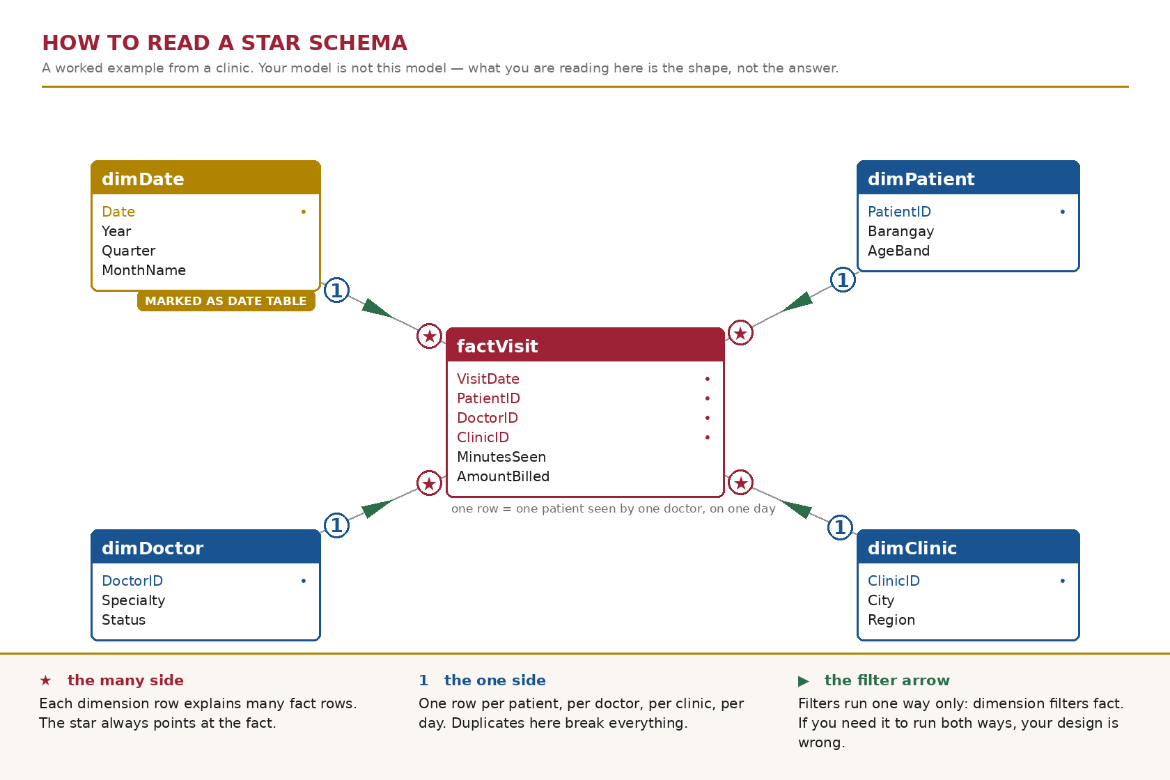
Figure 1. The shape you are aiming for, drawn on a clinic example so that it teaches the reading without handing you your own answer.
Part A — Read the model you already have (about 40 minutes)
ITEM 1 Open the model and write down what is already there 15 min
1.1 Go to app.powerbi.com → My workspace → your cleaned semantic model from B2 → Open data model.
1.2 Save the TMDL backup described on page 1 before you touch anything.
1.3 Take a screenshot of the Model view exactly as you find it. Name it before.png and keep it — it is part of your submission.
1.4 List every relationship that already exists. For each one: the table it goes from, the table it goes to, the two columns, the cardinality, the cross-filter direction, and whether it is active.
If there are none, write “none” and then explain in one sentence why that is the state you would expect after B2.
Analysis — what you found
Product —> Sales: ProductID
Products —> Inventory: ProductID
Sales —> Customers: CustomerID
Sales —> Branches: BranchID
Inventory —> Branches: BranchID
Branches —> Employees: BranchID

Reflection prompt. Power BI can detect relationships for you. It does that by matching column names, not by understanding your business. Name one relationship you would not want it to create on its own, and say what damage it would do to a branch manager's numbers if it did.
Reflection — what it means
Sales —> Customers: CustomerID
If Power BI makes this relationship by itself, the branch manager’s sales numbers could be wrong because sales may be counted more than once.
ITEM 2 Restate the grain against the real tables 25 min
2.1 Write the grain of each fact table in exactly this form: “One row of <table> represents …”.
2.2 Open each fact table and find one row that proves your statement. Record its key values.
2.3 Do the same for every dimension: one row represents one what?
Then compare all of it against the schema you drew for B3. Three of you drew that schema in software rather than on paper; if you were one of them, this is where you find out what the paper would have caught.
Analysis — what you found
One row of tblSales represents one sale of one product at one branch on one date
One row of tblCutomers represents one customer and the customer’s information
One row of tblBranches represents one branch and the branch’s information
One row of tblInventory represents one movement for one product at one branch, on a date, with one movement type and quantity moved
One row of tblCalendar represents one date
One row of tblProducts represents one product and the product’s information
One row of tblEmployees represents an employee and their information, their assigned branch and employment details

Reflection prompt. What did you have to change once you saw the real tables, and why did the paper design not show it to you?
Reflection — what it means
I did not change anything. I just made the grains more specific after seeing the real columns.

Part B — The date table (about 75 minutes)
This is the part of the activity that carries the most marks, and the part that will decide whether Week 10 time intelligence works for you or quietly produces wrong answers.
ITEM 3 Audit the calendar you were given 25 min
Power Query Online has no Column quality or Column profile pane — you already know this. Use Group By and Count Rows, which produce harder evidence anyway.
3.1 Measure your calendar table and record four numbers: total rows, distinct dates, earliest date, latest date.
3.2 Now do arithmetic the software will not do for you. Count the number of days from the earliest date to the latest date inclusive. Compare that to the number of rows.
3.3 If the two numbers differ, the table has gaps. Find them and list every missing date.
3.4 Separately: what is the latest date anywhere in your sales table, after the July append? Is it inside the calendar's range?
Analysis — what you found
3.1 Calendar table | total rows: 537 | distinct dates: 2 | earliest date: 1/1/2025 | latest date: 6/30/2025
3.2 The earliest date is January 1, 2025, and the latest date is June 30, 2026. The number of days between these dates, inclusive, is 181 days. Since the Calendar table has 537 rows, the number of rows is greater than the number of days, which means there are repeated dates in the table.
3.3 Missing dates:
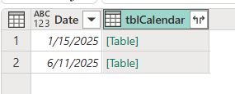
3.4 June 30, 2026 is the latest date. So the lates Sales date is not inside the Calendar’s range.

Reflection prompt. A gap in a date table throws no error anywhere. Explain, in one sentence a branch manager would understand, what a monthly sales trend chart does with a day that has no calendar row.
Reflection — what it means
A monthly sales trend chart will leave out sales from any day that has no matching calendar row, so that day's sales will not appear in the chart.
ITEM 4 Let Power BI tell you the table is not a date table 15 min
4.1 In Model view, select your calendar table. Open its menu and choose Mark as date table. Pick your date column.
4.2 Record what happens, word for word. If it refuses, transcribe the message exactly.
4.3 From that message, write down the conditions Power BI enforces before it will accept a table as a date table.
Analysis — what you found
4.2 After I pressed mark as a date table, it asked me to choose a date column. I picked date then it said “The date column can’t have gaps in dates.”
4.3 Power BI requires the date column to have no gaps in the dates before it can accept the table as a date table.

Reflection prompt. You have been using this calendar table since Week 2 and nothing has broken. Why not? Name the specific kind of calculation that would have exposed it, and say why you have not written one yet.
Reflection — what it means
It has not broken because we have not used a time calculation like YTD yet. We have only used basic sales totals and monthly trends.
ITEM 5 Build a date table that will survive the rest of the course 35 min
Your sales now run into July 2026. Your date table is going to cover whole calendar years — 1 January 2025 through 31 December 2026 — not just the span of the data you happen to hold today.
5.1 In Power Query, create a Blank query. Open the Advanced editor and paste the expression below exactly.
let
Start = #date(2025, 1, 1),
Finish = #date(2026, 12, 31),
Days = Duration.Days(Finish - Start) + 1,
Dates = List.Dates(Start, Days, #duration(1, 0, 0, 0)),
Source = Table.FromList(Dates, Splitter.SplitByNothing(), {"Date"}),
Typed = Table.TransformColumnTypes(Source, {{"Date", type date}})
in
Typed

5.2 Rename the query dimDate.
5.3 Using the Add column → Date menu — not typed formulas — add Year, Quarter, Month number, Month name, Day, and Day of week name. Rename every applied step so the list reads as documentation.
5.4 Close and apply. In Model view, mark dimDate as the date table.
5.5 Record the row count of dimDate, its earliest and latest date, and confirm that marking succeeded this time.
One more thing, and it is a marked one: explain in your own words what each of the three arguments of List.Dates does. You were given this expression; you still have to be able to read it.
Analysis — what you found
Row count of dimeDate: 730
Earliest date: 1/1/2025
Latest date: 12/31/2026
Date table marking: Successful
The first argument tells Power Query the starting date, the second argument tells it how many dates to create, and the third argument tells it how much to move forward between each date.

Reflection prompt. Your sales stop on 31 July 2026, but I asked for a table that runs to 31 December 2026. Give me a reason that is about next month, not about this activity.
Reflection — what it means
The date table should run to December 31, 2026 so it is ready to include next month’s sales when new sales data is added.

Part C — Wire the star, then prove it (about 55 minutes)
ITEM 6 Create every relationship your design calls for 30 min
6.1 Delete any relationship that points at the old calendar table, then connect each fact table to dimDate instead.
6.2 Create the remaining relationships your B3 design calls for. There are at least six in this model.
6.3 For every one of them, set cardinality and cross-filter direction deliberately. Do not accept the defaults without looking at them.
6.4 Record them all in a table: from, to, the two columns, cardinality, cross-filter direction, active or inactive.
6.5 Arrange the Model view so the fact table sits in the middle and the dimensions around it. Screenshot it as after.png.
Analysis — what you found
6.1 I was stuck and kept getting this:
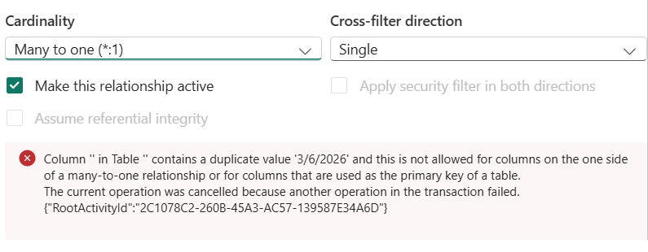
6.2 Remaining relationships
Products → Sales: ProductID → ProductID
Products → Inventory: ProductID → ProductID
Branches → Sales: BranchID → BranchID
Branches → Inventory: BranchID → BranchID
Branches → Employees: BranchID → BranchID
6.3 & 6.4 I could not due to the error in 6.1
6.5 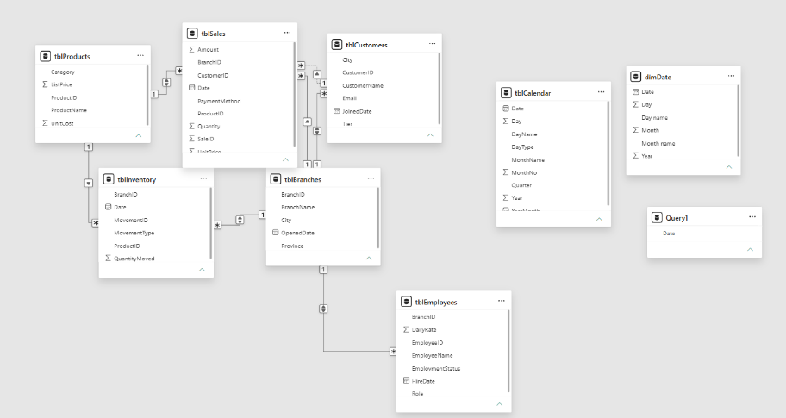

Reflection prompt. Name one relationship where you were tempted to set the cross-filter direction to Both. Say what you did instead, and what question you would have to be asked before Both became the right answer.
Reflection — what it means
I learned that relationships are important in Power BI because they connect the tables. I also learned that cardinality and cross-filter direction need to be set correctly. I had an error when connecting dimDate to Sales, so I could not finish some parts. This helped me understand that I need to check my tables and columns carefully before creating relationships.
ITEM 7 Validate, then count what fell off the edge 25 min
A model that returns a number is not a model that returns the right number. This is how you tell the difference.
7.1 Record the total of Amount across your whole sales table. This is your known total. Write it down before you go any further.
7.2 For each relationship, count the fact rows that match no row in the dimension — the left anti join technique from Week 4. Record one count per relationship.
7.3 Compare every count against the orphan numbers you reported in W4.
7.4 Where a number changed, explain why. Where a number did not change but you expected it to, say so — that is worth more than a silent correction.
Analysis — what you found
7.1 Total amount: 2,512,995.8
7.2
Sales —> Products: 9 rows
Sales —> Branches: This table has no rows
Sales —> dimDate: 12 rows
Inventory —> Products: This table has no rows.
Inventory —> Branches: This table has no rows.
Inventory —> dimDate: This table has no rows.
Employees —> Branches: 1 row
7.3
Sales —> dimDate: W4 – 1202, Now – 12
Inventory —> dimDate: W4 – 82, Now – 0
7.4
Sales —> Products: The orphan count changed from 0 to 9 because 9 Sales rows now have ProductID values that do not match the Products table.
Sales —> Branches: The count did not change. It stayed at 0, so there are no unmatched BranchID values.
Sales —> dimDate: The count changed from 1202 to 12 because the new dimDate table has better date coverage.
Inventory —> dimDate: The count changed from 82 to 0 because the new dimDate table now matches all Inventory dates.
Employees —> Branches: The count did not change. It stayed at 1, so one Employee row still has an unmatched BranchID.
Inventory —> Products and Inventory —> Branches: There was no W4 number provided, so I could not compare these results.

Reflection prompt. The blank CustomerID rows. In W3 you called them a limitation rather than a defect. Now that a relationship exists, those rows land somewhere specific. Find out where, say what it is called, and tell me whether building the relationship changes your W3 answer. Yes or no, then defend it.
Reflection — what it means
I learned that orphan checks are useful for finding data that does not match between tables. I also learned that fixing the date table can reduce the number of unmatched dates. The results helped me see why checking relationships is important before using the data for analysis.

What to submit
Everything goes into b4-star-schema/ in your own folder of the class repository, by 12:00 noon on Friday 9 October.
- B4_Star_Schema_<SURNAME>.docx — this sheet, with every Analysis and Reflection box filled in.
- model_2026-10-09.tmdl — the TMDL export of the finished model, in your backups folder. Nobody in this class submitted one for the midterm. It is a marked requirement this time.
- before.png and after.png — Model view at the start and at the end.
- ai-use-log.md — updated for this milestone, even if the entry is “none used”.

If you get stuck
Message the group chat, not me privately — if one of you is stuck on Item 4, all four of you are. I will be reading the chat through the evening.
If the model will not open or the workspace will not load, say so in the chat immediately and keep working on paper. A connectivity failure is not a missed deadline; silence is.
How this is marked — Rubric D
The course rubric for build milestones B3 to B7. Each criterion is scored on a four-point scale and weighted; your mark is the sum of (level × weight) ÷ 4.
Criterion | Weight | What I am looking for
Technical correctness | 35 | Relationships correct and deliberate. The date table is continuous, covers the range, and is marked. Validation performed and shown.
Business justification | 25 | Grain stated in business terms. Filter direction defended. Orphans explained as business facts, not as error counts.
Documentation and readability | 20 | Applied steps renamed. Queries named. Both screenshots present. The sheet is filled in, not gestured at.
Response to prior feedback | 15 | What your B3 and midterm feedback asked for, visibly acted on. This is where the TMDL export and the paper-first instruction are checked.
Timeliness and integrity | 5 | In the right folder by noon. AI Use Log complete: tool, date, purpose, what it produced, how you verified it.

Sanchez, Eliah Therrien Estrella  Name and signature | October 9, 2026 | 2:00 PM  Date and time submitted

Jerald B. Bongalos · Course Facilitator, BDAT04 Fundamentals of Data Warehousing · College of Business and Accountancy, LPU – Laguna

