Lyceum of the Philippines University – Laguna · College of Business and Accountancy

Session 7 — Star Schema, Relationships and the Date Table
Milestone B4 · Asynchronous activity · BDAT04 Fundamentals of Data Warehousing · Term 1, AY 2026–2027
Released | Thursday, 8 October 2026
Due | 12:00 noon, Friday 9 October 2026 — the §IX-C late cap applies after this.
Submit to | b4-star-schema/ in your folder of the class repository
Marked on | Rubric D (printed on the last page), out of 100
Platform | Power BI Service in the browser, My workspace. No Desktop, no Pro features.
Effort | About three hours. It is not a three-hour reading task — almost all of it is in the model view.

Read this before you open anything
Back up first. Open your B2 semantic model, go to TMDL view, copy the whole script and save it as model_2026-10-08_before.tmdl in your backups folder. If this activity goes wrong, that file is how you get back. You are changing the model today, not a report built on it.
You will not be able to finish Item 5 if you skip Item 3. The items are in this order on purpose.
AI use. Tier 2 applies — you may use an assistant to explain a concept or an error message, and you must log it. The M expression in Item 5 is given to you by me; that is not AI use and does not go in your log. Writing M or DAX with an assistant is Tier 3 and needs written approval first.
What you are building, and why it matters
In Session 6 you designed a dimensional model on paper. Today you build it. By noon tomorrow your model should have one fact table in the middle, dimensions around it, every relationship declared deliberately rather than guessed by the software, and a date table that Power BI itself has accepted as a date table.
There is one thing in your model that will not survive today, and I am not going to tell you what it is. Item 3 and Item 4 are designed so that you find it and so that Power BI tells you about it in its own words. When it does, do not work around it. Read the message and write it down — it is worth marks.
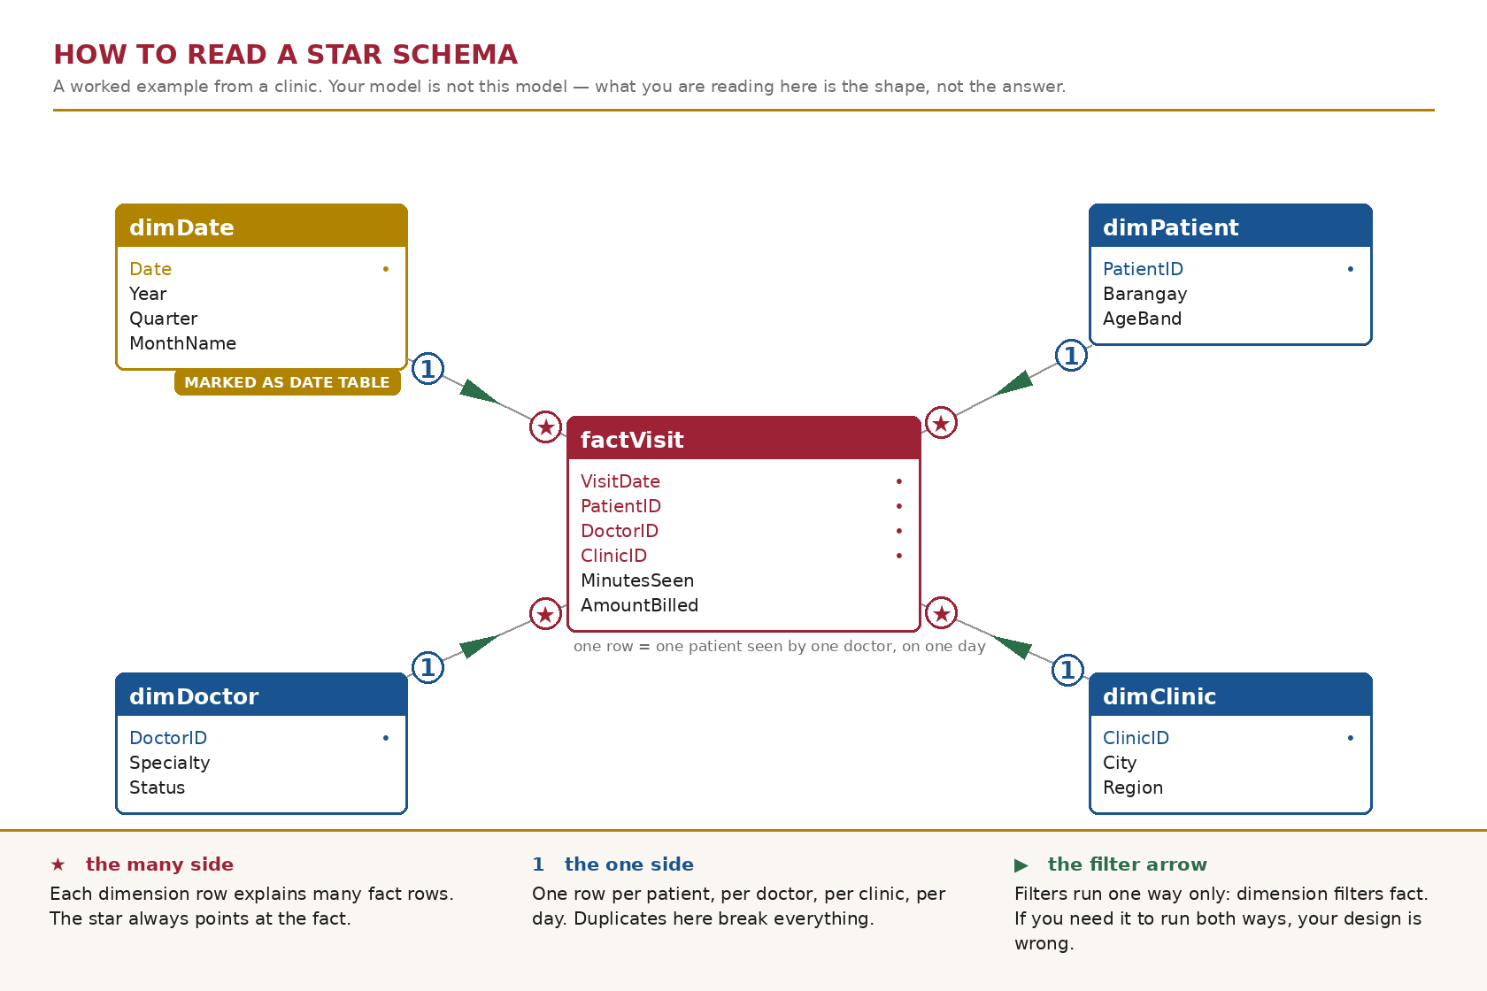
Figure 1. The shape you are aiming for, drawn on a clinic example so that it teaches the reading without handing you your own answer.
Part A — Read the model you already have (about 40 minutes)
ITEM 1 Open the model and write down what is already there 15 min
1.1 Go to app.powerbi.com → My workspace → your cleaned semantic model from B2 → Open data model.
1.2 Save the TMDL backup described on page 1 before you touch anything.
1.3 Take a screenshot of the Model view exactly as you find it. Name it before.png and keep it — it is part of your submission.
1.4 List every relationship that already exists. For each one: the table it goes from, the table it goes to, the two columns, the cardinality, the cross-filter direction, and whether it is active.
If there are none, write “none” and then explain in one sentence why that is the state you would expect after B2.
Analysis — what you found
The existing relationships in the Power BI model are as follows: tblProducts[ProductID] is connected to tblSales[ProductID] and tblInventory[ProductID] through one-to-many relationships. tblBranches[BranchID] is connected to tblSales[BranchID], tblInventory[BranchID], and tblEmployees[BranchID], also through one-to-many relationships. Meanwhile, tblCustomers[CustomerID] is connected to tblSales[CustomerID] through a one-to-many relationship. These relationships appear to be active and use single-direction cross-filtering, but the exact settings should be confirmed in the Edit Relationship dialog. The tblCalendar table appears to have no existing relationships, so its date relationships may still need to be established.

Reflection prompt. Power BI can detect relationships for you. It does that by matching column names, not by understanding your business. Name one relationship you would not want it to create on its own, and say what damage it would do to a branch manager's numbers if it did.
Reflection — what it means
I would not want Power BI to automatically create a relationship between tblSales[BranchID] and tblEmployees[BranchID] using many-to-many cardinality. If it did, the branch manager’s sales and employee-related numbers could become duplicated or incorrectly calculated, leading to inaccurate reports and poor business decisions.

ITEM 2 Restate the grain against the real tables 25 min
2.1 Write the grain of each fact table in exactly this form: “One row of <table> represents …”.
2.2 Open each fact table and find one row that proves your statement. Record its key values.
2.3 Do the same for every dimension: one row represents one what?
Then compare all of it against the schema you drew for B3. Three of you drew that schema in software rather than on paper; if you were one of them, this is where you find out what the paper would have caught.
Analysis — what you found
One row of tblSales represents one sales transaction line containing a product, its quantity, price, customer, branch, and transaction date. One row of tblInventory represents one inventory movement for a specific product at a particular branch on a specific date. One row of tblProducts represents one unique product. One row of tblBranches represents one branch location. One row of tblCustomers represents one customer. One row of tblEmployees represents one employee. One row of tblCalendar represents one calendar date.
To verify the grain, I would select one row from each table and record its actual key values, such as SaleID and ProductID from tblSales, and MovementID and ProductID from tblInventory. Finally, I would compare the actual tables and their keys with the B3 schema to ensure that the grain is correct and that the relationships support accurate reporting without duplicating sales or inventory quantities.

Reflection prompt. What did you have to change once you saw the real tables, and why did the paper design not show it to you?
Reflection — what it means
I had to check and verify the actual grain, key columns, and relationships of each table because the real data may contain missing values, duplicate keys, or unexpected records. The paper design did not show these issues because it only presented the planned structure, while the actual tables revealed the real data and its limitations.

Part B — The date table (about 75 minutes)
This is the part of the activity that carries the most marks, and the part that will decide whether Week 10 time intelligence works for you or quietly produces wrong answers.
ITEM 3 Audit the calendar you were given 25 min
Power Query Online has no Column quality or Column profile pane — you already know this. Use Group By and Count Rows, which produce harder evidence anyway.
3.1 Measure your calendar table and record four numbers: total rows, distinct dates, earliest date, latest date.
3.2 Now do arithmetic the software will not do for you. Count the number of days from the earliest date to the latest date inclusive. Compare that to the number of rows.
3.3 If the two numbers differ, the table has gaps. Find them and list every missing date.
3.4 Separately: what is the latest date anywhere in your sales table, after the July append? Is it inside the calendar's range?
Analysis — what you found
Calendar table total rows is 537, distinct dates total is 2 ,earliest date is 1/1/2025, and the latest date is 6/30/2026

There are 187 days starting from the 1/1/25 up to 6/30/25 meaning that there are a repeated tables.
The missing dates are 1/15/2025 and 6/11/2025
The latest date is June 30,2026 is the latest date, it is not inside the calendar range.

Reflection prompt. A gap in a date table throws no error anywhere. Explain, in one sentence a branch manager would understand, what a monthly sales trend chart does with a day that has no calendar row.
Reflection — what it means
I learned the importance of checking the quality and completeness of a calendar table in Power BI. By examining the total number of rows, distinct dates, minimum and maximum dates, and missing dates, I understood how to identify possible gaps in the calendar.

ITEM 4 Let Power BI tell you the table is not a date table 15 min
4.1 In Model view, select your calendar table. Open its menu and choose Mark as date table. Pick your date column.
4.2 Record what happens, word for word. If it refuses, transcribe the message exactly.
4.3 From that message, write down the conditions Power BI enforces before it will accept a table as a date table.
Analysis — what you found
After doing the instructions this is what the result showed me “Date columns can't have gaps in dates.”

A date table must contain a continuous sequence of dates without missing days. Its date column must also contain unique, nonblank date values.

The tblCalendar is rejected by the powerbi because its date columns have gaps in it.

Reflection prompt. You have been using this calendar table since Week 2 and nothing has broken. Why not? Name the specific kind of calculation that would have exposed it, and say why you have not written one yet.
Reflection — what it means
The calendar appeared to work because ordinary reports can still display sales using the dates available. Time-intelligence calculations, such as year-to-date sales and comparisons with previous periods, can reveal problems when dates are missing from the calendar.

ITEM 5 Build a date table that will survive the rest of the course 35 min
Your sales now run into July 2026. Your date table is going to cover whole calendar years — 1 January 2025 through 31 December 2026 — not just the span of the data you happen to hold today.
5.1 In Power Query, create a Blank query. Open the Advanced editor and paste the expression below exactly.
let
Start = #date(2025, 1, 1),
Finish = #date(2026, 12, 31),
Days = Duration.Days(Finish - Start) + 1,
Dates = List.Dates(Start, Days, #duration(1, 0, 0, 0)),
Source = Table.FromList(Dates, Splitter.SplitByNothing(), {"Date"}),
Typed = Table.TransformColumnTypes(Source, {{"Date", type date}})
in
Typed

5.2 Rename the query dimDate.
5.3 Using the Add column → Date menu — not typed formulas — add Year, Quarter, Month number, Month name, Day, and Day of week name. Rename every applied step so the list reads as documentation.
5.4 Close and apply. In Model view, mark dimDate as the date table.
5.5 Record the row count of dimDate, its earliest and latest date, and confirm that marking succeeded this time.
One more thing, and it is a marked one: explain in your own words what each of the three arguments of List.Dates does. You were given this expression; you still have to be able to read it.
Analysis — what you found
the dimDate table was successfully marked as a date table using the Date column. Power BI accepted the column, so the date-table validation was successful

Row count of dimedate is 730, the earliest date is 1/1/2025 and the latest date is 12/31/2026

Reflection prompt. Your sales stop on 31 July 2026, but I asked for a table that runs to 31 December 2026. Give me a reason that is about next month, not about this activity.
Reflection — what it means
I learned how to create a date table in Power BI and add useful columns such as Year, Quarter, Month, Day, and Day of Week. I learned that List.Dates generates a continuous list of dates based on a starting date, the number of dates, and the interval between them. I also learned how to mark a table as a date table and why having complete dates is important for accurate time-based analysis. Through this activity, I realized that creating a date table is not just about adding dates but also about organizing data so that it is easier to understand, compare, and analyze over time.

Part C — Wire the star, then prove it (about 55 minutes)
ITEM 6 Create every relationship your design calls for 30 min
6.1 Delete any relationship that points at the old calendar table, then connect each fact table to dimDate instead.
6.2 Create the remaining relationships your B3 design calls for. There are at least six in this model.
6.3 For every one of them, set cardinality and cross-filter direction deliberately. Do not accept the defaults without looking at them.
6.4 Record them all in a table: from, to, the two columns, cardinality, cross-filter direction, active or inactive.
6.5 Arrange the Model view so the fact table sits in the middle and the dimensions around it. Screenshot it as after.png.
Analysis — what you found
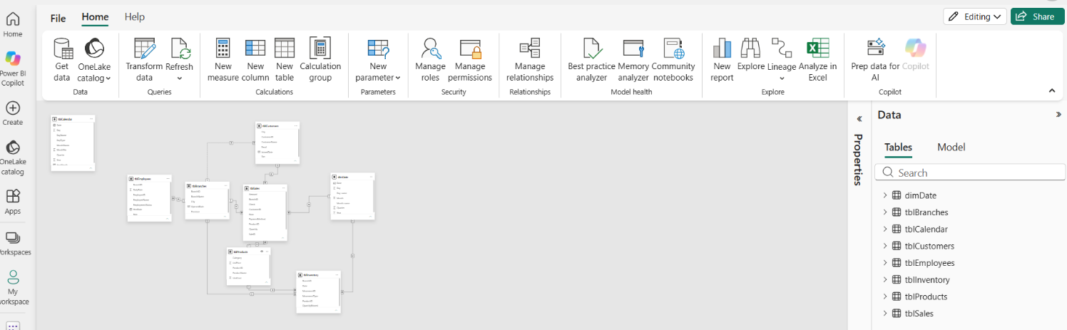

Reflection prompt. Name one relationship where you were tempted to set the cross-filter direction to Both. Say what you did instead, and what question you would have to be asked before Both became the right answer.
Reflection — what it means
I created relationships between the fact tables and the appropriate dimension tables. I connected tblSales and tblInventory to the new dimDate table and checked the cardinality, cross-filter direction, and active status of the relationships.

ITEM 7 Validate, then count what fell off the edge 25 min
A model that returns a number is not a model that returns the right number. This is how you tell the difference.
7.1 Record the total of Amount across your whole sales table. This is your known total. Write it down before you go any further.
7.2 For each relationship, count the fact rows that match no row in the dimension — the left anti join technique from Week 4. Record one count per relationship.
7.3 Compare every count against the orphan numbers you reported in W4.
7.4 Where a number changed, explain why. Where a number did not change but you expected it to, say so — that is worth more than a silent correction.
Analysis — what you found
₱2,519,910.80 total amount of sales.

Rows: 40 unmatched records
Columns: 11 (the number of columns doesn't affect the unmatched-row count)

Sales → Branches Left Anti Join: 40 rows
Sales → Products Left Anti Join: 9 rows
Sales → dimDate Left Anti Join: 12 rows

I got 10,589 rows for Sales → dimDate. That means none of the sales rows matched a date in dimDate in your Left Anti Join result — so every row is currently unmatched.
Unmatched rows: 12
Reason: The Date field is null in all 12 rows.
Interpretation: These sales records cannot match a calendar date because their dates are missing.
Action: Keep the original records and report the data-quality issue. Do not delete them just to make the join count zero.

Reflection prompt. The blank CustomerID rows. In W3 you called them a limitation rather than a defect. Now that a relationship exists, those rows land somewhere specific. Find out where, say what it is called, and tell me whether building the relationship changes your W3 answer. Yes or no, then defend it.
Reflection — what it means
Each unmatched row represents a sales record whose key value does not have a matching record in the related dimension table. The 40 unmatched rows in Sales to Branches mean that the sales records contain BranchID values that do not match any BranchID in the branch table. The 9 unmatched rows in Sales to Products mean that their ProductID values do not exist in the product table. The 12 unmatched rows in Sales to Calendar have null Date values, so they cannot match any date in the calendar table. These results help identify data-quality issues that need investigation to maintain accurate relationships and reports.

What to submit
Everything goes into b4-star-schema/ in your own folder of the class repository, by 12:00 noon on Friday 9 October.
- B4_Star_Schema_<SURNAME>.docx — this sheet, with every Analysis and Reflection box filled in.
- model_2026-10-09.tmdl — the TMDL export of the finished model, in your backups folder. Nobody in this class submitted one for the midterm. It is a marked requirement this time.
- before.png and after.png — Model view at the start and at the end.
- ai-use-log.md — updated for this milestone, even if the entry is “none used”.

If you get stuck
Message the group chat, not me privately — if one of you is stuck on Item 4, all four of you are. I will be reading the chat through the evening.
If the model will not open or the workspace will not load, say so in the chat immediately and keep working on paper. A connectivity failure is not a missed deadline; silence is.
How this is marked — Rubric D
The course rubric for build milestones B3 to B7. Each criterion is scored on a four-point scale and weighted; your mark is the sum of (level × weight) ÷ 4.
Criterion | Weight | What I am looking for
Technical correctness | 35 | Relationships correct and deliberate. The date table is continuous, covers the range, and is marked. Validation performed and shown.
Business justification | 25 | Grain stated in business terms. Filter direction defended. Orphans explained as business facts, not as error counts.
Documentation and readability | 20 | Applied steps renamed. Queries named. Both screenshots present. The sheet is filled in, not gestured at.
Response to prior feedback | 15 | What your B3 and midterm feedback asked for, visibly acted on. This is where the TMDL export and the paper-first instruction are checked.
Timeliness and integrity | 5 | In the right folder by noon. AI Use Log complete: tool, date, purpose, what it produced, how you verified it.

Name and signature | Date and time submitted

Jerald B. Bongalos · Course Facilitator, BDAT04 Fundamentals of Data Warehousing · College of Business and Accountancy, LPU – Laguna

