Week 3 – Ohm’s law

(TTI EL302RD DUAL POWER SUPPLY) 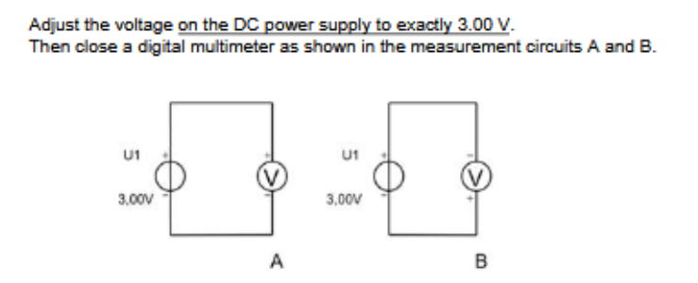

a.

Tension for schedule A: 2.980 V

Tension for schedule B: - 2.980 V

b.

I = 0  
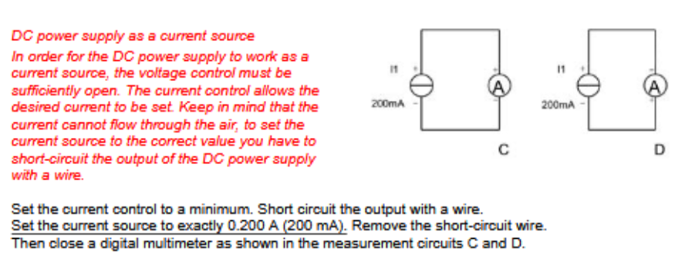c.

Current for circuit C: 199.8 mA

Current for circuit D: - 200.3 mA

d.

Measuring range is: 600 mA

e.

Voltage across the ammeter is 0.14 V

f.

R Ammeter = 0.727 kΩ

2. Verification of omh’s law

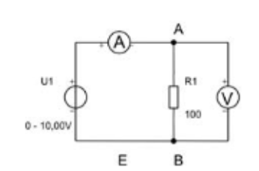

a.

|  |  |  |  |
| --- | --- | --- | --- |
| 100 Ω | U (V) | I (measured) | I (calculated) |
|  | 2, | 19.83 mA | 20 mA |
|  | 4, | 40 mA | 40 mA |
|  | 6, | 59.72 mA | 60 mA |
|  | 8, | 79.5 mA | 80 mA |
|  | 10, | 99.3 mA | 100 mA |

c.

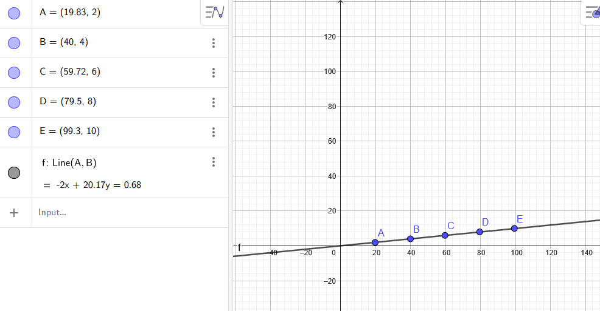The graph of the values

X axis represents the current expressed in mA, the Y axis represents the voltage, expressed in Volts

V = I * R

R = V/I

Both measured resistance values deviate only 0.2% and 0.83%, they both are fine with the 1-5% tolerance classes

100 Ω | Measured resistance: 76 Ω

d.

24Ω deviation

**3. Relationship between voltage and current in an incandescent bulb**

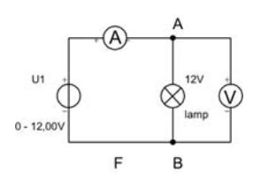 a.

|  |  |
| --- | --- |
| **U (V)** | **I** |
| 2 V | **289.4 mA** |
| 4 V | **409 mA** |
| 6 V | **505 mA** |
| 8 V | **589 mA** |
| 10 V | **680 mA** |
| 12 V | **748 mA** |