**Week 5: Kirchoff’s laws**

**1.**

a.

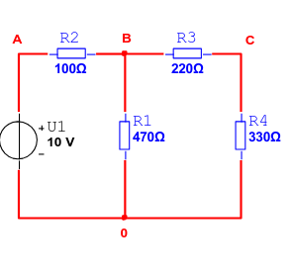

b.

|  |  |  |
| --- | --- | --- |
|  | meet-value() | Abs.error() |
| UAB | 2.810 V |  |
| UB0 | 7.16 |  |
| U0A | 9.97 |  |
|  |  |  |
| sum |  |  |