TEA MACHINE (Programming 2)
(Mario Filipov and Janosi Barna-Botond)

Summary
This report covers our Tea Machine project for the Programming 2 module. We programmed an automated system in C that brews and pours tea using Qt Creator. Our work focused on four main areas: the brewing process, dispensing, the pump, and the heater. The machine lets a user pick a tea, heats the water, and fills the cup. We used header files and comments to keep the code easy to follow.
Preface
This is the final report for the Tea Machine project in our programming module. At the start of the class, our team did not have much experience with C programming. By working together, we were able to finish the project with a good result. We made a plan before starting the work to make sure we stayed on schedule and finished on time.

Content:
1. Introduction 3
2. Definition phase 4
2.1 Background project 4
2.2 Functional specification 4
2.3 Technical specification 5
3. Design fase 6
3.1 Layered Architecture 6
3.1.1 User Interface Layer 7
3.1.2 System Control Layer 7
3.1.3 Subsystems Layer 7
3.1.4 Hardware Abstraction Layer 7
3.2 State machine 8
4. Realization and testing 8
4.1 Development environment 8
4.2 Userinterface 10
4.3 Acceptance test 11
4.4 Documentation 12
5. End result and recommendations 17

1. Introduction
The project "Tea Machine" is a software engineering initiative where our team programmed an automated tea-dispensing system using the C language. While many industrial beverage machines are built for commercial use worldwide, this project focuses on the logic required to safely manage the brewing and dispensing process.
This report details the development of a state machine designed to control the various phases of tea preparation. The tea machine consists of several key components, including a heating element, a dispensing subsystem, a control panel with start and reset buttons, an emergency stop, and a safety lid for the brewing chamber.
The structure of this report is as follows:
- Chapter 2 describes the definition phase, containing the functional and technical specifications that show how the tea machine operates and which hardware components are simulated.
- Chapter 3 outlines the design phase, explaining the technical solutions and diagrams, such as the layered architecture and the Finite State Machine (FSM).
- Chapter 4 covers the realization phase and testing, showing how the program is structured in the development environment and how the team verified the system through acceptance tests.
- Chapter 5 presents the final results and recommendations, providing a conclusion based on our team's project goals.
- The Appendix at the end of the report contains the user manual for operating the tea machine.

2.Definition Phase
The tea machine consists of a large amount of electronics and how it works is presented below.
2.1 Background problem
People often times find themselves short on time, any opportunity so save time or convenience the user is considered valuable. The problem that led to the creation of the TeaMaster tea machine is the inconvenience of having to boil water, and the need to infuse the tea for the adequate amount of time. This may differ between different types of tea, further complicating a process as simple as making a cup of tea.
The tea machine can handle the entire process of heating water and infusing tea from the press of a button, saving the user time and guaranteeing the same quality beverage every time. The operation consists of heating water which is fed to machine, then pouring said water into a container provided by the user and infusing said water with a tea of the user’s choice. Once the tea has infused for enough time, the machine extracts the tea packet from the finished beverage and disposes of it. Tea packets can be refilled through the back of the machine. There is a selection of 4 teas available.
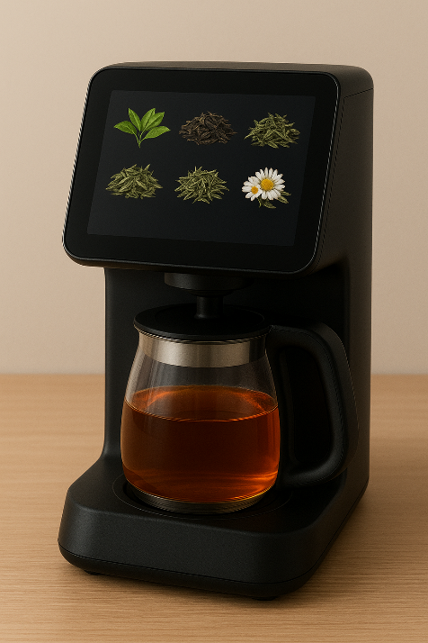
figure 1 (tea machine)

2.2 Functional specifications
- The tea machine will wait for user interaction in standby mode
- Intuitive interface
- All tea options are visible and selectable in standby mode, tea has to be periodically refilled
- During the tea making process, the machine displays what stage of the process it is in, and the (estimated) time until done
- If a product is chosen, the machine will request payment via card.
- In case of successful payment, the machine will fill its internal reservoir if needed, and proceed to heat the water to 100 degrees Celsius.
- The water temperature is read inside the reservoir.
- When hot water is available, it is poured into the provided container.
- The machine inserts a tea packet into the hot water and keeps it there until a pre-programmed amount of time, ideal for the selected tea.
The machine will make a beeping sound when the tea is ready to be removed.
- After the tea container is removed, the machine disposes of the tea packet, dropping it into an internal container which has to be periodically emptied.

2.3 Technical specifications
- Programming language: C
- Development environment: QtCreator
- UML diagram editor: PlantUML, draw.io
- Display: 7-inch touchscreen display
- Custom made shell, internal hardware for tea making
A user can interact with the machine through the integrated touchscreen. Here they may choose which tea they want to purchase. Each option has an illustration and a name displayed, along with a small sign on beverages with a high caffeine content.
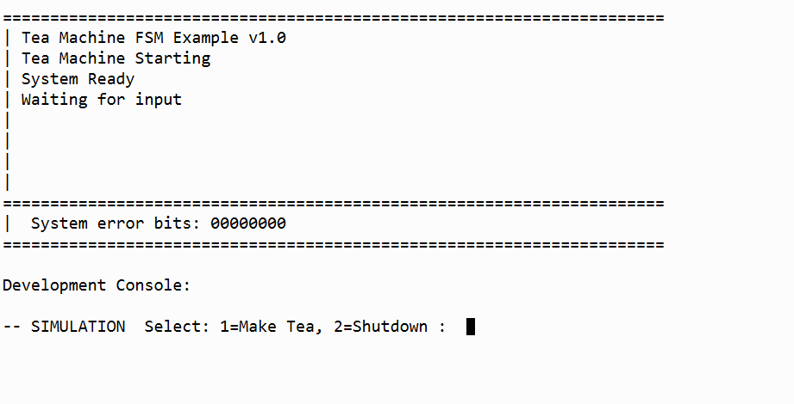
Figure 2(user interface)
The user can interact with the machine by pressing 1 to make a tea cup and 2 to shut down the machine.

3. Design phase
This chapter describes the technical design of the tea machine. The structure is based on a layered architecture that ensures clear separation between the user interaction and the low-level hardware control.
3.1 Layered architecture
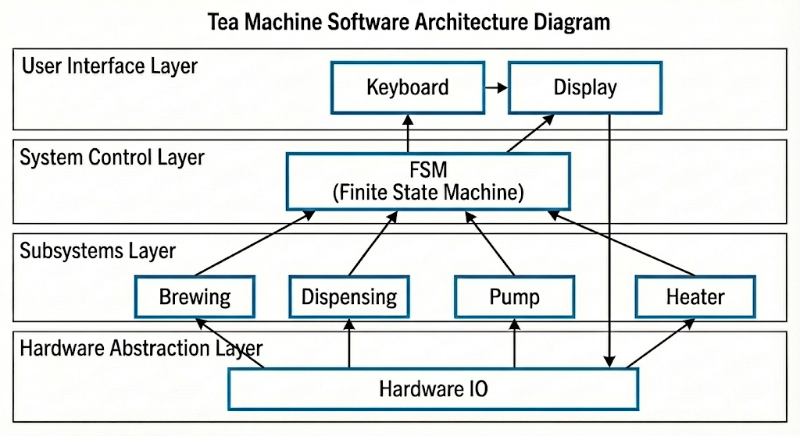
Figure 3(architecture diagram)

The diagram below represents the software layers developed for the tea machine:
- User Interface Layer: Contains the Keyboard and Display modules. This layer communicates bidirectionally with the Hardware Abstraction Layer to express desired commands.
- System Control Layer: The system is governed by a Finite State Machine (FSM), which serves as the central hub where all operational states are processed. At any given moment, the machine exists in only one specific state, transitioning to subsequent states only when a defined event occurs. Furthermore, the FSM is tasked with the execution of various system functions.
- Subsystems Layer: This layer contains the specific functional components of the tea machine:
  - Brewing: Manages the steeping process logic.
  - Dispensing: Controls the release of the final product.
  - Pump: Simulates the movement of water through the system.
  - Heater: Manages the temperature logic for the water.
- Hardware Abstraction Layer: The Hardware IO module acts as the bridge to the simulated physical components. In this specific design, the User Interface can talk directly with the Hardware IO to allow for manual hardware testing and direct feedback.
3.2 State machine
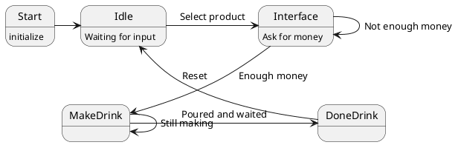
Figure 4 (FSM diagram)

The operational logic of the tea machine is governed by a Finite State Machine (FSM), as illustrated in the following UML state diagram:
The machine transitions through various operational phases based on user interaction and internal logic:
- Start: Upon activation, the system enters the initialization phase to ready all internal components for operation.
- Idle: After initialization, the machine remains in a standby state, waiting for the user to select a product.
- Interface: Once a selection is made, the system prompts the user for payment. If the funds provided are insufficient, the machine remains in this state.
- MakeDrink: Upon receiving enough money, the machine initiates the brewing and dispensing sequence. The system remains in this active processing state until the beverage is fully prepared.
- DoneDrink: Once the pouring and steeping cycles are finished, the machine signals that the beverage is ready. The system can then be reset to return to the Idle state for the next user.

4. Realization and testing
The way in which the tea machine is realized is detailed in the following chapters. Extensive testing was carried out by the team to ensure all customer requirements for the tea machine were met. Every operational scenario was evaluated to determine how the software reacts to user input and hardware simulation.
4.1 Development environment
The "Tea Machine" project was developed using the QT-Creator program. The project structure is managed through a .pro file, which organizes the necessary header files and source files.
- The code is programmed in the C language using the C11 standard.
- On the bottom there are pictures of the structure of the project, we manage header files (e.g., tea_logic.h, fsm.h) and source files (e.g., main.c, display.c).
- The "Issues" function within QT-Creator is utilized as a primary tool for debugging the tea machine logic.
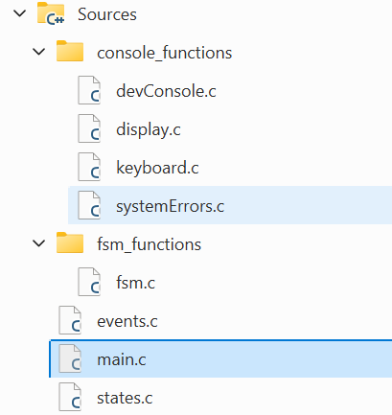
Figure 5 (Source files)
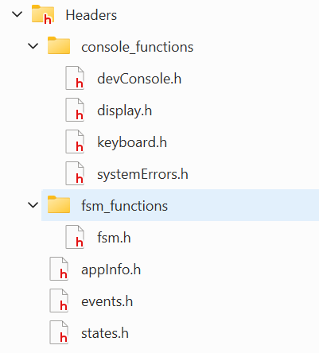
Figure 6 (header files)
4.2 User interface
The user interface for the tea machine provides clear feedback regarding the machine's current state. It is divided into a status area and an instruction area for the operator.

Figure 7 (user interface)

4.3 Acceptance testing
In order to deliver the machine to the customer properly, it is necessary to thoroughly test the machine. Figure 9 shows a test table of the tests performed.
The sequence of testing is as follows:
- Test 1: Start application
- Test 2: Input from the user
- Test 3: Error input from the user
- Test 4: Selecting a tea that exists in the machine
- Test 5: Selecting a tea that does not exist in the machine
- Test 6: inserting the amount of money needed to pay for the tea.

Project name: Tea machine |  |  |  | Date: 20.12.2025
Test case ID: 1 |  | Names: Mario Filipov and Janosi Barna-Botond
Function/module/program under test: Tea machine
Test | Action/input |  | Expected result |  | Pass  Fail | Actual result if test has failed
1. | Application starts properly |  | Displayed the main menu properly |  | Pass
2. | Application accepts user input |  | Application accepts user inputs as expected |  | Pass
3. | Application handle user input errors |  | Prompts the user to enter again |  | Pass
4. | Selecting herbal tea |  | Tea gets selected and we are prompted the price and to insert money |  | Pass
5. | Selecting a tea that doesn’t exist e.g. number 5 |  | Prompted to try again |  | Pass
6. | Entering 5 dollars for green tea(2$) |  | our tea is getting poured and we are get back 3$ |  | Pass

4.4 Tea Machine FSM - Function Documentation

Main Program Flow:

main()
Purpose: Initializes and runs the finite state machine for the tea vending machine.
Behaviour:
- Registers all states with their entry/exit handlers
- Defines state transitions based on events
- Enables unexpected event flushing
- Starts FSM in S_START state with E_START event
- Runs event loop until shutdown
State Entry and Exit Functions:
INIT State
S_Init_onEntry()
Purpose: System initialization when entering INIT state.
Actions:
- Initializes display and keyboard subsystems
- Shows startup messages ("Tea Machine Starting", "System Ready")
- Logs system state and event information
- Generates E_CONTINUE event to transition to IDLE

S_Init_onExit()
Purpose: Cleanup when exiting INIT state.
Actions:
- Logs exit from INIT state

IDLE State
S_Idle_onEntry()
Purpose: Waits for user input in IDLE state.
Actions:
- Displays "Waiting for input" message
- Calls getUserChoice() to get user decision
- Generates event based on user choice (tea selection or shutdown)

S_Idle_onExit()
Purpose: Cleanup when exiting IDLE state.
Actions:
- Logs exit state and event information

SELECT TEA State
S_SelectTea_onEntry()
Purpose: Handles tea selection process.
Actions:
- Displays "Select your tea" prompt
- Calls getTeaSelection() to get tea choice
- Sets selectedTea and teaPrice variables
- Generates E_TEA_SELECTED event

S_SelectTea_onExit()
Purpose: Cleanup when exiting tea selection state.
Actions:
- Logs selected tea type and price

ASK FOR MONEY State
S_AskForMoney_onEntry()
Purpose: Handles money insertion process.
Actions:
- Displays tea price
- Prompts user to insert money
- Calls getMoneyInput() to process payment
- Generates event based on payment sufficiency

S_AskForMoney_onExit()
Purpose: Cleanup when exiting money input state.
Actions:
- Logs money status (inserted vs. required amount)

MAKE TEA State
S_MakeTea_onEntry()
Purpose: Simulates tea preparation process.
Actions:
- Clears display
- Shows sequential messages: "Making [tea type]", "Pouring tea...", "Please wait...", "Tea is ready!"
- Adds delays to simulate preparation time (30s + 20s + 20s + 10s)
- Generates E_POURED_AND_WAITED event when complete

S_MakeTea_onExit()
Purpose: Cleanup when exiting tea making state.
Actions:
- Logs exit from tea making state

DONE TEA State
S_DoneTea_onEntry()
Purpose: Finalizes transaction and prepares for next customer.
Actions:
- Displays completion messages
- Increments totalTeas counter
- Calculates and displays change if applicable
- Resets transaction variables (insertedMoney, teaPrice)
- Generates E_RESET event to return to IDLE

S_DoneTea_onExit()
Purpose: Cleanup when exiting completion state.
Actions:
- Logs exit state
- Clears display

SHUTDOWN State
S_Shutdown_onEntry()
Purpose: Graceful system shutdown.
Actions:
- Clears display
- Shows shutdown message
- Displays total teas sold during session
- Waits 15 seconds before exit

S_Shutdown_onExit()
Purpose: Final cleanup and program termination.
Actions:
- Logs final state
- Exits program with status 0

Helper Functions
getUserChoice()
Purpose: Gets main menu selection from user.
Returns:
- E_SELECT_TEA - User wants to make tea (input: '1')
- E_SHUTDOWN - User wants to shutdown (input: '2')
- E_NO - Invalid input
Input Options:
- '1' = Make Tea
- '2' = Shutdown

getTeaSelection()
Purpose: Gets tea type selection and sets pricing.
Returns:
- E_TEA_SELECTED - Valid tea selected
- E_NO - Invalid input
Input Options and Pricing:
- '1' = Green Tea ($2.00)
- '2' = Black Tea ($2.00)
- '3' = Herbal Tea ($2.50)
- '4' = Oolong Tea ($2.75)
Side Effects:
- Sets global selectedTea (tea name string)
- Sets global teaPrice (cost in dollars)

getMoneyInput()
Purpose: Processes money insertion and validates payment.
Returns:
- E_ENOUGH_MONEY - Sufficient funds inserted
- E_NOT_ENOUGH_MONEY - More money needed
Input Options:
- '1' = Insert $1.00
- '2' = Insert $2.00
- '3' = Insert $5.00
Behavior:
- Displays current inserted amount
- Accumulates money in global insertedMoney variable
- Compares with teaPrice to determine sufficiency
- Logs insertion and requirement amounts

delay_us()
Purpose: Simulates time delay in microseconds.
Parameters:
- d - Delay duration in microseconds
Behavior:
- Logs delay duration
- Sleeps for d/10000 seconds (conversion from microseconds)
- Used to simulate real-world tea preparation timing

Global Variables
state (state_t) - Current FSM state
event (event_t) - Current event being processed
totalTeas (int) - Counter for teas sold (initialized to 0)
selectedTea (char*) - Currently selected tea name (default: "Black Tea")
teaPrice (float) - Price of selected tea (default: 0.0)
insertedMoney (float) - Total money inserted by user (default: 0.0)

5. End result and recommendations
The primary objective of this project was to develop a control system for an automated tea machine that is both reliable and user-friendly. By implementing a structured Finite State Machine (FSM), the team has successfully met all project requirements and safety standards.
Final Result
The following features have been successfully realized for the tea machine:
- Initialization Cycle: The machine correctly resets all parameters and initializes subsystems upon startup.
- User Interaction: Operators can select products and manage payment through simulated keyboard inputs.
- State Management: The machine transitions correctly between Idle, Interface, MakeDrink, and DoneDrink states based on events like "Enough money" or "Reset".
- Ingredient Logic: The system accurately calculates ingredient values and triggers an Error state if incorrect proportions or excess ingredients are detected.
- Safety Integration: The software successfully monitors the safety lid and emergency stop, moving to a MachineNotSafe state to prevent operation during unsafe conditions.
- Shutdown Cycle: The machine performs a clean de-initialization of all subsystems-including the heater and pump-before the application closes.
The acceptance tests confirm that the tea machine reacts correctly to all defined scenarios, providing clear feedback to the user on the display regarding current status and safety notifications.
Recommendations
While the current software effectively simulates the tea-making process, we identify several areas for future development:
- Hardware Integration: Future iterations should move beyond simulation by connecting the C application to actual physical hardware, such as a heating element and a water pump.
- Sensor Communication: Investigation into real-time communication with temperature sensors and flow meters is recommended to replace the current logic-based simulations.
- Hardware Safety Interrupts: While safety is currently managed in the software, a physical build must include hardware-level interrupts to ensure the heater and pump are disabled immediately if the lid is opened.
- Payment Hardware: The "Interface" state currently relies on keyboard input for money; future development could include integration with an actual coin or card reader.

