Automated tea machine
Janosi Barna-Botond

Summary

*Something about tea, the need for automated tea machine*
Vending machines serve the purpose of providing easy, fast access to goods. One problem which might arise from a vending machine which happens to serve tea is that it might let the tea infuse for too long or too short, affecting the taste. For this reason I designed an automated tea machine which leaves the tea to infuse for the ideal amount of time.

Contents

- Title page
- Summary
- Contents
4

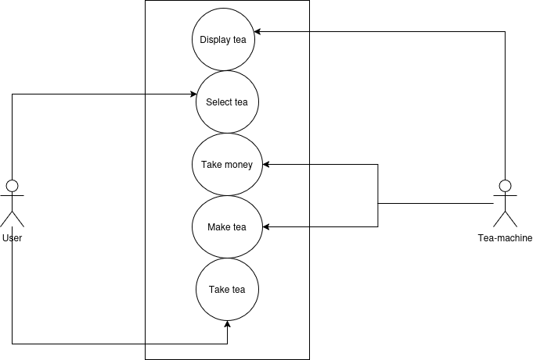
Use case diagram:

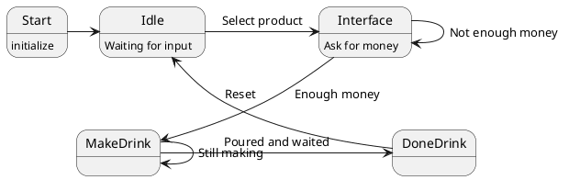
State machine diagram:
Functional specifications:
Technical specifications:

