Background of the problem
People often times find themselves short on time, any opportunity so save time or convenience the user is considered valuable. The problem that led to the creation of the *name* tea machine is the inconvenience of having to boil water, and the need to infuse the tea for the adequate amount of time. This may differ between different types of tea, further complicating a process as simple as making a cup of tea.
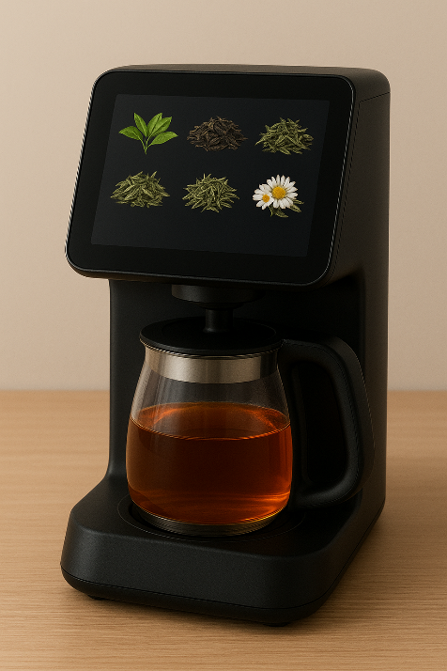
The tea machine can handle the entire process of heating water and infusing tea from the press of a button, saving the user time and guaranteeing the same quality beverage every time. The operation consists of heating water which is fed to machine, then pouring said water into a container provided by the user and infusing said water with a tea of the user’s choice. Once the tea has infused for enough time, the machine extracts the tea packet from the finished beverage and disposes of it. Tea packets can be refilled through the back of the machine. There is a selection of 5 teas available.

