Background of the problem
People often times find themselves short on time, any opportunity so save time or convenience the user is considered valuable. The problem that led to the creation of the *name* tea machine is the inconvenience of having to boil water, and the need to infuse the tea for the adequate amount of time. This may differ between different types of tea, further complicating a process as simple as making a cup of tea.
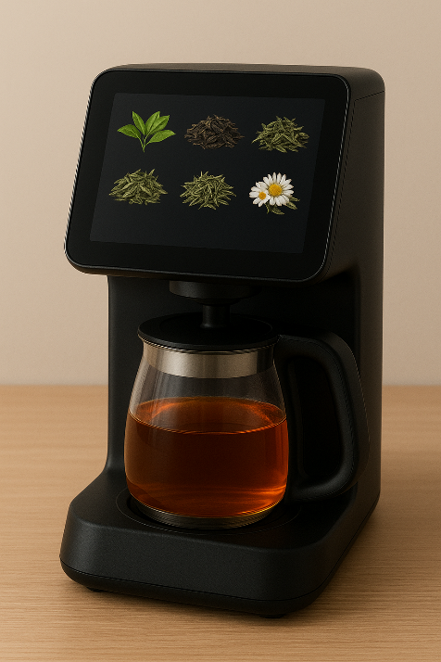
The tea machine can handle the entire process of heating water and infusing tea from the press of a button, saving the user time and guaranteeing the same quality beverage every time. The operation consists of heating water which is fed to machine, then pouring said water into a container provided by the user and infusing said water with a tea of the user’s choice. Once the tea has infused for enough time, the machine extracts the tea packet from the finished beverage and disposes of it. Tea packets can be refilled through the back of the machine. There is a selection of 5 teas available.

Functional specifications
- The tea machine will wait for user interaction in standby mode
- Intuitive interface
- All tea options are visible and selectable in standby mode, tea has to be periodically refilled
- During the tea making process, the machine displays what stage of the process it is in, and the (estimated) time until done
- If a product is chosen, the machine will request payment via card.
- In case of successful payment, the machine will fill its internal reservoir if needed, and proceed to heat the water to 100 degrees Celsius.
- The water temperature is read inside the reservoir.
- When hot water is available, it is poured into the provided container.
- The machine inserts a tea packet into the hot water and keeps it there until a pre-programmed amount of time, ideal for the selected tea.
- The machine will make a beeping sound when the tea is ready to be removed.
- After the tea container is removed, the machine disposes of the tea packet, dropping it into an internal container which has to be periodically emptied.

Technical specifications

- Programming language: C
- Development environment: Clion
- UML diagram editor: PlantUML, draw.io
- Display: 7-inch touchscreen display
- Custom made shell, internal hardware for tea making
A user can interact with the machine through the integrated touchscreen. Here they may choose which tea they want to purchase. Each option has an illustration and a name displayed, along with a small sign on beverages with a high caffeine content.
*Insert a concept image here*

