Title: Week 6 - Power, Energy and Complex Load
Date: [Insert Date Here]
Student Name: [Your Name]
Student Number: [Your Number]
Class: [Your Class]
Teacher: [Teacher Name]

1. MEASUREMENT CIRCUIT 1: COMPLEX LOAD (RC SERIES)
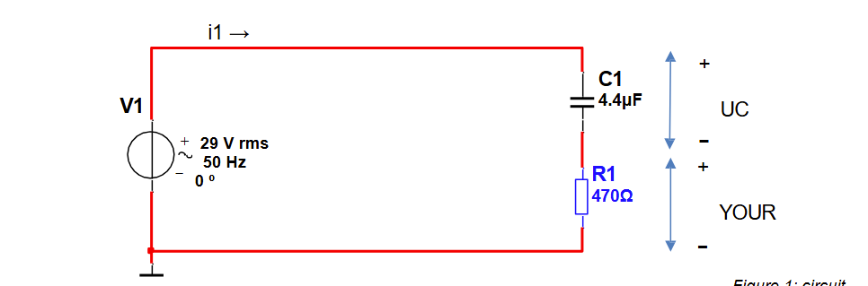
Circuit Parameters:
- Voltage Source (V1): 29 V rms, 50 Hz
- Resistor (R1): 470 Ω
- Capacitor (C1): 4.4 µF

Expectation & Calculations (A0 - A9):

First, we calculate the theoretical impedance to find the expected current in Amps.
Formula: Xc = 1 / (2 * π * f * C)
Calculation: Xc = 1 / (2 * π * 50 * 0.0000044) ≈ 723.4 Ω

Formula: Z = √(R² + Xc²)
Calculation: Z = √(470² + 723.4²) ≈ 862.6 Ω

Formula: I = V / Z
Calculation: I = 29 / 862.6 ≈ 0.0336 A
A0.
Is = 0.0336 A
V1 = 28.95 V
UC = 15.6 V
UR = 28.93 V
A1. Energy supplied by source in 1 hour:
To find energy, we first need Real Power (Pn).
Formula: cos(φ) = R / Z
Calculation: cos(φ) = 470 / 862.6 ≈ 0.545
Formula: Pn = V * I * cos(φ)
Calculation: Pn = 29 * 0.0336 * 0.545 ≈ 0.531 W
Formula: E = P * t
Calculation: E = 0.531 W * 3600 s ≈ 1911.6 Joules

A2. KVL Equation:
Formula: V_source = √(UR² + UC²) (Phasor sum)
Expectation: The sum of the voltage drops UR and UC will equal 29 V only when added as vectors, not algebraically.
Expected UR = I * R = 0.0336 * 470 = 15.8 V
Expected UC = I * Xc = 0.0336 * 723.4 = 24.3 V

A3. Calculated Powers:
- Apparent Power (S):
Formula: S = V * I
Calculation: S = 29 * 0.0336 ≈ 0.974 VA
- Reactive Power (Qc):
Formula: Qc = I² * Xc
Calculation: Qc = 0.0336² * 723.4 ≈ 0.817 VAr
- Real Power (Pr):
Formula: Pr = I² * R
Calculation: Pr = 0.0336² * 470 ≈ 0.531 W

A5. Phase Angle (φ):
Formula: φ = arccos(P / S)
Calculation: φ = arccos(0.531 / 0.974) ≈ 56.9°

A6. Energy consumed by resistor in 1 hour:
Formula: E_R = Pr * t
Calculation: E_R = 0.531 * 3600 ≈ 1911.6 Joules

A7. Conclusion on Energy Difference:
The energy supplied by the source (A1) matches the energy consumed by the resistor (A6). This confirms that only the resistive part of a circuit consumes real energy over time; the capacitor merely stores and releases it.

A8. Power Factor:
Formula: PF = cos(φ)
Calculation: PF ≈ 0.545

---

2. MEASUREMENT CIRCUIT 2: PHASE COMPENSATION
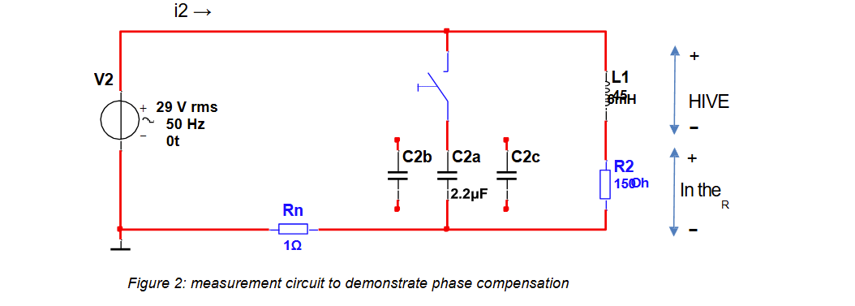
Circuit Parameters:
- Voltage Source (V2): 29 V rms, 50 Hz
- Inductor (L1): 0.045 H (45 mH)
- Resistor (R2): 150 Ω
- Capacitors (C2a, b, c): 2.2 µF each

Part 1: Uncompensated Load (Only L and R) - Expectations:

First, determine the inductive reactance and impedance.
Formula: XL = 2 * π * f * L
Calculation: XL = 2 * π * 50 * 0.045 ≈ 14.14 Ω

Formula: Z = √(R² + XL²)
Calculation: Z = √(150² + 14.14²) ≈ 150.7 Ω

Formula: I2 = V / Z
Calculation: I2 = 29 / 150.7 ≈ 0.192 A
B0.
I2 = 0.134 A
V2 = 28.87 V
Ul = 28.84 V
B1. Calculated Powers (Uncompensated):
- Apparent Power (S):
Calculation: S = 29 * 0.192 ≈ 5.57 VA
- Reactive Power (Ql):
Calculation: Ql = I² * XL = 0.192² * 14.14 ≈ 0.52 VAr
- Real Power (Pr):
Calculation: Pr = I² * R = 0.192² * 150 ≈ 5.53 W
B2. The Power Triangle#
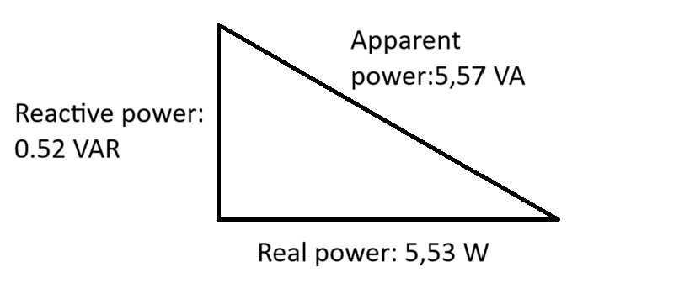
B3. CALCULATION: PHASE ANGLE (φ)
2. FORMULAS:
- Inductive Reactance: XL = 2 * π * f * L
- Phase Angle (φ) : φ = arctan( XL / R_tot )

3. CALCULATIONS:
A) Calculate Reactance (XL):
XL = 2 * π * 50 * 0.045
XL ≈ 14.14 Ohm
B) Calculate Phase Angle (φ):
φ = arctan( 14.14 / 151 )
φ = arctan( 0.0936 )
φ ≈ 5.35 degrees
The phase angle φ between current and voltage is approximately 5.35°.
B4. Draw a phase diagram for V2 and i2 of the circuit without C2.
1. CALCULATED PHASOR VALUES:
-------------------------
* Voltage Vector (V2):
- Magnitude: 29 V
- Angle : 0° (Reference)
- Notation : V2 = 29∠0° V

* Current Vector (i2):
- Impedance (Z): √(151² + 14.14²) ≈ 151.7 Ω
- Magnitude : 29 V / 151.7 Ω ≈ 0.191 A
- Angle : -5.35° (Lagging behind voltage)
- Notation : i2 = 0.191∠-5.35° A
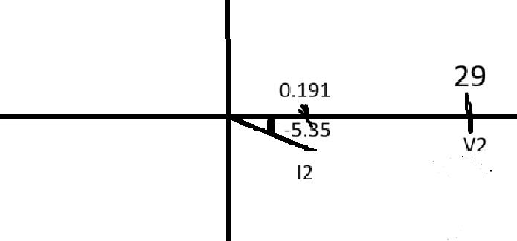
Part 2: Compensated Load (Adding Capacitors) - Expectations:

We add capacitors to neutralize the Inductive Reactive Power (Ql = 0.52 VAr).
Reactance of one capacitor:
Calculation: Xc = 1 / (2 * π * 50 * 0.0000022) ≈ 1447 Ω

Reactive power generated by one capacitor (Qc):
Calculation: Qc = V² / Xc = 29² / 1447 ≈ 0.58 VAr

Comparison:
The inductive load Ql is 0.52 VAr.
One capacitor provides Qc of 0.58 VAr.
Since 0.58 VAr is very close to 0.52 VAr, adding 1 capacitor should result in nearly perfect compensation (Phase angle ≈ 0). Adding 2 or 3 capacitors will result in over-compensation (capacitive circuit) and the total current will rise again.
B5.Table
Number of Capacitors | I2() |  | IC() | UR()
0 | 0.134A |  | 0.132A | 17.68V
1 | 0.025A |  | 0.036A | 0.0254V
2 | 0.044A |  | 0.052A | 0.0441V
3 | 0.063A |  | 0.072A | 0.061V

B6. Calculated Powers (Compensated with 1 Capacitor):
- Real Power (Pr): Remains constant at ≈ 5.53 W (Resistor does not change).
- Apparent Power (S): Should decrease to be approximately equal to Real Power (S ≈ P)
because the reactive currents cancel out.
B7. Phasor Diagram
Reference: Voltage V2 is at 0 degrees.
2. PHASOR VALUES (CALCULATED):
---------------------------
A) Reference Voltage (V2):
- Magnitude : 29 V
- Angle : 0°

B) Branch Current (iR) [Flows through L1 + R2]:
- Magnitude : 0.192 A (192 mA)
- Angle : -5.4° (Lagging)
- Notation : iR = 0.192∠-5.4° A

C) Capacitor Current (iC) [Flows through 3x Caps]:
- Magnitude : 0.060 A (60 mA)
- Angle : +90° (Leading purely)
- Notation : iC = 0.060∠+90° A

D) Total Current (i2) [Vector Sum: iR + iC]:
- Magnitude : 0.196 A (196 mA)
- Angle : +12.4° (Leading)
- Notation : i2 = 0.196∠+12.4° A
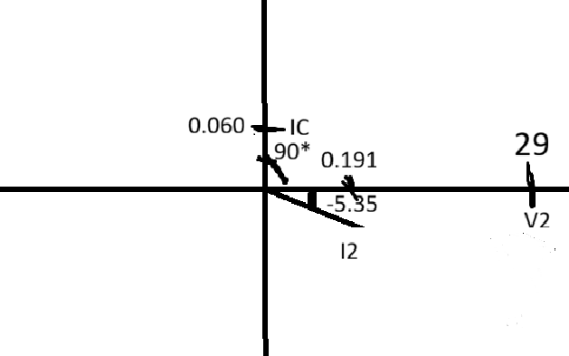

3. SUMMARY AND CONCLUSION (C1 - C2)

C1. Summary of Outcome:
In the uncompensated circuit (B1), the Apparent Power (S) was higher than the Real Power (P) due to the reactive power of the inductor.
In the compensated circuit (B6), adding the capacitor provided reactive power that canceled out the inductor's reactive power. This reduced the phase angle (φ) towards 0 degrees and caused the Apparent Power (S) to equal the Real Power (P).

C2. Usefulness of Phase Compensation:
Phase compensation is useful because it reduces the reactive power drawn from the grid. By bringing the power factor closer to 1 (reducing the phase angle), the total current required from the source is minimized for the same amount of useful work. This reduces energy losses in transmission cables and allows for more efficient use of the electrical infrastructure.

2 Measurement task part 3: Measuring voltage and current with the oscilloscope.

MEASUREMENT DATA: SOURCE V2 & IRN
1. SOURCE PARAMETERS (V2):
- Frequency (f) : 50 Hz
- Voltage (AC RMS) : 28.389 V

2. MEASURED CURRENT (IRN):
- Current Magnitude: 0.672 A

