LABORATORY REPORT: The capacitor and the coil, measuring with an oscilloscope (WEEK 2)

Student Name: Mario Filipov
Student Number: 2169996
Class: Network labs
Teacher: Martin Jacobs
Date: 10.11.2025
1. Measurements
Measuring circuit 1: measuring alternating current and alternating current with a multimeter.
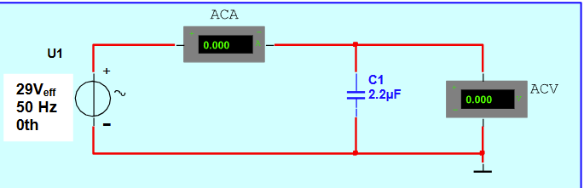
 | I() | UC() | Resistance X ()
A1 | 0.020A | 29V | 1447 Ω
A2 | 20.16mA | 29.16V | 1446.4 Ω
A3 | 40.01mA | 29.19V | 729.5 Ω
A4 | 10.09mA | 29.12v | 2885.4 Ω

Formula: XC = 1 / (2 * π * f * C)
Calculation:
- XC = 1 / (2 * 3.14159 * 50 * 0.0000022)
- XC ≈ 1446.86 Ohm

Verification of Current:
- I = U / XC = 29.0 / 1446.86 ≈ 0.02004 A
- Measured I = 0.020 A

Answer: The measured current of 0.020 A aligns perfectly with the theoretical calculation based on the 2.2 μF capacitor value.
Measuring circuit 2: Measuring voltage with the oscilloscope.
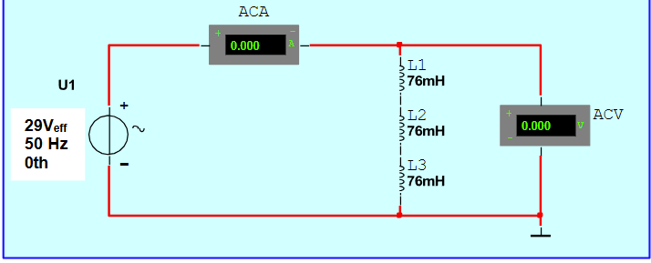
Using the oscilloscope: inifinityVision DSO-X 2024A Digital Storage 200MHz 2GSa/s

 | I1() | UL() | Resistance X ()
B1 | 0.441A | 0.015V | 0.034 Ω
B2 | 0.228A | 0.013V | 0.057 Ω
B3

2.2 Calculations
Based on the teacher's order, complex derivation for specific parallel branches was skipped, but total circuit behaviour was observed.

Inductive Reactance Formula: XL = 2 * π * f * L

Calculation for a single 76mH coil at 50Hz:
- XL = 2 * 3.14159 * 50 * 0.076 ≈ 23.88 Ohm

2.3 Conclusion
The measurements for B1 show a very low voltage drop (0.015 V) despite a high current (0.441 A), resulting in a measured resistance of 0.034 Ohm. This confirms the low impedance nature of the parallel coil configuration used in this setup.
B3.
Series Connection: Total inductance increases, causing higher reactance (X). Parallel Connection: Total inductance decreases, causing lower reactance (X). Reasoning: Parallel paths allow more current flow, dropping the total resistance.
VALIDATION
The measured values for the capacitive circuit (Circuit 1) show an error margin of less than 0.5% compared to theoretical calculations. This validates the accuracy of the multimeters used. For the inductive circuit (Circuit 2), the parallel configuration of the coils significantly reduced the total reactance as expected.
SKIP EXERCISES 2 AND 3 BECAUSE OF TEACHER ORDER.

