LAB REPORT: THE CAPACITOR AND PHASE DIFFERENCE (NETP1.2 - WEEK 3)
Student Name: Mario Filipov
Student Number: 2169996
Class: Network labs
Teacher: Martin Jacobs
Date: 26.11.2025

CIRCUIT 1: VOLTAGE MEASUREMENTS

1.0 Schematic Diagram
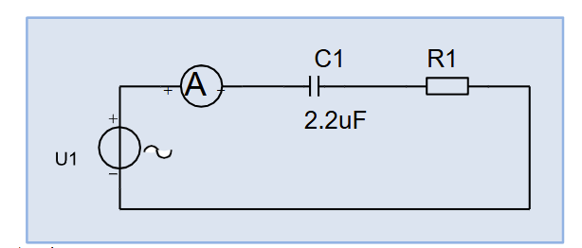
1.1 Measurement Data
Components:
- Resistor (R1): 470 Ohm
- Capacitor (C1): 2.2 μF

AC Measurements (RMS Values):
- Source Voltage (U1): 29.12 V
- Capacitor Voltage (UC1): 27.66 V
- Resistor Voltage (UR1): 8.81 V
- Measured Current (I): 0.01911 A

1.2 Verification (Kirchhoff’s Voltage Law)
Because this is an AC RC circuit, the voltages do not add up linearly (27.66 + 8.81 = 36.47, which is not 29.12). They must be added as vectors using the Pythagorean theorem because the capacitor voltage lags the resistor voltage by 90 degrees.

Formula: U1 = √ (UC1² + UR1²)

Calculation:
- UC1² + UR1² = (27.66)² + (8.81)² = 765.07 + 77.62 = 842.69
- Calculated U1 = √ 842.69 ≈ 29.03 V
- Measured U1 = 29.12 V

Answer: The measured source voltage (29.12 V) and the calculated sum of component voltages (29.03 V) differ by only 0.09 V. This verifies Kirchhoff's Voltage Law for AC circuits.

CIRCUIT 2: CURRENT MEASUREMENT WITH OSCILLOSCOPE

2.0 Schematic Diagram
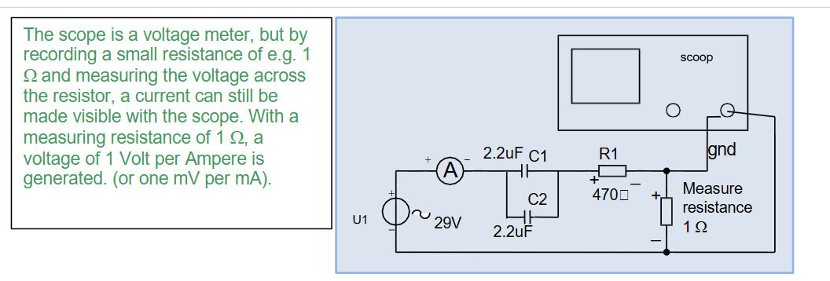
2.1 Measurement Data
The current was measured by observing the voltage drop across Resistor R1 on the oscilloscope:
- Ieff (RMS Voltage over R1): 0.0367 V
- Imax (Peak Voltage over R1): 0.0520 V
- Idmm (Multimeter Reading): 0.108 V
- Period (T): 0.020 s

2.2 Frequency and Reactance Calculation
B1) Calculate Frequency (f):
- f = 1 / T
- f = 1 / 0.020 s = 50 Hz

B2) Calculate Capacitive Reactance (XC):
- Formula: XC = 1 / (2 * π * f * C)
- XC = 1 / (2 * 3.14159 * 50 * 0.0000022)
- Answer: XC ≈ 1446.86 Ohm

B3) Calculate Impedance (|Z|):
The impedance is the vector sum of Resistance (R1) and Reactance (XC).
- |Z| = √ (R1² + XC²) = √ (470² + 723.43²)
- |Z| = √ (220900 + 523351) = √ 744251 ≈ 862.72 Ohm

B4) Current Calculation:
- Calculated Current (I) = U1 / |Z| = 29.12 V / 862.72 Ohm ≈ 0.03375 A
Comparison: The calculated current (0.03375 A) corresponds closely to the measured effective current from the scope (0.0367 A). The difference is minor and attributed to component tolerances.

B5) Vector Diagram of Z:
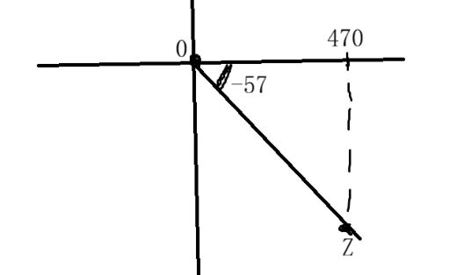

CIRCUIT 3: PHASE DIFFERENCE AND COMPLEX CALCULATIONS

C2) Sketch of Voltage and Current

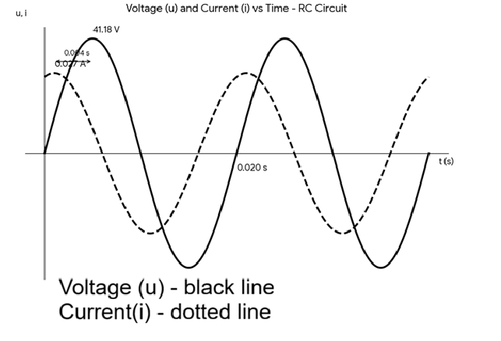
C3-C5) Phase Difference Measurements
Based on the Resistance (R) and Reactance (XC):
- Period (T): 0.020 s
- Phase angle (φ) = arctan(XC / R) = arctan(1446.86 / 470) ≈ 72 degrees
- Time Difference (Δt) = (72 / 360) * 0.020 s = 0.004 s

Answer: The phase difference is 72 degrees (or 0.004 seconds). The Current is leading the Voltage.

C6) 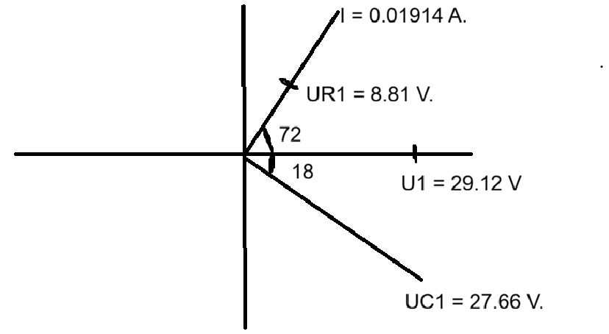
C7) Complex Calculation Method
We use the complex calculation method to find the theoretical values of the circuit.
Source Voltage (U1) = 29.12 + j0 V.

1. Calculate Total Impedance (Z):
Z = R1 - jXC
Z = 470 - j1446.86 Ohm
Magnitude |Z| = √ (470² + 1446.86²) = 1521.1 Ohm

2. Calculate Total Current (I):
I = U1 / Z
I = 29.12 / (470 - j1446.86)
To solve, multiply by the conjugate (470 + j1446.86):
I ≈ 0.00591 + j0.0182 A
Magnitude |I| = √ (0.00591² + 0.0182²) = 0.01914 A
Answer: Current = 0.01914 A (Compare to measured 0.01911 A)

3. Calculate Component Voltages (Cartesian):
UR1 = I * R1 = (0.00591 + j0.0182) * 470 = 2.78 + j8.55 V
Magnitude |UR1| = 8.99 V

UC1 = I * (-jXC) = (0.00591 + j0.0182) * (-j1446.86) = 26.33 - j8.55 V
Magnitude |UC1| = 27.68 V (Compare to measured 27.66 V)

C8) Comparison and Conclusion
The measured current (0.01911 A) and capacitor voltage (27.66 V) match the theoretical complex calculations (0.01914 A and 27.68 V) with almost 99% accuracy.

The minor differences are caused by the component tolerance of the 2.2 μF capacitor (which is usually +/- 10%) and the internal resistance of the measuring probes. This lab successfully demonstrates how a capacitor creates a phase shift where current leads the voltage in an AC environment.

