LABORATORY REPORT: IMPEDANCE AND COMPLEX CALCULATIONS (WEEK 5)
Student Name: Mario Filipov
Student Number: 2169996
Class: Network labs
Teacher: Martin Jacobs
Date: 10.12.2025

INTRODUCTION
In this experiment, the impedance of series and series-parallel AC networks is analysed using complex calculations and verified with multimeter measurements. The frequency is assumed to be 50 Hz.

TEST 1: SERIES CIRCUIT CALCULATIONS (CIRCUIT 1)

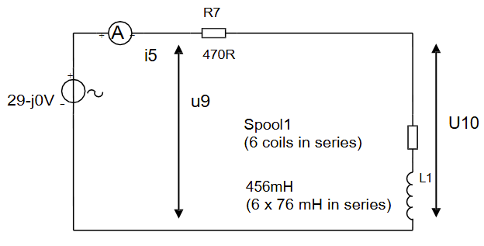
1. Calculation of Inductive Reactance and Impedance Z_L1 (Question 1b)
To determine the impedance of the coil, the inductive reactance (X_L) is calculated first.

Formulas:
X_L = 2 · π · f · L
Z = R + jX_L

Calculation:
Given:
f = 50 Hz, L1 = 0.390 H (6 x 65 mH).
X_L1 = 2 · 3.14159 · 50 · 0.390
X_L1 = 122.52 Ω

Since the coil L1 is treated as an ideal inductor (0 Ω resistance) for this calculation:

Answer (Cartesian):
Z_L1 = 0 + j122.52 Ω

Answer (Polar):
Z_L1 = 122.52 ∠ 90° Ω

2. Calculation of Current i5 and Voltage u10
To calculate the total current, the total impedance of the series circuit (R7 + L1) is determined, followed by Ohm's law.

Formulas:
Z_total = R + jX_L
|Z| = √(R² + X_L²)
φ = arctan(X_L / R)
i = U_source / Z_total
u = i · Z_component

Calculation of Total Impedance:
Given: R7 = 470 Ω, X_L1 = 122.52 Ω.
Z_total (Cartesian) = 470 + j122.52 Ω

Converting Z_total to polar form for division:
|Z| = √(470² + 122.52²) = 485.71 Ω
φ = arctan(122.52 / 470) = 14.61°
Z_total (Polar) = 485.71 ∠ 14.61° Ω

Calculation of Current i5:
Given: U_source = 29 ∠ 0° V.
i5 = (29 ∠ 0°) / (485.71 ∠ 14.61°)
i5 = 0.0597 ∠ -14.61° A

Result i5 (Cartesian):
Real Part = 0.0597 · cos(-14.61°) = 0.0578 A
Imaginary Part = 0.0597 · sin(-14.61°) = -0.0151 A
i5 = 0.0578 - j0.0151 A

Calculation of Voltage u10 (Voltage across L1):
u10 = i5 · Z_L1
u10 = (0.0597 ∠ -14.61°) · (122.52 ∠ 90°)
u10 = 7.31 ∠ 75.39° V

Result u10 (Cartesian):
Real Part = 7.31 · cos(75.39°) = 1.84 V
Imag Part = 7.31 · sin(75.39°) = 7.07 V
u10 = 1.84 + j7.07 V
3. Verification of Meter Readings
The calculated values are compared to the measured values to check for accuracy.
Measured u10: 7.28 V
Calculated u10: 7.31 V
Difference: within margin

Measured i5: 0.64 A
Calculated i5: 0.0597 A
Difference: within margin

Conclusion: The calculated values match the measured values within the expected 1-2% tolerance.

4. Calculation of Phase Difference
The phase difference is the angle between the source voltage vector and the current vector.

Formula:
Phase Difference = Angle(u) - Angle(i)

Calculation:
Angle(U9) = 0° (Reference)
Angle(i5) = -14.61°
Difference = 0° - (-14.61°) = 14.61°

Result:
The voltage U9 leads the current i5 by 14.61°.

TEST 2: SERIES-PARALLEL CIRCUIT CALCULATIONS (CIRCUIT 2)

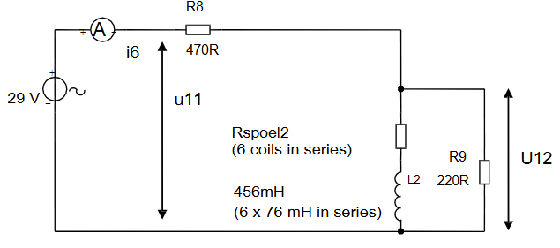
1. Calculation of Parallel Impedance (Question 2a/Preparation)
The circuit consists of a resistor R8 in series with a parallel combination of R9 and L2. First, the equivalent impedance of the parallel part (Z_p) is calculated.

Formula:
Z_p = (Z1 · Z2) / (Z1 + Z2)

Calculation:
Given: R9 = 220 Ω, Z_L2 = j122.52 Ω.
Numerator = 220 · j122.52 = j26954.4
Denominator = 220 + j122.52

Converting denominator to polar:
|Denominator| = √(220² + 122.52²) = 251.82 Ω
Angle = arctan(122.52 / 220) = 29.11°
Denominator = 251.82 ∠ 29.11° Ω

Division:
Z_p = (26954.4 ∠ 90°) / (251.82 ∠ 29.11°)
Z_p = 107.04 ∠ 60.89° Ω

Z_p (Cartesian):
Real = 107.04 · cos(60.89°) = 52.06 Ω
Imag = 107.04 · sin(60.89°) = 93.52 Ω
Z_p = 52.06 + j93.52 Ω

2. Calculation of Total Current i6 (Question 2c)
The series resistor R8 is added to the parallel impedance to find the total impedance, followed by the total current.

Calculation:
Z_total = R8 + Z_p
Z_total = 470 + 52.06 + j93.52
Z_total = 522.06 + j93.52 Ω

Converting Z_total to polar:
|Z_total| = √(522.06² + 93.52²) = 530.37 Ω
Angle = arctan(93.52 / 522.06) = 10.15°

Current i6:
i6 = U_source / Z_total
i6 = (29 ∠ 0°) / (530.37 ∠ 10.15°)

Result i6 (Polar):
i6 = 0.0547 ∠ -10.15° A

3. Calculation of Voltage u12 (Question 2c)
The voltage u12 is the voltage across the parallel branch Z_p.

Formula:
u12 = i6 · Z_p

Calculation:
u12 = (0.0547 ∠ -10.15°) · (107.04 ∠ 60.89°)
Magnitude = 0.0547 · 107.04 = 5.86 V
Angle = -10.15° + 60.89° = 50.74°

Result u12 (Polar):
u12 = 5.86 ∠ 50.74° V

4. Verification of Meter Readings (Question 2d)
The measurement results are compared with the expected values.

Measured u12: 6.12V
Calculated u12: 5.86 V
Difference: within margin

Measured i6: 0.0570 A
Calculated i6: 0.0547 A
Difference: within margin

Conclusion: The measured values are consistent with the complex calculations within the required accuracy.

