

**Basic Linux Commands Assignments**

Assignment-1

Connect and disconnect with login Access

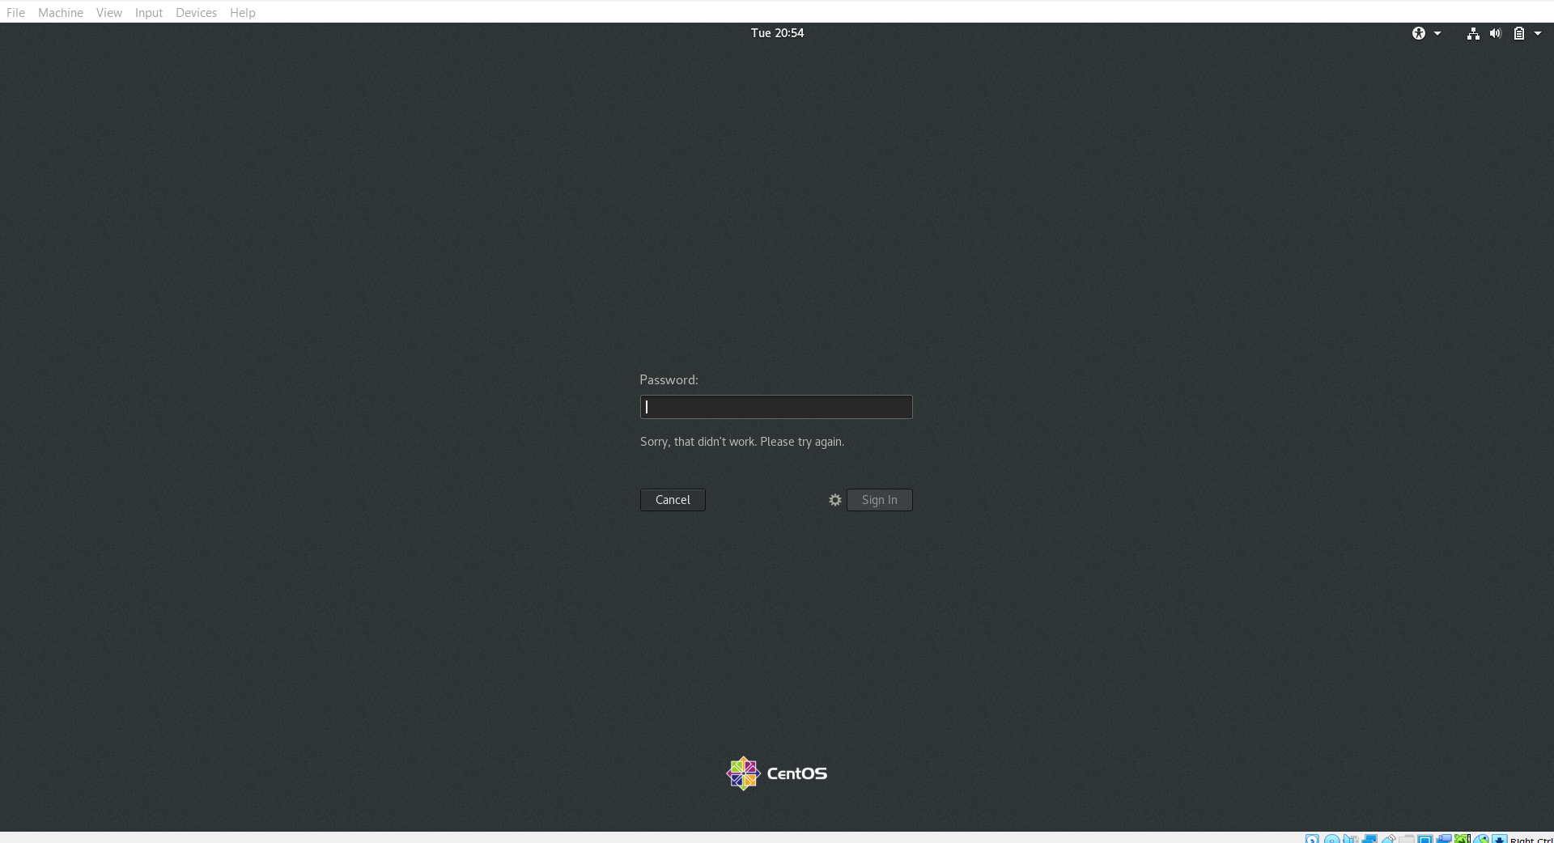

* What happens when you login a non-existent users or username?
  + Provide Screenshot and What you understand, explain in short brief?  
    ***Because the user does not exist. (*cat /etc/passwd| grep “/bin/bash*”* |cut -d “:” -f1,7*)***

Assignment-2

Password changing

Login into your account and then change password?

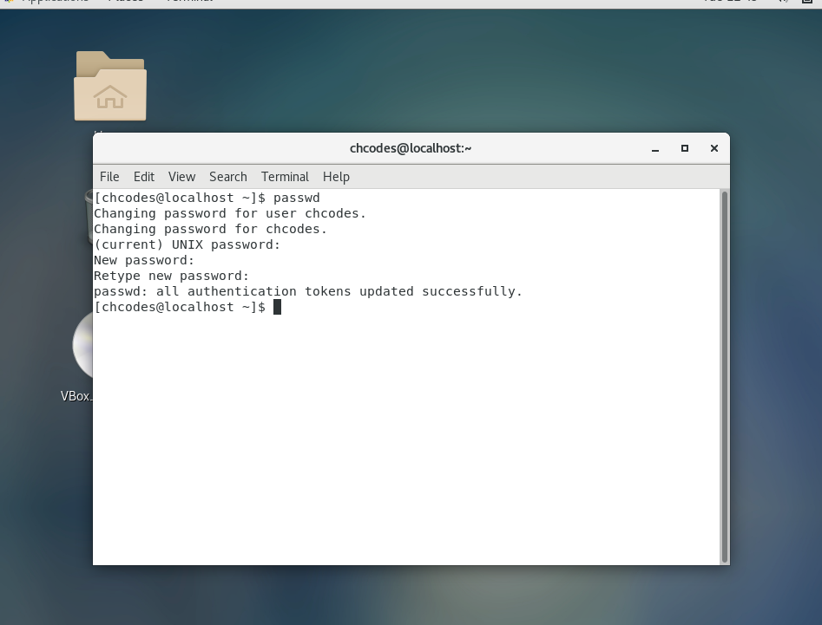

* + Change your password into **IneuR0n#42** and hit the **Enter** key

Explain what happen and give screenshot?

* + Try again to change password but use like password ***1234*** or ***abcd***
    - Explain what happen and give screenshot?
  + Got response as BAD PASSWORD: The Password is shorter than 8 characters
  + Try again to change password but now don’t use any password just hit **Enter** key
    - Explain what happen and give screenshot?
  + Got response as BAD PASSWORD: No password supplied and exhausted maximum retries

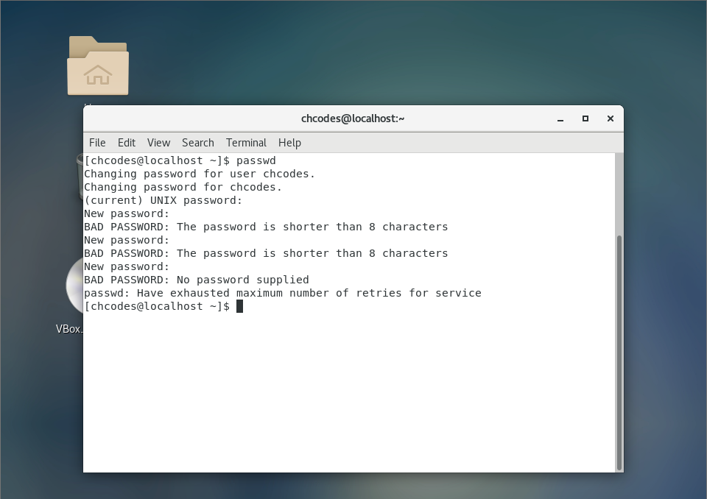  
  
  
Assignment-3

Working with Directories

* Enter the command **cd /** and then **ls** and then hit **Enter** key
  + Take screenshot and explain what output we got?  
    move from current directory to root directory of the user(may be normal user or root user) and list all the files and directories under root directory
* Enter the command now **cd /home** and then hit **Enter** key
  + Do **ls,** provide screenshot and explain what is **/home** directory used for?  
    change directory to home directory of the user
* Enter **cd ..** and hit **Enter** key [ *Note: here we have space after cd then use double dot*]
  + Check what happen and give screenshot? Used to move one level outer or one folder back

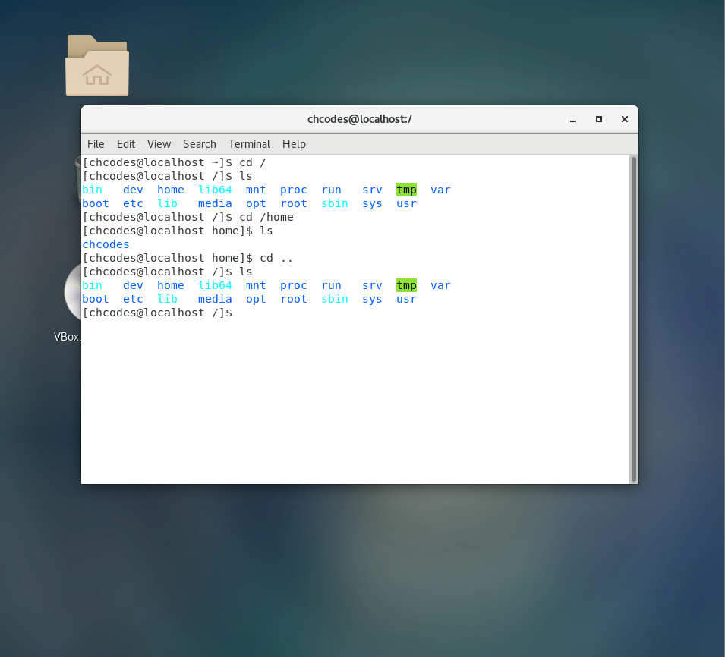

* Now enter **cd /var/www/html** and then type **cd** and hit **Enter** key
  + Explain what happen and give screenshot?  
    No such directory exist “html”
* Now type **cd /root** and then hit **Enter** key
  + Do **ls,** check any output we have on screen if yes then take screenshot?  
    permission denied-only root user can access that root directory

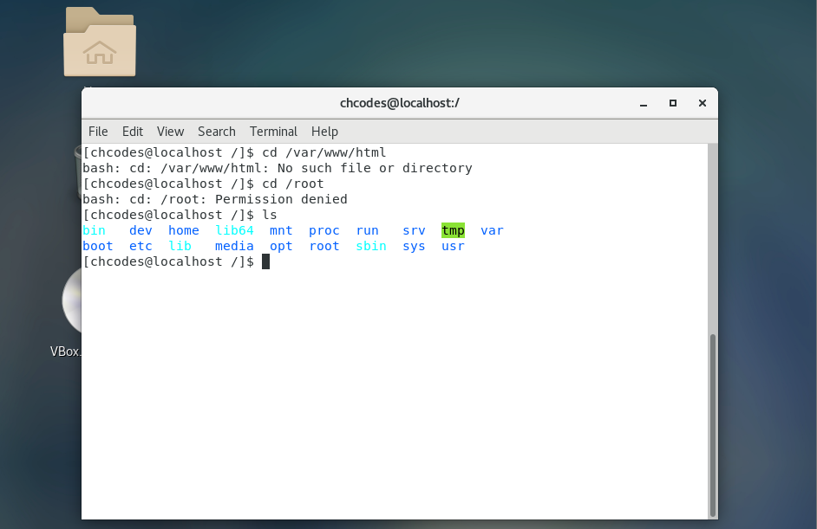

Assignment-4

Working with File Listing

* Go to **cd /etc** and type **ls**
  + Take screenshot and explain what files you have seeing?

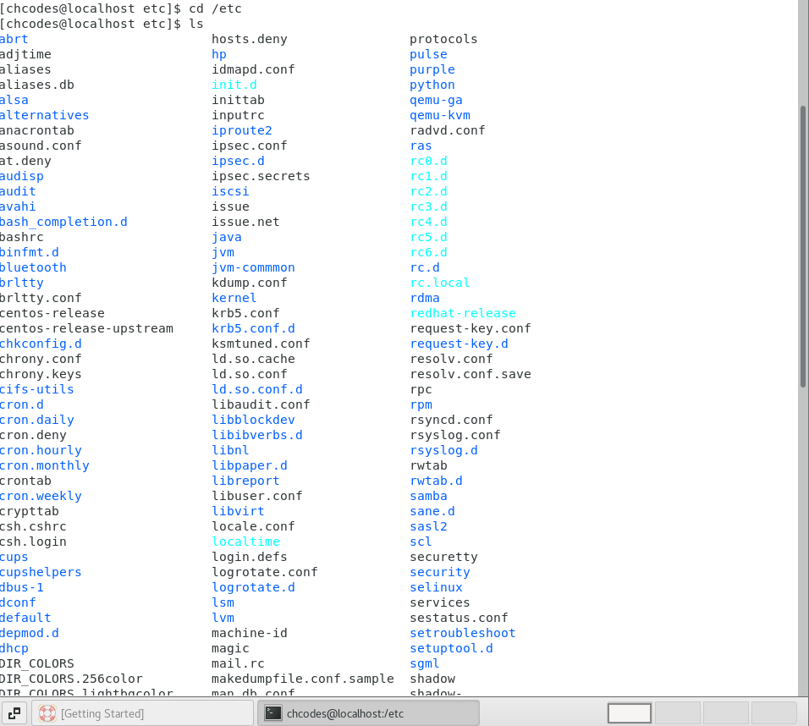

* + Take screenshot and explain what different output you found compare to previous command you used? Used to show all the files (-), directories (d) and links (l) under the etc directory
* Then type **ls -al** and hit **Enter** key
  + Take screenshot and explain what new file or directory you found? shows all files, directories and links in a long list manner including hidden files and directories whose name starting with (‘.’ - period)

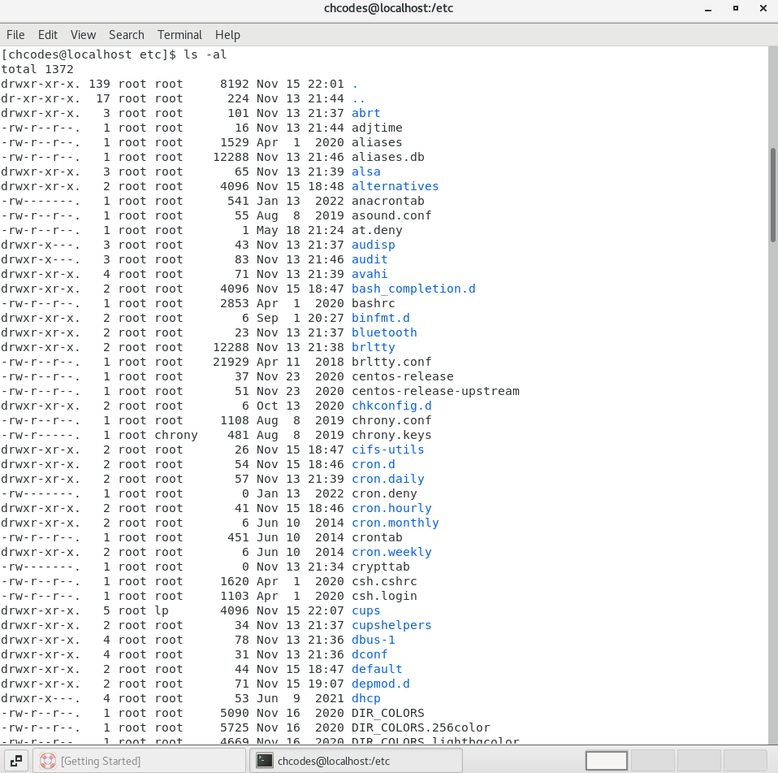

* Then use **ls -i** and hit **Enter** key
  + Now see what different output its shows and take screenshot?  
    displays files and directories with inode (index number)

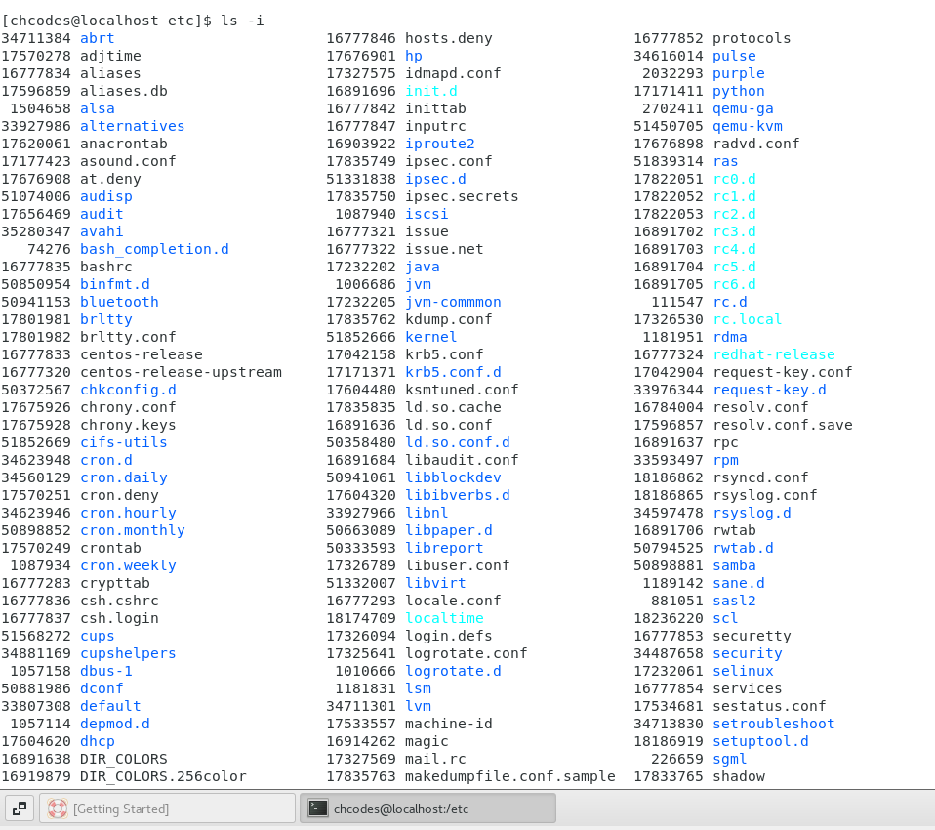

* Then use **ls –help** and see other options about **ls** command
  + Explore it and try with other attribute we can use with **ls** command  
    shows all the different ls commands with different attributes.

Assignment-5

Know where you are and where you working

*Here we use* ***pwd, cd and ls*** *as combine task to understand where you working on terminal and how you can switch from one directory to another one.*

* Open terminal after restart the linux
  + Check which location you working, type **pwd** and take screenshot
* Now use **cd /var** and hit **Enter** key
  + Do **ls,** and see what output comes, give screenshot?
* Do explore other help options of each command to learn more other things we can do with these commands

