(Quantitative & Order Flow)
1. Order Book Imbalance (The "Pressure" Metric)
This is the most profitable "Scraper" metric. You aren't just scraping the price; you are scraping the Bid/Ask Spread and the Volume sitting at each price level.
- Logic: If the total volume of Limit Buy orders ($V_{bid}$) is 2x or 3x higher than Limit Sell orders ($V_{ask}$), price is likely to tick upward within the next 30-60 seconds.
- The Calculation:
$$\text{Imbalance} = \frac{V_{bid} - V_{ask}}{V_{bid} + V_{ask}}$$
  - An Imbalance $> 0.6$ suggests a high-probability scalp long.
2. VWAP (Volume Weighted Average Price) Deviations
On the 1-minute chart, the VWAP is the "Fair Value" line. Institutional algos use this as their benchmark.
- The Scraper's Edge: Don't just trade when price touches VWAP. Calculate the Standard Deviation Bands (similar to Bollinger Bands, but volume-weighted).
- Profitability: Selling at the +2.0 Standard Deviation band and taking profit at the Mean (VWAP) is one of the most consistent mean-reversion strategies for M1/M5.

Refining the Strategic Recommendation
Three-Step Validation Loop.
Step 1: The Macro Filter (5-Minute Window)
Before the bot looks for a trade, it must check the "River Direction."
- Requirement: Price must be above the 5m VWAP for Longs, or below for Shorts.
- Volatility Check: Scrape the ATR (Average True Range). if ATR is too low (flat market) or too high (news spike), the bot should "Sleep" to avoid spread-hunting.
Step 2: The Micro Entry (1-Minute Window)
Once the direction is set, look for the entry "Trigger."
- Scrape Target: Look for a Liquidity Sweep. This happens when price briefly dips below a recent 1-minute low to hit "Stop Losses" and then immediately bounces back.
- Confirmation: The bounce must be accompanied by an Order Book Imbalance (see above) in the opposite direction.
Step 3: The "Exit" Logic (The Hardest Part)
In 1-minute trading, you cannot use wide Stop Losses.
- Dynamic Stop: Set your Stop Loss at the recent 1-minute swing high/low.
- Time-Based Exit: If the trade hasn't hit its target within 3 to 5 minutes, close it manually. On the M1 timeframe, if the "pop" doesn't happen immediately, the thesis is likely dead.

Product requirement documentation
This Product Requirements Document (PRD) focuses on a high-frequency Order Flow & Quantitative Scraper (The "Engine") designed for M1/M5 forex scalping.

PRD: High-Frequency Order Flow Scraper
1. Executive Summary
Product Goal: To identify micro-inefficiencies in the Forex market by scraping data and executing mean-reversion and momentum trades on the 1-minute and 5-minute timeframes.
Target Edge: Exploiting Order Book Imbalance and VWAP Deviations before they are reflected in standard retail "lagging" indicators.

2. Functional Requirements
A. Data Scraper Engine (The Core)
- WebSocket Integration: Must connect to a Tier-1 Liquidity Provider (e.g., LMAX, Saxo, or Interactive Brokers) via WebSockets to minimize latency.
- Level 2 Depth: Scrape the top 10 levels of the Bid/Ask Book every 100ms.
- Volume Aggregator: Calculate the Cumulative Volume Delta (CVD) to see if market buy orders are aggressively hitting the "Ask."
B. Analysis & Signal Logic (Strategic Recommendation Focus)
The bot must validate trades using a "Triple-Filter" system:
- Macro Filter (5m): The bot only buys if the current price is above the Volume Weighted Average Price (VWAP).
- Volatility Guard: Scrape the ATR (Average True Range). If ATR is $< 1.5$ pips on M1, the bot stays flat (to avoid "choppy" sideways markets).
- The Trigger (1m):
  - Imbalance Ratio: Trigger a "Long" if $\text{Bid Volume} > 2.5 \times \text{Ask Volume}$ at the current price level.
  - Mean Reversion: Trigger a "Short" if the price hits the $+2.0$ Standard Deviation band of the VWAP and the Order Book shows a sudden "Sell Wall."
C. Execution Module
- Order Type: Must use Limit Orders for entry to avoid "Slippage" (paying the spread).
- Smart Exit: * Hard Stop: $1.5 \times$ ATR.
  - Time-Decay Exit: If the trade isn't profitable within 180 seconds (3 minutes), exit at market price. High-frequency edges decay rapidly.

3. Technical Specifications
Feature | Specification
Language | Python (using asyncio for concurrency) or Rust (for ultra-low latency).
Data Feed | WebSocket (JSON) for real-time; REST API for historical backtesting.
Database | TimescaleDB (PostgreSQL optimized for time-series) to log every tick.
Latency Target | < 200ms from Signal Generation to Order Execution.

4. Profitability & Risk Categorization
Analysis Method | Category | Logic for Bot
Order Book Imbalance | Highest | Direct view of "Intent." High win rate, low risk.
VWAP Mean Reversion | High | Based on institutional "Fair Value." Good for 5m trends.
News Sentiment Scraping | Medium | Scrapes Reuters/X (Twitter). High profit, but high risk of "Slippage."
RSI/Stochastic | Low | Too much noise on M1. Only used as a secondary confirmation.

5. Success Metrics (KPIs)
- Profit Factor: $> 1.4$ (Total Gross Profit / Total Gross Loss).
- Maximum Drawdown: $< 5\%$ of total account equity.
- Execution Slippage: Average slippage per trade $< 0.2$ pips.

1. Order Book Imbalance (The Entry Trigger)
This calculation identifies when one side of the market (Buyers or Sellers) is overwhelming the other at the micro-level.
Instead of looking at a single price, the bot scrapes the top $L$ levels of the Order Book (typically $L=10$).
$$I = \frac{\sum_{i=1}^{L} V_{bid,i} - \sum_{i=1}^{L} V_{ask,i}}{\sum_{i=1}^{L} V_{bid,i} + \sum_{i=1}^{L} V_{ask,i}}$$
- $V_{bid,i}$: Volume of buy orders at level $i$.
- $V_{ask,i}$: Volume of sell orders at level $i$.
- Logic: * If $I > 0.6$: Strong Buy pressure (Long signal).
  - If $I < -0.6$: Strong Sell pressure (Short signal).

2. Volume Weighted Average Price (VWAP)
Standard Moving Averages (SMA) are "blind" to volume. On M1/M5, VWAP tells you the "True Fair Value" where the most money has changed hands.
$$\text{VWAP} = \frac{\sum (Price_i \times Volume_i)}{\sum Volume_i}$$
Statistical Deviation (Mean Reversion)
To know if the price is "overextended" and due for a snap-back to the mean, calculate the Standard Deviation ($\sigma$) of the VWAP:
$$\sigma = \sqrt{\frac{\sum (Price_i - \text{VWAP})^2}{n}}$$
- Trade Rule: If $Price > \text{VWAP} + 2\sigma$, the pair is statistically overbought. The bot prepares a Short entry as soon as the Order Book Imbalance ($I$) turns negative.

3. Position Sizing & Risk Management
In scalping, your "Edge" is thin, so your math on risk must be precise to avoid "Ruination."
The Kelly Criterion (Optimal Bet Size)
This determines what percentage ($K\%$) of your capital to risk based on your historical win rate ($W$) and your Reward-to-Risk ratio ($R$).
$$K\% = W - \frac{1 - W}{R}$$
Example: If your bot wins 60% of the time ($W=0.60$) with a 1.5:1 reward ratio ($R=1.5$):
$$K\% = 0.60 - \frac{1 - 0.60}{1.5} = 0.333 \text{ or } 33\%$$
Note: For Forex, it is standard to use "Fractional Kelly" (e.g., 1/10th of $K\%$) to account for market black-swan events.
Expected Value (EV)
The bot should only take trades where $EV > 0$.
$$EV = (P_{win} \times \text{Profit}) - (P_{loss} \times \text{Loss})$$

4. Latency & Slippage Decay
Because you are scraping, you must factor in the "Cost of Time." Every millisecond of delay ($t$) decays your expected profit ($P$).
$$P_{actual} = P_{signal} - (Spread + \text{Slippage}_t)$$
- Scraper Logic: If $(Spread + \text{Slippage}_t) > 0.3 \times \text{Target Profit}$, the bot must abort the trade automatically. The math simply doesn't support the risk.

Summary Table for Bot Logic
Component | Formula | Application
Micro-Trend | Cumulative Volume Delta (CVD) | $\sum (\text{Market Buys} - \text{Market Sells})$
Volatility | ATR (Average True Range) | Setting dynamic Stops (e.g., $1.5 \times \text{ATR}$)
Efficiency | Sharpe Ratio | $\frac{R_p - R_f}{\sigma_p}$ (Used to grade bot performance)

Using a Python-to-MT5 bridge (via the official MetaTrader5 library) is the most effective way to combine Python’s quantitative power with MT5’s execution engine. However, at M1/M5 timeframes, the "bridge" itself introduces a latency of roughly 200ms–600ms, which you must account for in your math.
Here is the architectural and mathematical design for your Python-MT5 scraper.

1. System Architecture: The "Loop"
Your Python script acts as the "Brain," and the MT5 Terminal acts as the "Hands."
- Data Ingestion: Python calls mt5.copy_ticks_from() every 100ms.
- Vectorized Analysis: Use pandas and numpy to calculate the Order Book Imbalance or Tick Velocity across the last 1,000 ticks.
- Signal Generation: If math conditions are met, Python sends a JSON request to MT5.
- Execution: MT5 executes the mt5.order_send() and returns a retcode.

2. Mathematical Logic for the Bridge

A. The "Speed of Tape" (Tick Velocity)
Since many MT5 brokers don't provide a full Limit Order Book (L2), you must use Tick Velocity as a proxy for institutional interest.
$$\text{Tick Velocity} (V_t) = \frac{\Delta \text{Ticks}}{\Delta \text{Time}}$$
- Logic: If $V_t > \mu + 3\sigma$ (where $\mu$ is the 5-minute rolling average velocity), the scraper detects a "High Activity Pulse." This is your cue to check for a breakout.

B. Latency-Adjusted Expected Value (EV)
You must penalize your profit targets based on the "Bridge Delay." If your execution takes 500ms, the price may have moved by the time your order reaches the broker.
$$EV = (P_{win} \times \text{Net Profit}) - (P_{loss} \times \text{Net Loss}) - \text{Slippage}_{\text{delay}}$$
- Slippage Factor: Calculate the average price change over your bridge's latency period. If your latency is 500ms and the average M1 move per 500ms is 0.2 pips, you must subtract 0.4 pips (entry + exit) from your total expected profit.

3. Python Execution Code (Snippet)
This is the core logic your bridge will use to communicate with MT5.
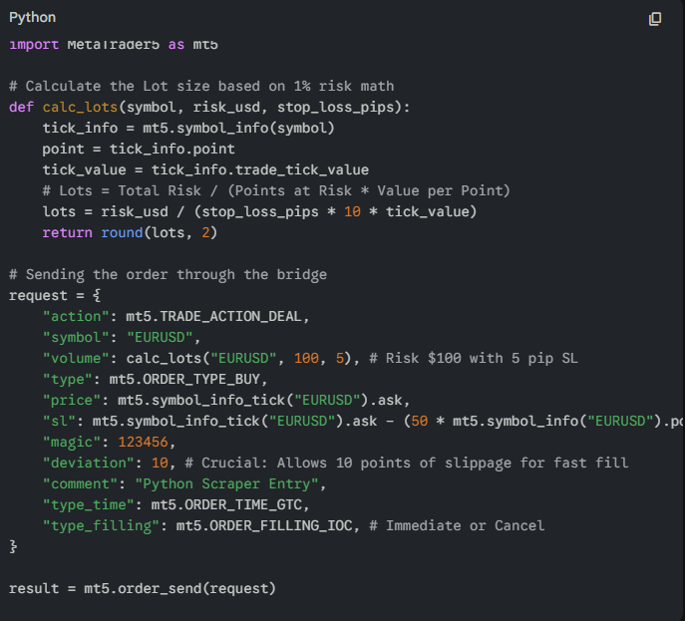

4. MT5 Specific PRD Additions
- Fill Policy: Set type_filling to ORDER_FILLING_IOC (Immediate or Cancel). In M1 scalping, if you aren't filled instantly at your price, the opportunity is gone; you don't want a "resting" order that gets filled later at a bad price.
- Asynchronous Requests: Use mt5.order_send inside a Python threading or asyncio loop. This prevents the scraper from "freezing" while waiting for the broker to confirm the trade.
- Server Colocation: Since you are using a bridge, host both your Python script and the MT5 Terminal on a Windows VPS located in the same data center as your broker (usually London Equinix LD4 or New York NY4). This can reduce your bridge-to-broker latency from 100ms to <2ms.

5. Risk Categorization for MT5
Method | MT5 Implementation | Profitability
CVD (Cumulative Volume Delta) | Calculated via mt5.copy_ticks_from | Very High
Z-Score Mean Reversion | Calculated via numpy on M5 bars | High
Grid Scraping | Sending multiple ORDER_TYPE_BUY_LIMIT | Medium (High Drawdown risk)
Export to Sheets
Would you like me to create the mathematical logic for a "Trailing Stop" that adjusts every 500ms through the MT5 bridge?
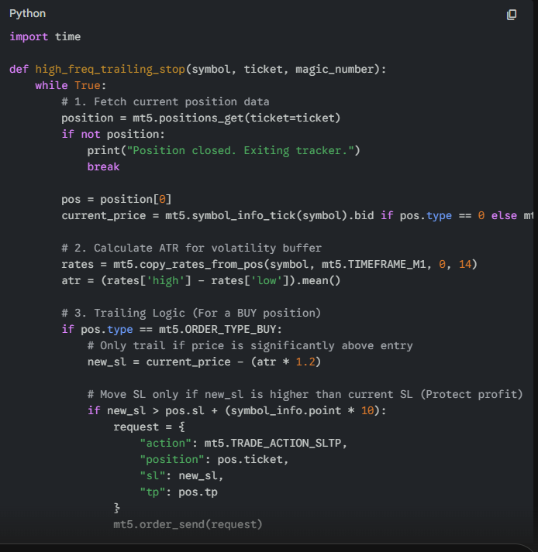

The "Breakeven" Trigger Math
For M1 scalping, the most critical math is the Breakeven Jump. This is where the bot moves the Stop Loss to $Entry + Commission + 1 Tick$ as soon as the trade covers its own costs.
$$\text{Breakeven Point} = \text{Entry Price} + \left( \frac{\text{Commission}}{\text{Lot Size} \times \text{Tick Value}} \right) + \text{Spread}$$

4. Final Strategic Recommendation: The "Ghost" Stop Loss
Since you are using a Python bridge, you can implement Virtual (Ghost) Stops.
- The Logic: Do not send the Stop Loss to the MT5 server. Keep it in Python’s memory.
- The Math: If $Price_{current} \leq SL_{memory}$, Python sends an ORDER_TYPE_MARKET_CLOSE.
- Why? This prevents "Stop Hunting" by B-Book brokers who can see your orders on the book. It also allows you to exit based on momentum slowing down rather than just a price hit.

