### CASdesigner manual

[leodespaux@gmail.com](mailto:leodespaux@gmail.com)

[CASdesigner](https://app.mybinder.org:80/1886226665/notebooks/CASdesigner_beta.ipynb) is a web tool to help you design donor DNA cassettes for genomic integration. These integrations can be used to delete or replace existing genes, or to introduce genes into well-characterized empty loci. We have expression level data for 24 loci, and 37 promoters to help you design your expression cassette. We also have protein tags you can add to your CDS, to alter the protein’s subcellular localization, stability, or solubility.

You tell the program what you want to do, and it provides you primers to construct your donor DNA cassette. The marker-less cassette will contain your genetic edit flanked by 1kb homology regions. In the case of a deletion, the donor DNA is just these homology regions fused so as to delete the CDS. A “standard cassette” consists of a 600nt promoter, your CDS, and a 250nt terminator. The promoter and terminator sequences are always the same size and can be PCRd from genomic DNA.

You will also need a plasmid containing Cas9 and encoding a guide RNA (gRNA) targeting your chromosomal region. If you’re using our well-characterized empty loci, you can borrow our plasmids. Otherwise if you’re targeting a specific gene, you will need to pick a gRNA sequence and clone it, or gap-repair it with the backbone, along with your donor DNA. I use this [DNA2.0 tool](https://www.dna20.com/eCommerce/cas9/input) to pick 20nt gRNAs, and they almost always work. Just check that the sequence is found in your cassette followed by “NGG”, and that you copy the correct 20nt (not the complement or reverse complement).

*S. cerevisiae* is great at homologous recombination, so you can add your donor DNA as separate fragments that recombine in vivo. You can also add your cut plasmid backbone and new gRNA as linear DNAs homology to each other.

Generally, the fewer the total HR events required (chromosome-donor, donor-donor, bb-gRNA), and the greater the homology between fragments, the higher the likelihood of success. Usually, for a 3-piece donor DNA and a pre-cloned plasmid, I get 100s of colonies 50-80% of them containing the correct chromosomal edit. Sometimes, less.

Good luck!

Leo, Amanda, & Maren

**Links:**

Step-by-step guide

Loci Data

Promoter Data

Feedback, Tips, Tricks, etc.

## Step-by-step guide

1. There are two things needed: a [cut plasmid](https://drive.google.com/file/d/0B07-But7wUA7Yk1KcXlKOVVtc2M/view?usp=sharing) targeting your chosen genomic locus, and a donor DNA cassette (flanked at the 5’ and 3’ side with sequences homologous to those that flank your cut site).
   * We have a collection of pre-built plasmids that target the empty loci the program describes (using a URA marker for the plasmid).
   * We also have a backbone with a LEU marker, tho you will have to clone (or gap-repair) your chosen guide (cut) sequence.
2. Use [CASdesigner](https://app.mybinder.org:80/1886226665/notebooks/CASdesigner_beta.ipynb) to help design donor DNA cassettes and if needed, a plasmid targeting a new locus
   * This [Dueber lab paper](http://pubs.acs.org/doi/abs/10.1021/sb500366v) has information on some promoters and terminators.
3. PCR DNA fragments that make up your integration cassette (donor DNA)
   * If you’ve chosen a standard cassette, your donor DNA will have
     1. up homology regions (1kb)
     2. promoter (600bp)
     3. your CDS
     4. terminator (250nt)
     5. down homology region (1kb)
   * For promoters/terminators/homology regions (up and down) use genomic DNA as template.
   * The primers have Tms ~57C. I typically get good results by using touchdown starting at 65C and going down to 50C, lowering Tm by 1C/cycle then keeping it fixed at the lower temp. Or whatever works for you. For more details, see my [Standard Protocols](https://docs.google.com/document/d/17zNhSG1f-K_LW_py78egyDzoXaTw_qbfQ1QI4bCooPk/edit?usp=sharing).
4. Primer nomenclature:
   * F means fwd primer, R rev. Then the name of the DNA it amplifies, followed, sometimes, by the name of the DNA a primer adds homology to in (). For example, LTEF1ps(up1014a)+RTEF1ps(GENE1) amplifies a fragment containing the TEF1 promoter (s=standard, ie 600nt for promoter and 250nt for terminator). The resulting DNA fragment has 5’ homology to up1014a (a sequence homologous to the 1kb a little up from the 1014a cut site). The resulting DNA fragment also has 3’ homology to GENE1. The homology Tm and length varies.
5. Assemble the PCR fragments into donor DNA piece(s)
   * The PCR fragments have terminal homology to each other and can assemble by homologous recombination inside the cell, or PCR-sewing
   * Having fewer fragments that need to HR leads to greater likelihood of successful assembly and integration (using five pieces sometimes works, four works pretty often, three almost all the time, etc.)
   * I usually stitch together the two terminal fragments (e.g. upHomology+promoter, and downHomology+terminator). These with your gene make three pieces. Sometimes homology-Promoter/Term pairs will already exist in a different strain, which you can use as template.
   * To stitch together fragments, I typically perform a short PCR reaction with PCR-purified fragments at equimolar concentration (e.g., size in bp/20=ng of frament to add), doing touchdown from ~72C to 57C (only 15 cycles), then use 1ul of this reaction in a 100ul reaction to which I add terminal primers.
6. Transform cut plasmid and donor DNA
   * I usually add 100ng plasmid and ~1ug donor DNA by electroporation for a ~2kb cassette
   * More specifically, for each fragment, (size in bp)/2=ng to add. So for a 1kb fragment, add 500ng
7. Colony PCR
   * Make sure you have single colonies. It’s a great idea to restreak/inoculate your colonies in selective media and let the population expand. If the plate is too crowded, you might pick up negative background cells alongside your real colony, and the former may take over your population as Cas9 expression is deleterious to growth.
   * Using a pre-cloned plasmid (you can also gap-repair your cut site via homologous recombination with the backbone) and 1-3 pieces as donor DNA, I usually get ~1000 colonies, ~70-100% of which are positive.

## Loci Data

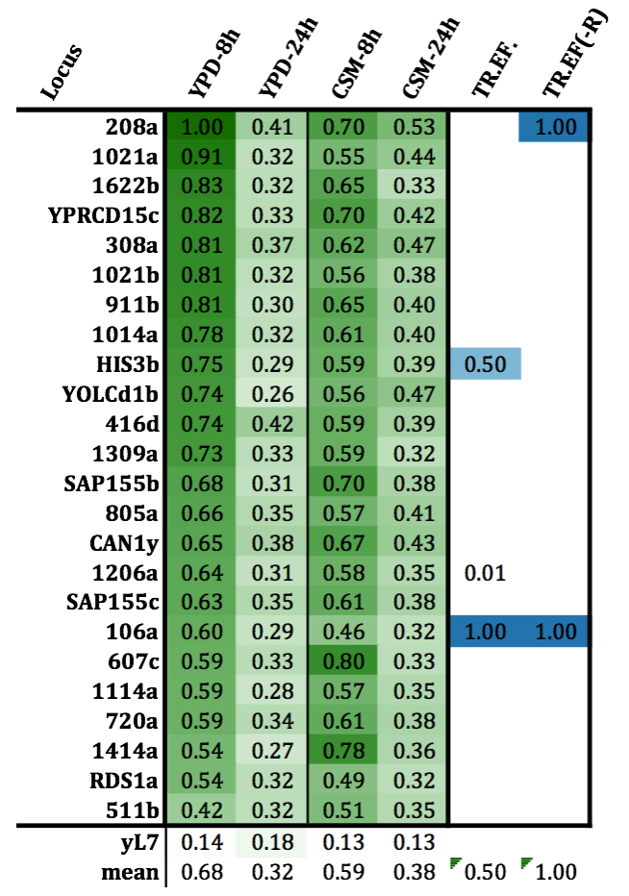

## Promoter Data

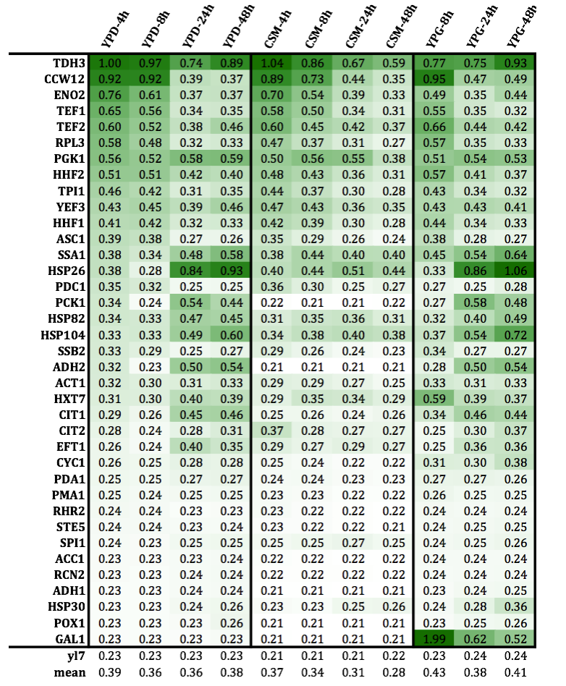

## Feedback, Tips, Tricks, etc.