Facebook Page Guide (Taglish) — Existing Page
Para sa: video tutorial (isa-isang step)
Assumption: may existing Facebook Page ka na
Note: Sample pictures lang ito (mockup). Pwede magiba ang exact labels sa Facebook UI, pero pareho ang landmarks (profile switcher, Edit Page info, Settings, Page access, Page setup).

Paano gamitin sa video
Segment | Ano i-record
Intro (10–15s) | “May existing Page tayo — ituturo ko kung saan makikita, maglalagay ng details, magdadagdag ng authority, at magpapalit ng name.”
Per step | Screen recording + picture sa guide bilang B-roll / thumbnail
Outro | Checklist + reminder: Full control lang ang pwedeng mag-change ng name at mag-add ng access

Quick map (buod)
- Hanapin at i-switch ang Page
- Buksan ang Edit Page info
- I-fill out ang details (About / contact / address)
- Mag-add ng authority (Page access)
- Palitan ang Page name (kung kailangan)
- Bonus: photo, username, CTA button, privacy

STEP 1 — Saan mo makikita ang Page mo?
Ano gagawin
- Mag-login sa Facebook gamit ang personal account mo (desktop recommended).
- I-click ang profile photo mo sa kanan itaas.
- I-click ang See all profiles.
- Piliin ang Page mo sa listahan.
- Kapag napili, mag-switch ang buong Facebook papunta sa Page profile (hindi na personal account ang “nagsasalita”).
Alternatibong daan
- Sa left menu / shortcuts, hanapin ang Pages, then open your Page.
- O i-type sa search bar ang exact Page name.
Ano i-show sa screen
Profile menu → See all profiles → click your Page.
Sample script (Taglish)
“Una, hanapin natin yung Page. Click lang yung profile photo sa taas, then See all profiles. Dito lalabas yung Page mo — click mo para mag-switch.”
Picture (reference)
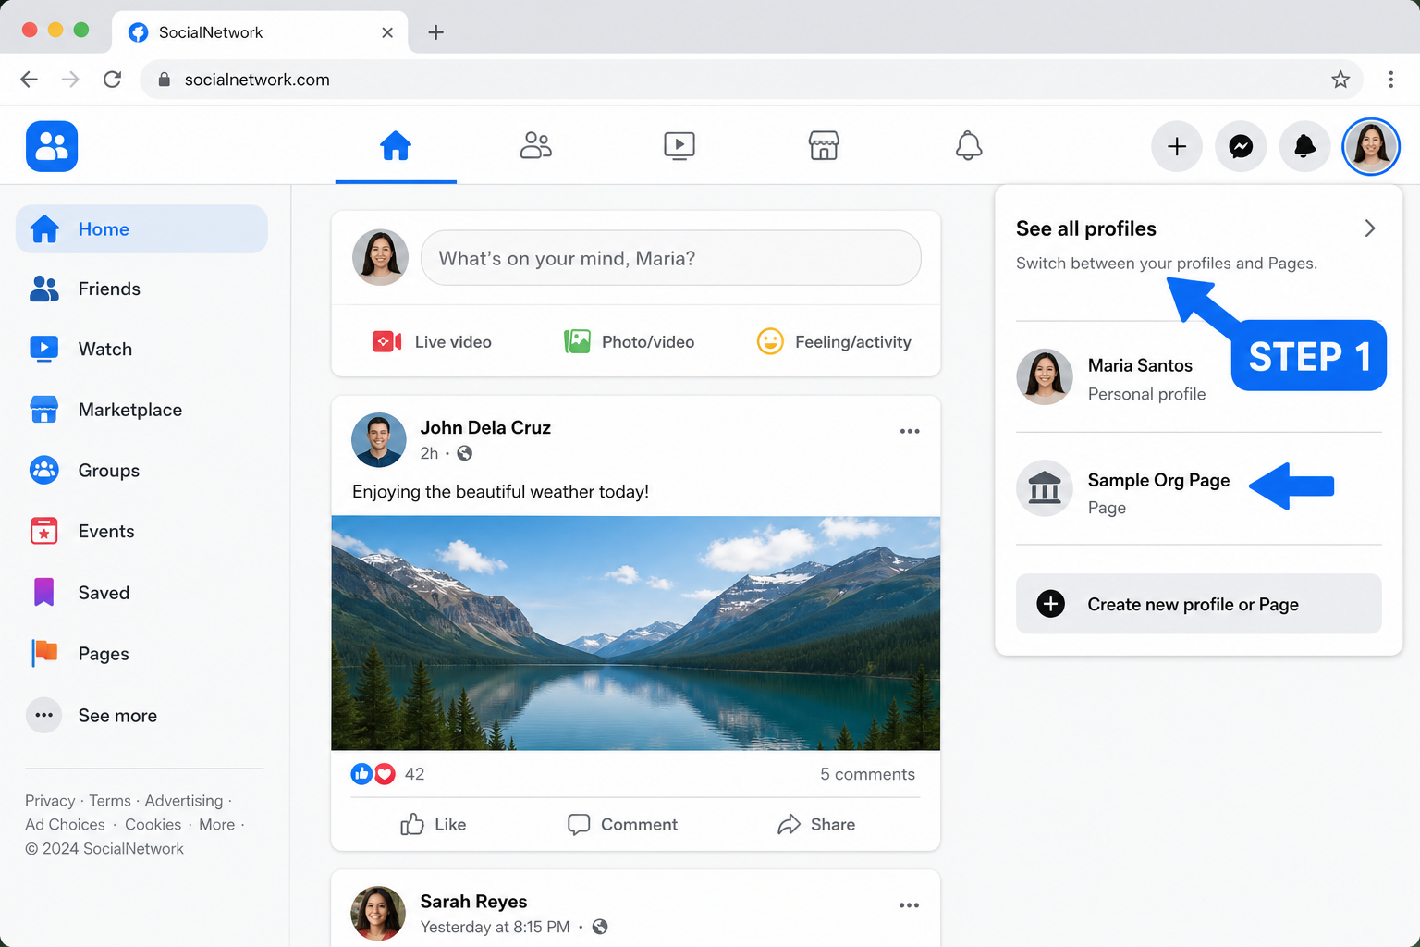
Video tip: Mag-pause ng 2 segundos habang naka-highlight ang Page name sa list.

STEP 2 — I-switch muna bago mag-edit
Bakit importante
Maraming settings hindi lalabas kung personal account ka pa. Kailangan naka-switch ka as the Page.
Paano malalaman na naka-switch ka na
- Profile photo sa kanan itaas = logo / avatar ng Page
- Name sa top = Page name, hindi personal name
- Kapag magpo-post, as the Page ka magpo-post
Ano i-show
Before/after: personal avatar → Page avatar.
Sample script
“Important: bago tayo mag-edit, siguraduhing naka-switch tayo as the Page. Kung personal account pa, hindi complete yung options.”
Picture (reference)
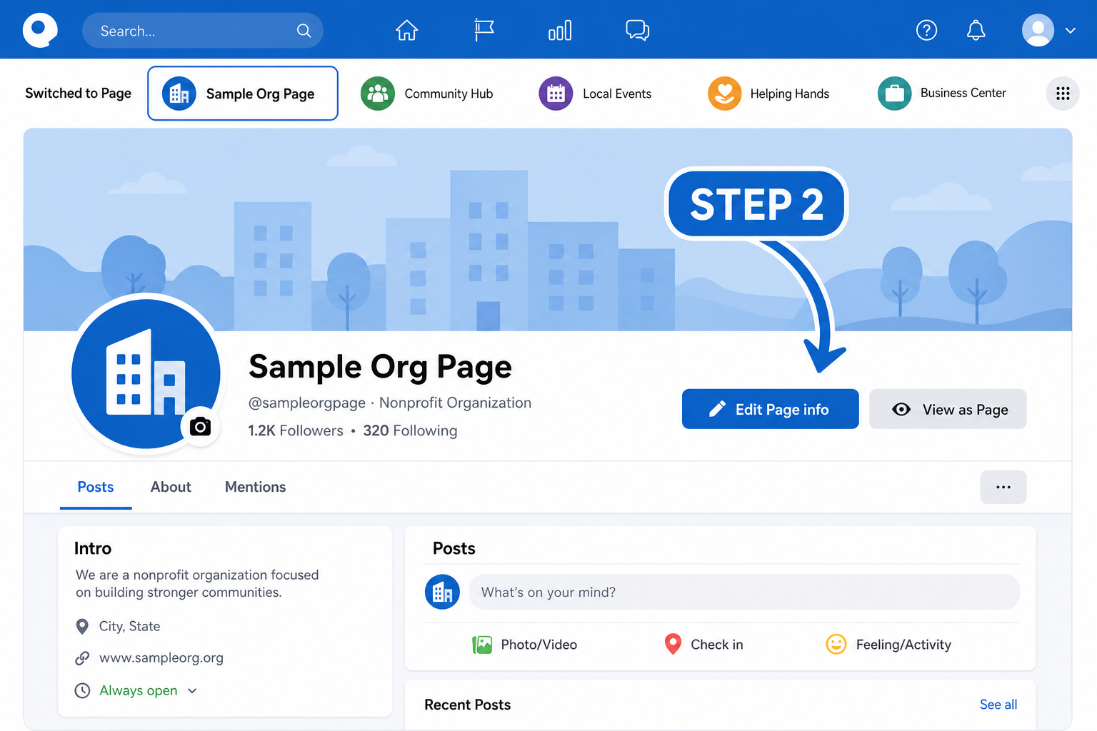

STEP 3 — Saan maglalagay ng details (Page info)?
Ano gagawin
- Habang naka-switch as Page, pumunta sa Page mo (Feed / profile ng Page).
- Hanapin ang button na Edit Page info (malapit sa cover photo), o
- Pumunta sa tab / section na About, then Edit.
- I-update ang details:
Field | Ano ilalagay (example)
Category | Organization / Education / Community, etc.
Phone | Landline o mobile ng office
Email | Official email (hindi personal kung possible)
Website | Official site o link
Address | Physical address kung may office
Hours | Open hours (kung applicable)
Description / Bio | Short intro kung ano ang Page
- I-save / Confirm.
Via Settings (alternate)
- Click Page photo (kanan itaas) → Settings & privacy → Settings
- Hanapin Page setup / Page info
- I-edit ang fields doon
Ano i-show
Edit Page info form — category, contact, address, hours.
Sample script
“Para sa details: click Edit Page info. Dito mo ilalagay yung category, phone, email, website, address, at short description. Completein niyo ito para madaling mahanap at magtiwala ang audience.”
Picture (reference)
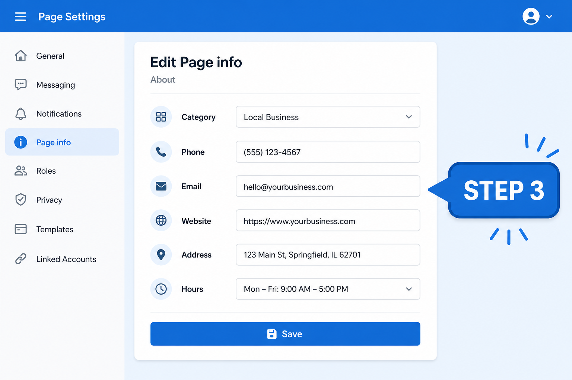
Video tip: Mag-scroll slow sa form. Fill out 1–2 sample fields live.

STEP 4 — Saan magdadagdag ng authority (Page access)?
Maikling explanation (bago mag-demo)
Sa New Pages Experience, hindi na “Admin / Editor / Moderator” ang labels. Ngayon:
Type | Meaning (simple)
Facebook access — Full control | Parang Admin. Pwedeng mag-manage ng settings, mag-add/remove ng tao, even delete the Page.
Facebook access — Partial control | Pwedeng mag-manage as Page, pero limited sa settings/access.
Task access | Para sa specific tasks (content, ads, insights) via Meta Business Suite — hindi sila fully “switch into” the Page tulad ng Facebook access.
Reminder: Ikaw dapat may Full control para makapag-add ng iba.
Ano gagawin
- Switch into your Page.
- Click Page photo (kanan itaas) → Settings & privacy → Settings.
- Sa left side, hanapin Page access (minsan under New Pages Experience).
- Under People with Facebook access, click Add New.
- Search by name o email ng Facebook account nila.
- Decide:
  - Full control ON = trusted co-admin only
  - Full control OFF = partial control
- Click Give Access → enter password → Confirm.
- Sabihin sa tao na i-accept ang invitation (Notifications).
Para sa Task access
Sa same Page access screen → People with task access → Add New → piliin kung ano ang pwedeng i-manage (content, messages, ads, insights, etc.).
Ano i-show
Settings → Page access → Add New → Full control toggle.
Sample script
“Para magdagdag ng authority: Settings → Page access. Dito may Facebook access at Task access. Kung gusto mong full admin-level, i-on ang Full control — pero ingat, kasi same power nila sayo. Pagkatapos, kailangan i-accept nila yung invite.”
Picture (reference)
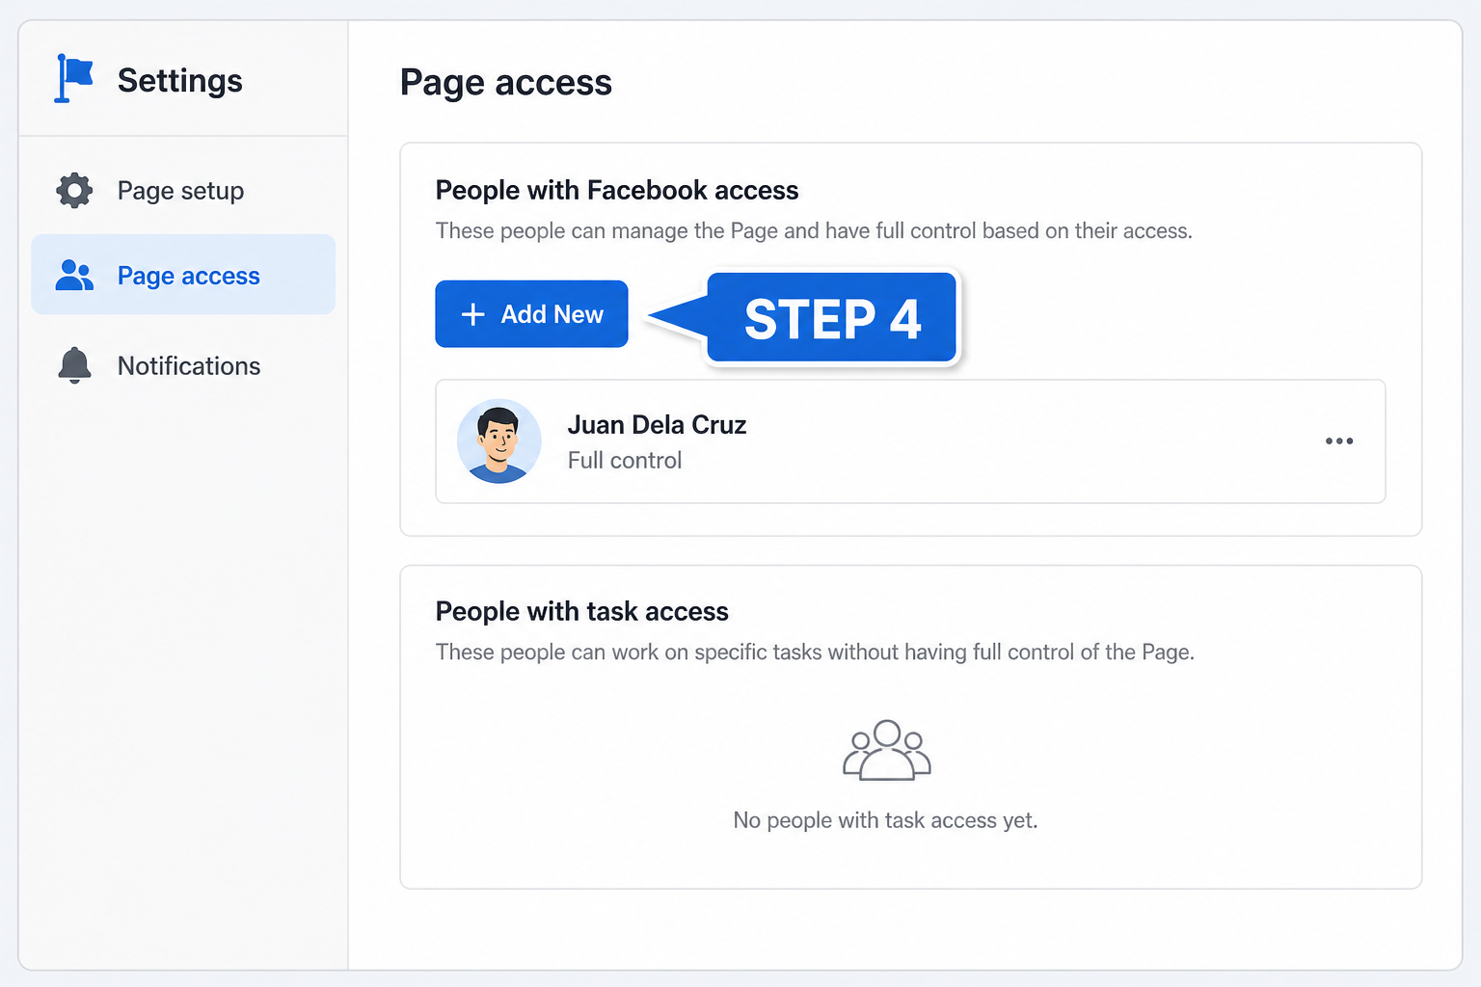
Safety tip (sabihin on cam): Huwag magbigay ng Full control sa random / bagong kakilala.

STEP 5 — Saan magpapalit ng Page name?
Ano gagawin
- Switch into your Page (Full control required).
- Page photo → Settings & privacy → Settings.
- Click Page setup.
- Click Name (or Edit beside Name).
- Under General Page Settings, Edit beside your Page name.
- Type new name → Review Change.
- Enter password → Request Change.
- Maghintay ng review (minsan hours, minsan hanggang ~3 days).
Important notes
- Name ≠ Username. Pag palit ng name, hindi automatic nagbabago ang @username / URL.
- Malaking rebrand = mas matagal ang review; minsan may documentation request.
- May cooldown minsan bago ka pwedeng magbago ulit — double-check spelling.
Ano i-show
Page setup → Name → Edit → Review Change.
Sample script
“Kung gusto mong palitan ang Page name: Settings → Page setup → Name → Edit. I-type ang bagong name, then Review Change. May review si Facebook, so hindi instant always. Tandaan: pag palit ng name, hindi automatic napapalitan ang username.”
Picture (reference)
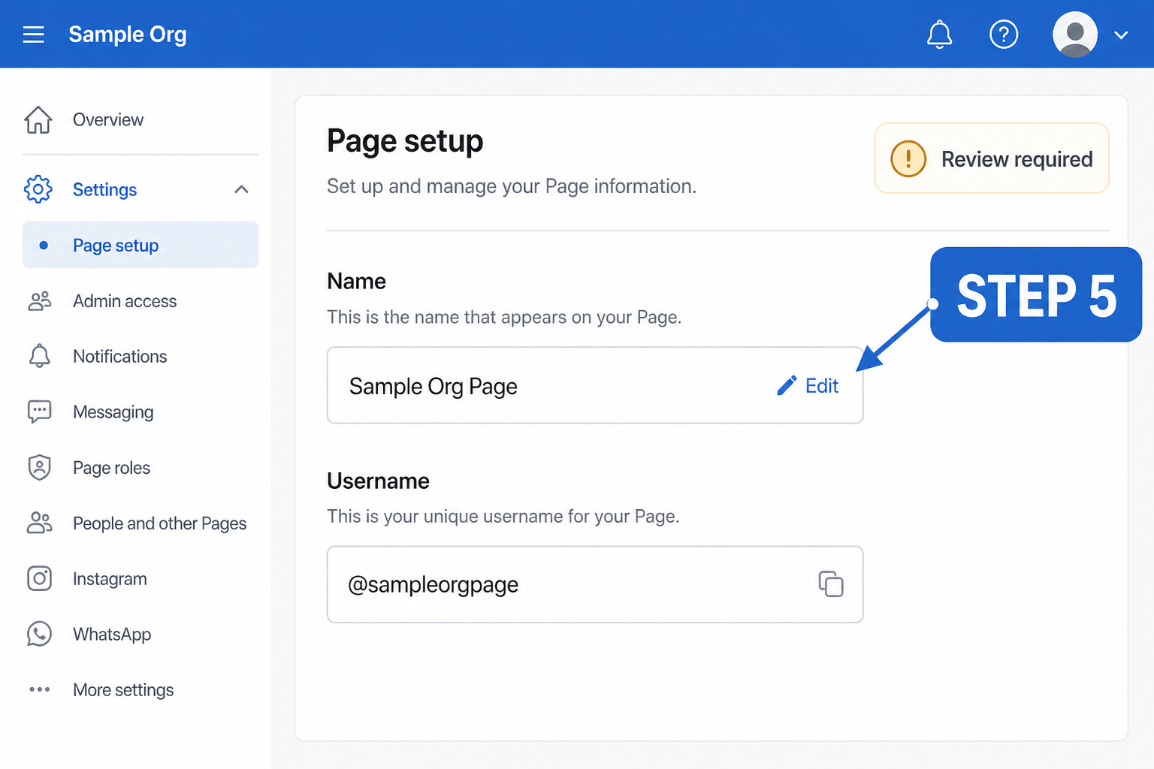

STEP 6 — Bonus extras (dagdag value sa video)
Picture (overview)
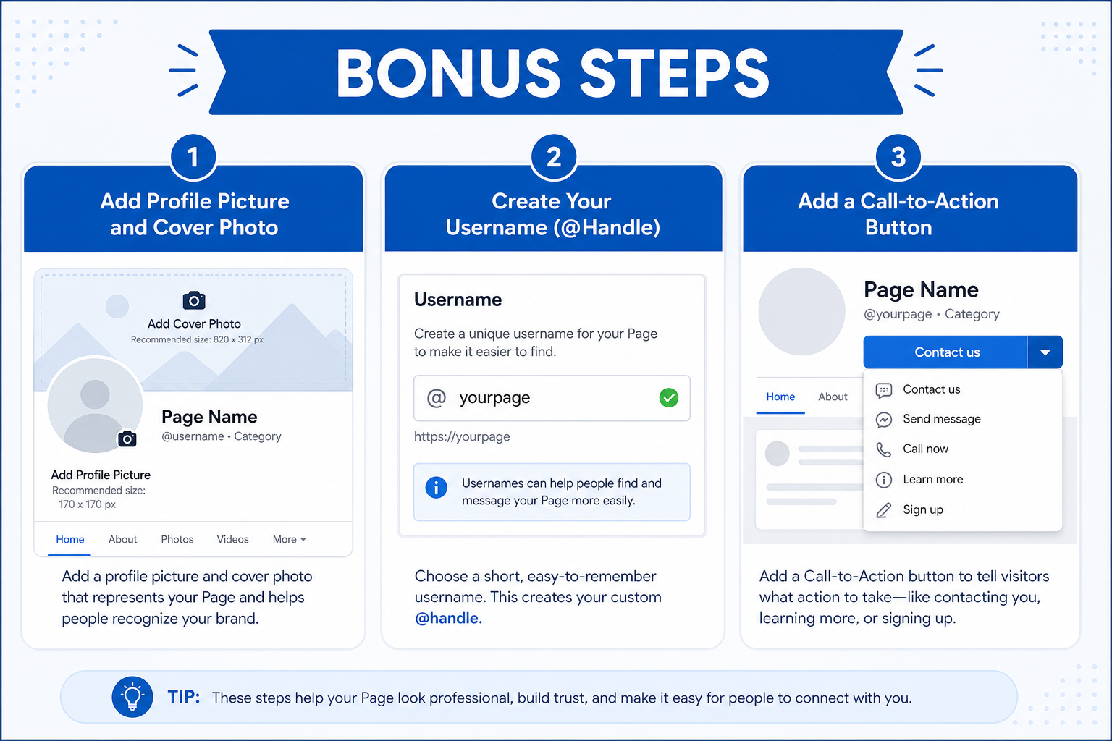
6A. Profile picture + Cover photo
- Habang as Page, open your Page profile.
- Click camera / edit icon sa profile picture → Upload.
- Same sa cover photo.
- Use clear logo + readable cover (brand + short tagline).
Script: “Update din ang profile at cover photo — first impression ito kapag naghahanap ang tao.”
6B. Username (@handle) / web address
- Settings → Page setup → Name / Username section.
- Edit beside username.
- Choose available @yourpage (usually desktop only).
- Save.
Script: “Username ang @handle at facebook.com/username — mas madaling i-share kaysa long link.”
6C. Call-to-action (CTA) button
- On your Page profile, look for Add a button / edit action button.
- Choose: Contact us, Learn more, Sign up, Call now, etc.
- Link to website / form / Messenger / phone.
- Save.
Script: “Lagyan ng CTA button para one-click ang next action — call, website, o message.”
6D. Who can post / privacy basics
- Settings → look for Audience and visibility / Page moderation / posting permissions.
- Decide kung public followers lang ba ang pwedeng mag-post sa Page, o admin-only posts.
- Review blocked words / messaging settings if needed.
Script: “I-check din kung sino pwedeng mag-post o mag-message — para controlled ang Page.”
6E. Meta Business Suite shortcut (optional clip)
- Pumunta sa business.facebook.com
- Select your Page (top-left selector)
- Settings → Page info / access — useful kung hindi makita ang option sa regular Facebook UI
Script: “Kung kulang ang option sa Facebook, subukan ang Meta Business Suite — same Page, mas complete ang tools.”

Video checklist (bago mag-upload)
- ☐ Step 1: Show See all profiles → select Page
- ☐ Step 2: Confirm naka-switch as Page
- ☐ Step 3: Edit Page info (fill 2–3 fields live)
- ☐ Step 4: Page access → explain Full vs Task access
- ☐ Step 5: Page setup → Name change + review note
- ☐ Bonus: photo / username / CTA (kahit short)
- ☐ Outro: “Full control = careful; accept invite; name ≠ username”

Troubleshooting (mabilis)
Problema | Try this
Walang Edit / walang Page access | Hindi ka naka-switch as Page, o wala kang Full control
Hindi makapag-change ng name | Task access lang ang role mo; kailangan Facebook access with Full control
Hindi makita ang Page sa list | Search the Page name, or check if you’re logged into the correct personal account that manages it
Invite hindi natanggap | Sabihin sa tao i-check Notifications / email; re-send access if needed
UI iba sa video | Normal — Meta updates UI; sundin ang keywords: See all profiles, Edit Page info, Page access, Page setup

File map (para sa editor)
docs/facebook-page-guide/
├── facebook-page-guide-taglish.md ← script + steps
└── images/
├── step-01-hanapin-page.png
├── step-02-edit-page-info.png
├── step-03-page-details.png
├── step-04-page-access.png
├── step-05-change-name.png
└── step-06-bonus-extras.png
Kapag nagre-record: open Facebook live + gamitin ang pictures bilang intro card per segment (hal. “STEP 4 — Page Access” overlay).

