3. Analyses
Aleksandra Urman and Johannes B. Gruber
2026-02-28

Introduction
This file contains the code to reproduce all figures, plots and in-text numbers in “Gender Representation in Large Language Models: A Cross-Linguistic and Cross-Model Analysis”

Packages

Data
We construct a grid of the different prompts (one for each language), the selected nouns, and a range of different models.

Main

Table 1
Official language support for LLMs used in this study. Based on systematic verification of official documentation from model providers (January 2025). Legend: ✓ = Officially supported with explicit documentation; - = Not officially supported or no explicit documentation available.
Model | English | German | Serbian | Russian | Czech | Albanian
deepseek-r1:* | ✓ | - | - | - | - | -
gemma:2b/7b | ✓ | - | - | - | - | -
gemma3:* | ✓ | ✓ | - | - | - | -
gpt-oss:* | ✓ | - | - | - | - | -
llama3:8b | ✓ | - | - | - | - | -
llama3.1:* | ✓ | ✓ | - | - | - | -
llama3.2:* | ✓ | ✓ | - | - | - | -
llama4:latest | ✓ | ✓ | - | - | - | -
mistral:latest | ✓ | ✓ | - | - | - | -
mistral-small3.1:latest | ✓ | ✓ | ✓ | ✓ | - | -
qwen2.5:* | ✓ | ✓ | - | ✓ | - | -

Table 2
RQ1: Does gender representation differ across stereotype dimensions?
#> Chi-square test of independence:
#> χ²(24) = 34059.126, p < .001
#> Cramér's V = 0.230
#> Cramér's V² = 0.053 (effect size: small)
Standardized Residuals from Chi-Square Test of Independence by Stereotype Dimension and Association Pattern
Stereotype Dimension | All three | Men + Nonbinary | Men + Women | Men only | Non-binary only | Women + Nonbinary | Women only
agency | 17.02*** | 2.02* | -0.05 | 35.04*** | 24.93*** | -3.39*** | -72.52***
communality | 4.79*** | -0.91 | -2.01* | -103.56*** | -0.11 | 6.55*** | 105.64***
dominance | -12.62*** | 1.51 | -4.73*** | 128.99*** | -39.08*** | -7.64*** | -87.77***
giftedness | 1.51 | 0.18 | 2.28* | -10.33*** | 16.64*** | 4.07*** | -7.18***
weakness | -8.65*** | -2.58** | 5.31*** | -55.03*** | 6.11*** | 2.11* | 56.99***

Figure 1
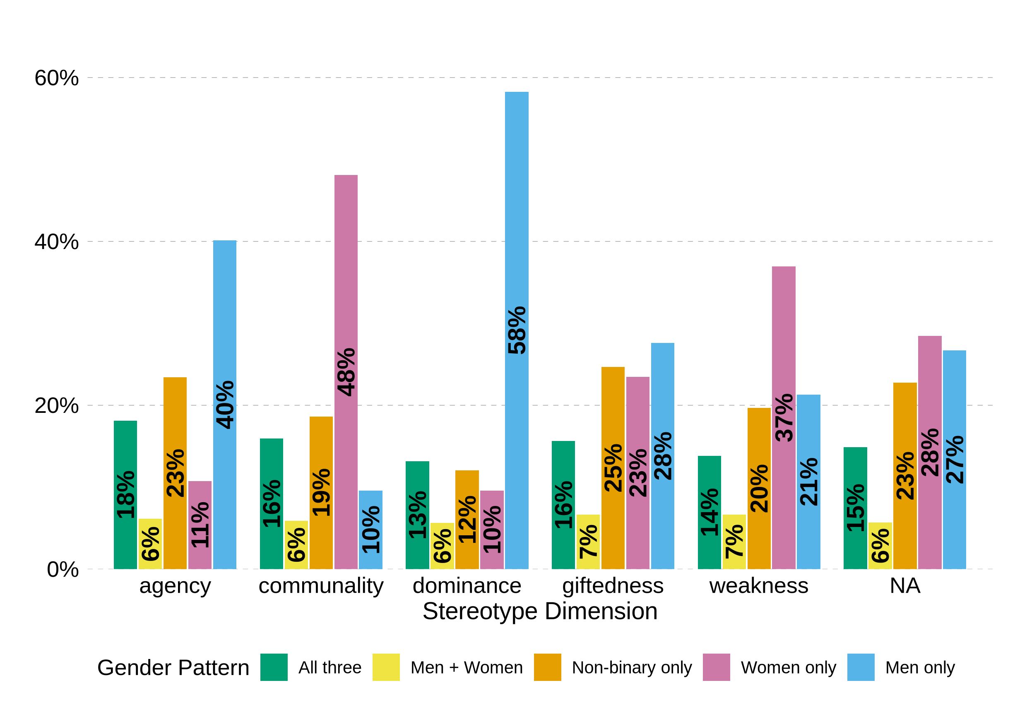
Figure 1: Gender Association Patterns by Stereotype Dimension

Table 3
RQ2: Does gender representation vary across languages?
Sample size: 161467
 Detailed results
Table 1
#> Three-way chi-square test:
#> χ²(174) = 73590.383, p < .001
#> Cramér's V = 0.276
#> Cramér's V² = 0.076 (effect size: small)
#> agency: χ²(30) = 7949.93, p < .001, Cramér's V = 0.219
#> communality: χ²(30) = 8668.21, p < .001, Cramér's V = 0.220
#> dominance: χ²(30) = 8818.43, p < .001, Cramér's V = 0.210
#> giftedness: χ²(30) = 3061.51, p < .001, Cramér's V = 0.238
#> weakness: χ²(30) = 9493.91, p < .001, Cramér's V = 0.213

Table 2: Language Differences in Gender Association Patterns by Stereotype Dimension
Dimension | Chi_square | df | p_value | Cramers_V
giftedness | 3061.51 | 30 | < .001 | 0.238
communality | 8668.21 | 30 | < .001 | 0.220
agency | 7949.93 | 30 | < .001 | 0.219
weakness | 9493.91 | 30 | < .001 | 0.213
dominance | 8818.43 | 30 | < .001 | 0.210

Figure 2
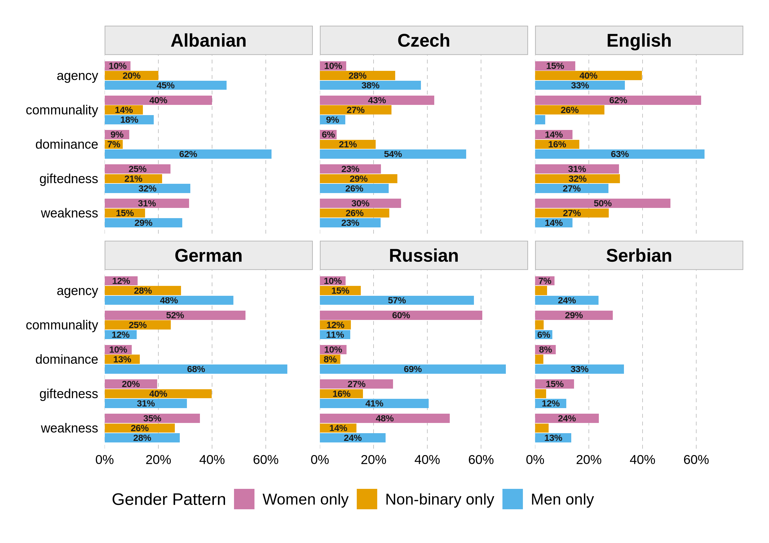
Gender Association Patterns by Language and Stereotype Dimension

Figure 3
RQ3a: Do different models vary in gender representation?
#> Chi-square test: Model × Gender Pattern
#> χ²(138) = 63050.015, p < .001
#> Cramér's V = 0.255
#> Cramér's V² = 0.065 (effect size: small)
Sample size: 161467
Extra: Within-family variation
model_family | avg_sd | max_range
Mistral | 14.132895 | 46.845217
DeepSeek | 8.603649 | 44.546425
Llama | 7.184093 | 30.398181
Gemma | 6.850732 | 38.149113
Qwen | 6.305645 | 33.801756
Other | 2.318023 | 8.430656
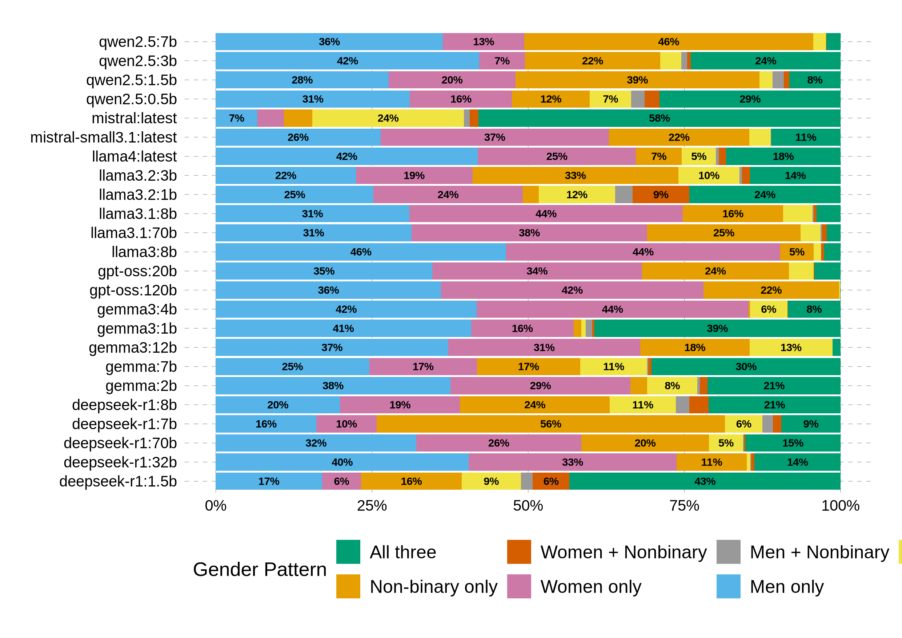
Distributions of gender association patterns by model
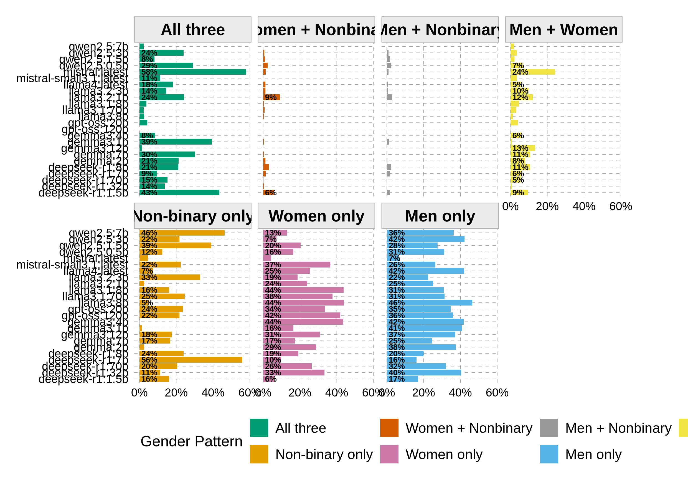
Distributions of gender association patterns by model

Supplementary Analysis: Variability Across Gender Patterns
This section is not reported in the main text but provides additional insights into pattern consistency across models.
#> Variability metrics by gender pattern:
#> (CV = Coefficient of Variation; higher values indicate greater variability)
Supplementary: Coefficient of Variation by Gender Pattern
gender_pattern | n_models | mean_pct | sd_pct | min_pct | max_pct | range | cv
Women + Nonbinary | 23 | 0.01 | 0.02 | 0.00 | 0.09 | 0.09 | 152.84
Men + Nonbinary | 22 | 0.01 | 0.01 | 0.00 | 0.03 | 0.03 | 110.57
All three | 24 | 0.17 | 0.15 | 0.00 | 0.58 | 0.58 | 88.05
Men + Women | 24 | 0.06 | 0.05 | 0.00 | 0.24 | 0.24 | 84.42
Non-binary only | 24 | 0.19 | 0.14 | 0.00 | 0.56 | 0.56 | 76.55
Women only | 24 | 0.25 | 0.13 | 0.04 | 0.44 | 0.40 | 50.26
Men only | 24 | 0.31 | 0.10 | 0.07 | 0.46 | 0.40 | 31.79

Supplementary: Variance by Gender Pattern
gender_pattern | variance
All three | 0.02
Non-binary only | 0.02
Women only | 0.02
Men only | 0.01
Men + Women | 0.00
Women + Nonbinary | 0.00
Men + Nonbinary | 0.00

Supplementary: Homogeneity Comparison for Men-only vs Women-only Patterns
gender_pattern | mean | sd | cv | range
Women only | 0.25 | 0.13 | 50.26 | 0.4
Men only | 0.31 | 0.10 | 31.79 | 0.4
Interpretation: Non-binary only shows highest variability (CV = 76.5%), compared to Women only (CV = 50.3%) and Men only (CV = 31.8%). This suggests Women-only and Men-only patterns are comparatively homogeneous across models.

Table 4
RQ3b: Do models vary across languages?
Sample size: 161467
 Detailed results
#> Within-language model consistency:
#> ------------------------------------------------------------
#>
#> Average standard deviation by language (lower = more consistent):
#> English: Average SD = 11.5%, Max Range = 91.3%
#> German: Average SD = 12.0%, Max Range = 90.4%
#> Russian: Average SD = 12.3%, Max Range = 83.8%
#> Albanian: Average SD = 14.6%, Max Range = 99.8%
#> Serbian: Average SD = 15.0%, Max Range = 98.3%
#> Czech: Average SD = 17.9%, Max Range = 99.3%
#> Albanian: χ²(132) = 14287.43, p < .001, Cramér's V = 0.364
#> Czech: χ²(138) = 50234.70, p < .001, Cramér's V = 0.512
#> English: χ²(138) = 24835.39, p < .001, Cramér's V = 0.362
#> German: χ²(138) = 21658.28, p < .001, Cramér's V = 0.356
#> Russian: χ²(138) = 22137.75, p < .001, Cramér's V = 0.386
#> Serbian: χ²(138) = 30942.84, p < .001, Cramér's V = 0.439
Table 3: Within-Language Model Consistency
Language | Average SD (%) | Max Range (%)
English | 11.5 | 91.3
German | 12.0 | 90.4
Russian | 12.3 | 83.8
Albanian | 14.6 | 99.8
Serbian | 15.0 | 98.3
Czech | 17.9 | 99.3

Table 4: Model Effects within Each Language
Language | Chi_square | df | p_value | Cramers_V
Czech | 50234.70 | 138 | < .001 | 0.512
Serbian | 30942.84 | 138 | < .001 | 0.439
Russian | 22137.75 | 138 | < .001 | 0.386
Albanian | 14287.43 | 132 | < .001 | 0.364
English | 24835.39 | 138 | < .001 | 0.362
German | 21658.28 | 138 | < .001 | 0.356

Figure 4
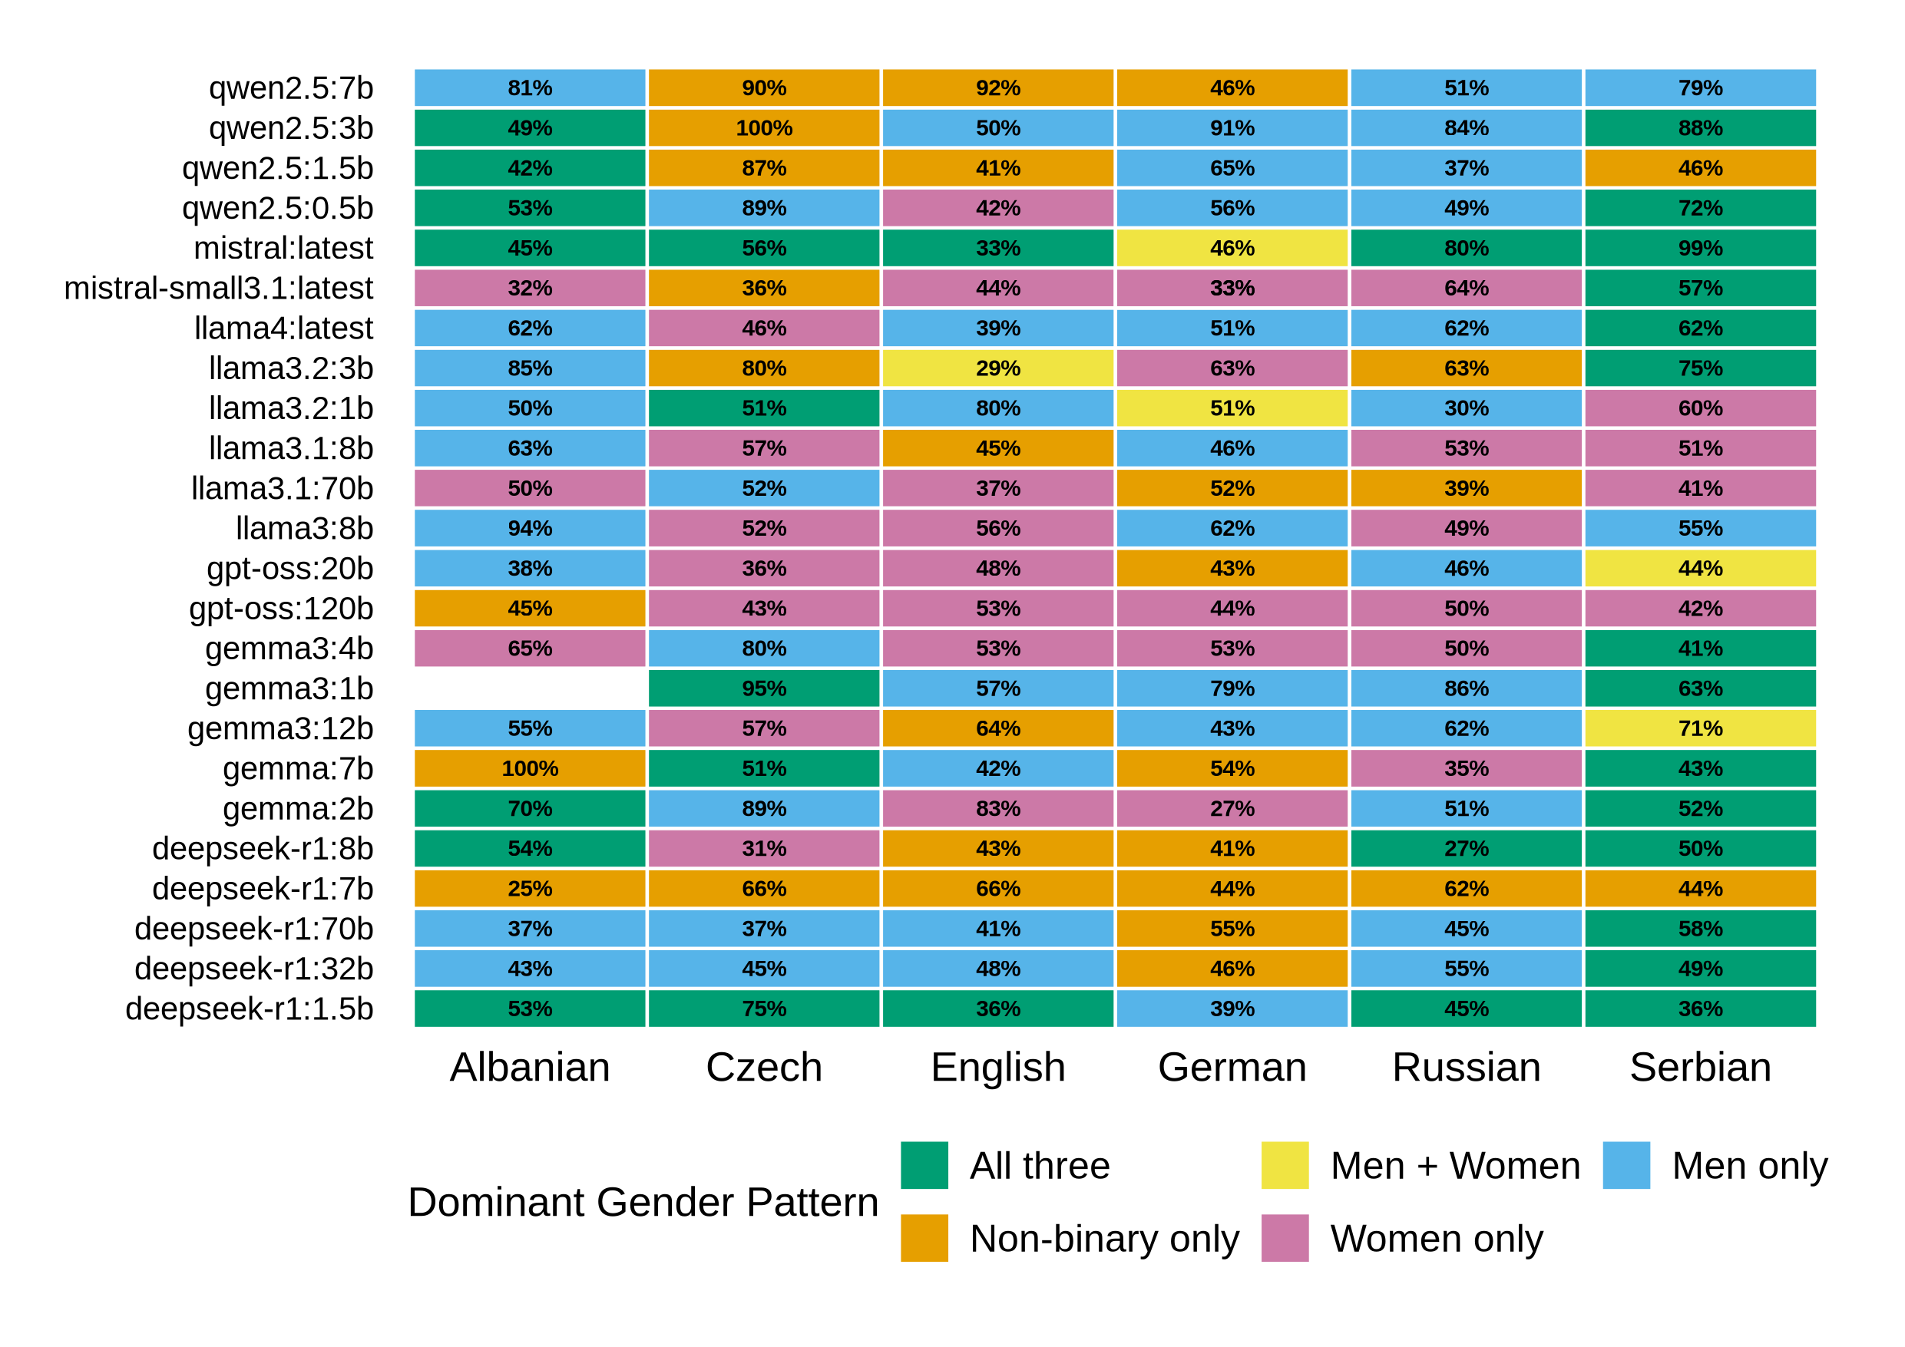
The most frequent gender association patterns by model and language

Table 5
RQ3c: Do models vary across stereotype dimensions?
Sample size: 161467
 Detailed results
Table 5
#> Three-way chi-square test:
#> χ²(714) = 114845.654, p < .001
#> Cramér's V = 0.344
#> Cramér's V² = 0.119 (effect size: medium)
#> agency: χ²(138) = 14568.73, p < .001, Cramér's V = 0.271
#> communality: χ²(138) = 21209.99, p < .001, Cramér's V = 0.314
#> dominance: χ²(138) = 17383.43, p < .001, Cramér's V = 0.270
#> giftedness: χ²(138) = 5778.89, p < .001, Cramér's V = 0.299
#> weakness: χ²(138) = 18827.95, p < .001, Cramér's V = 0.274

#> Within-dimension model consistency:
#> ------------------------------------------------------------
#>
#> Average standard deviation by stereotype dimension (lower = more consistent):
#> dominance: Average SD = 8.81%, Max Range = 65.9%
#> weakness: Average SD = 9.30%, Max Range = 57.9%
#> agency: Average SD = 9.33%, Max Range = 67.1%
#> giftedness: Average SD = 10.84%, Max Range = 65.3%
#> communality: Average SD = 11.07%, Max Range = 80.8%
Table 6: Model Effects within Each Stereotype Dimension
Dimension | Chi_square | df | p_value | Cramers_V
communality | 21209.99 | 138 | < .001 | 0.314
giftedness | 5778.89 | 138 | < .001 | 0.299
weakness | 18827.95 | 138 | < .001 | 0.274
agency | 14568.73 | 138 | < .001 | 0.271
dominance | 17383.43 | 138 | < .001 | 0.270
Within-Dimension Model Consistency Across Gender Patterns
Stereotype Dimension | Average SD (%) | Max Range (%)
dominance | 8.81 | 65.94
weakness | 9.30 | 57.91
agency | 9.33 | 67.09
giftedness | 10.84 | 65.34
communality | 11.07 | 80.81

Figure 5
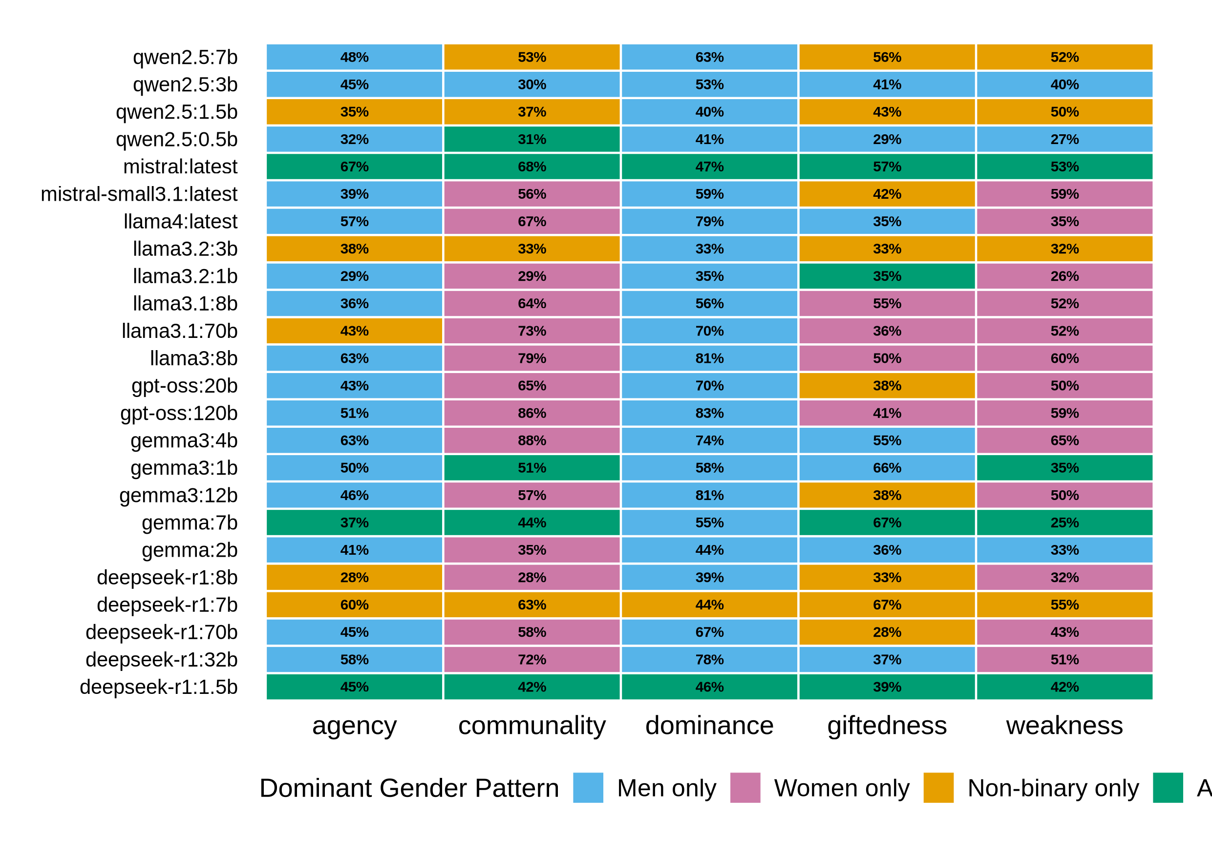
The most frequent gender association patterns by model and stereotype dimension.

Table 6
RQ4: Do temperature effects vary across stereotype dimensions?
Sample size: 161467
 Detailed results
#> Pattern Stability Analysis: Most Frequent Pattern Across Temperatures
#> ======================================================================
#> Stability by Stereotype Dimension:
#> ----------------------------------------------------------------------
#> dominance: 82.4% stable (117/142 model-language combinations)
#> communality: 72.5% stable (103/142 model-language combinations)
#> agency: 69.7% stable (99/142 model-language combinations)
#> weakness: 66.4% stable (95/143 model-language combinations)
#> giftedness: 51.4% stable (72/140 model-language combinations)
#>
#>
#> Stability by Language within Each Dimension:
#> ======================================================================
#>
#> agency:
#> ----------------------------------------------------------------------
#> Czech: 79.2% stable (19/24)
#> English: 75.0% stable (18/24)
#> Serbian: 75.0% stable (18/24)
#> Albanian: 63.6% stable (14/22)
#> German: 62.5% stable (15/24)
#> Russian: 62.5% stable (15/24)
#>
#> communality:
#> ----------------------------------------------------------------------
#> Czech: 87.5% stable (21/24)
#> English: 83.3% stable (20/24)
#> Russian: 70.8% stable (17/24)
#> Serbian: 70.8% stable (17/24)
#> German: 62.5% stable (15/24)
#> Albanian: 59.1% stable (13/22)
#>
#> dominance:
#> ----------------------------------------------------------------------
#> Czech: 100.0% stable (24/24)
#> English: 87.5% stable (21/24)
#> Albanian: 81.8% stable (18/22)
#> German: 79.2% stable (19/24)
#> Russian: 75.0% stable (18/24)
#> Serbian: 70.8% stable (17/24)
#>
#> giftedness:
#> ----------------------------------------------------------------------
#> Czech: 66.7% stable (16/24)
#> English: 58.3% stable (14/24)
#> Serbian: 56.5% stable (13/23)
#> Russian: 54.2% stable (13/24)
#> German: 45.8% stable (11/24)
#> Albanian: 23.8% stable (5/21)
#>
#> weakness:
#> ----------------------------------------------------------------------
#> Czech: 79.2% stable (19/24)
#> English: 79.2% stable (19/24)
#> Albanian: 65.2% stable (15/23)
#> German: 62.5% stable (15/24)
#> Russian: 62.5% stable (15/24)
#> Serbian: 50.0% stable (12/24)
#> ANCOVA: Temperature × Dimension
#> Df Sum Sq Mean Sq F value Pr(>F)
#> temperature 1 14.05 14.053 312.817 <2e-16 ***
#> noun_category 4 3.73 0.932 20.756 <2e-16 ***
#> temperature:noun_category 4 0.13 0.032 0.702 0.591
#> Residuals 4175 187.56 0.045
#> ---
#> Signif. codes: 0 '***' 0.001 '**' 0.01 '*' 0.05 '.' 0.1 ' ' 1
Table 7: Most Frequent Pattern Stability by Dimension and Language
Stereotype Dimension | Total Combinations | Stable Combinations | Stability %
dominance | 142 | 117 | 82.4
communality | 142 | 103 | 72.5
agency | 142 | 99 | 69.7
weakness | 143 | 95 | 66.4
giftedness | 140 | 72 | 51.4
Stereotype Dimension | Language | Total Combinations | Stable Combinations | Stability %
agency | Czech | 24 | 19 | 79.2
agency | English | 24 | 18 | 75.0
agency | Serbian | 24 | 18 | 75.0
agency | Albanian | 22 | 14 | 63.6
agency | German | 24 | 15 | 62.5
agency | Russian | 24 | 15 | 62.5
communality | Czech | 24 | 21 | 87.5
communality | English | 24 | 20 | 83.3
communality | Russian | 24 | 17 | 70.8
communality | Serbian | 24 | 17 | 70.8
communality | German | 24 | 15 | 62.5
communality | Albanian | 22 | 13 | 59.1
dominance | Czech | 24 | 24 | 100.0
dominance | English | 24 | 21 | 87.5
dominance | Albanian | 22 | 18 | 81.8
dominance | German | 24 | 19 | 79.2
dominance | Russian | 24 | 18 | 75.0
dominance | Serbian | 24 | 17 | 70.8
giftedness | Czech | 24 | 16 | 66.7
giftedness | English | 24 | 14 | 58.3
giftedness | Serbian | 23 | 13 | 56.5
giftedness | Russian | 24 | 13 | 54.2
giftedness | German | 24 | 11 | 45.8
giftedness | Albanian | 21 | 5 | 23.8
weakness | Czech | 24 | 19 | 79.2
weakness | English | 24 | 19 | 79.2
weakness | Albanian | 23 | 15 | 65.2
weakness | German | 24 | 15 | 62.5
weakness | Russian | 24 | 15 | 62.5
weakness | Serbian | 24 | 12 | 50.0

Table 8: Gender Parity Gap Statistics by Stereotype Dimension
Dimension | Mean Gap (%) | SD (%) | Range (%)
dominance | 22.7 | 36.1 | 108.3
communality | -16.7 | 33.5 | 121.4
agency | 13.6 | 27.8 | 93.6
weakness | -6.8 | 31.6 | 105.3
giftedness | 2.3 | 28.5 | 121.0

Note. Parity gap = % Men-only − % Women-only associations. Positive values indicate male bias; negative values indicate female bias. SD = standard deviation across all 24 models. Range = maximum parity gap − minimum parity gap across models.

Figure 6
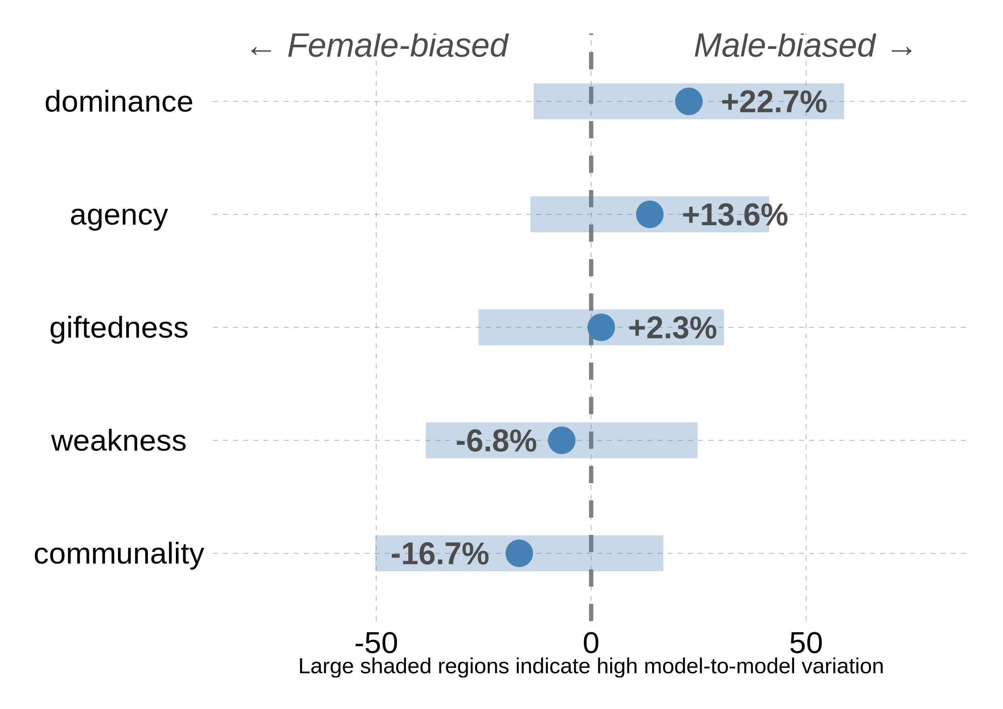
Gender parity gap by stereotype dimension
Note: Points show mean parity gap (% Men-only - % Women-only); shaded regions show ±1 SD across models. Large shaded regions indicate high model-to-model variation. Positive values indicate men male bias (above zero line); negative values indicate women female bias (below zero line).

Supplementary Analysis: Pattern Stability Across Temperatures
This section is not reported in the main text but examines whether models maintain consistent dominant patterns across different temperature settings.
Supplementary: Pattern Stability by Stereotype Dimension
Dimension | N Combinations | N Stable | % Stable
dominance | 142 | 117 | 82.4
communality | 142 | 103 | 72.5
agency | 142 | 99 | 69.7
weakness | 143 | 95 | 66.4
giftedness | 140 | 72 | 51.4
#> Warning: No shared levels found between `names(values)` of the manual scale and the
#> data's fill values.
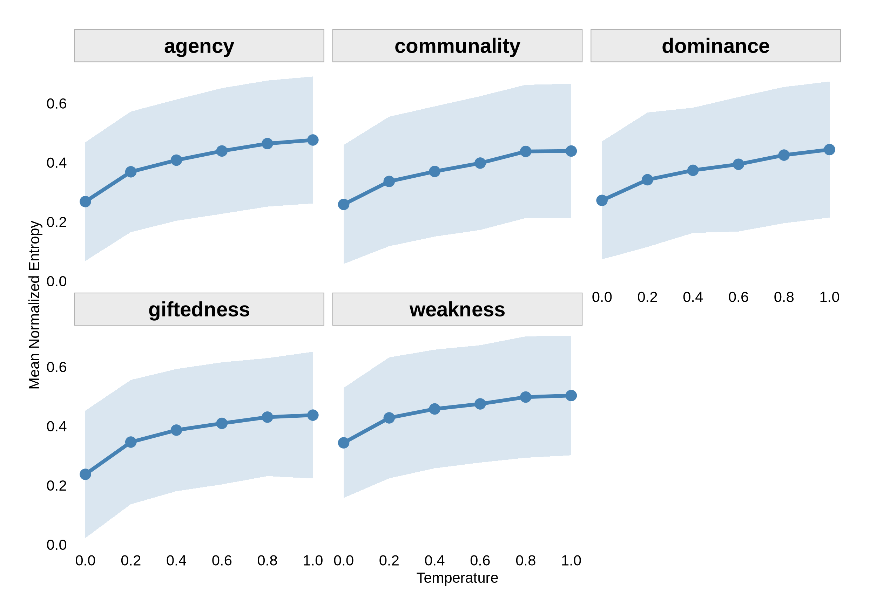
Additional plot: Temperature by Mean Normalized Entropy

Table 7
Table 9: Mean concentration strength by stereotype dimension for the lowest (0) and highest (1) temperature
Dimension | Mean Low (T=0) | Mean High (T=1) | Mean Change | SD
agency | 75.99 | 61.42 | -15.10 | 19.06
giftedness | 75.00 | 60.91 | -14.16 | 20.78
communality | 77.57 | 65.98 | -11.53 | 16.85
dominance | 76.64 | 65.83 | -10.81 | 16.99
weakness | 68.23 | 59.52 | -8.85 | 17.33

Table 8
Table 10: Shannon entropy values by stereotype dimension for the lowest (0) and highest (1) temperature
Dimension | Low Temp (T=0) | High Temp (T=1) | Change | SD
weakness | 0.344 | 0.504 | 0.163 | 0.167
dominance | 0.273 | 0.444 | 0.171 | 0.196
communality | 0.259 | 0.439 | 0.182 | 0.199
giftedness | 0.238 | 0.437 | 0.211 | 0.220
agency | 0.269 | 0.477 | 0.214 | 0.216

Supplementary Analysis: Linear Regression by Dimension
This section is not reported in the main text but provides dimension-specific regression analyses of entropy changes with temperature.
Statistical models

agency
communality
dominance
giftedness
weakness
(Intercept)
0.31***
0.29***
0.30***
0.29***
0.38***

(0.01)
(0.01)
(0.01)
(0.01)
(0.01)
temperature
0.19***
0.18***
0.16***
0.18***
0.15***

(0.02)
(0.02)
(0.02)
(0.02)
(0.02)
R2
0.09
0.07
0.06
0.08
0.06
Adj. R2
0.09
0.07
0.06
0.07
0.06
Num. obs.
847
837
847
809
845
***p < 0.001; **p < 0.01; *p < 0.05

wrap up
Some information about the session:
#> R version 4.5.2 (2025-10-31)
#> Platform: x86_64-pc-linux-gnu
#> Running under: EndeavourOS
#>
#> Matrix products: default
#> BLAS: /usr/lib/libblas.so.3.12.0
#> LAPACK: /usr/lib/liblapack.so.3.12.0 LAPACK version 3.12.0
#>
#> locale:
#> [1] LC_CTYPE=en_GB.UTF-8 LC_NUMERIC=C
#> [3] LC_TIME=de_DE.UTF-8 LC_COLLATE=en_GB.UTF-8
#> [5] LC_MONETARY=de_DE.UTF-8 LC_MESSAGES=en_GB.UTF-8
#> [7] LC_PAPER=de_DE.UTF-8 LC_NAME=C
#> [9] LC_ADDRESS=C LC_TELEPHONE=C
#> [11] LC_MEASUREMENT=de_DE.UTF-8 LC_IDENTIFICATION=C
#>
#> time zone: Europe/Berlin
#> tzcode source: system (glibc)
#>
#> attached base packages:
#> [1] stats graphics grDevices utils datasets methods base
#>
#> other attached packages:
#> [1] kableExtra_1.4.0 knitr_1.51 DescTools_0.99.60 infer_1.1.0
#> [5] lubridate_1.9.5 forcats_1.0.1 stringr_1.6.0 dplyr_1.2.0
#> [9] purrr_1.2.1 readr_2.2.0 tidyr_1.3.2 tibble_3.3.1
#> [13] ggplot2_4.0.2 tidyverse_2.0.0
#>
#> loaded via a namespace (and not attached):
#> [1] gld_2.6.8 gtable_0.3.6 xfun_0.56
#> [4] lattice_0.22-9 tzdb_0.5.0 vctrs_0.7.1
#> [7] tools_4.5.2 generics_0.1.4 proxy_0.4-29
#> [10] pkgconfig_2.0.3 Matrix_1.7-4 data.table_1.18.2.1
#> [13] RColorBrewer_1.1-3 S7_0.2.1 readxl_1.4.5
#> [16] lifecycle_1.0.5 rootSolve_1.8.2.4 compiler_4.5.2
#> [19] farver_2.1.2 textshaping_1.0.4 Exact_3.3
#> [22] htmltools_0.5.9 class_7.3-23 yaml_2.3.12
#> [25] pillar_1.11.1 MASS_7.3-65 boot_1.3-32
#> [28] tidyselect_1.2.1 digest_0.6.39 mvtnorm_1.3-3
#> [31] stringi_1.8.7 labeling_0.4.3 fastmap_1.2.0
#> [34] grid_4.5.2 lmom_3.2 expm_1.0-0
#> [37] cli_3.6.5 magrittr_2.0.4 dichromat_2.0-0.1
#> [40] e1071_1.7-17 withr_3.0.2 scales_1.4.0
#> [43] timechange_0.4.0 rmarkdown_2.30 httr_1.4.8
#> [46] otel_0.2.0 cellranger_1.1.0 ragg_1.5.0
#> [49] hms_1.1.4 evaluate_1.0.5 haven_2.5.5
#> [52] viridisLite_0.4.3 rlang_1.1.7 Rcpp_1.1.1
#> [55] glue_1.8.0 xml2_1.5.2 svglite_2.2.2
#> [58] rstudioapi_0.18.0 jsonlite_2.0.0 R6_2.6.1
#> [61] texreg_1.39.5 systemfonts_1.3.1 fs_1.6.6
#> [1] "2026-02-28 15:45:58 CET"
#> Time difference of 51.74541 secs

Only English and Chinese officially supported (GitHub; Hugging Face).
Only English officially supported (Model Card).
140+ languages claimed, specific languages not listed (Model Card).
Model card shows benchmarks for Arabic, Bengali, Chinese, French, German, Hindi, Indonesian, Italian, Japanese, Korean, Portuguese, Spanish, Swahili, and Yoruba. Serbian, Russian, Czech, and Albanian not explicitly listed (Model Card; also see OpenAI announcement; GitHub).
“High-quality non-English data that covers over 30 languages”, specific languages not listed (Meta Blog).
Officially supports 8 languages (English, German, French, Italian, Portuguese, Hindi, Spanish, Thai), trained on a broader collection of languages than these 8 supported languages, specific languages not listed (Model Card).
Officially supports 8 languages (English, German, French, Italian, Portuguese, Hindi, Spanish, Thai), trained on a broader collection of languages than these 8 supported languages, specific languages not listed (Model Card).
Officially supports 12 languages (Arabic, English, French, German, Hindi, Indonesian, Italian, Portuguese, Spanish, Tagalog, Thai, Vietnamese), pre-training includes 200 total languages, specific languages not listed (Model Card).
Neither the official announcement nor the model card mention supported languages other than English (model announcement; Model Card).
Explicitly languages including English, French, German, Greek, Hindi, Indonesian, Italian, Japanese, Korean, Malay, Nepali, Polish, Portuguese, Romanian, Russian, Serbian, Spanish, Swedish, Turkish, Ukrainian, Vietnamese, Arabic, Bengali, Chinese, Farsi (Model Card; Mistral AI).
29+ languages officially supported, including Chinese, English, French, Spanish, Portuguese, German, Italian, Russian, Japanese, Korean, Vietnamese, Thai, and Arabic. Serbian, Czech, and Albanian not explicitly listed (GitHub; Model Card).

