|  |
| --- |
|  |
| Men’s Shed Web Application Final Close-out Report  SOC09109 2022-3 TR2 001 - Group Project |
| |  |  |  | | --- | --- | --- | | Men’s Shed Group | 2/4/13 | SOC09109 | |

Table of Contents

Introduction 2

Group Project 2

The Team 2

Project Description 2

Dunfermline Men’s Shed objective. 2

The project 3

MoSCoW prioritisation (Proposed) 4

MoSCoW prioritisation (Achieved) 4

Deliverables Map 5

Project Management 5

The PM role 6

Principle Backend Developer 6

Secondary Backend Developer 6

Principle UI Developer 6

Secondary UI Developer 6

Security and Testing 6

Deliverable’s timeline 6

Stakeholder List 8

Appendix 1 Follow-Up Register 9

Appendix 2 Project Final Close-Out Peer Review 10

Appendix 3 Client Project Final Report Feedback 11

Appendix 4 Lessons Learned 12

Appendix 5 Packaged File Structure Diagram 13

Appendix 6 Evaluations 14

# Introduction

## Group Project

This is the final report for the Group Project. The Project chosen by the team was the Men’s Shed Web Application. This report will focus on the overarching principles of managing a project, the dynamics of the team and the initial assessment, agreement, and delivery of the chosen project. The report will also discuss the methods used to deliver the project and there will be a stakeholder evaluation and analysis covering the project.

## The Team

The Men’s Shed group team is made up of 3 disciplines Computing Engineering, Software Developers and Security Specialists. The individuals who signed up to be part of the team and their roles are listed in Table 1 below:

|  |  |  |
| --- | --- | --- |
|  | Name | Role |
| 1 | John Johnston | Project Manager (PM) |
| 2 | Jonathan Cloke | Security and testing (ST) |
| 3 | Rory Mackintosh | Principle Backend Developer (PBD) |
| 4 | Duncan Hastie | Secondary Backend Developer (SBD) |
| 5 | Joe Black | Principle UI Developer (PUD) |
| 6 | Daniel Beardmore | Secondary UI Developer (SUD) |
| 7 | Iain Donald | Sponsor |

Table Men’s Shed Project Team and Roles

## The Goal

The goal of this exercise was to develop a piece of work for a live project proposed by a real client. The client being the Dunfermline Men’s Shed Committee. Mr Ron Skirving (MS) is their spokesperson and the main contact for the project, all communications with the client are passed through the PM to the MS.

# Project Description

## Dunfermline Men’s Shed objective.

The committee of the Dunfermline Men’s Shed (MS) aspires to create a comprehensive and engaging resource for their community The MS has access to some additional facilities and is keen to attract additional members and promote diverse activities. They already have selection of interest groups away from the typical MS Activities of woodwork or metalwork. As part of their aspirations, the intended application should provide a platform upon which they can build as the need arises.

## The project

Following the initial between the university Project Team and the MS representatives on the 2nd February 2023. The MS representatives highlighted their vision for the Dunfermline association, their long-term objectives, and aspirations. The MS team want to build an exemplar of a modern adaptive association embracing the wider community and diverse interests. i.e., Computer club, guitar club and workshop facilities. But also a lending library for the many tools, books, videos, and publications that the people of the community have donated at large.

They proposed the development of a web application as a tool for both embers and the management of the organisation to track the donated equipment and manage their equipment, including the facility at large.

The PT highlighted to MS representatives this module’s learning objectives and the available time available to produce a worthwhile and in-depth application proposal. The reality of the project is that the exercise is to be done over a trimester and that the PT members will have other learning and assignments to achieve during the same time allocation, so the time available is limited.

The negotiations cleared a way forward from the conversation, and the PT suggested as a team, the limited time would be better spent on creating a foundation piece of work that could be developed further by subsequent student project teams.

There were many different directions that the MS wished to develop the application however, much of their aspirations were simply not feasible within the time frame allowed. Therefore, an agreement was confined to the following list.

1. Core application with:
   1. User interface
   2. Database
   3. Administrators User interface.
   4. Administrators access to maintain Data.

The MS agreed to provide the following items to assist with the development of the application:

1. Management personal information for the Administrator’s access
2. A spreadsheet with tools and images to display as being available for use.

## MoSCoW prioritisation (Proposed)

|  |  |
| --- | --- |
| Label | Interpretation |
| M | * Constructing the backend and the database * Way method to restrict users from accessing dangerous tools that have or could have a severe impact on health and safety (Mental Health, Ability) * Admin check that items are still safe to use, * Health and safety requirements, PPE is needed for the item. * Admin functions * The ability to add/update/retire resources, User registration, * User Registration |
| S | * Hiding an item from view if currently booked out. * High amount of good documentation for people in the future to build on. * The static directory should be required to hold all images that will be used for the web app. |
| C | * Could have a feature to possibly set up a delivery option for larger equipment for sharing amongst Men's shed locations |
| W | * The blog page application Men’s Shed expressed interest in will not be involved in our project. |

## MoSCoW prioritisation (Achieved)

|  |  |
| --- | --- |
| Label | Interpretation |
| M | * Constructing the backend and the database * Way method to restrict users from accessing dangerous tools that have or could have a severe impact on health and safety (Mental Health, Ability) * Admin check that items are still safe to use, * Health and safety requirements, PPE is needed for the item. * Admin functions * The ability to add/update/retire resources, User registration, * User Registration |
| S | * Hiding an item from view if currently booked out. * High amount of good documentation for people in the future to build on. * The static directory should be required to hold all images that will be used for the web app. The only time this would not be required is if the web app did not have any images involved. |
| C | * Could have a feature to possibly set up a delivery option for larger equipment for sharing amongst Men's shed locations |
| W | * The blog page application Men’s Shed expressed interest in will not be involved in our project. |

## Deliverables Map

Figure 1 Deliverables Map

## Project Management

The PT is happy to report that the project has been a valuable learning experience and that all members have actively participated in the development of the project. At the start of this learning experience the team members were invited to share their preferences on what element they wished to contribute, 50% volunteered their roles and where positions were appointed those team members embraced their roles with enthusiasm. Each member of the team has been valued and their opinions sought at every stage of the development of the project.

With each role being clearly defined i.e. Project manager, Principle Backend Developer, Principle UI Developer and finally, Security and Testing, The PM (Project Manager) used his experience to enable the team to take ownership of their area of work. They have been guided where necessary to collaborate with their counterparts for the benefit of the overall project. Each area of development has had the benefit of multidisciplinary team members from the BEng Computing and BSc Software development courses. This worked well as team members collaborated and complimented each other’s disciplines. The net result is a comprehensive cross-learning experience and collaboration on a live project.

All the project monitoring paperwork was collated and where necessary table and spreadsheets joined to update each other, making recording information and time spent on the project simple and streamlined. Each scrum meeting the members were encouraged to complete their contributions maintaining the ownership of their individual contributions.

In the absence of the PM the ST, Mr Cloke deputised and maintained the continuity of the team, hosting meetings and ensuring that the team met deadlines.

## The PM role

## Principle Backend Developer

## Secondary Backend Developer

## Principle UI Developer

## Secondary UI Developer

## Security and Testing

**User Interface**

## Deliverable’s timeline

Application progress aims; along with the development of the server side administration (Backend team) structures and database implementation, the User Interface (UI) team have structure the UI development along the timeline detailed in the table below.

|  |  |
| --- | --- |
| Week | Objectives |
| Week 8 | Adjust features implemented by client request |
| Week 9-10 | Testing of front-end UI, identify any potential errors and correct code |
| Week 11 | Final testing, prepare interface for final submission |
| Week 12 | Submit code |

Table 2 Deliverable’s timeline

## Stakeholder List

The stakeholders for this project include the following personnel.

|  |  |  |
| --- | --- | --- |
| **Role** | **Name** | **Organization** |
| Project manager | John Johnston | Napier University PT |
| Main Client Contact | Ron Skirving | Men’s Shed Committee |
| Sponsor | Iain Donald | Napier University Tutor |
| Project Team | Jonathan Cloke | Napier University PT |
| Project Team | Rory Mackintosh | Napier University PT |
| Project Team | Joe Black | Napier University PT |
| Project Team | Daniel Beardmore | Napier University PT |
| Project Team | Duncan Hastie | Napier University PT |
| Men’s Shed | Committee members | Men’s Shed Committee |

Table 3 Stakeholder List

## Appendix 1 Follow-Up Register

|  |  |  |  |  |  |  |  |  |  |  |  |  |  |  |
| --- | --- | --- | --- | --- | --- | --- | --- | --- | --- | --- | --- | --- | --- | --- |
| **Type** | | **Cause** | **Effect** | **Impact** | | **Likelihood** | | **Importance** | **Response** | | **Response** | | **Custodian** | |
| R | Coding | | Inefficient application and failures. Incorrect programming, being under pressure | | 70 | 50 | 2 | | Avoid | Testing and Adjust | | JJ, RM, JB, JC, DB, DH | |
| R | Joining coding elements between team members | | Inefficient application and failures. Incorrect programming, being under pressure | | 70 | 50 | 2 | | Avoid | Testing and Adjust | | JJ, RM, JB, JC, DB, DH | |
| R | SQL Scripting errors | | Inefficient application and failures. Incorrect programming, being under pressure | | 70 | 50 | 2 | | Avoid | Testing and Adjust | | JJ, RM, JB, JC, DB, DH | |
| R | Broken Object Level Authorization | | Integrity of the site being compromised | | 60 | 30 | 1 | | Avoid | Testing and Adjust | | JJ, RM, JB, JC, DB, DH | |
| R | Broken User Authentication | | Unauthorised access to the site | | 50 | 30 | 1 | | Avoid | Testing and Adjust | | JJ, RM, JB, JC, DB, DH | |
| R | Broken Function Level Authorization | | Application failure | | 40 | 30 | 1 | | Avoid | Testing and Adjust | | JJ, RM, JB, JC, DB, DH | |
| R | Security Misconfiguration | | Application security compromise | | 40 | 30 | 1 | | Avoid | Testing and Adjust | | JJ, RM, JB, JC, DB, DH | |
|  |  | |  | |  |  |  | |  |  | |  | |
|  |  | |  | |  |  |  | |  |  | |  | |
|  |  | |  | |  |  |  | |  |  | |  | |

## Appendix 2 Project Final Close-Out Peer Review

**Reviewer: Team:**

**Reviewee: Team:**

**Date of review:**

**Project description**

**Reviewer’s comments and recommendations**

**Response and actions taken**

**Deliverables map**

**Reviewer’s comments and recommendations**

**Response and actions taken**

**Follow-up register**

**Reviewer’s comments and recommendations**

**Response and actions taken**

**Quality of document (clarity, presentation, etc.)**

**Reviewer’s comments and recommendations**

**Response and actions taken**

## Appendix 3 Client Project Final Report Feedback

## Appendix 4 Lessons Learned

## Appendix 5 Packaged File Structure Diagram

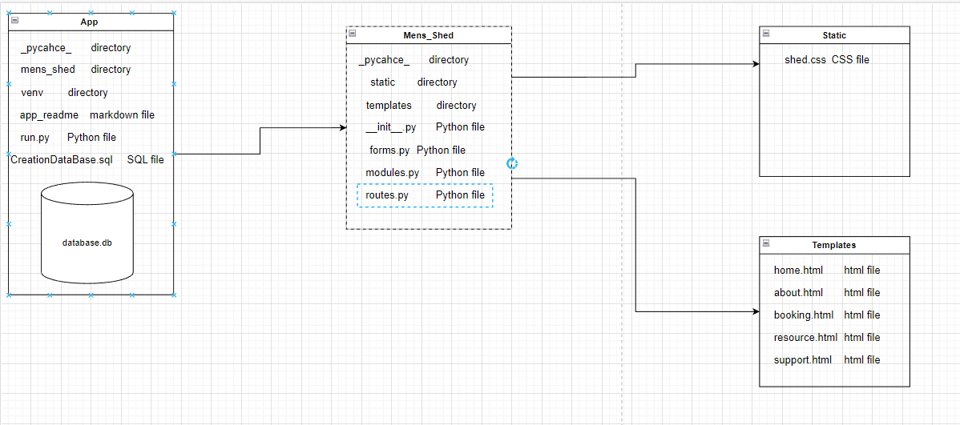

## Appendix 6 Evaluations

|  |  |  |  |  |  |  |  |  |  |
| --- | --- | --- | --- | --- | --- | --- | --- | --- | --- |
| **Evaluate stakeholder satisfaction** | | | | | | | | |  |
|  |  |  |  |  |  |  |  |  |  |
| On a scale of 0-10 where 10 is perfectly satisfied, how satisfied were you with: | | | | | | |  |  |  |
|  |  |  |  |  |  |  |  |  |  |
|  |  |  |  |  |  | Mth 1 | mth 2 | mth 3 |  |
| 1 | The project documentation that you saw | | | |  |  |  |  |  |
| 2 | Communications with the team | | |  |  |  |  |  |  |
| 3 | The quality of the work that you have seen | | | |  |  |  |  |  |
| 4 | The pace of the project | | |  |  |  |  |  |  |
|  |  |  |  |  | Total | 0 | 0 | 0 |  |
|  |  |  |  |  |  |  |  |  |  |
| Please provide any suggestions you may have for improving our project management | | | | |  | | | |  |
|  |
|  |  |  |  |  |  |
|  |  |  |  |  |  |
|  |  |  |  |  |  |
|  |  |  |  |  |  |  |  |  |  |