**User Interface**

In the development of our application, we wanted to consider the user base of our product. The Men’s Shed organisation is built on allowing individuals to access a wide range of resources, no matter their experience or ability. Therefore, we believed that it was highly important that our website reflected this accessibility. When it came to the layout and design of our page, we decided on some key ideas to prioritise:

1. The pages contain information which is concise and helpful
2. The layout is readable and easy to navigate
3. The style of each page looked professional

These were the key points in designing our interface. Our page should be informative but only contain necessary information. It should be clear and easy to navigate for users of all differing abilities and experience. And finally, considering that our application was to be delivered to a real-world client for professional use, we should aim to develop an interface which looked professional and well made. We aimed to use colour schemes, fonts and a layout which would reflect this.

We took care to ensure that our interface would contain all the information necessary, without overcrowding the pages with useless information. Our users may suffer from poor eyesight or dyslexia, so it was important to limit the amounts of text where possible and consider other ways in which we could communicate the features to maintain high accessibility, such as images.

As for navigation, we decided that we should keep the number of pages to a minimum where possible. To keep the navigation straightforward and clear, six main pages were decided on;

1. Home
2. About
3. Resource Library
4. Booking
5. Support
6. Login

This would allow users to clearly determine where to find each function or piece of information on the application, without overcomplicating things. With this in mind, we began to implement these pages aiming towards a working prototype.

When corresponding with the back-end development team, the suggestion was made that we change our method of implementation. Before, we were using raw HTML code; pages made from scratch, but we had been recommended to use Bootstrap and Jinja2 templates as an alternative. This method of HTML implementation is much more commonly used when developing Python Flask web applications, as it is based on pre-made templates which can be edited to suit your application. We made the change to Bootstrap templates after this meeting, and this is the method of implementation we have used since. This eliminated many of the formatting/style issues we were facing with our page, and makes for an overall clearer and more professional looking web app.

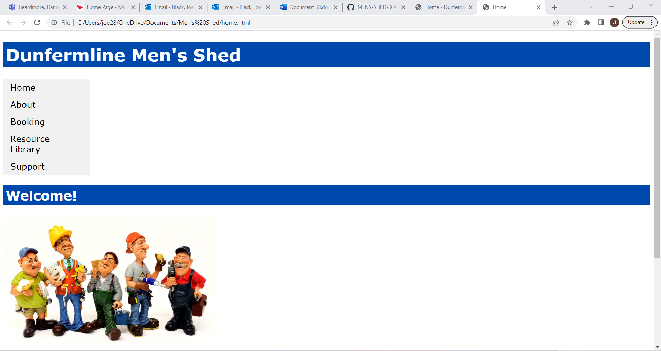

The Home page layout when designed without Bootstrap templates

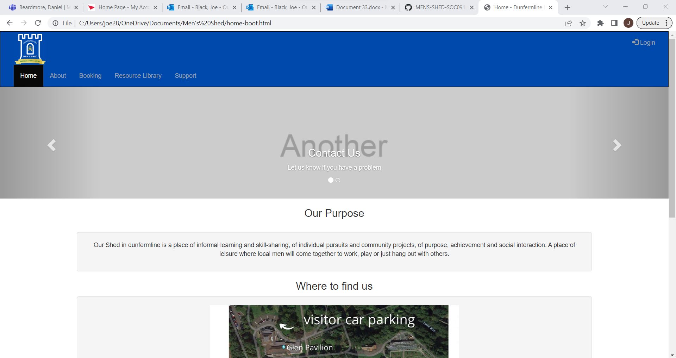

The web page design following the change to Bootstrap

On top of creating a more visually appealing layout, this also makes linking each page with the Python Flask application much easier, meaning that the implementation process became much more straightforward for both the front-end (user interface and web page implementation) and back-end (database and Python Flask application implementation) teams.