Test_word_output

Bob

7 novembre 2018

# Introduction

Simulated data set of a trawl survey.

# Materials and Methods

## Data

sp <- ggplot(data=df_data, aes(x=Avg_net_depth, y=Biomass)) +  
 geom_point(size=1)  
print(sp)

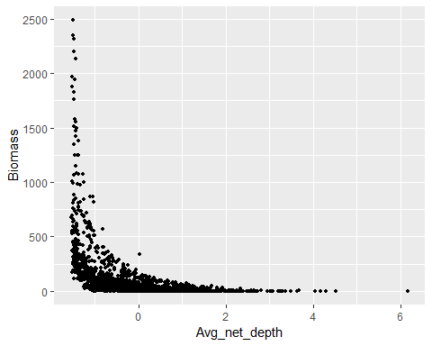

## Modelling approach

# Results

my_lm <- lm(Biomass ~ Avg_net_depth, data = df_data)

##   
## Call:  
## lm(formula = Biomass ~ Avg_net_depth, data = df_data)  
##   
## Coefficients:  
## (Intercept) Avg_net_depth   
## 108.6 -109.7

# Discussion

Where you want to discuss.

# References