How to use papaja: An Example Manuscript Including Basic Instructions

|  |
| --- |
| Frederik Aust1 |
| 1 University of Cologne |
|  |

# Author note

papaja has not yet been submitted to CRAN; a development version is available at <https://github.com/crsh/papaja>.

Correspondence concerning this article should be addressed to Frederik Aust, Department Psychology, University of Cologne, Herbert-Lewin-Str. 2, 50931 Köln, Germany. E-mail: [frederik.aust@uni-koeln.de](mailto:frederik.aust@uni-koeln.de)

Abstract

This manuscript demonstrates how to use R Markdown and papaja to create an APA conform manuscript. papaja builds on R Markdown, which uses pandoc to turn Markdown into PDF or Word documents. The conversion to Word documents currently supports only a limited set of features.

*Keywords:* APA style, knitr, R, R markdown, papaja

Word count: Too lazy to count

How to use papaja: An Example Manuscript Including Basic Instructions

# Introduction

Simulated data set of a trawl survey.

# Materials and Methods

## Data

sp <- ggplot(data=df_data, aes(x=Avg_net_depth, y=Biomass)) +  
 geom_point(size=1)  
print(sp)

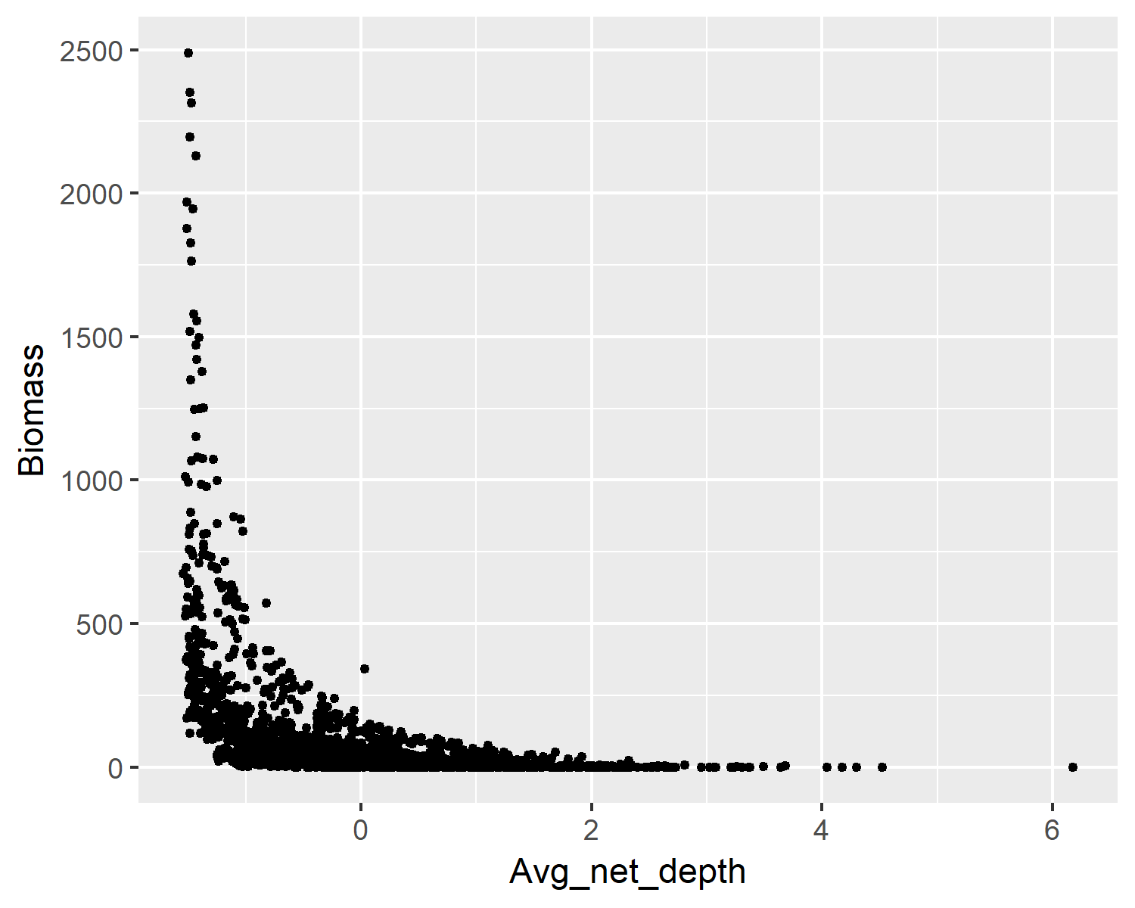

## Modelling approach

Code of a linear model:

my_lm <- lm(Biomass ~ Avg_net_depth + Avg_net_temp + Year_fac, data = df_data)

# Results

## <caption>(\#tab:lm2)</caption>  
##   
## <caption>*Regression table.*</caption>  
##   
##   
##   
## Predictor $b$ 95\% CI $t(1902)$ $p$   
## -------------- ------- --------------------- ---------- -------  
## Intercept 1.22 $[-14.61$, $17.06]$ 0.15 .880   
## Avg net depth 32.31 $[20.37$, $44.24]$ 5.31 < .001   
## Avg net temp 181.10 $[168.91$, $193.29]$ 29.14 < .001   
## Year fac2007 64.40 $[41.24$, $87.57]$ 5.45 < .001   
## Year fac2009 108.66 $[84.60$, $132.71]$ 8.86 < .001   
## Year fac2011 90.14 $[67.85$, $112.43]$ 7.93 < .001   
## Year fac2013 286.52 $[263.46$, $309.58]$ 24.37 < .001

# Discussion

Where you want to discuss.

# References