Titre

Auteur

17 Décembre 2017

# Header 1

Block of content below header one. Block of content below header one. Block of content below header one. Block of content below header one. Block of content below header one. Block of content below header one. Block of content below header one. Block of content below header one. Block of content below header one.

Block of content below header one. Block of content below header one. Block of content below header one. Block of content below header one. Block of content below header one. Block of content below header one.

Block Adults (> 2 years old) potentially move among the different “zones” at each time step.

Block Adults (> 2 years old) potentially move among the different “zones” at each time step.

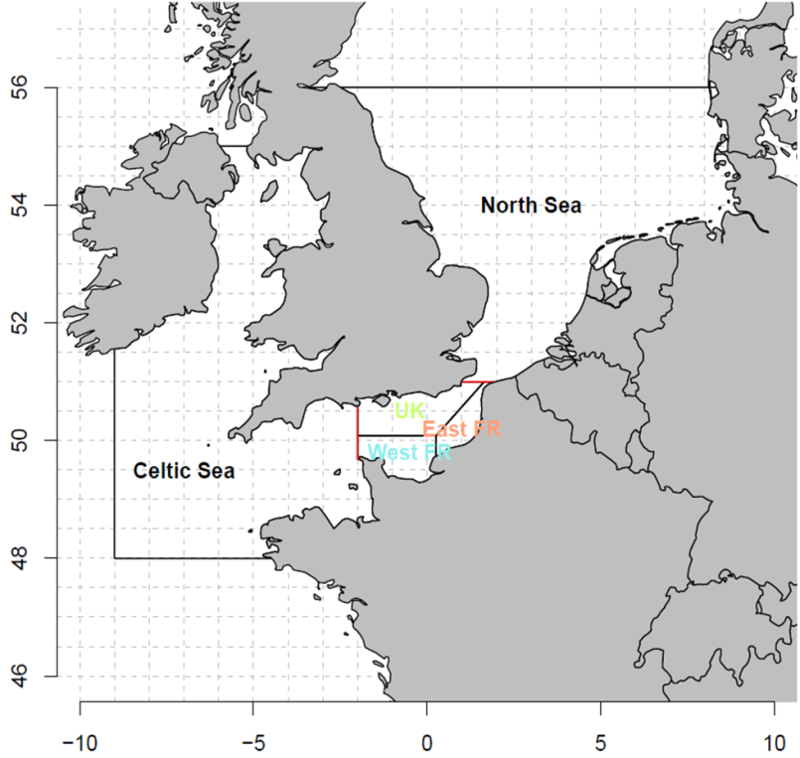

Figure 1: The 5 zones to be considered for the movement of adults fish.

# Adult movements

Block of content below header two. Block of content below header two. Block of content below header two. Block A quarter time step would best describe migration

Block of content below header two. Block of content below header two. Block of content below header two. Block

### Header 2

Block of content below header two. Block of content below header two. Block of content below header two. Block of content below header two. Block of content below header two. Block of content below header two. Block of content below header two. Block of content below header two. Block of content below header two.

### Header 3

Block of content below header three. Block of content below header three. Block of content below header three. Block of content below header three. Block of content below header three. Block of content below header three. Block of content below header three. Block of content below header three. Block of content below header three.

#### Header 4

Block of content below header four. Block of content below header four. Block of content below header four. Block of content below header four. Block of content below header four. Block of content below header four. Block of content below header four. Block of content below header four. Block of content below header four.

The Markdown code '**#####**' is originally reserved for *header 5*. However, we will use it to insert a pagebreak in a .docx document.

Pagebreak

Block of content below page break. Block of content below page break. Block of content below page break. Block of content below page break. Block of content below page break. Block of content below page break. Block of content below page break. Block of content below page break. Block of content below page break. Block of content below page break. Block of content below page break. Block of content below page break. Block of content below page break. Block of content below page break. Block of content below page break. Block of content below page break. Block of content below page break. Block of content below page break.

|  |  |  |  |  |
| --- | --- | --- | --- | --- |
| Campaign | Marked | Recaptured | Time at liberty | Rate |
| CEFAS 1970 | 21994 | 3627 | 6.260546 | 0.1649086 |
| CEFAS 2002 | 2644 | 29 | 5.586207 | 0.0109682 |
| ISPTM | 5028 | 305 | 4.072131 | 0.0606603 |
| SMAC | 3073 | 70 | 3.042857 | 0.0227790 |
| Total | 32739 | 4031 | 6.034235 | 0.1231253 |