Test_word_output

Bob

7 novembre 2018

## Getting Started

str(df_data)

## 'data.frame': 1909 obs. of 18 variables:  
## $ Year : int 2005 2005 2005 2005 2005 2005 2005 2005 2005 2005 ...  
## $ Month : int 7 7 7 7 7 7 7 7 7 7 ...  
## $ DURATION_MINUTES: int 21 20 21 21 20 20 20 21 21 20 ...  
## $ AREA : Factor w/ 2 levels "5AB","5CD": 1 1 1 1 1 1 1 1 1 1 ...  
## $ Avg_net_depth : num -0.316 -0.435 -0.442 -0.234 -0.171 ...  
## $ Avg_net_temp : num 0.3939 0.4339 0.3004 0.1335 -0.0267 ...  
## $ Date : Date, format: "2005-07-06" "2005-07-06" ...  
## $ Lon : num -128 -128 -128 -128 -128 ...  
## $ Lat : num 51.2 51.1 51.6 51.6 51.7 ...  
## $ X : num 572025 570307 553665 551917 546338 ...  
## $ Y : num 5668122 5665874 5717947 5719597 5723992 ...  
## $ X_km : num 572 570 554 552 546 ...  
## $ Y_km : num 5668 5666 5718 5720 5724 ...  
## $ Pres : num 1 1 1 1 1 1 1 0 0 1 ...  
## $ Year_fac : Factor w/ 5 levels "2005","2007",..: 1 1 1 1 1 1 1 1 1 1 ...  
## $ AREA_num : num 1 1 1 1 1 1 1 1 1 1 ...  
## $ nFish : int 1 1 3 0 1 3 0 0 1 2 ...  
## $ Biomass : num 3.06 2.1 10 0 2.76 ...

## Scatter plot: Depth and Biomass

sp <- ggplot(data=df_data, aes(x=Avg_net_depth, y=Biomass)) +  
 geom_point(size=1)  
print(sp)

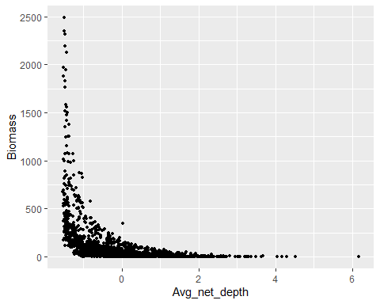

## Scatter plot with color: Depth and Biomass

sp_color <- ggplot(df_data, aes(x=Avg_net_depth, y=Biomass,  
 color=AREA)) +  
 geom_point(size=1)  
print(sp_color)

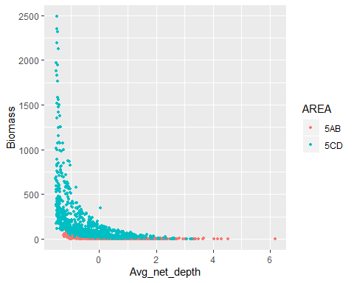

## How to cite

An interesting paper Hooten and Wikle (2007).

Balalalaa (Ntzoufras 2011).

## Reference

Hooten, Mevin B., and Christopher K. Wikle. 2007. “A hierarchical Bayesian non-linear spatio-temporal model for the spread of invasive species with application to the Eurasian Collared-Dove.” *Environmental and Ecological Statistics* 15 (1): 59–70. <https://doi.org/10.1007/s10651-007-0040-1>.

Ntzoufras, I. 2011. *Bayesian modeling using WinBUGS*. Vol. 698. Hoboken, NJ: Wiley. <http://books.google.fr/books?hl=fr\&amp;lr=\&amp;id=1yZnwnOxXsEC\&amp;oi=fnd\&amp;pg=PR17\&amp;dq=ntzoufras\&amp;ots=ZHRIG6nhLH\&amp;sig=4AvsgZEoEQIV38noR2OQ0D0cJVE>.