# Partie I







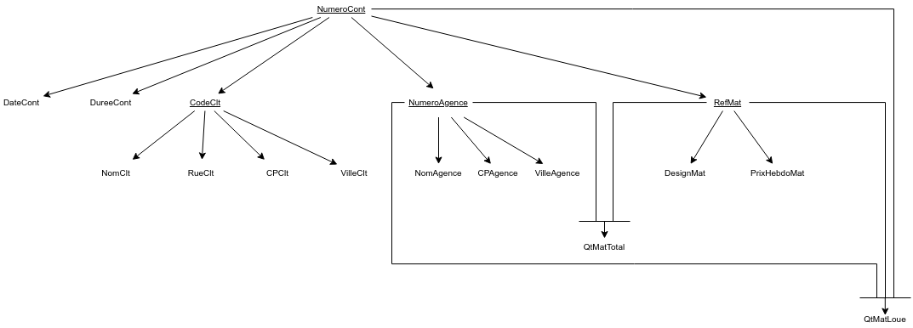

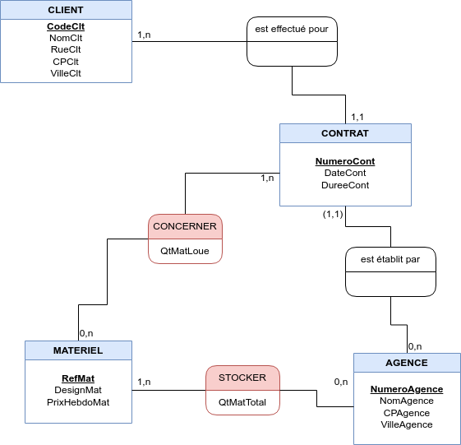

CLIENT (**CodeClt**, NomClt, RueClt, CPClt, VilleClt)

AGENCE (**NumeroAgence**, NomAgence, CPAgence, VilleAgence)

CONTRAT (**NumeroAgence#, NumeroCont**, DateCont, DureeCont, CodeClt#)

MATERIEL (**RefMat**, DesignMat, PrixHebdoMat)

STOCKER (**RefMat#, NumeroAgence#**, QtMatTotal)

CONCERNER (**NumeroAgence#, NumeroCont#, RefMat#**, QtMatLoue)

# Partie II

## A.

1. πCodeClt, NomClt, RueClt, CPClt, VilleClt(σVilleClt=’Paris’(CLIENT))
2. πCodeClt, NomClt, NomAgence(πCodeClt, NomClt(CLIENT)⋈(πNomAgence, CodeClt (πNumeroAgence, CodeClt(σDateCont<=2017-04-03 ^ >=2017-05-05(CONTRAT)))⋈(πNumeroAgence, NomAgence(AGENCE))))
3. πVilleClt(CLIENT)∪πVilleAgence(AGENCE)
4. πCodeClt, NomClt(CLIENT)⋈(πCodeClt(CLIENT)-πCodeClt(CONTRAT))
5. πRefMat(πCodeClt(σVilleClt = ’Paris’(CLIENT))⋈(πNumeroAgence, CodeClt(CONTRAT)⋈(πNumeroAgence(σVilleAgence ≠’Paris’(AGENCE))⋈(πNumeroAgence, RefMat(CONCERNER)))))

## B.

1. 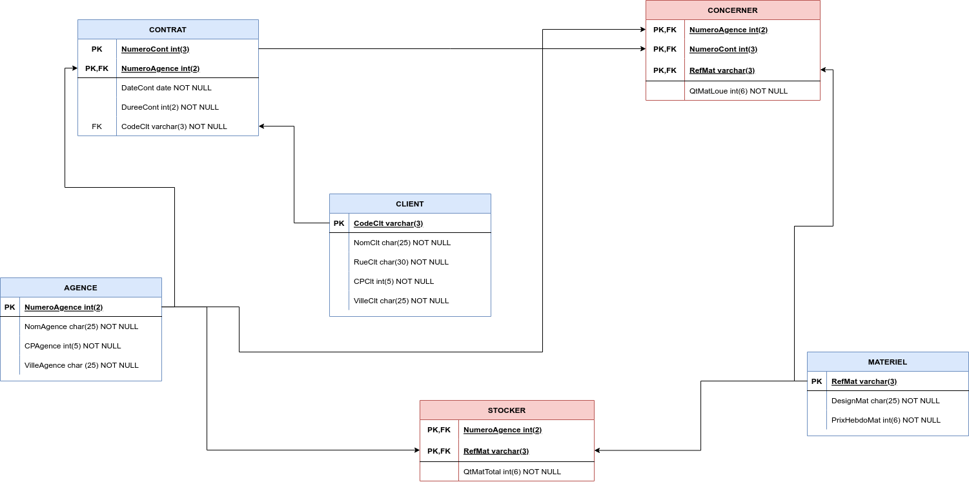

drop database if exists locamatos;

create database locamatos;

use locamatos;

-- creation de la table CLIENT

create table CLIENT(

CodeClt varchar(3),

NomClt char(25) NOT NULL,

RueClt char(30) NOT NULL,

CPClt int(5) NOT NULL,

VilleClt char(25) NOT NULL,

constraint pk_client primary key(CodeClt)

);

-- creation de la table AGENCE

create table AGENCE(

NumeroAgence int(2),

NomAgence char(25) NOT NULL,

CPAgence int(5) NOT NULL,

VilleAgence char (25) NOT NULL,

constraint pk_agence primary key(NumeroAgence)

);

-- creation de la table MATERIEL

create table MATERIEL(

RefMat varchar(3),

DesignMat char(25) NOT NULL,

PrixHebdoMat int(6) NOT NULL,

constraint pk_materiel primary key(RefMat)

);

-- creation de la table CONTRAT

create table CONTRAT(

NumeroCont int(3),

NumeroAgence int(2),

DateCont date NOT NULL,

DureeCont int(2) NOT NULL,

CodeClt varchar(3) NOT NULL,

constraint pk_contrat primary key(NumeroCont, NumeroAgence),

constraint fk_contrat_numeroagence foreign key(NumeroAgence) references AGENCE(NumeroAgence)

);

-- creation de la table CONCERNER

create table CONCERNER(

NumeroAgence int(2),

NumeroCont int(3),

RefMat varchar(3),

QtMatLoue int(6) NOT NULL,

constraint pk_concerner primary key(NumeroAgence, NumeroCont,RefMat),

constraint fk_concerner_numeroagence foreign key(NumeroAgence) references AGENCE(NumeroAgence),

constraint fk_concerner_numerocont foreign key(NumeroCont) references CONTRAT(NumeroCont),

constraint fk_concerner_refmat foreign key(RefMat) references MATERIEL(RefMat)

);

-- creation de la table STOCKER

create table STOCKER(

NumeroAgence int(2),

RefMat varchar(3),

QtMatTotal int(6) NOT NULL,

constraint pk_stocker primary key(NumeroAgence, RefMat),

constraint fk_stocker_numeroagence foreign key(NumeroAgence) references AGENCE(NumeroAgence),

constraint fk_stocker_refmat foreign key(RefMat) references MATERIEL(RefMat)

);

use locamatos;

-- On efface le contenu des tables en commencant par celles AYANT des clés étangeres.

delete from CONCERNER;

delete from STOCKER;

delete from CONTRAT;

delete from MATERIEL;

delete from AGENCE;

delete from CLIENT;

-- On remplit les tables en commençant par celles n'ayant PAS de clés étrangères.

-- Table CLIENT

insert into CLIENT values('A01', 'DUPONT', '5 rue MONGE', 75005, 'PARIS');

insert into CLIENT values('A25', 'DURAND', '3 rue BELLEVILLE', 75020, 'PARIS');

insert into CLIENT values('B03', 'DUPONT', '6 rue DU REGARD', 75006, 'PARIS');

-- Table AGENCE

insert into AGENCE values(01, 'PARIS CENTRE', 75001, 'PARIS');

insert into AGENCE values(02, 'PARIS', 75012, 'PARIS');

insert into AGENCE values(03, 'CLICHY', 92110, 'PARIS');

-- Table MATERIEL

insert into MATERIEL values('X01', 'AMPLI', 200);

insert into MATERIEL values('X02', 'MAGNETOSCOPE', 300);

insert into MATERIEL values('X03', 'TELE', 150);

insert into MATERIEL values('X04', 'HAUT PARLEUR', 50);

insert into MATERIEL values('X05', 'DISQUE LASER', 200);

insert into MATERIEL values('X06', 'TELE', 250);

-- Table CONTRAT

insert into CONTRAT values(201, 01, '1988/02/15', 4, 'A01');

insert into CONTRAT values(201, 02, '1988/02/16', 2, 'A25');

insert into CONTRAT values(302, 02, '1988/02/16', 2, 'A01');

-- Table CONCERNER

insert into CONCERNER values(01, 201, 'X06', 1);

insert into CONCERNER values(01, 201, 'X02', 1);

insert into CONCERNER values(02, 201, 'X01', 1);

insert into CONCERNER values(02, 201, 'X04', 2);

insert into CONCERNER values(02, 302, 'X03', 1);

-- Table STOCKER

insert into STOCKER values(01, 'X01', 21);

insert into STOCKER values(01, 'X02', 41);

insert into STOCKER values(01, 'X03', 40);

insert into STOCKER values(01, 'X04', 52);

insert into STOCKER values(01, 'X05', 10);

insert into STOCKER values(01, 'X06', 1);

insert into STOCKER values(02, 'X01', 40);

insert into STOCKER values(02, 'X04', 50);

insert into STOCKER values(02, 'X03', 1);

* 1. SELECT CodeClt, NomClt, RueClt, CPClt FROM CLIENT

WHERE VilleClt=’Paris’ ;

* 1. select CodeClt, NomClt, NomAgence from CLIENT CL

join CONTRAT CO on CL.CodeClt=CO.CodeClt

join AGENCE A on CO.NumeroAgence=A.NumeroAgence

where CO.DateCont between ‘2017-04-03’ and ‘2017-05-05’ ;

* 1. select VilleClt from CLIENT union all select VilleAgence from AGENCE ;
  2. select CodeClt, NomClt from CLIENT CL

where CodeClt not in (select CodeClt from CONTRAT) ;

* 1. select RefMat from CONCERNER CO

join AGENCE A on CO.NumeroAgence=A.NumeroAgence

join CONTRAT C on A.NumeroAgence=C.NumeroAgence

join CLIENT CL on C.CodeClt=CL.CodeClt

where A.VilleAgence!=’Paris’ and CL.VilleClt=’Paris’ ;

* 1. select CodeClt, NomClt from CLIENT CL

join CONTRAT C on CL.CodeClt=C.CodeClt

group by CodeClt having count(*)>1 ;