Lab: Docker Cluster (part 1)
Objective: | Understanding the basics of Docker and successfully execute basic entry-level exercises.
Successful Outcome: | You will have ran basic commands and task, and feel better prepared to begin working with Hadoop in Docker.
Before You Begin: | Open terminal up into your host machine.

Before we begin, here is a list of core Docker commands:
Docker Core Commands
build | Build an image from a Dockerfile
commit | Create a new image from a container's changes
exec | Run a command in a running container
images | List images
kill | Kill one or more running containers
login | Log in to a Docker registry.
port | List port mappings or a specific mapping for container
ps | List containers
restart | Restart a container
rm | Remove one or more containers
rmi | Remove one or more images
run | Run a command in a new container
top | Display the running processes of a container
FULL LIST | docs.docker.com/engine/reference/commandline/

Step 1. Let’s get started! Let’s start by downloading a new image, making some changes to that image, commit the changes, and then confirm our new image is in our local repository.

1.1. Let’s first grab an official Ubuntu image down, without using pull:

$ docker run -it ubuntu /bin/bash

Step 2. If successful you should find yourself logged into a new container as ‘root.’
Let’s now make the following changes, exit our container, and then verify changes
made.
NOTE: Notice that ‘$’ is used when outside the container, and ‘#’ when inside.

2.1. Let's first load our local apt repository with the code we need to install:
# sed -i ’s/us.archive.ubuntu.com/mirrors.163.com/' \
/etc/apt/sources.list

2.2. Now that's update our system and install Apache:
# apt-get update && apt-get install -y apache2

Step 3. Do NOT exit! But do open another terminal window once you’ve completed
the above step.

3.1. Now, let’s check to see if our container is running:

$ docker ps -l

3.2 Okay, now we can commit our changes, or 'save' or work:
$ docker commit <container id> apache2-example

Step 4. We should now be able to see our new image, created from our running
container, in our local repository.

4.1. Let's now check to see if our newly created and named images exist:

$ docker images

4.1. And, we can verify our container is still running:

$ docker ps

Step 5. Did you see it? If so, we can now spin up a new container, from our newly
created image, while still allowing our previous container to still run.

5.1. Do this by executing the 'run -it' command using the new image name:

$ docker run -it apache2-example bash

5.2. Now you can exit out of the container:
# exit

Step 6. Let's assign ports to our container by specifying them when we first launch our images with 'run' command. All specifications must be made when you launch. If we are successful we will be able to access our port via 'localhost' in our browser.
6.1. Launch a new container from our Apache image with these specifications:
$ docker run -p 25890:25890 -it apache2-example bash

6.2. Don't forget to start your Apache server up:
# service apache2 start

Step 7. We can now go and see if our work paid off. Hopefully we find a working introduction page in our localhost on the port we specified. Are you ready?
7.1. In your browser's address bar you'll want to type the following:
localhost:25890
NOTE: If you are working in a virtual environment and this doesn't work, find you're assigned ip address and use that instead of 'localhost'.

Great job! You have just run your first container, download and installed new components, commit-ed those changes, started up a server and verified it was working using your browser.

Lab: Docker Cluster (part 2)
Objective: | Learning more about Docker by setting up a developer environment with Hadoop 2.x and Ambari 2.x installed into Docker multiple containers.
Successful Outcome: | A standing Hadoop multi-node cluster, with Ambari running, all inside a specified number of Docker containers.
Before You Begin: | Open terminal up into your host machine.

Step 1. In this lesson we will setup a developer environment for running Hadoop 2.x in containers, using Docker 12. This is the lab environment you will use for the remained of the class.
1.1. Visit the following site and follow the instructions listed there:
https://github.com/Virtuant/hadoop2.x-cluster-docker12

Step 2. After you have complete the Github instructional you should have three individual containers, all using the network “hadoop,” and each running Hadoop 2.x.
2.1. We can confirm this by running a WordCount:
./run-wordcount.sh

Step 3. Confirm the results listed below:
***output***
input file1.txt:
Hello Hadoop
input file2.txt:
Hello Docker
wordcount output:
Docker 1
Hadoop 1
Hello 2
- Once you have confirmed a successful WordCount job has completed, it's time to move on to the big stuff. We have three containers running now, all with Hadoop, but we do not have Ambari setup and configured to run.

Lab: Implementing NameNode HA
Objective: | To configure and verify NameNode High Availability using Ambari.
Successful Outcome: | Your cluster will have a Standby NameNode along with Active NameNode.
Before You Begin: | Open the Ambari UI at [localhost]:8080

- Enable NameNode HA
  - Go to the Admin page and select High Availability. Click on Enable NameNode HA button.
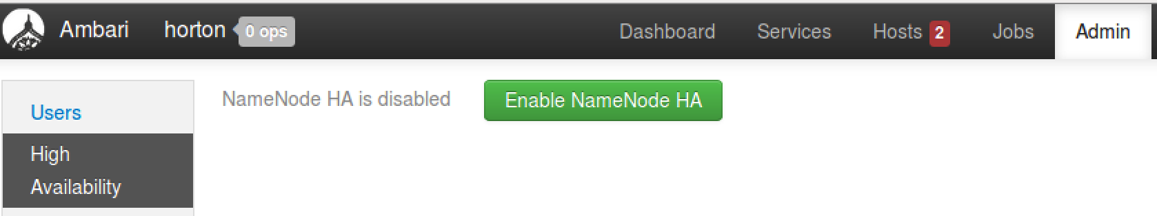
  - Enter HACluster as the Nameservice ID for your NameNode HA cluster. (The name must consist of one word and not have any special characters.) Click the Next button:
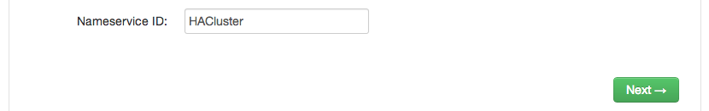
  - Choose node4 as the Additional NameNode:
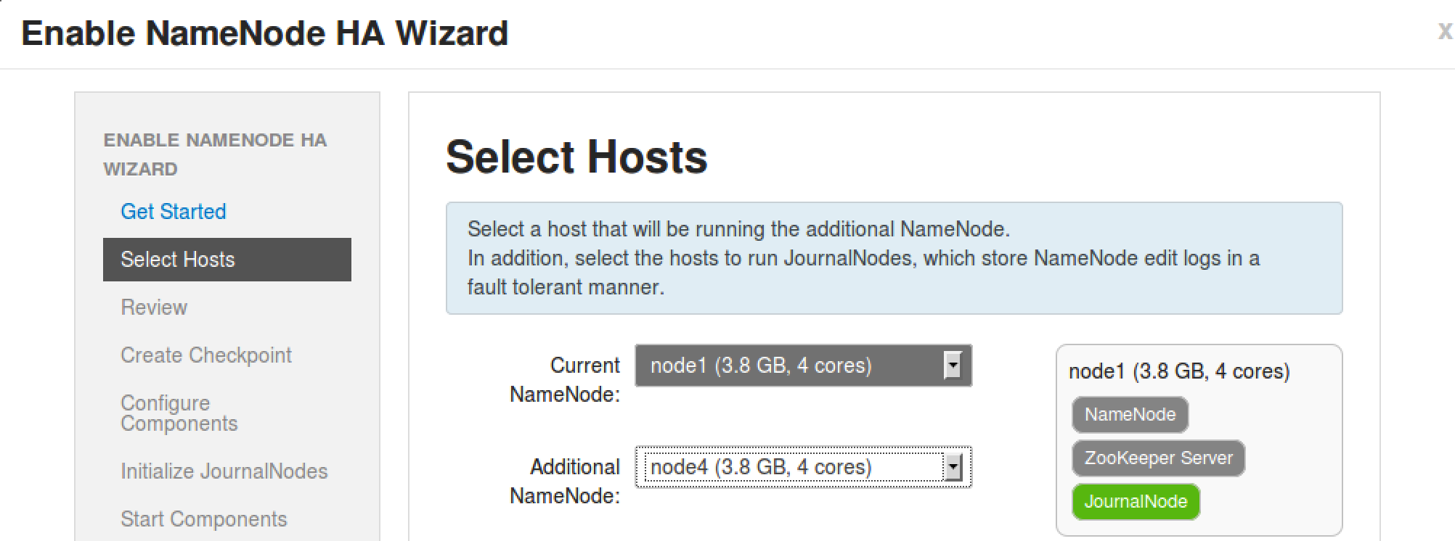
  - Click the Next button.
  - Notice that a Secondary NameNode is not allowed if you have NameNode HA configured. Ambari takes care of this for you, as you can see on the Review step of the wizard:
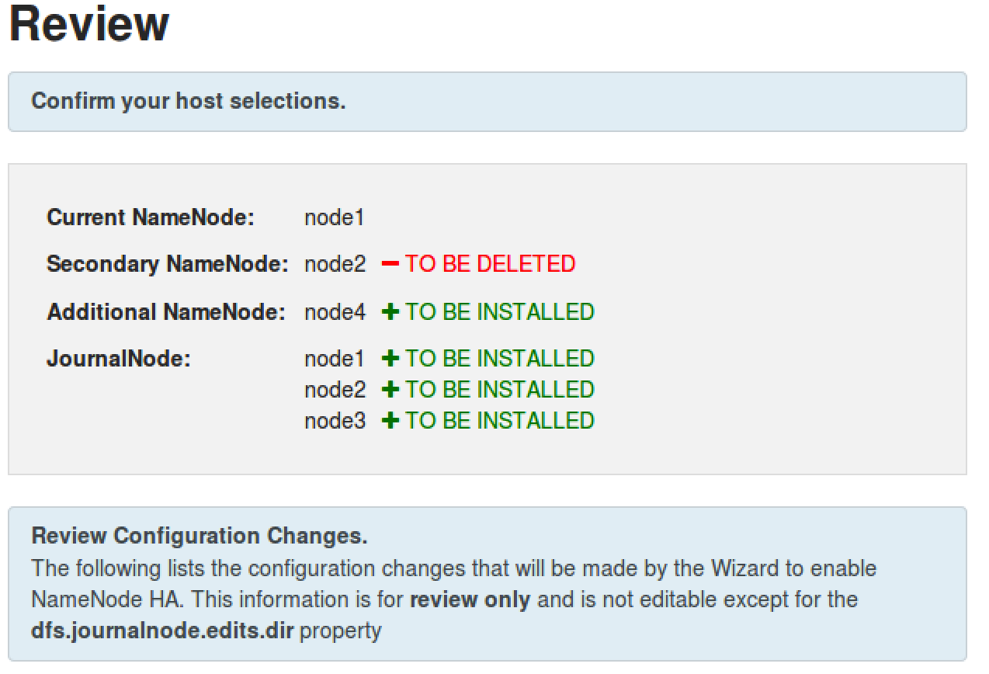
  - Review changes in the configuration and click the Next button to continue the wizard.
- Perform the Manual Steps
  - Notice the Enable NameNode HA Wizard is requiring you to perform some manual steps before you are able to continue.
  - Start by SSH-ing into node1.
  - Put the NameNode in Safe Mode:
# sudo su -l hdfs -c 'hdfs dfsadmin -safemode enter'
  - Create a Checkpoint:
# sudo su -l hdfs -c 'hdfs dfsadmin -saveNamespace'
  - Once Ambari recognizes that your cluster is in Safe Mode and a Checkpoint has been made, you will be able to click the Next button.
- Wait for the Configuration
  - At this point, Ambari will stop all services, install the necessary components, and restart the services. Wait for these tasks to complete:
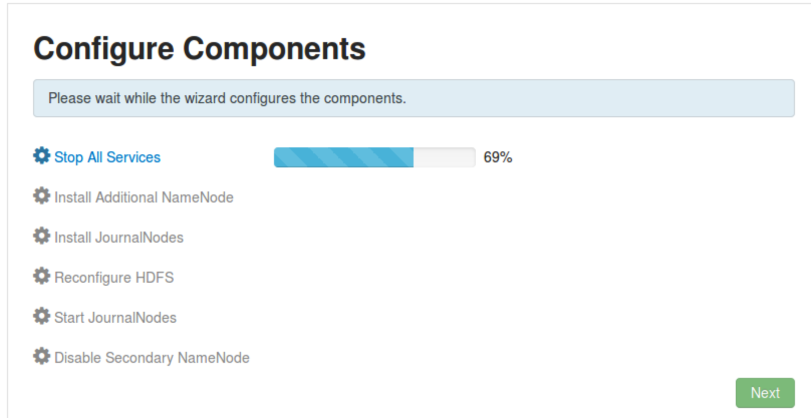
  - Once all the tasks are complete, click the Next button.
- Initialize the JournalNodes
  - On node1, enter the command shown in the wizard to initialize the JournalNodes:
# sudo su -l hdfs -c 'hdfs namenode -initializeSharedEdits'
  - Once Ambari determines that the JournalNodes are initialized, you will be able to click the Next button:
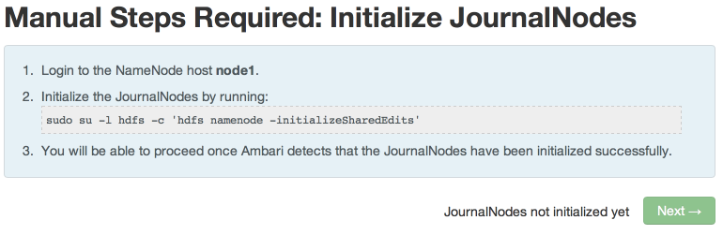
- Start the Components
  - In the next step, Ambari will start ZooKeeper and the NameNode service. Click Next when its complete:
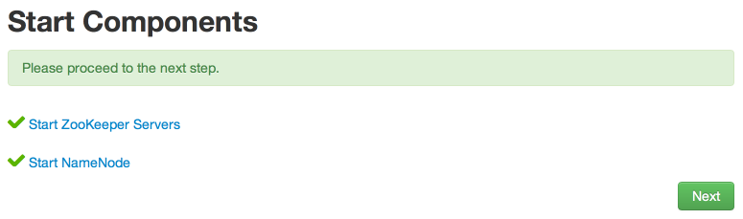
- Initialize NameNode HA Metadata
  - On node1, enter the command shown in the wizard to configure the metadata for automatic failover:
# sudo su -l hdfs -c 'hdfs zkfc -formatZK'
  - On node4, run the command to initialize the metadata for the new NameNode:
# sudo su -l hdfs -c 'hdfs namenode -bootstrapStandby'
  - Click the Next button to continue.
- Wait for the Wizard to Finish
  - In this final step, the wizard will start all required services and delete the Secondary NameNode:
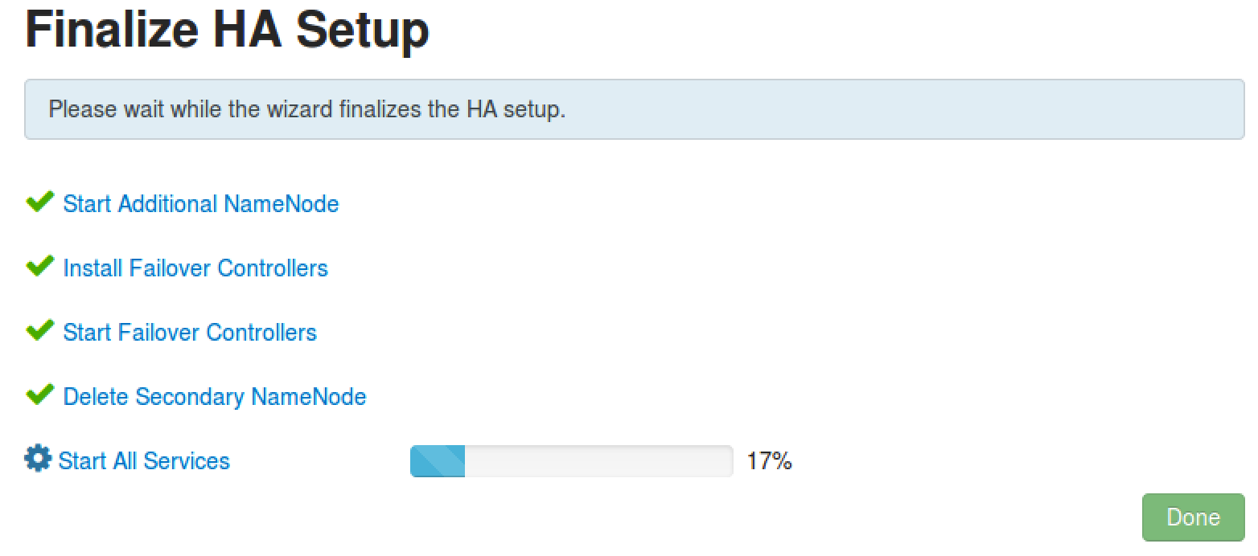
  - Click the Done button when all the tasks are complete.
- Verify the Standby NameNode
  - Go to the HDFS service page. You should see an Active NameNode and a Standby NameNode:
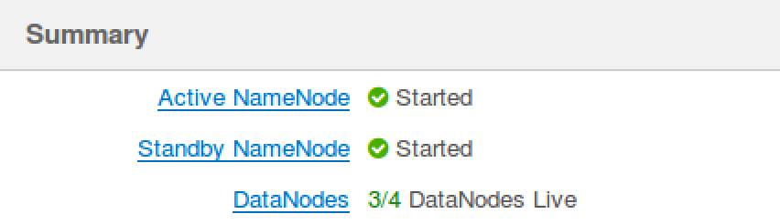

- Test NameNode HA.
  - Go the Host page of node1 in Ambari.
  - Next to the Active NameNode component, select Stop from the Action menu:
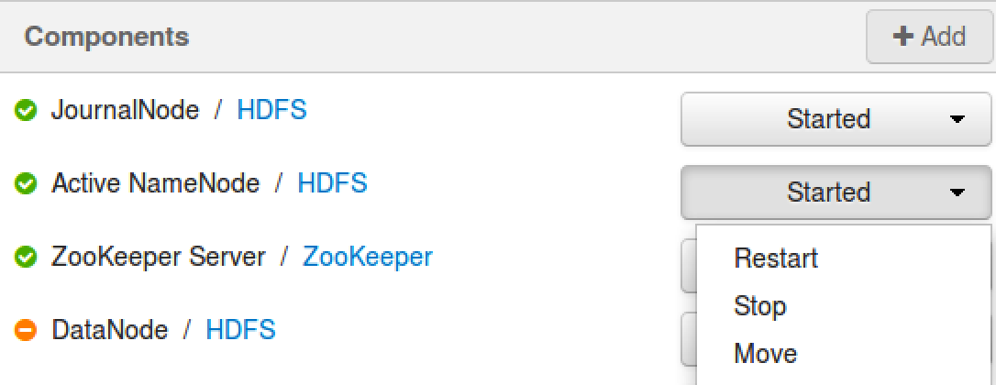
  - Go back the HDFS page in Ambari. Notice the Standby NameNode has become the Active NameNode:
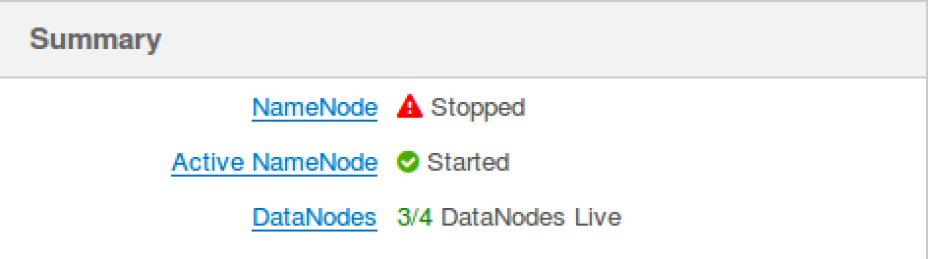
  - Now start the stopped NameNode again, and you will notice that it becomes a Standby NameNode:
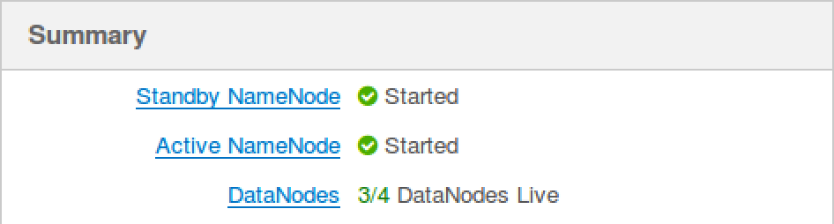

RESULT: You now have NameNode HA configured on your cluster, and you have also verified that the HA works when one of the NameNodes stops.

Lab: Add a New Host to the Cluster

Objective: | Add an additional node to a cluster.
Successful Outcome: | hadoop-slave will be added to your Hadoop cluster as a DataNode.
Before You Begin: | Your 3-node cluster should have Hadoop successfully installed.

NOTE: this lab includes RESIZE of Hadoop Docker clusters

- Login to Ambari
  - If you are not logged in already, login to the Ambari Dashboard of your cluster at [localhost]:8080.
- Run the Add Hosts Wizard
  - Click on the Hosts tab of Ambari.
  - Click on the Action Dropdown and choose Add New Hosts option to start the Add Host Wizard:
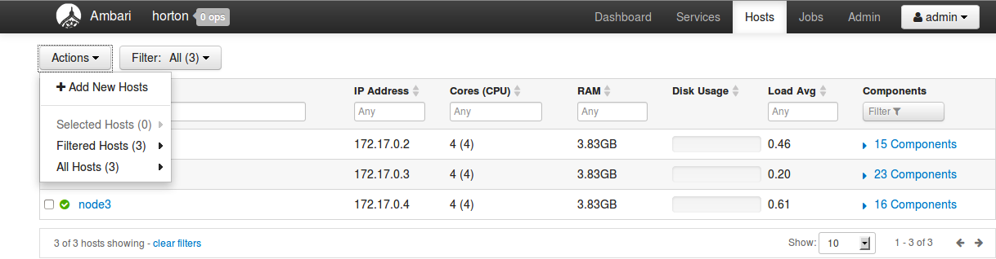
- Complete the Add Host Wizard
  - You have seen this wizard before when you installed HDP, so we will provide only a few hints in this lab. Read through the following hints before running the wizard.
  - The hostname of the node you are adding is node4.
  - On the Assign Slaves and Clients step, choose only the Client option.
- Verify the New Host
  - Go to the Hosts page of Ambari. You should see all four of your nodes now listed.

RESULT: You have added a new node to the cluster and Hadoop is installed on it. In a later lab, you will commission this node as a DataNode.

Lab: Securing a Hadoop Cluster

Objective: | To understand how to configure security for HDP.
Successful Outcome: | The hadoop user will be authenticated and authorized to view the contents of the /user folder in HDFS.
Before You Begin: | SSH into hadoop-master.

- Create a New User
  - On hadoop-slave1 as root, create a new user named hadoop:
# useradd -g hadoop hadoop
  - Switch to the hdfs user and create a new directory in HDFS named /user/hadoop.
  - Change ownership of /user/hadoop in HDFS to the hadoop user.
  - Exit out from the hdfs user, and switch to the hadoop user.
  - Check whether you can do a listing of the /user directory successfully:
$ hadoop fs -ls /user
  - Exit out from the hadoop user.
NOTE: The current cluster is not a secure cluster so you can easily do a listing of the /user directory in HDFS successfully.
- Install Kerberos
  - As the root user on hadoop-slave1, install the following packages:
# yum -y install krb5-server krb5-libs krb5-auth-dialog krb5-workstation
  - Login to hadoop-slave2, hadoop-slave3 and hadoop-slave4 and install the Kerberos client only:
# yum -y install krb5-workstation
- Configure Kerberos
  - On hadoop-slave1, edit the configuration file /etc/krb5.conf and modify the value for kdc and admin_server to hadoop-slave1:
# vi /etc/krb5.conf

[realms]
EXAMPLE.COM = {
kdc = hadoop-slave1
admin_server = hadoop-slave1
}
  - Copy the /etc/krb5.conf file to all the other nodes:
# ~/scripts/distFile.sh /etc/krb5.conf /etc/krb5.conf
  - Enter the following command to create a Kerberos database using the kdb5_util utility:
# kdb5_util create -s
During this step it will ask you to define a master key. Enter 1234 as the key.
- Start Kerberos
  - Start the KDC server by executing following commands:
# /etc/rc.d/init.d/krb5kdc start
# /etc/rc.d/init.d/kadmin start
- Run the Enable Security Wizard
  - In Ambari, go the Admin page and click on the Security link:
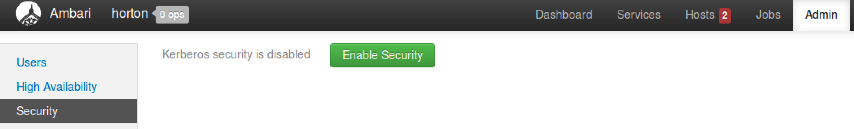
  - Click the Enable Security button.
  - Notice on the Get Started step of the Enable Security Wizard there are four manual steps that must be completed first. We have already executed the first 2 steps. For the remaining 2 steps, click the Next button.
  - The default settings on the Configure Services step of the wizard are fine, so click Next to continue.
- Create the Principals and Keytabs
  - On the Create Principals and Keytabs step of the wizard, all the required default settings for Kerberos are shown in a tabular format. Click the Download CSV button at the bottom of the page and save the file:
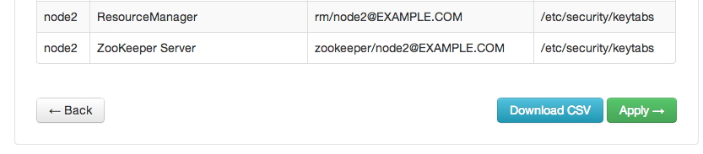
  - Exit from hadoop-slave1, so that you will be no more on any node. The command prompt should show root@ubutnu:
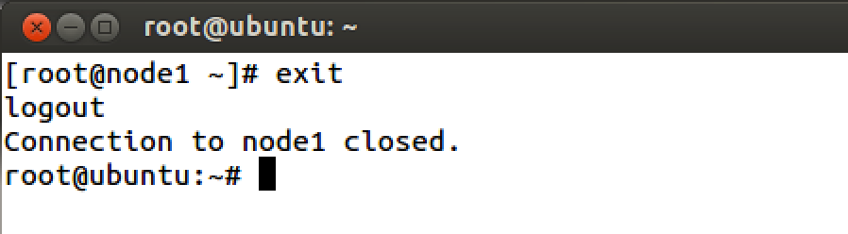
  - Execute following command to copy CSV file to hadoop-slave1 (type this command in one line):
# scp Downloads/host-principal-keytab-list.csv hadoop-slave1:scripts/kerberos.csv
  - Now login back to hadoop-slave1 and navigate to /root/scripts folder. You must see kerberos.csv file there.
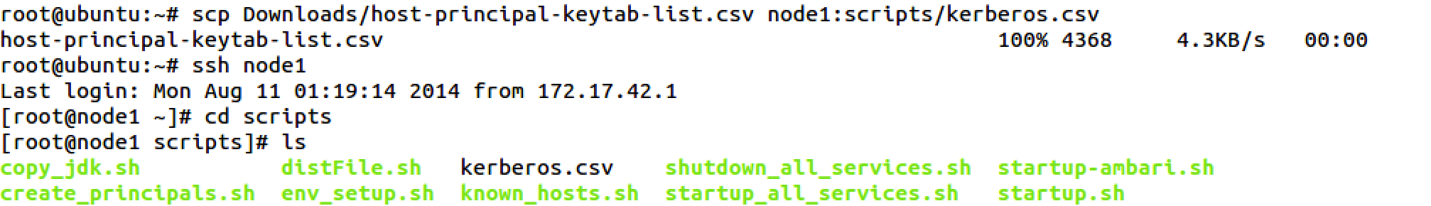
  - Run the pre-written script to create all required principals and keytabs. It will ask for the location of the CSV file you created. Provide the full path (/root/scripts/Kerberos.csv) to the file:
# /root/scripts/create_principals.sh
NOTE: This step will create all required principals and keytab files on all the nodes. Once you are done with the step, go back to Ambari UI.
- Finish the Enable Security Wizard
  - We have completed all 4 required steps. Now it is time to enable security through Ambari. Click the Apply button.
  - The Save and Apply Configuration step can take 5-10 minutes. When the task is complete, click the Done button:
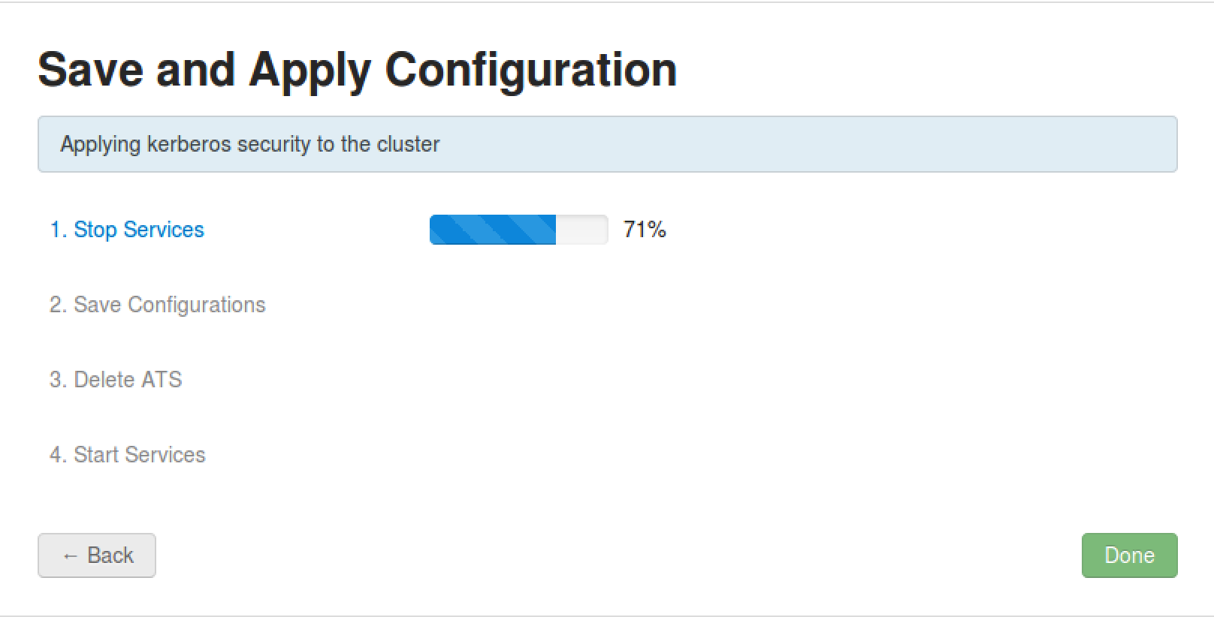
- Verify Security is Enabled
  - On hadoop-slave1, switch to the hadoop user and try to list the contents of /user in HDFS:
# su - hadoop
$ hadoop fs -ls /user
The command should throw an error.
- Configure User Permissions
  - Logout from ‘hadoop’ user.
  - As the root user, add hadoop to the Kerberos database. Start the kadmin service by typing following:
# kadmin.local
  - Type following command to create a hadoop principal:
kadmin.local: addprinc -randkey hadoop@EXAMPLE.COM
  - Now create a keytab file in the /etc/security/keytabs directory using the following command:
kadmin.local: xst -norandkey -k /etc/security/keytabs/hadoop.headless.keytab hadoop@EXAMPLE.COM

kadmin.local: exit
  - Set appropriate permissions for the keytab file for the hadoop user:
# chown hadoop:hadoop /etc/security/keytabs/hadoop.headless.keytab

# chmod 440 /etc/security/keytabs/hadoop.headless.keytab
  - Switch to the hadoop user and initialize the keytab file:
# su - hadoop
$ kinit -kt /etc/security/keytabs/hadoop.headless.keytab hadoop@EXAMPLE.COM
  - Now try to list the contents of /user in HDFS again. This time you should be able to view the folder’s contents!

RESULT: You have enabled Kerberos security for your HDP cluster.

Lab: Configuring the Capacity Scheduler
Objective: | Learn how to define and configure queues for the Capacity Scheduler.
Successful Outcome: | You will have two new queues configured.
Before You Begin: | Your cluster should be up and running.

- View the Status of the Capacity Scheduler
  - Point your web browser to http://[server]:8088 to view the UI of the Resource Manager.
  - In the menu on the left side, click on the Scheduler link to view the current status of the Capacity Scheduler:
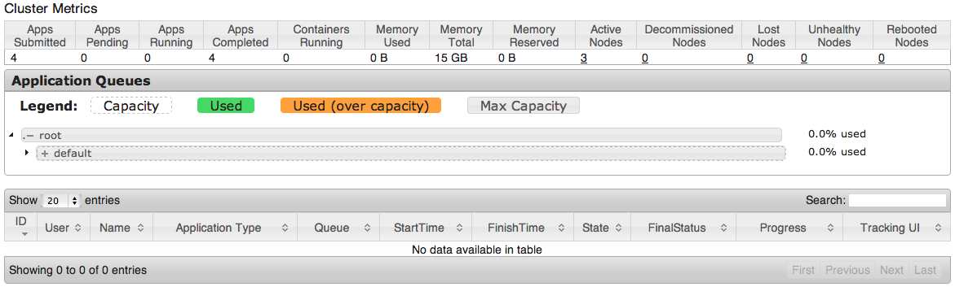
  - Notice there is one child queue of root defined. What is the name of the queue? _________________
  - Click on the arrow to the left of “default” to expand and view the settings of the default queue:
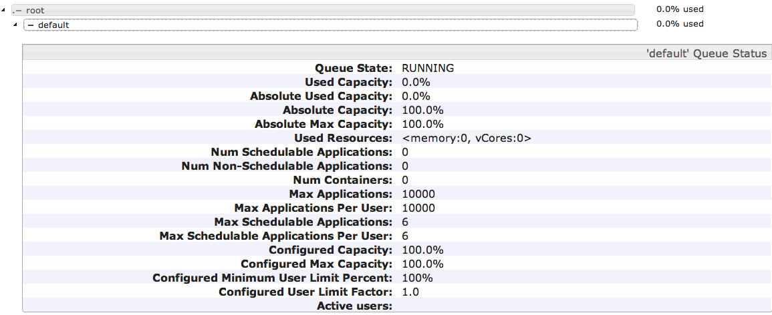
  - Notice since there are no jobs running on your cluster, the status page simply shows 0.0% of default is being used right now.
- View the Settings of the Capacity Scheduler
  - Go to the Ambari Dashboard page (port 8080).
  - Click on the YARN link in the list of services, then click on the Configs tab and scroll down to the Scheduler section:
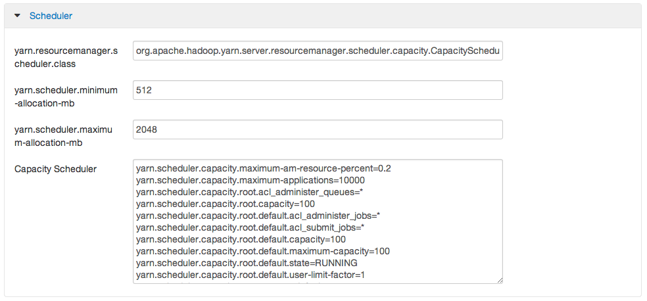
  - Notice this is where you configure the settings for the scheduler of the Resource Manager. Which type of scheduler is currently being used? ________________________________________
- Define Custom Queues
  - From the Configs tab of the YARN Services page, add two new queues named A and B to the Capacity Scheduler (and leave the default queue defined also):
yarn.scheduler.capacity.root.queues=default,A,B
  - Assign the following capacities to the three queues:
default capacity = 20%
A capacity = 50%
B capacity = 30%
  - Assign the following maximum capacities to the three queues:
default maximum capacity = 100%
A maximum capacity = 70%
B maximum capacity = 50%
  - Save your changes by clicking the Save button at the bottom of the page. You should see the following confirmation dialog:
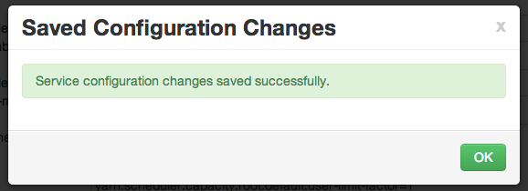
  - Click OK to close the dialog window.
- ReStart YARN
  - Go back to the Summary page of YARN and click the Start button to start the YARN service again.
- Verify the Changes
  - Go back to the Scheduler web page at http://[localhost]:8088/cluster/scheduler.
  - You should see the A and B queues now:
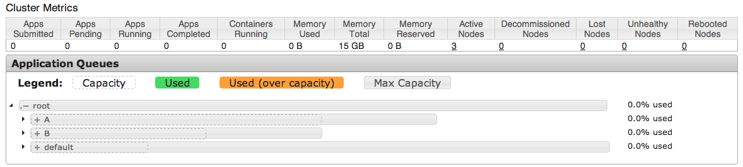
  - Expand the A queue and verify its capacity is 50% and its maximum capacity is 70%:

  - Similarly, verify B and default are configured correctly.
  - Leave this web page open - you are going to view it in the next step.
- Submit a Job to a Specific Queue
  - Let’s submit a MapReduce job to each new queue. SSH into hadoop-master, and change directories to the /root/labs folder:
[root@node1 ~]# cd ~/labs
  - Make sure environment variable JAVA_HOME is defined, so enter the following command:
# export JAVA_HOME=/usr/jdk64/jdk1.6.0_31/
  - Make sure you have a file in /user/root in HDFS named hbase.jar. If not, put the HBase jar from the labs folder into HDFS, giving it the name hbase.jar.
  - In the first window, submit the test1.pig script to queue A by running the following command (all on a single line):
# pig -Dmapreduce.job.queuename=A test1.pig 1>pig1.out &>pig1.err &
  - While test1.pig is running, submit the test2.pig script to queue B in the other terminal window:
# pig -Dmapreduce.job.queuename=B test2.pig 1>pig2.out &>pig2.err &
  - While both jobs are running, refresh the Scheduler status page. (It may take a minute for both jobs to run long enough to show up in the queues, so refresh the page often until they do):
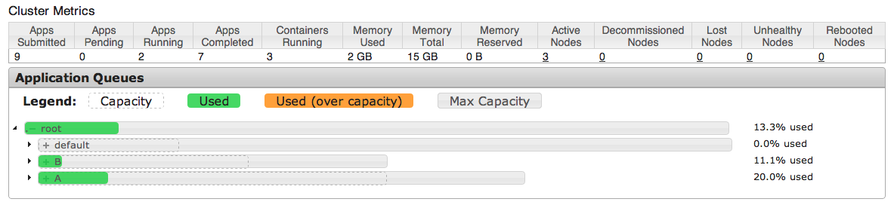
  - You should see resources being used in both the A and B queues.

RESULT: You just defined two queues for the Capacity Scheduler, configured specific capacities for each queue, and submitted a job to each queue.

ANSWERS:
1.3: default
2.3: The Capacity Scheduler

Lab: Using HDFS Snapshots

Objective: | Understand how snapshots work in Hadoop.
Successful Outcome: | The data folder has a snapshot taken of it.
Before You Begin: | SSH into node1.

- Load a File into HDFS
  - Start by creating a new directory in HDFS:
# hadoop fs -mkdir data
  - Put a file in the new directory:
# hadoop fs -put ~/labs/constitution.txt data/
  - Run the fsck command on the file:
# hdfs fsck /user/root/data/constitution.txt -files -blocks -locations
Select-and-copy the block ID.
  - Use the find command to identify the location of the block on your local file system. The command will look like the following, and you may need to run it on node2 or node3:
# find / -name "blk_ 1073743186"
  - Which node and folder is the block stored in? ________________________
- Enable Snapshots
  - Now let’s enable the /user/root/data directory for taking snapshots:
# su -l hdfs -c "hdfs dfsadmin -allowSnapshot /user/root/data"
You should see the following confirmation:
Allowing snaphot on /user/root/data succeeded
- Create a Snapshot
  - Now create a snapshot of /user/root/data:
# hdfs dfs -createSnapshot /user/root/data ss01
You should see the following confirmation:
Created snapshot /user/root/data/.snapshot/ss01
  - Verify the snapshot was created by viewing the contents of the data/.snapshot folder:
# hadoop fs -ls -R data/.snapshot
drwxr-xr-x - root hadoop 0 data/.snapshot/ss01
-rw-r--r-- 3 root hadoop 44841 data/.snapshot/ ss01/constitution.txt
  - Try to delete the data folder:
# hadoop fs -rm -R data
You cannot delete the folder. Why not? _________________________________
- Delete the File
  - Delete the constitution.txt file in data:
# hadoop fs -rm data/constitution.txt
  - Use the ls command to verify the file is no longer in the data folder in HDFS.
  - Check whether the file still exists in /user/root/data/.snapshot/ss01. It should still be there.
  - Run the same find command again that you ran in the earlier step. Does the block file still exist on your local file system? _____________________________
- Recover the File
  - Let’s copy this file from data/.snapshot/ss01 to the data directory.
# hadoop fs -cp data/.snapshot/ss01/constitution.txt data/
  - Run the fsck command again on data/constitution.txt. Notice that the block and location information have changed for this file.
  - Run the find command for the new blocks. Notice the blocks for the constitution.txt file appear in two locations on your local file system (before deleting the file and after copying the file).

RESULT: This lab demonstrates how the snapshot process locks down the blocks from deleting and editing, and the blocks are always available in case you need to recover your file in future.

Answers:
Step 1.5: In a subfolder of: /hadoop/hdfs/data/current/
Step 3.3: The command should read:
# hadoop fs -rm –R –skipTrash data
Step 4.4: Yes

Lab: Commissioning & Decommissioning Services
Objective: | Commission a new DataNode to an existing cluster, and also decommission a node.
Successful Outcome: | A hadoop-slave is successfully added to your cluster as a DataNode, and hadoop-master is successfully decommissioned from the cluster.
Before You Begin: | Open the Ambari UI (port 8080)

- Copy a significant big directory to HDFS
  - Copy /root/repo directory to HDFS.
- Commission a New DataNode.
  - Go to the Hosts page of Ambari.
  - Click on the host for hadoop-slaveX.
  - Click on the + Add button and select DataNode:
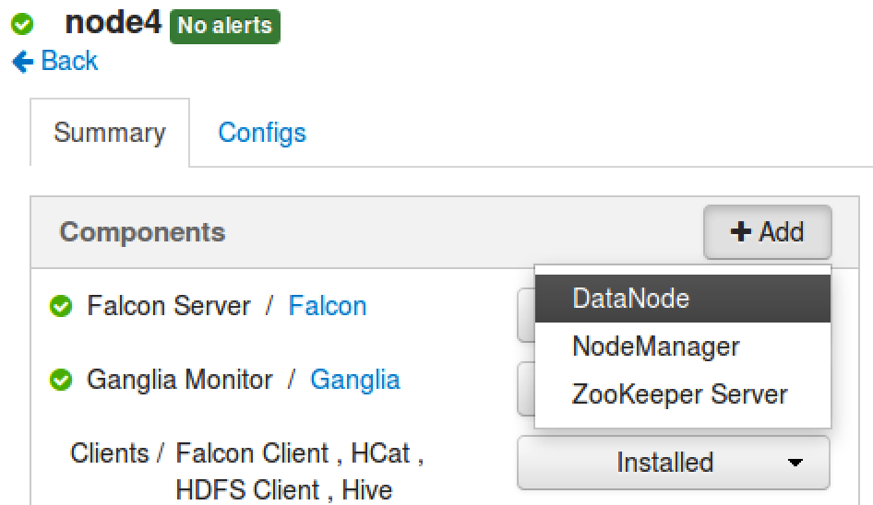
  - Click ‘Confirm Add’ when the confirmation dialog appears.

  - Wait for the DataNode component to be installed. When the install is complete, DataNode should appear in the list of Components on hadoop-slaveX:
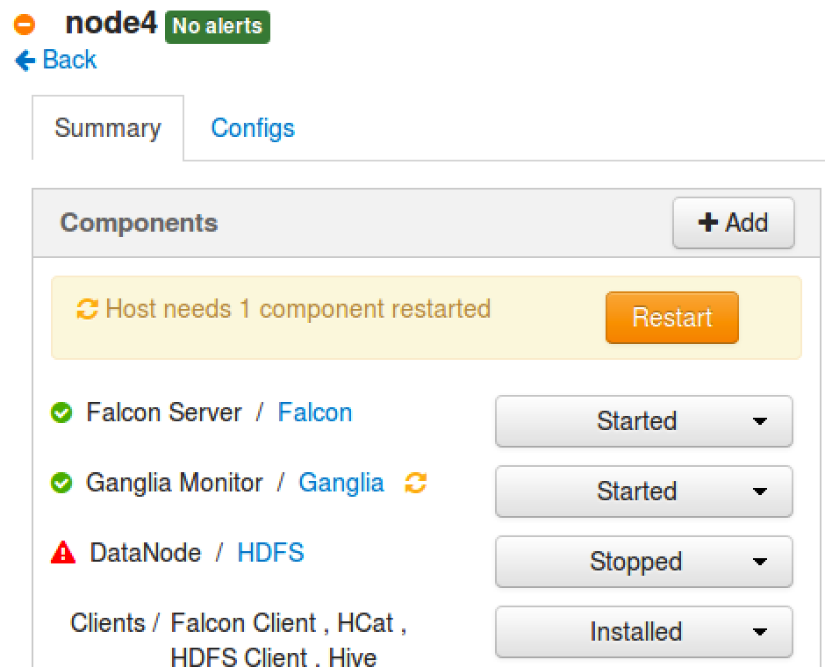

- Start the DataNode
  - Click on the Action menu next to DataNode and choose Start.
  - Wait for the DataNode service to start.
- Click on Restart button to start any dependent services. Also restart Ganglia and Nagios services if “restart” icon is there on Ambari Dashboard.
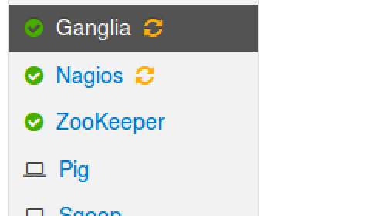
- Verify the Commissioned Node
  - Once the DataNode is started successfully on hadoop-slaveX, go back to the Ambari Dashboard. You should see 4 live DataNodes:
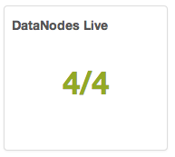

- Run the Balancer
  - Go to the NameNode UI. Notice it also shows 4 live DataNodes.
  - Click on Live Nodes link.
  - Notice that the new DataNode does not have any data blocks currently.
  - Run following command to run the balancer process on your cluster:
# su -l hdfs -c "hdfs balancer -threshold 1"
  - Wait a couple minutes for the balancer to even out the block storage. You will see at the command prompt as blocks get moved from one node to another:
INFO balancer.Balancer: 0 over-utilized: []
INFO balancer.Balancer: 1 underutilized: [BalancerDatanode[10.222.133.205:50010, utilization=0.40288804420577484]]
INFO balancer.Balancer: Need to move 173.74 MB to make the cluster balanced.
INFO balancer.Balancer: Decided to move 89.95 MB bytes from 10.170.202.246:50010 to 10.222.133.205:50010
INFO balancer.Balancer: Decided to move 151.79 MB bytes from 10.174.49.252:50010 to 10.222.133.205:50010
INFO balancer.Balancer: Will move 241.74 MB in this iterationINFO balancer.Balancer: Moving block 1073742573 from 10.174.49.252:50010 to 10.222.133.205:50010 through 10.174.50.60:50010 is succeeded.
INFO balancer.Balancer: Moving block 1073742572 from 10.174.49.252:50010 to 10.222.133.205:50010 through 10.174.50.60:50010 is succeeded.
...
  - Refresh the Live Nodes page of the NameNode UI. Your hadoop-slaveX DataNode should now have blocks on it, and the number of blocks will gradually increase as the balancer app continue to even out the block storage on your cluster.
NOTE: The balancer app will run for a long time. Just leave the process open in your terminal window. If you need to perform any future tasks on hadoop-master, just open a new terminal window.

- Decommission a DataNode
  - From the Hosts page of Ambari, click on the host for hadoop-master.
  - In the Components section, click on the Action menu next to DataNode and select Decommission:
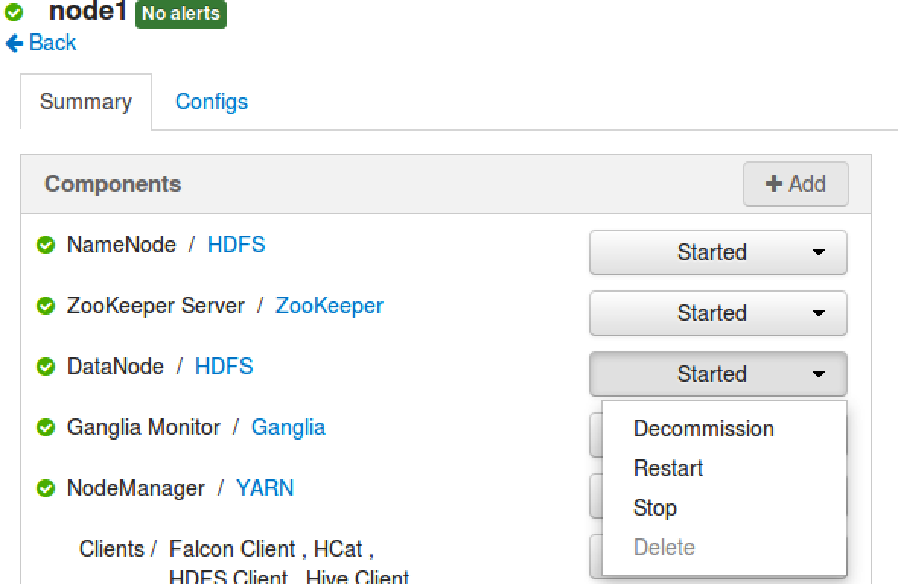
  - Click OK in the confirmation dialog, and wait for the decommissioning task to complete.
NOTE: There is a minimal chance that the decommissioning task may fail due to a known bug in Hadoop 2.0 where the node contains a block that belongs to a file with a replication factor larger than the rest of the cluster size. The work-around is to locate and delete any files that have a replication factor larger than 3. View https://issues.apache.org/jira/browse/HDFS-5662 for more details.

- View the NameNode UI
  - Go to the Namenode UI. Notice that Decommissioning Nodes is 1 and Live Nodes is still X:
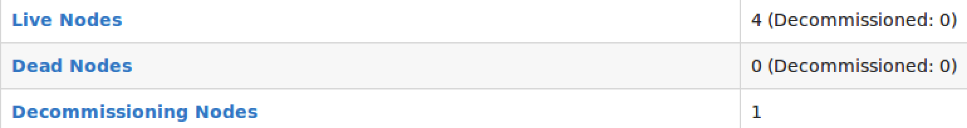
  - Click on Decommissioning Nodes and it will show that hadoop-master is undergoing the decommission process.
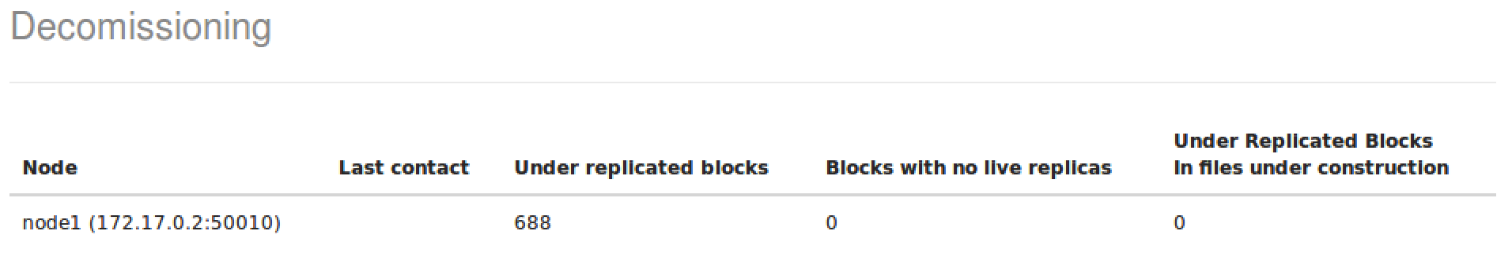
  - You will also see that blocks are gradually being copied from hadoop-master to the other nodes. The Admin State of hadoop-master is going to be either Decommission in Progress or Decommissioned. Refresh the page until the status is Decommissioned.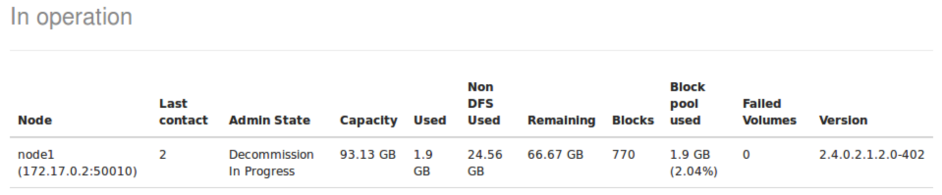
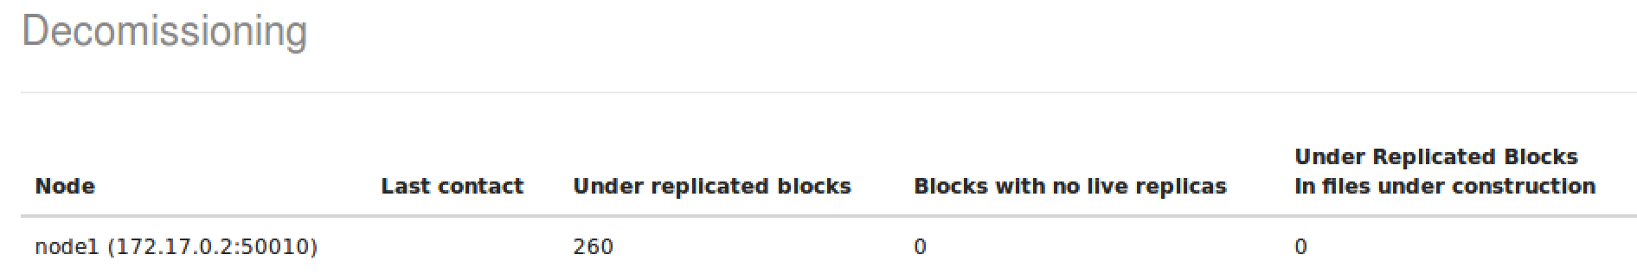
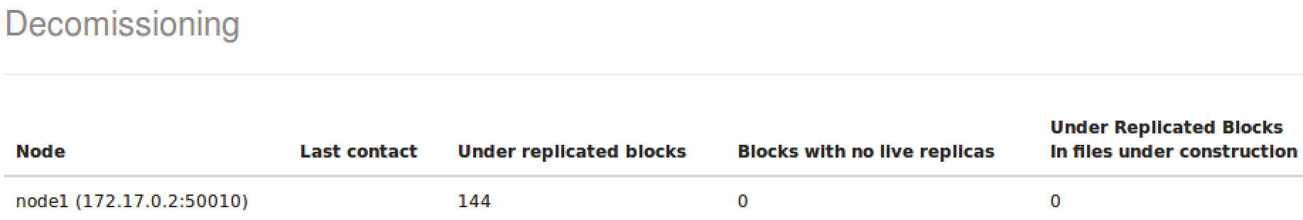
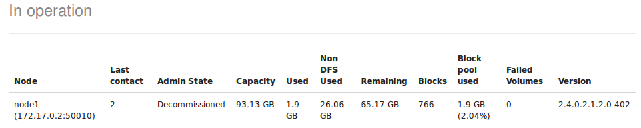

  - Go back to the NameNode UI page. Notice you have 4 Live Nodes, and 1 of them is Decommissioned:

- Stop the DataNode
  - Once the decommissioning process is complete, go back to the Hosts page for hadoop-master in Ambari.
  - In the Action menu next to DataNode, select Stop:
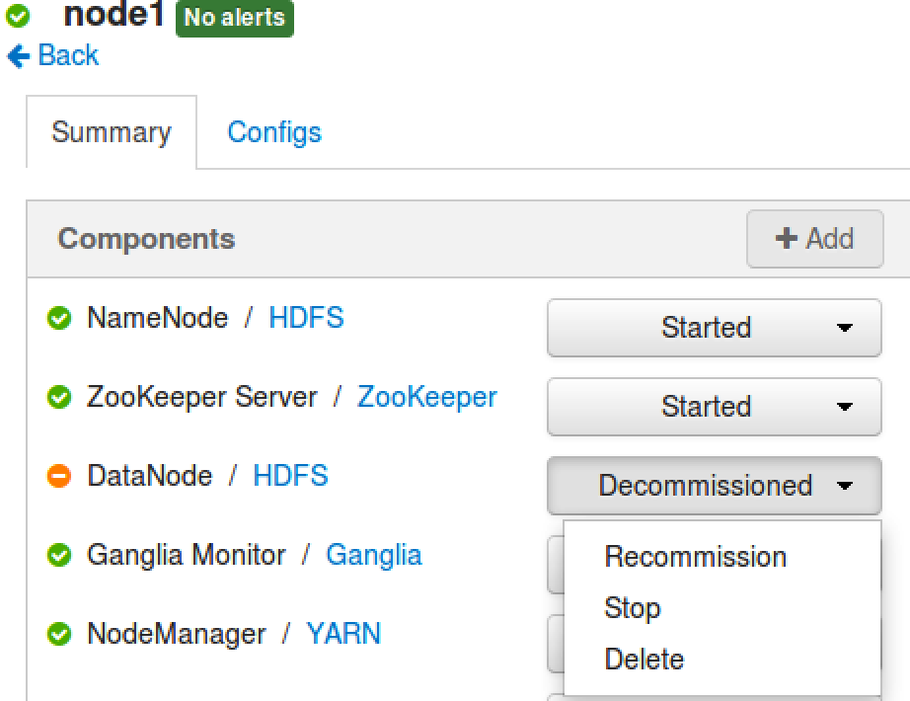

  - From the Ambari Dashboard page, you should see 3/4 live DataNodes:
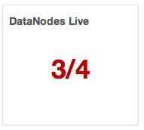
NOTE: You can decommission/commission a nodemanager also in the same way.

RESULT: You have now seen how to commission a new DataNode, and also how to run the balancer tool to balance the blocks across a cluster once new DataNodes are commissioned. You also have decommissioned one of the DataNodes from your cluster.

Lab: Configuring Rack Awareness

Objective: | Configure a Hadoop cluster to be rack-aware.
Successful Outcome: | Each node in your cluster will be assigned to a rack.
Before You Begin: | SSH into hadoop-master.

- View the Current Rack Awareness
  - Check out how many racks are being recognized by the cluster by running the fsck command:
$ su - hdfs
$ hdfs fsck –racks
Notice you only have one rack in your cluster:
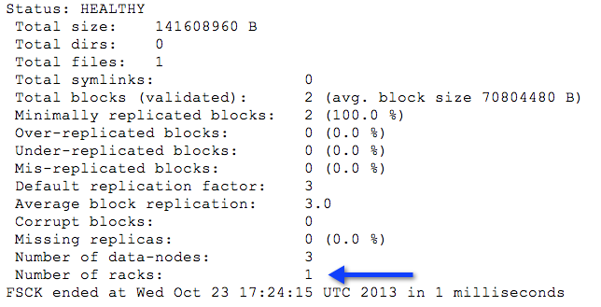
  - Switch back to the root user.
- View the rack-topology Script
  - On hadoop-master, change directories to ~/labs.
  - View the contents of rack-topology.sh.sample, a sample rack topology script provided for you:
#!/bin/bash

ipaddr=$1

rack=`echo $ipaddr | cut -f1-3 -d '.' `

if [ -z "$rack" ] ; then
echo -n "/default-rack"
else
echo -n "/$rack"
fi
NOTE: this script calculates the rack name using the IP address of the node. The first three parts of the IP address become its rack name. For example: if 192.168.1.100 is the IP address, then the rack name would be /192.168.1.
- Configure the Rack Script
  - Copy the script to directory /etc/hadoop/conf as rack-topology.sh:
# cp rack-topology.sh.sample
/etc/hadoop/conf/rack-topology.sh
  - Edit core-site.xml and add the following properties:
<property>
<name>topology.script.file.name</name>
<value>/etc/hadoop/conf/rack-topology.sh</value>
</property>

<property>
<name>topology.script.number.args</name>
<value>1</value>
</property>
  - Distribute both rack-topology.sh and the modified core-site.xml file to all the nodes in the cluster:
# ~/scripts/distFile.sh rack-topology.sh /etc/hadoop/conf
# ~/scripts/distFile.sh core-site.xml /etc/hadoop/conf
  - Restart the NameNode so your changes to core-site.xml take effect:
# su -l hdfs -c "/usr/lib/hadoop/sbin/hadoop-daemon.sh stop namenode"
# su -l hdfs -c "/usr/lib/hadoop/sbin/hadoop-daemon.sh start namenode"
- Verify the Rack Awareness
  - Look in the NameNode log after starting the NameNode service. Identify the following lines by running the grep command:
# grep 'Adding' /var/log/hadoop/hdfs/hadoop-hdfs-namenode-hadoop-master.log
  - Notice the prior entries for “Adding a new node” used the default-rack, but now your nodes should each be in the appropriate rack from the rack-topology.sh script:
INFO net.NetworkTopology (NetworkTopology.java:add(413)) - Adding a new node: /10.174.50/10.174.50.60:50010
INFO net.NetworkTopology (NetworkTopology.java:add(413)) - Adding a new node: /10.170.202/10.170.202.246:50010
INFO net.NetworkTopology (NetworkTopology.java:add(413)) - Adding a new node: /10.174.49/10.174.49.252:50010
Notice the rack names are in bold in the output above.
  - Run the fsck command. You should see 3 racks now:
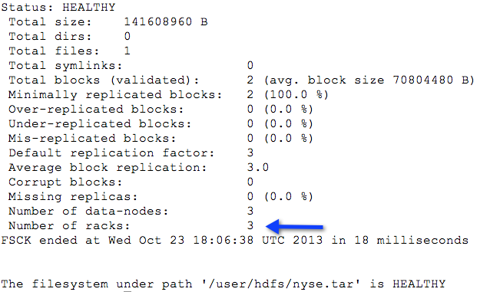

RESULT: The nodes in your cluster are now each assigned to a rack, and the rack assignment takes place automatically using the rack-topology.sh script. You can write your own custom script for automatically determining the appropriate rack names for your cluster nodes.

Lab: Running an Oozie Workflow
Objective: | Deploy and run an Oozie workflow
Successful Outcome: | You will run an Oozie job that executes a Pig script and a Hive script.
Before You Begin: | SSH into hadoop-master.

- View the Raw Data
  - On hadoop-master, change directories to the oozielab folder:
# cd ~/labs/oozielab/
  - Unzip the archive in the oozielab folder, which contains a file named whitehouse_visits.txt that is quite large:
# unzip whitehouse_visits.zip
  - View the contents of this file:
# tail whitehouse_visits.txt
This publicly available data contains records of visitors to the White House in Washington, D.C.
- Load the Data into HDFS
  - Make a new directory in HDFS named whitehouse. (If you already have a whitehouse folder in HDFS, delete it first):
# hadoop fs -rm -R whitehouse
# hadoop fs -mkdir whitehouse
  - Use the put command in the Grunt shell to copy the whitehouse_visits.txt file the whitehouse folder in HDFS, renaming the file visits.txt. (Be sure to enter this command on a single line):
# hadoop fs -put whitehouse_visits.txt whitehouse/visits.txt
  - Use the ls command to verify the file was uploaded successfully:
# hadoop fs -ls whitehouse
Found 1 items
-rw-r--r-- 3 root root 183292235 whitehouse/visits.txt
- Configure Oozie User Permissions
  - In Ambari, go to the Services page and click the Stop All button (or use the shutdown script in the /root/scripts folder).
  - Go the HDFS page in Ambari, then scroll down and expand the Custom core-site.xml section.
  - The Oozie workflow you defined is going to be executed by the root user, so root needs permission to communicate with the Oozie server. Add root to the hadoop.proxyuser.oozie.groups property:
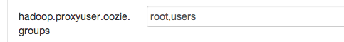
  - Click the Add Property... link and add two properties. Assign the hadoop.proxyuser.root.hosts property to * and also the hadoop.proxyuser.root.groups:
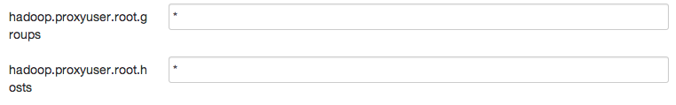
  - Click the Save button to save your changes to the HDFS config.
  - Restart all dependent services as marked in Services tab.
- Deploy the Oozie Workflow
  - SSH into hadoop-master.
  - View the file workflow.xml in /root/labs/oozielab.
  - How many actions are in this workflow? _____________
  - Which action will execute first? _________________
  - If the first action is successful, which action will execute next? ____________
  - To deploy this workflow, we need a directory in HDFS:
# hadoop fs -mkdir congress
  - Put congress_visits.hive and whitehouse.pig from the oozielab folder into the new congress folder in HDFS.
  - Also, put workflow.xml into the congress folder.
  - If you look at the Hive action in workflow.xml, you will notice that it references a file named hive-site.xml within the <job-xml> tag. This file represents the settings Oozie needs to connect to your Hive instance, and the file needs to be deployed in HDFS (using a relative path to the workflow directory). Put hive-site.xml into the congress directory:
# hadoop fs -put /etc/hive/conf/hive-site.xml congress
  - Verify you have four files now in your congress folder in HDFS:
# hadoop fs -ls congress
Found 4 items
-rw-r--r-- 3 root root 429 congress/congress_visits.hive
-rw-r--r-- 3 root root 3509 congress/hive-site.xml
-rw-r--r-- 3 root root 580 congress/whitehouse.pig
-rw-r--r-- 3 root root 1623 congress/workflow.xml
- Define the OOZIE_URL Environment Variable
  - Although not required, you can simplify oozie commands by defining the OOZIE_URL environment variable. From the command line, enter the following command:
# export OOZIE_URL=http://hadoop-master:11000/oozie
- Define the Job Properties
  - View the contents of job.properties in oozielab.
  - Notice the oozie.wf.application.path property points to the congress folder in HDFS. This property is how you denote which Oozie job is going to execute.
  - Make sure the resourceManager and nameNode properties are defined properly.
- Run the Workflow
  - From the oozielab folder, run the workflow with the following command:
# oozie job -config job.properties -run
If successful, the job ID should be displayed at the command prompt.
- Monitor the Workflow
  - Point your Web browser to the Oozie Web Console:
http://hadoop-master:11000/oozie/
You should see your Oozie job in the list of Workflow Jobs:
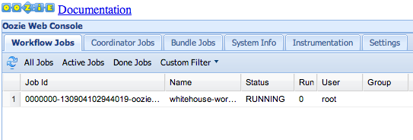

  - Double-click on the Job Id to view the Job Info page:
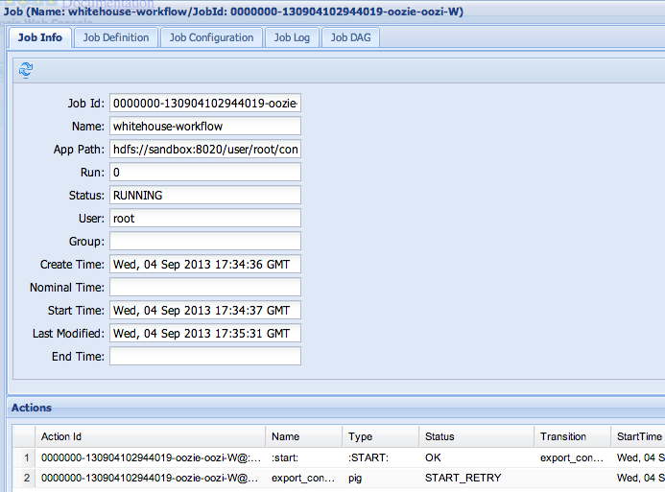
Notice you can view the status of each Action within the workflow.
- Verify the Results
  - Once the Oozie job is completed successfully, start the Hive Shell.
  - Run a select statement on congress_visits and verify the table is populated:
hive> select * from congress_visits;
...
WATERS MAXINE 12/8/2010 17:00 POTUS OEOB MEMBERS OF CONGRESS AND CONGRESSIONAL STAFF
WATT MEL 12/8/2010 17:00 POTUS OEOB MEMBERS OF CONGRESS AND CONGRESSIONAL STAFF
WEGNER DAVID L 12/8/2010 16:46 12/8/2010 17:00 POTUS OEOB MEMBERS OF CONGRESS AND CONGRESSIONAL STAFF
WILLOUGHBY JEANNE P 12/8/2010 17:07 12/8/2010 17:00 POTUS OEOB MEMBERS OF CONGRESS AND CONGRESSIONAL STAFF
WILSON ROLLIE E 12/8/2010 16:49 12/8/2010 17:00 POTUS OEOB MEMBERS OF CONGRESS AND CONGRESSIONAL STAFF
YOUNG DON 12/8/2010 17:00 POTUS OEOB MEMBERS OF CONGRESS AND CONGRESSIONAL STAFF
MCCONNELL MITCH 12/14/2010 9:00 POTUS WH MEMBER OF CONGRESS MEETING WITH POTUS.
Time taken: 1.082 seconds, Fetched: 102 row(s)

RESULT: You have just executed an Oozie workflow that consists of a Pig script followed by a Hive script.

ANSWERS:
Step 4.2: Two
Step 4.3: The Pig action named export_congress
Step 4.4: The Hive action named define_congress_table

Lab: Setting up Knox gateway
Objective: | Setting up “Knox gateway” on a new node (hadoop-master) and access Hadoop cluster (node1-node4) through Knox gateway.
Successful Outcome: | Once you run a mapReduce job without accessing Hadoop cluster using Knox gateway.
Before You Begin: | SSH into hadoop-master.

- Install Knox
  - Login to hadoop-master
  - Execute following command to install Knox gateway:
# yum –y install knox
- Configure Knox
  - Create a copy of the default topology file ‘/etc/knox/conf/topologies/sandbox.xml’:
# cd /etc/knox/conf/topologies
# cp sandbox.xml cluster-horton.xml
  - Look for ‘sandbox’ keyword and replace ‘sandbox,sandbox.hortonworks.com’ with ‘hadoop-master’:
<provider>
<role>hostmap</role>
<name>static</name>
<enabled>true</enabled>
<param><name>localhost</name><value>hadoop-master</value></param>
</provider>

  - Look for ‘NAMENODE’, ’JOBTRACKER’, ‘WEBHDFS’, WEBHCAT’ & ‘OOZIE’ role and change their hostname from ‘localhost’ to following:
NAMENODE: localhost -> node1
JOBTRACKER: localhost -> node2
WEBHDFS: localhost -> node1
WEBHCAT: localhost -> node2
OOZIE: localhost -> node3
  - Save and close the file.
  - Open /etc/knox/conf/users.ldif’ file and replace ‘guest’ keyword with ‘root’. Also change ‘userPAssword’ to ‘hadoop’:
# Entry for a sample end user
# Please replace with site specific values
dn: uid=root,ou=people,dc=hadoop,dc=apache,dc=org
objectclass:top
objectclass:person
objectclass:organizationalPerson
objectclass:inetOrgPerson
cn: Guest
sn: User
uid: root
userPassword:hadoop
  - Now run following setup command. When prompted for “master secret”. Leave it blank and ‘enter’:
# su -l knox -c "/usr/lib/knox/bin/gateway.sh setup"
  - Start knox gateway and ldap services:
su -l knox -c "/usr/lib/knox/bin/gateway.sh start"

su -l knox -c "/usr/lib/knox/bin/ldap.sh start"

  - Now check whether you can access HDFS from ‘hadoop-master’ by executing following:
# curl -iku root:hadoop -X GET 'https://node1:8443/gateway/cluster-horton/webhdfs/v1/user?op=LISTSTATUS'
It provides listing of /user directory in HDFS:
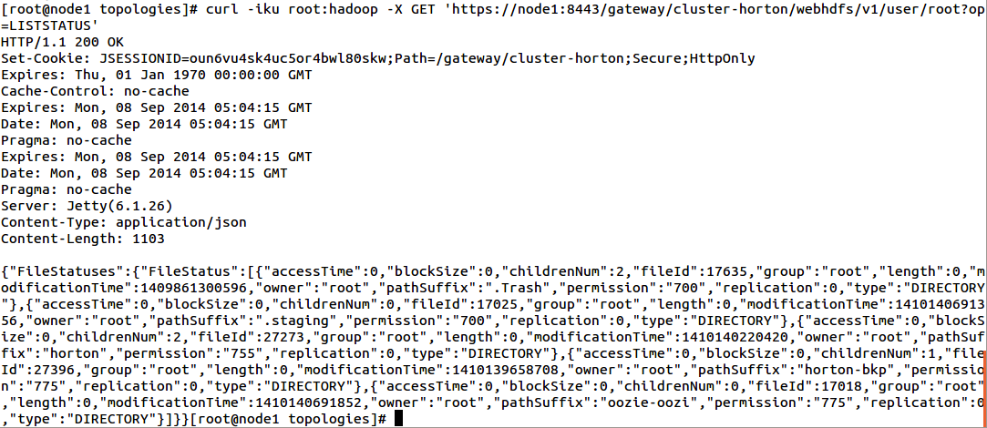

Now you can execute various Hadoop commands and MapReduce jobs using regular WebHDFS commands on Knox gateway without exposing your hadoop cluster.

Lab: Mounting HDFS to a Local File System

Objective: | To learn how to mount HDFS to a local file system.
Successful Outcome: | HDSF will be mounted to /home/hdfs/hdfs-mount.
Before You Begin: | SSH into node1.

- Install NFS
  - Execute following yum command to install NFS on node1:
# yum -y install nfs*
- Configure NFS
  - Within Ambari, stop the HDFS service.
  - Go to Services -> HDFS -> Configs, scroll down to the Advanced section and click on the Advanced heading to expand the section.
  - Locate the dfs.namenode.accesstime.precision property and set it to 3600000.
  - Scroll down to the "Custom hdfs-site.xml" section.
  - Using the "Add Property..." link, add the following new properties:
dfs.nfs3.dump.dir=/tmp/.hdfs-nfs

dfs.nfs.exports.allowed.hosts=* rw
  - Scroll down to the "Custom core-site.xml" section.
  - Using the "Add Property..." link, add the following new properties:
hadoop.proxyuser.root.groups=users

hadoop.proxyuser.root.hosts=*
  - Click the Save button to save your changes.
  - Restart all impacted services as pointed on ambari UI.

- Start NFS
  - Run the following commands to stop the nfs and rpcbind services. (If they are not running, the following commands will fail, which is no problem):
# service nfs stop
# service rpcbind stop
  - Now start the NFS services:
# hdfs portmap &
# hdfs nfs3 &
NOTE: If you don’t see your command prompt, simply press Enter.
  - Verify that the required services are up and running.
# rpcinfo -p node1
You should se output similar to the following:
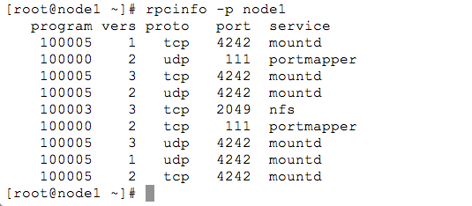
  - Verify that the HDFS namespace is exported and can be mounted by any client.
# showmount -e node1
You should se output similar to the following:
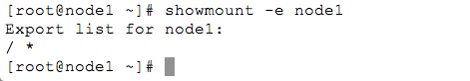

- Mount HDFS to the Local File System
  - As the root user, create a new directory on your local file system named /home/hdfs/hdfs-mount.
  - Change its ownership to the hdfs user.
  - Execute the following command on a single line to mount HDFS to the hdfs-mount directory:
# mount -t nfs -o vers=3,proto=tcp,nolock
node1:/ /home/hdfs/hdfs-mount
  - Browse HDFS now on your local file system.
# ls -l /home/hdfs/hdfs-mount

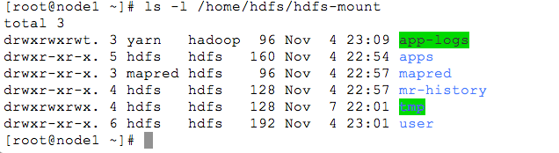
  - Switch to the hdfs user.
  - Copy a local file using the cp command into the hdfs-mount directory, and then check whether you can see this file using the hadoop fs -ls / command.
  - Delete the file from the local file system using the rm command, and verify the file is no longer in HDFS.
  - Try other Linux commands and see whether they work successfully.

RESULT: You have mounted HDFS to a local file system, which can be a convenient skill to know how to do when working frequently with files in HDFS.

Lab 21.1: Setting up Knox gateway
Objective: | Setting up “Knox gateway” on a new node (hadoop-master) and access Hadoop cluster (node1-node4) through Knox gateway.
Successful Outcome: | Once you run a mapReduce job without accessing Hadoop cluster using Knox gateway.
Before You Begin: | SSH into hadoop-master.

- Install Knox
  - Login to hadoop-master
  - Execute following command to install Knox gateway:
# yum –y install knox
- Configure Knox
  - Create a copy of the default topology file ‘/etc/knox/conf/topologies/sandbox.xml’:
# cd /etc/knox/conf/topologies
# cp sandbox.xml cluster-horton.xml
  - Look for ‘sandbox’ keyword and replace ‘sandbox,sandbox.hortonworks.com’ with ‘hadoop-master’:
<provider>
<role>hostmap</role>
<name>static</name>
<enabled>true</enabled>
<param><name>localhost</name><value>hadoop-master</value></param>
</provider>

  - Look for ‘NAMENODE’, ’JOBTRACKER’, ‘WEBHDFS’, WEBHCAT’ & ‘OOZIE’ role and change their hostname from ‘localhost’ to following:
NAMENODE: localhost -> node1
JOBTRACKER: localhost -> node2
WEBHDFS: localhost -> node1
WEBHCAT: localhost -> node2
OOZIE: localhost -> node3
  - Save and close the file.
  - Open /etc/knox/conf/users.ldif’ file and replace ‘guest’ keyword with ‘root’. Also change ‘userPAssword’ to ‘hadoop’:
# Entry for a sample end user
# Please replace with site specific values
dn: uid=root,ou=people,dc=hadoop,dc=apache,dc=org
objectclass:top
objectclass:person
objectclass:organizationalPerson
objectclass:inetOrgPerson
cn: Guest
sn: User
uid: root
userPassword:hadoop
  - Now run following setup command. When prompted for “master secret”. Leave it blank and ‘enter’:
# su -l knox -c "/usr/lib/knox/bin/gateway.sh setup"
  - Start knox gateway and ldap services:
su -l knox -c "/usr/lib/knox/bin/gateway.sh start"

su -l knox -c "/usr/lib/knox/bin/ldap.sh start"

  - Now check whether you can access HDFS from ‘hadoop-master’ by executing following:
# curl -iku root:hadoop -X GET 'https://node1:8443/gateway/cluster-horton/webhdfs/v1/user?op=LISTSTATUS'
It provides listing of /user directory in HDFS:

Now you can execute various Hadoop commands and MapReduce jobs using regular WebHDFS commands on Knox gateway without exposing your hadoop cluster.

Lab: Mounting HDFS to a Local File System

Objective: | To learn how to mount HDFS to a local file system.
Successful Outcome: | HDSF will be mounted to /home/hdfs/hdfs-mount.
Before You Begin: | SSH into node1.

- Install NFS
  - Execute following yum command to install NFS on node1:
# yum -y install nfs*
- Configure NFS
  - Within Ambari, stop the HDFS service.
  - Go to Services -> HDFS -> Configs, scroll down to the Advanced section and click on the Advanced heading to expand the section.
  - Locate the dfs.namenode.accesstime.precision property and set it to 3600000.
  - Scroll down to the "Custom hdfs-site.xml" section.
  - Using the "Add Property..." link, add the following new properties:
dfs.nfs3.dump.dir=/tmp/.hdfs-nfs

dfs.nfs.exports.allowed.hosts=* rw
  - Scroll down to the "Custom core-site.xml" section.
  - Using the "Add Property..." link, add the following new properties:
hadoop.proxyuser.root.groups=users

hadoop.proxyuser.root.hosts=*
  - Click the Save button to save your changes.
  - Restart all impacted services as pointed on ambari UI.

- Start NFS
  - Run the following commands to stop the nfs and rpcbind services. (If they are not running, the following commands will fail, which is no problem):
# service nfs stop
# service rpcbind stop
  - Now start the NFS services:
# hdfs portmap &
# hdfs nfs3 &
NOTE: If you don’t see your command prompt, simply press Enter.
  - Verify that the required services are up and running.
# rpcinfo -p node1
You should se output similar to the following:
  - Verify that the HDFS namespace is exported and can be mounted by any client.
# showmount -e node1
You should se output similar to the following:

- Mount HDFS to the Local File System
  - As the root user, create a new directory on your local file system named /home/hdfs/hdfs-mount.
  - Change its ownership to the hdfs user.
  - Execute the following command on a single line to mount HDFS to the hdfs-mount directory:
# mount -t nfs -o vers=3,proto=tcp,nolock
node1:/ /home/hdfs/hdfs-mount
  - Browse HDFS now on your local file system.
# ls -l /home/hdfs/hdfs-mount

  - Switch to the hdfs user.
  - Copy a local file using the cp command into the hdfs-mount directory, and then check whether you can see this file using the hadoop fs -ls / command.
  - Delete the file from the local file system using the rm command, and verify the file is no longer in HDFS.
  - Try other Linux commands and see whether they work successfully.

RESULT: You have mounted HDFS to a local file system, which can be a convenient skill to know how to do when working frequently with files in HDFS.

Lab 9.1: Use distcp to Copy Data from a Remote Cluster

Objective: | To become familiar with how to copy data from one cluster to another.
Successful Outcome: | Data from a remote cluster is copied to your own cluster.
Before You Begin: | For this exercise use “node1” as your Remote-Cluster.

- Access Remote-Cluster
  - Verify you can reach the NameNode of the Remote-Cluster by executing the ls command.
$ hadoop fs -ls hdfs://node1:8020/
You should see the / folder of the Remote-Cluster.
- View the Remote Folder
  - Use the ls command and view the contents of the remote directory that you are going to copy:
$ hadoop fs -ls hdfs://node1:8020/user/root
- Copy the Data from Remote-Cluster
  - First create a new directory in HDFS called distcp_target.
  - Execute the following command to copy a remote file into distcp_target directory:
$ hadoop distcp
hdfs://Remote-Cluster:8020/user/root/test_data distcp_target
  - View the contents of distcp_target and verify test_data file copied over to your cluster:
$ hadoop fs -ls distcp_target
  - Copy one or many directories/files into distcp_target:
$ hadoop distcp
hdfs://node1:8020/user/root/wordcount
hdfs://node1:8020/user/root/constitution.txt
distcp_target
  - View the contents of distcp_target and verify the wordcount & constitution.txt file copied over to your cluster again.
- Copy only new/updated files and directories using -update option.
  - Check the timestamp for files in /user/root/wordcount directory. Delete part-r-00000 file from wordcount directory.
  - Now run following command with -update option.
$ hadoop distcp -update
hdfs://node1:8020/user/root/wordcount
distcp_target/wordcount
  - View the contents of distcp_target and compare timestamp of all the files. You can see that the timestamp changed only for part-r-00000 file and wordcount folder timestamp.
- Copy data from a ‘Remote-Cluster’ running different version of Hadoop.
  - Execute the following command to copy a remote file into distcp_target.
$ hadoop distcp
hftp://node1:50070/user/root/test/hdfs-audit.log
distcp_target
  - View the contents of distcp_target and verify test_data file copied over to your cluster.

RESULT: You have learnt the steps to copy data from one cluster to another.

Lab: Verify Data with Block Scanner and fsck

Objective: | View the various tools for performing block verification and the health of files in HDFS.
Successful Outcome: | You will see the result of the Block Scanner Report on node1, and the output of the fsck command.
Before You Begin: | SSH into node1.

- Configure the Scan Period
  - Go to HDFS -> Configs, then expand the Custom hdfs-site.xml section and click the Add Property
  - Add the following property and save the configs:
dfs.datanode.scan.period.hours=1
- Restart the HDFS Service
- View the Block Scanner Report
  - Point your web browser to http://node1:50075/blockScannerReport. The report will look similar to the following:
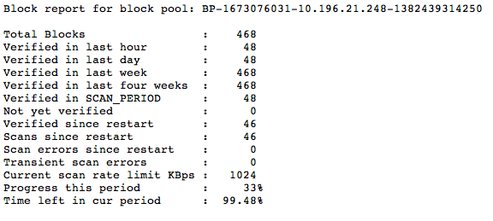
  - How many blocks are on your node1 DataNode? ______________
- View the Block Details
  - Add the listblocks parameter to the blockScannerReport URL:
http://node1:50075/blockScannerReport?listblocks
You should see a list of all blocks on that DataNode and their status:
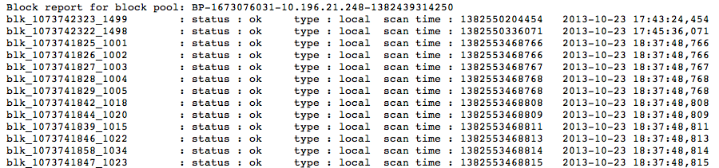
NOTE: If a block is corrupt, the NameNode is notified and attempts to fix the issue. The default time period for scanning blocks is every three weeks, so in a production environment you would not set this interval to 30 minutes like you did in this lab. Use the block scanner report as a quick way to verify the integrity of the blocks in your cluster.
- Run the fsck Command on a File
  - Put the file /root/data/test_data into the /user/root folder of HDFS:
# hadoop fs -put ~/data/test_data
  - Run the fsck command for the file /user/root/test_data:
# hdfs fsck /user/root/test_data -files
  - How many blocks did test_data get split into? ____________
  - What is the average block replication of test_data? ___________
- Using fsck Options
  - Run the fsck command again, but this time add the -blocks option:
# hdfs fsck /user/root/test_data -files -blocks
  - What did the blocks option add to the output? _________________________
  - Add the -locations option as well:
# hdfs fsck /user/root/test_data -files -blocks -locations
  - What did the locations option add to the output? _______________________
- Run a File system Check
  - You can run fsck on the entire file system. Enter the following command:
# hdfs fsck /
Notice this command fails, because root does not have permission to view all the files in HDFS.
  - Switch to the hdfs user:
# su - hdfs
  - Run fsck on the entire file system:
$ hdfs fsck /
  - What is the total size of your HDFS? _______________________
  - How many directories does your cluster have? ____________
  - How many files are on your cluster? _____________
  - How many total blocks are on your cluster? ___________
  - What is the average block replication of your cluster? ________________
  - Switch back to the root user:
[hdfs@node1 ~]$ exit
- View the Health of your Cluster
  - From the Hosts page for node1 in Ambari, stop the DataNode service on node1.
  - Click on the Services page, then HDFS. You should see that one of your DataNodes is not live.
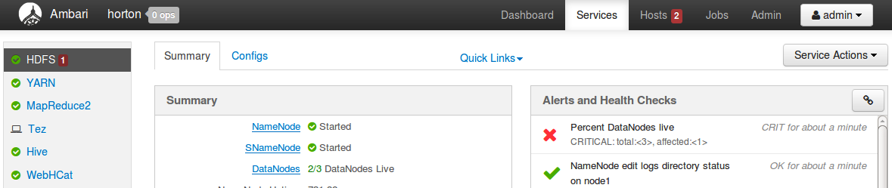
  - Using the Quick Links menu on the HDFS Services page (shown in the screenshot below), open the NameNode UI:
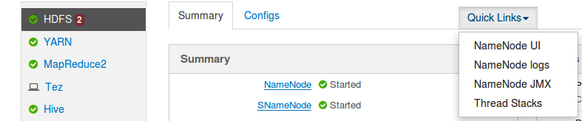
The NameNode UI opens the dfshealth.jsp page by default.
  - Notice you still have 3 Live Nodes and 0 Dead Nodes:
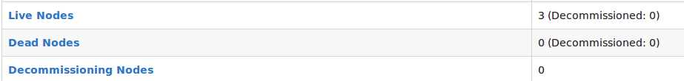
NOTE: It takes 10.5 minutes for a DataNode to be marked as dead in a cluster.
  - Click on the Live Nodes link to view the Live DataNodes in your cluster:
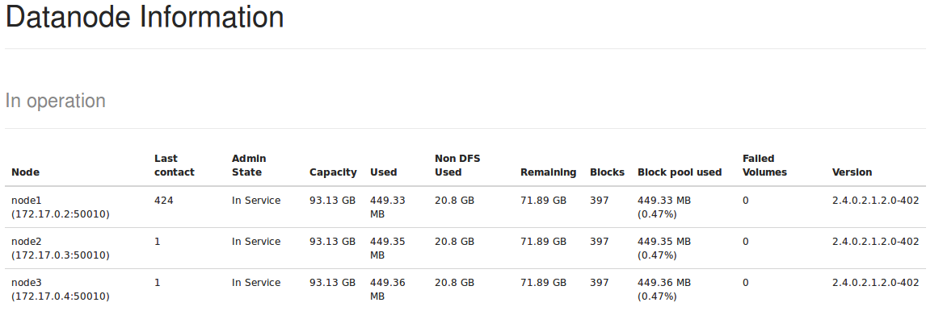
- Take a Break
  - ...and wait for your DataNode to be marked as Dead in your cluster!
  - Refresh the Live DataNodes page, and you should only see two live DataNodes:
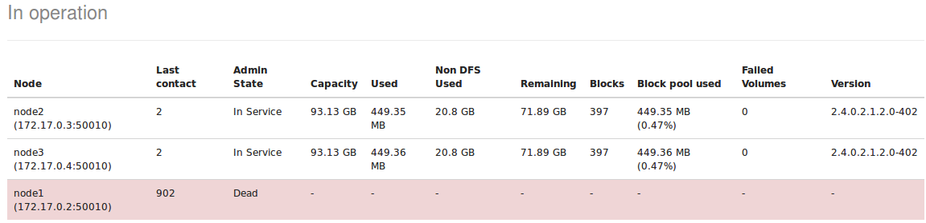
  - Go back to the dfshealth.jsp page and refresh it. Notice you now have 1 Dead Node and a large number of under-replicated blocks:
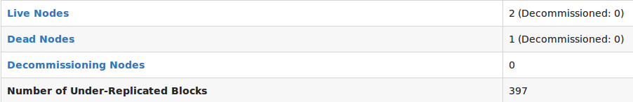
  - Why does your cluster have so many under-replicated blocks? ___________
_________________________________________________________________
- Run fsck Again
  - Switch to the hdfs user and run fsck on the entire file system:
# su - hdfs
[hdfs@node1 ~]$ hdfs fsck /
Notice you get a long list of every file that contains under-replicated blocks.
  - What is the average block replication now on your cluster? _____________
  - Compare the value of Missing replicas in the output of fsck with the value of Number of Under-Replication Blocks in the NameNode UI.
- Start the DataNode Again
  - Using Ambari, start the DataNode process on node1.
  - Refresh the dfshealth.jsp page in the NameNode UI frequently, and you can watch as the number of under-replicated blocks gradually decreases to 0:
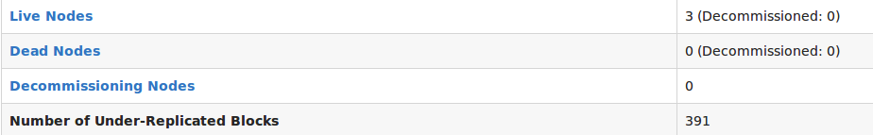
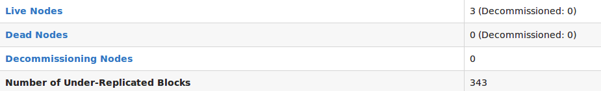

  - Run fsck again on your entire file system, and notice everything is back to normal again.

RESULT: The Block Scanner Report is a quick way to view the status of the blocks on the DataNodes of your cluster. The fsck tool is a great way to view the health of your file system and block replication, as is using the NameNode UI.

Lab: Dataset mirroring using Falcon
Objective: | To replicate data from one Cluster to another.  In this case we the source and target cluster will be the same.
Successful Outcome: | You successfully replicate data from the source cluster to the target cluster.
Before You Begin: | SSH into node1.

- Configure falcon User Permissions
  - Go the HDFS page in Ambari, then scroll down and expand the Custom core-site.xml section.
  - The Falcon job you defined is going to be executed by the root user, so root needs permission to communicate with the falcon server. Add root to the hadoop.proxyuser.falcon.groups property:
  - Click the Save button to save your changes to the HDFS config.
  - Restart all dependent services as marked in Services tab.
  - Make sure to restart ‘oozie’ service as well.

- Kick off the Dataset mirroring pipeline
  - Login to node1 and change directory to /root/labs/falcon:
# cd ~/labs/falcon
  - Let’s review cluster and data-feed configuration files:
# cat horton.xml
# cat horton-bkp.xml
# cat data-feed.xml
  - Submit above configuration files to Falcon server:
# falcon entity -type cluster -submit -file horton.xml
# falcon entity -type cluster -submit -file horton-bkp.xml
# falcon entity -type feed -submit -file data-feed.xml
  - Navigate to following URL and check the status of above entities. They must be in ‘SUBMITTED” state:
http://node1:15000
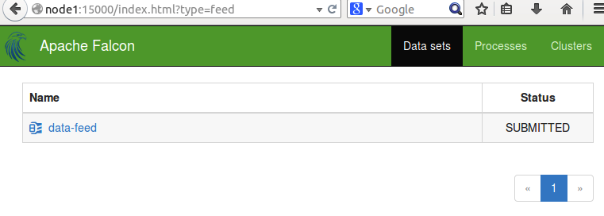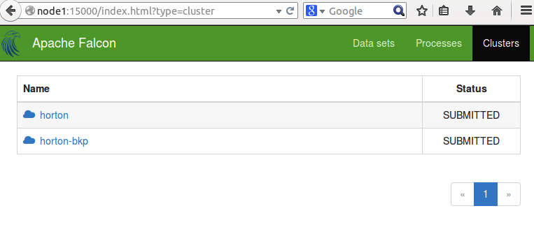
  - Click on ‘data-feed’. It will show its configuration/definition. It also shows that it is dependent upon ‘horton’ and ‘horton-bkp’ clusters.
  - Now, schedule the data-feed. Once it is done successfully, it will wait for new feed to process in /user/root/horton/email-logs directory:
# falcon entity -type feed -schedule -name data-feed
  - Now check the status on Falcon UI and you will see 2 instances are running, which are waiting for the data feed:
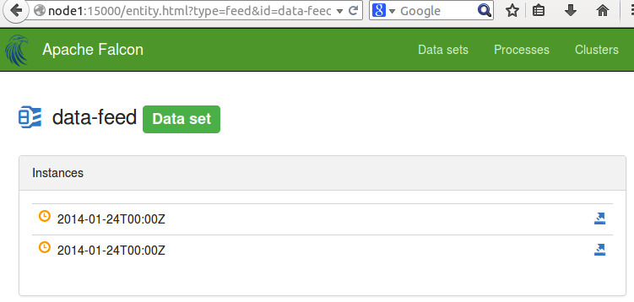
  - Now, let’s create an input directory ‘horton’ in HDFS and copy some data (email log):
# hadoop fs -mkdir horton
# hadoop fs -put email-logs horton
  - Reload Falcon UI after few seconds. You will see a new set of instances running and they started processing data: 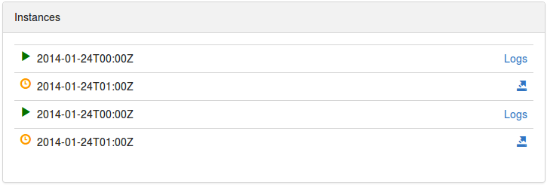
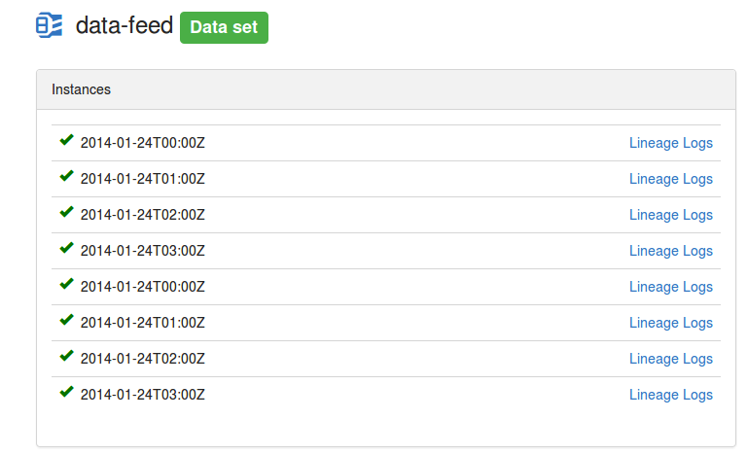

  - Check HDFS for new files and you will see that a new directory ‘horton-bkp’ is created by Falcon instances, which has the same contents as ‘horton’ directory. If you add a new file in ‘horton’ folder now. It will be automatically recognized by Falcon instances after 1 hour. Please review ‘data-feed.xml’ file and check the ‘frequency’ parameter.
- Delete the data-feed and cluster definition
  - If you do not want to run this job any more then you can do the cleanup by running following commands:
# falcon entity -type feed -delete -name data-feed
# falcon entity -type cluster -delete -name horton
# falcon entity -type cluster -delete -name horton-bkp

