Lab: Install Hadoop 1.3 using Ambari

Objective: | To install a Hadoop cluster using Ambari UI.
Successful Outcome: | You can see the various HDP 2.0 services running from within the Ambari UI.
Before You Begin: | Log into the sandbox.

- Install ambari-server
  - From the command line of sandbox, enter the following command:
# yum -y install ambari-server
- Copy JDK-7.x into Ambari setup folder.
  - Ambari downloads JDK 7 during the setup process. We can avoid downloading by copying it manually into Ambari setup folder, execute the following script:
# /root/scripts/copy_jdk.sh
- Setup ambari-server
  - The Ambari Server manages the install process. Run the Ambari Server setup using the following command:
# ambari-server setup -s
NOTE: The -s option runs the setup in silent mode, meaning all default values are accepted at any prompts.
  - Now start the Ambari Server:
# ambari-server start
- Login to Ambari
  - Start Firefox browser in the VM (4th icon from top):
  - Navigate to following URL:
http://sandbox:8080
  - Log in to the Ambari server using the default credentials admin/admin:
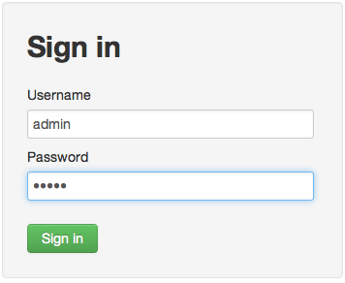

- Run the Install Wizard
  - At the Welcome page, enter the name “horton” for your cluster and click the Next button.
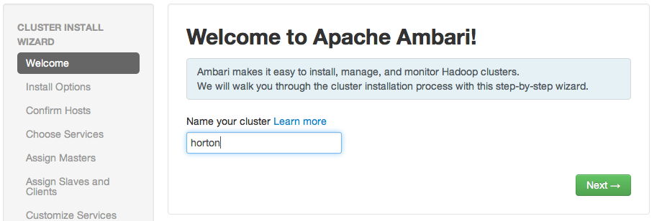

  - Select the service stack HDP2.1:
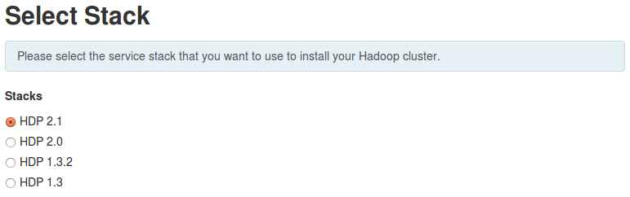
- Under “Advanced Repository Options”, uncheck “Red Hat 5” & “SLES 11” and update URL for “Red Hat 6” as mentioned below http://sandbox/hdp/HDP-2.1.2.0
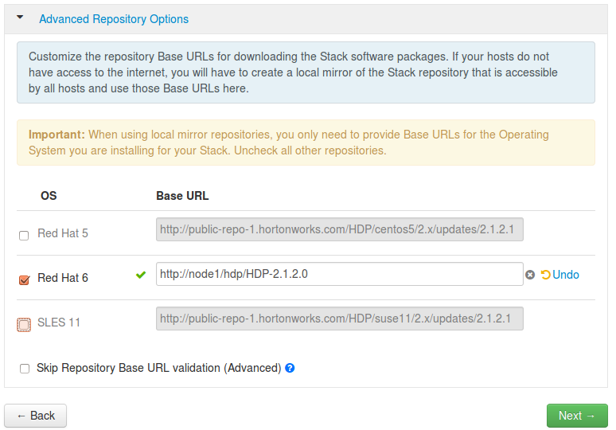
  - Click “Next” button

- Enter the Host and SSH Key Details
  - Enter sandbox, node2 and node3 in the list of Target Hosts. (Do not enter node4; you will add that node to the cluster in a later lab.)
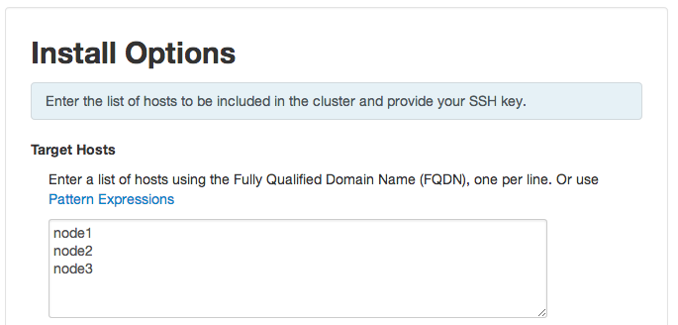
  - In the Host Registration Information section, click the Choose File button, then browse to and select the training-keypair.pem file (it must be pre-selected, if not you can find it on “Desktop”) :
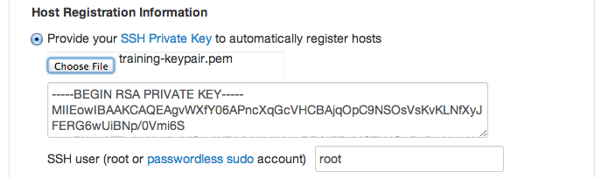

  - Click the Register and Confirm button. Click OK if you are warned about not using fully qualified domain names.
- Confirm Hosts
  - Wait for some initial verification to occur on your cluster. Once the process is done, click the Next button to proceed:
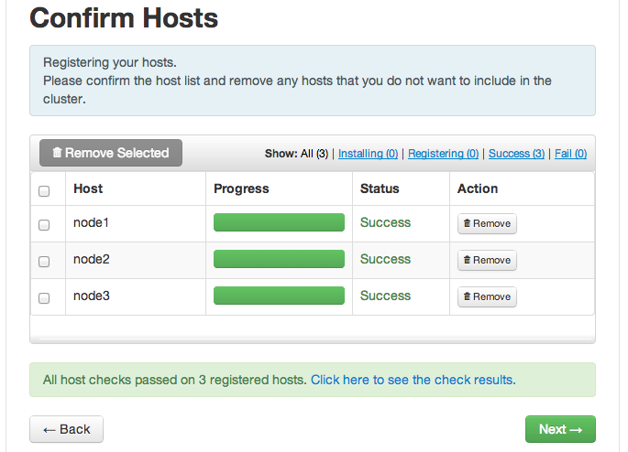

- Choose the Services to Install
  - Hortonworks Data Platform is made up of a number of components. You are going to install following services on your cluster initially (Uncheck HBase, Falcon & Storm, we will install them later):
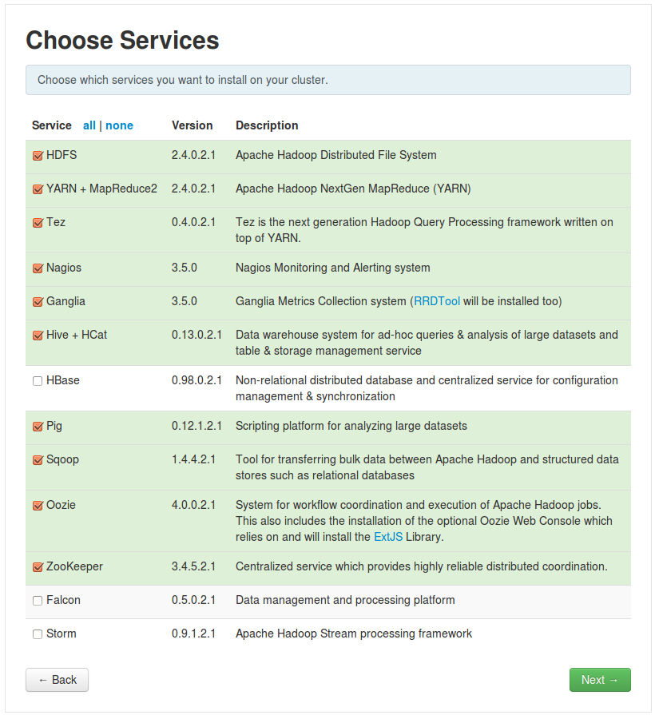

  - , Click the Next button:
- Assign Master Nodes
  - The Ambari wizard attempts to assign the various master services on appropriate hosts in your cluster. Carefully choose the following assignments of the master services.
CAUTION: Make sure to choose the right node for each master service as specified below. Once the installation starts, you cannot change the selection!
NameNode: | sandbox
SNameNode: | node2
History Server: | node2
App Timeline Server | node2
ResourceManager: | node2
Nagios Server: | node3
Ganglia Server: | node3
HiveServer2: | node2
Oozie Server: | node2
ZooKeeper: | sandbox
ZooKeeper: | node2
ZooKeeper: | node3
  - Verify your assignments match the following:
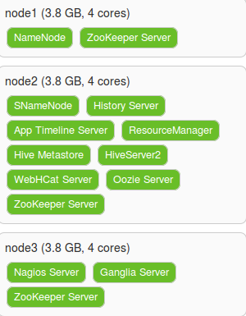
  - Click the Next button to continue.
- Assign Slaves and Clients
  - Assign all slave and client components to all nodes in the list:
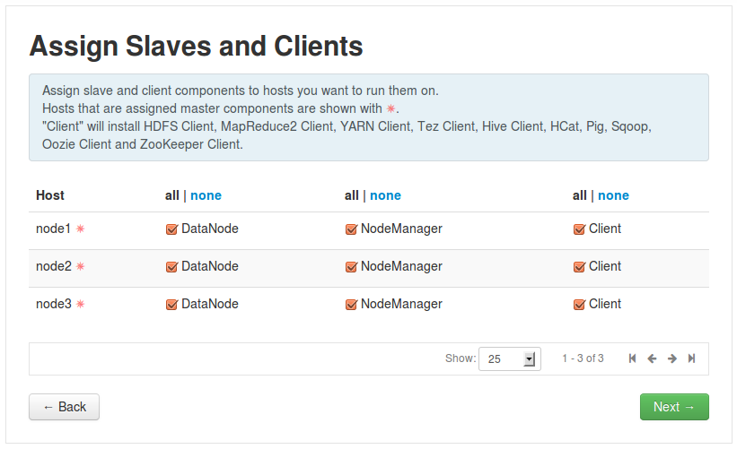
  - Click the Next button to continue.
- Customize Services
  - Notice three services require additional configuration: Hive, Oozie and Nagios. Click on the Hive tab, then enter hive for the Database Password:
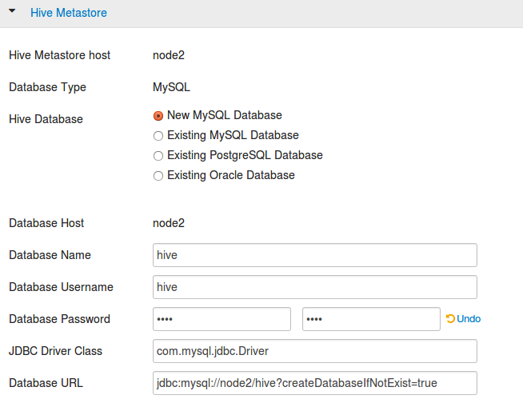

  - Click on the Oozie tab and enter oozie for its Database Password:
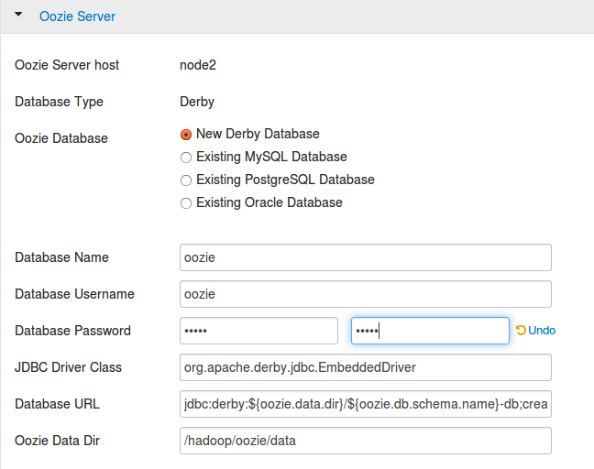
  - Click on the Nagios tab. Enter admin for the Nagios Admin password, and enter your email address in the Hadoop Admin email field:
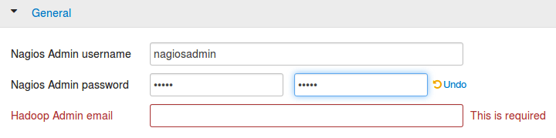
  - Click the Next button to continue.
- Review the Configuration
  - Notice the Review page allows you to review your complete install configuration. If you’re satisfied that everything is correct, click Deploy to start the installation process. (If you need to go back and make changes, you can use the Back button.)
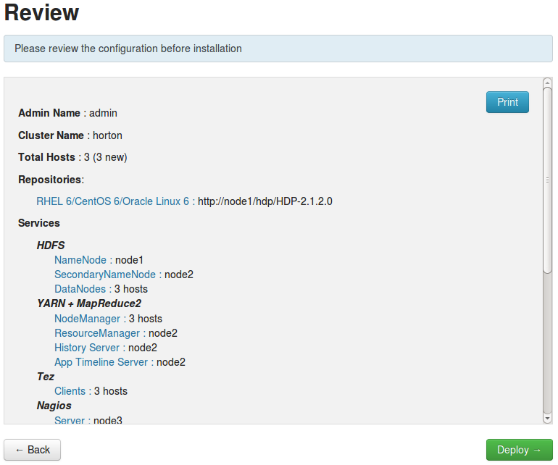
- Wait for HDP to Install
  - The installation will begin now. It will take up to 30 minutes to complete, depending on your computer processor and allocated RAM. You will see progress updates under the Status column as components are installed, tested, and started:
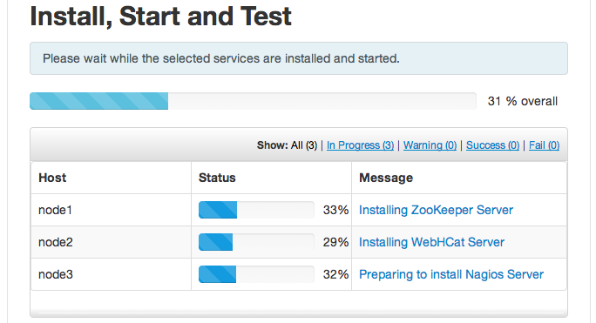
  - You should see the following screen if the installation completes successfully:
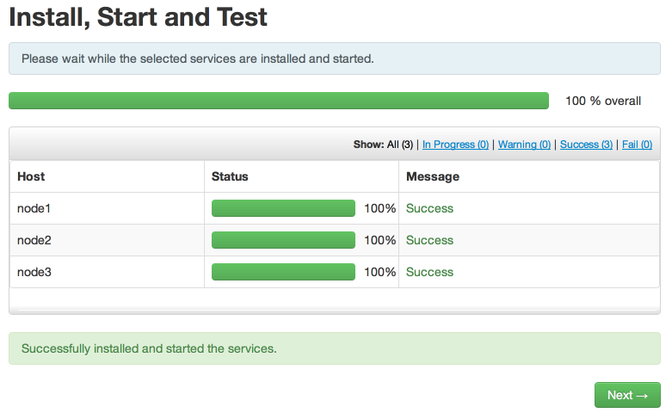
  - When the process completes, click Next to get a summary of the installation process. Check all configured services are on the expected nodes, then click Complete:
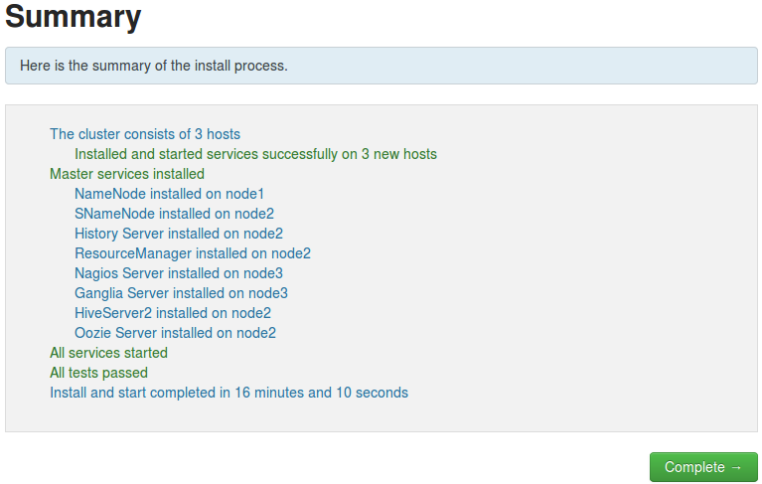
- View the Ambari Dashboard
  - After the install wizard completes, you will be directed to your cluster’s Ambari Dashboard page. Verify the DataNodes Live status shows 3/3:

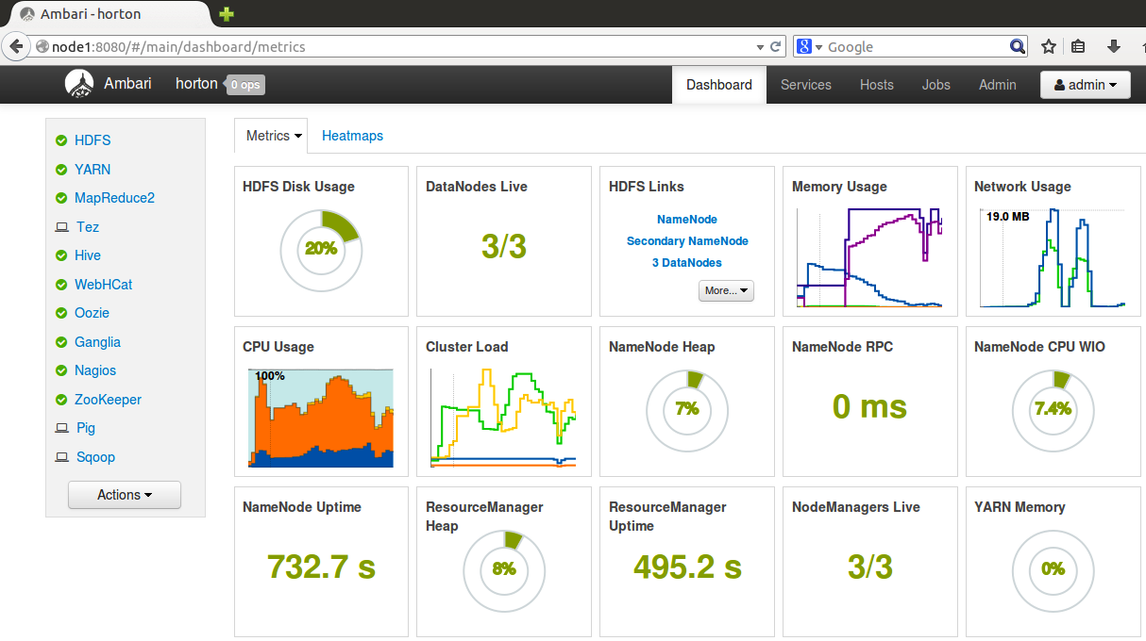
RESULT: You now have a running 3-node cluster of the Hortonworks Data Platform!

Lab: Setup

Objective: | To learn about the environment we will be working in and to setup up everything we'll need for our labs.
Successful Outcome: | Working instances of Hadoop and Ambari running in our VirtualBox.
Before You Begin: | Ask instructor how to begin.

- Download the .ova file your instructor gives you.
  - Your instructor will tell you where to locate and download the .ova file here.
  - Once you have successfully downloaded the .ova file, secure it somewhere where it will not get deleted.
  - Now, double-click the icon.
- Verifying progress in VirtualBox.
  - Now, open up VirtualBox in on the your local machine (Not inside your VirtualBox.
  - Once you have started VirtualBox you will notice that by double-clicking the .ova file you have created a new instance. Double-click it!
- Logging into terminal.
  - Great job! Now you are inside your live instances. Login with <root> as the <username and <hadoop> for our password.
- Running Ambari and getting your serviced started.
  - Almost there! Now, inside your home directory you should see a file named 'start-ambari.sh.' You can run this file like this:
$ ./start-ambari.sh

  - Now, in your browser, enter “<localhostip>:8080” into your address bar. Do you see it?
- Logging into Ambari.
  - Username is <admin> and password is <admin>.
  - Wait for your instructor for further instruction on installing Ambari.
- [Ask your instructor before taking this step] To download your lab materials for this class you will want to do the following:
$ wget https://dl.dropboxusercontent.com/u/48319837/materials.zip
$ unzip materials.zip

Lab: Managing Hadoop Services

Objective: | To learn how to start and stop the various HDP, rolling restart bulk-host operations, service and component restart.
Successful Outcome: | You learn various ways to manage HDP service.
Before You Begin: | Your cluster should be up and running. Go to the Ambari Dashboard [localhost]:8080

You can stop/start/restart service(s) at different levels
- Some OR all the services running in a cluster (e.g. stop HDFS)
- Some OR all the services running on a specific host (e.g. stop HDFS services on one host only)
- An individual component of a service (e.g. restart NameNode only)

- Stop the HDFS service (Cluster level operation)
  - Go to your Ambari Dashboard and click on Services tab:
  - By default ‘HDFS’ is preselected. Click on ‘Service Action’ drop down and click on ‘Stop’ option. Select ‘Confirm Stop’ in the confirmation popup and see the progress of stopping progress:
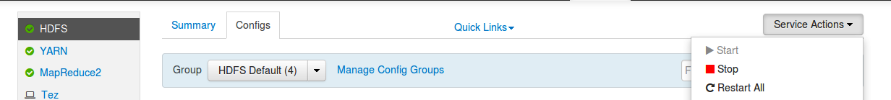

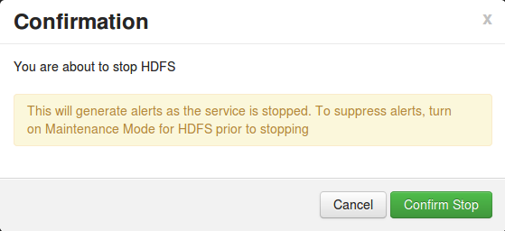
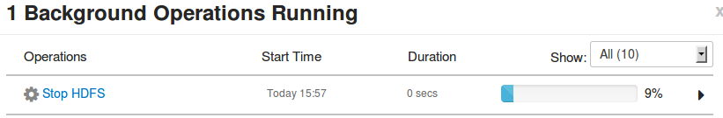
  - Press ‘OK’ once it is done. Now you can see in the dashboard that HDFS service is completely stopped (It takes couple of mins to get status update):
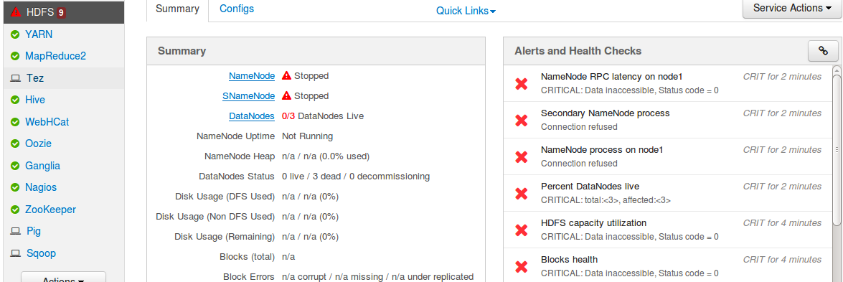

- Start HDFS services for ‘hadoop-master’ only (Component level operation):
  - Click on Hosts tab and click on ‘hadoop-master’:

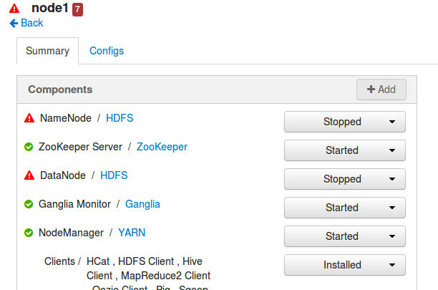

  - Click on Hosts tab and click on ‘hadoop-master’:

  - Start NameNode and DataNode components from the drop down.
  - Now go to node3 and start the DataNode.

- Start all stopped services for node2 (Host-level operation)
  - Go to node2 and under ‘Host Action’ click ‘Start All Components’. It will start all stopped services on the host:
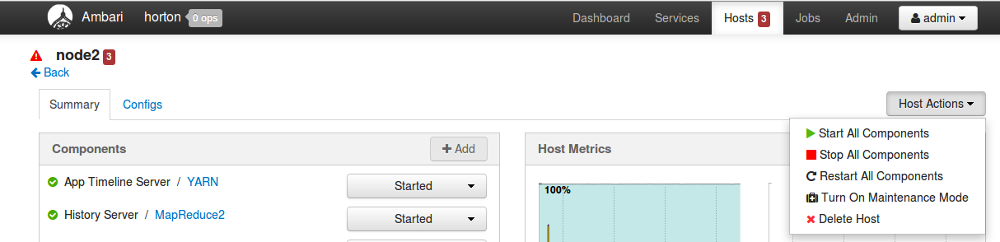

- Manage services from command line using Ambari Command Line API.
  - Login to hadoop-master using ‘Terminal’ application and review following script:
# cat ~/scripts/restartYARN.sh
It has 2 commands, one to stop YARN service and other to start YARN service.
  - Run the script to restart YARN service on your cluster:
# ~/scripts/restartYARN.sh
  - Wait for the script to execute and YARN service to restart. You can track the progress by click here:
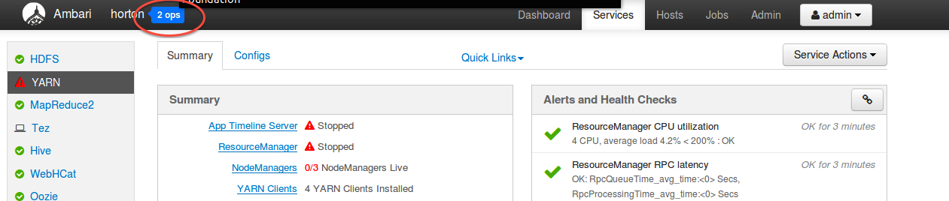

- Take a backup of your VM.
  - From the Services page, click the Stop All button. Click the OK button to confirm.
  - Run the following script to shutdown all Ambari services on your cluster:
# ~/scripts/stop_ambari.sh
  - Go to VMWare Player/Fusion Menu and shutdown the VM.
  - Copy the existing VM folder from current location to a new location.
  - Once you are done with backup, go to VMWare Player/Fusion Menu and start the VM again.
NOTE: It is important to take a backup of the VM now so that you do not need to start from beginning in case of a fatal error.
- Start Ambari services
  - Login to hadoop-master again
  - Run the following script to start all Ambari services on your cluster:
# ~/scripts/start_ambari.sh
- Start the HDP Services from Ambari UI
  - Go To Ambari UI using Firefox browser
  - From the Services page, click the Start All button. Click the OK button to confirm.
  - Wait for the services to start, which can take 10-15 minutes. If you click the small arrow to the right of “Start All Services”, you can view the progress on each node:
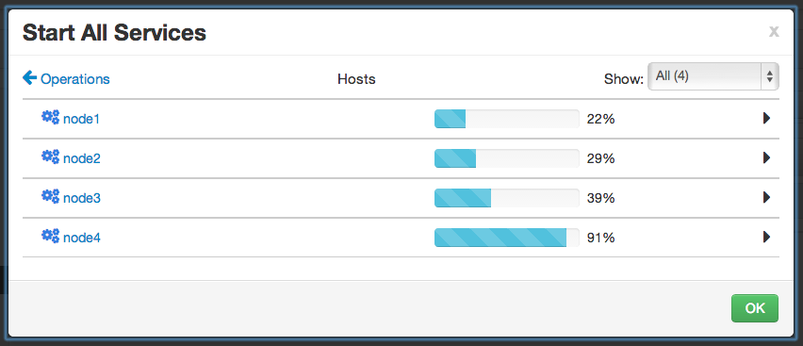
  - Once all the services are started, click the OK button to close the progress dialog.
  - Verify on the Services page of Ambari that all the HDP services in your cluster are up and running.

Lab: Using Hadoop Client Commands

Objective: | To become familiar running HDFS commands and how to view the HDFS file system.
Successful Outcome: | You will have added and deleted several files and folders in HDFS.
Before You Begin: | Go into terminal on hadoop-master.

- View the hadoop fs Command
  - From the command line, enter the following command to view the usage of hadoop fs:
# hadoop fs
Notice the usage contains options for performing file system tasks in HDFS, like copying files from a local folder into HDFS, retrieving a file from HDFS, copying and moving files around, and making and removing directories.
  - If its valid, enter the following command:
# hdfs dfs
Notice you may get the same usage list as the hadoop fs command. In case you don’t it means that Hadoop isn’t up to the release that successfully has the alias yet.
NOTE: The hadoop command is a more generic command that has fewer options than the hdfs command. However, notice hdfs dfs is just an alias for hadoop fs.

- Understanding the Default Folders in HDFS
  - Enter the following -ls command to view the contents of the user’s root directory in HDFS, which is /user/root:
# hadoop fs -ls
You do have not a /user/root directory yet, so no output is displayed:
ls: `.': No such file or directory
  - View the contents of the /user directory in HDFS:
# hadoop fs -ls /user
Found 4 items
drwxrwx--- - ambari-qa hdfs 0 /user/ambari-qa
drwxr-xr-x - hcat hdfs 0 /user/hcat
drwx------ - hive hdfs 0 /user/hive
drwxrwxr-x - oozie hdfs 0 /user/oozie
Notice HDFS may have more folders than what we have here.
  - Run the -ls command again, but this time specify the root HDFS folder:
# hadoop fs -ls /
The output should look like:
Found 6 items
drwxrwxrwt - yarn hdfs 0 2013-08-20 13:59 /app-logs
drwxr-xr-x - hdfs hdfs 0 2013-08-20 13:53 /apps
drwxr-xr-x - mapred hdfs 0 2013-08-20 13:57 /mapred
drwxr-xr-x - hdfs hdfs 0 2013-08-20 13:58 /mr-history
drwxrwxrwx - hdfs hdfs 0 2013-08-28 22:03 /tmp
drwxr-xr-x - hdfs hdfs 0 2013-08-28 22:03 /user

  - Which user is the owner of the /user folder? ___________________
IMPORTANT: Notice how adding the / in the -ls command caused the contents of the root folder to display, but leaving off the / attempted to list the contents of /user/root. If you do not specify an absolute path, then all hadoop commands are relative to the user’s default home folder.
- Create a User Directory in HDFS
  - Enter the following mkdir command:
# hadoop fs -mkdir /user/root
Notice the root user does not have permission to create this folder.
  - Change the permissions to make root the owner of the directory:
$ hadoop fs -chown root:root /user/root
  - Verify the folder was created successfully and root is the owner:
$ hadoop fs -ls /user
...
drwxr-xr-x - root root 0 /user/root
  - Switch back to the root user:
$ exit
logout
[root@sandbox ~]#
  - Now view the contents of /user/root using the following command again:
# hadoop fs -ls
The directory is empty, but notice this time the command worked.
- Create Directories in HDFS
  - Enter the following command to create a directory named test in HDFS:
# hadoop fs -mkdir test
  - Verify the folder was created successfully:
# hadoop fs -ls
Found 1 items
drwxr-xr-x - root root 0 test
  - Create a couple of subdirectories of test:
# hadoop fs -mkdir test/test1
# hadoop fs -mkdir test/test2
# hadoop fs -mkdir test/test2/test3
  - Use the -ls command to view the contents of /user/root:
# hadoop fs -ls
Notice you only see the test directory. To recursively view the contents of a folder, use: -ls -R:
# hadoop fs -ls -R
The output should look like:
drwxr-xr-x - root root 0 test
drwxr-xr-x - root root 0 test/test1
drwxr-xr-x - root root 0 test/test2
drwxr-xr-x - root root 0 test/test2/test3
- Delete a Directory
  - Delete the test2 folder (and recursively its subcontents) using the –rmr command:
# hadoop fs -rmr test/test2
  - Now run the -ls -R command:
# hadoop fs -ls -R
The directory structure of the output should look like:
.Trash
.Trash/Current
.Trash/Current/user
.Trash/Current/user/root
.Trash/Current/user/root/test
.Trash/Current/user/root/test/test2
.Trash/Current/user/root/test/test2/test3
test
test/test1
NOTE: Notice Hadoop created a .Trash folder for the root user and moved the deleted content there. The .Trash folder empties automatically after a configured amount of time.
- Upload a File to HDFS
  - Now let’s put a file into the test folder. Change directories to /var/log/hadoop/hdfs:
# cd /var/log/hadoop/hdfs
  - Notice this folder contains a file named hdfs-audit.log:
# tail hdfs-audit.log
  - Run the following -put command to copy hdfs-audit.log into the test folder in HDFS:
# hadoop fs -put hdfs-audit.log test/
  - Verify the file is in HDFS by listing the contents of test:
# hadoop fs -ls test
Found 2 items
-rw-r--r-- 3 root root 3744098 test/hdfs-audit.log
drwxr-xr-x - root root 0 test/test1
- Copy a File in HDFS
  - Now copy the hdfs-audit.log file in test to another folder in HDFS:
# hadoop fs -cp test/hdfs-audit.log test/test1/copy.log
  - Verify the file is in both places by using the -ls -R command on test. The output should look like the following:
# hadoop fs -ls -R test
-rw-r--r-- 3 root root 3744098 test/hdfs-audit.log
drwxr-xr-x - root root 0 test/test1
-rw-r--r-- 3 root root 3744098 test/test1/copy.log
  - Now delete the copy.log file using the -rm command:
# hadoop fs -rm test/test1/copy.log
  - Verify the copy.log file is in the .Trash folder.
- View the Contents of a File in HDFS
  - You can use the -cat command to view text files in HDFS. Enter the following command to view the contents of data.txt:
# hadoop fs -cat test/hdfs-audit.log
  - You can also use the -tail command to view the end of a file:
# hadoop fs -tail test/hdfs-audit.log
Notice the output this time is only the last 20 rows of hdfs-audit.log.
- Getting a File from HDFS
  - See if you can figure out how to use the get command to copy test/hdfs-audit.log into your local /tmp folder.
- The getmerge Command
  - Put the file /var/log/hadoop/hdfs/hadoop-hdfs-namenode-hadoop-master.log into the test folder in HDFS. You should now have two files in test: hdfs-audit.log and hadoop-hdfs-namenode-hadoop-master.log:
# hadoop fs -ls test
Found 3 items
-rw-r--r-- 3 root root 1033038 test/hadoop-hdfs-namenode-hadoop-master.log
-rw-r--r-- 3 root root 3744098 test/hdfs-audit.log
drwxr-xr-x - root root 0 test/test1
  - Run the following getmerge command:
# hadoop fs -getmerge test /tmp/merged.txt
  - What did the previous command do? Compare the file size of merged.txt with the two log files from the test folder.
- Specify the Block Size of a File
  - Change directories to /root/materials
Notice this folder contains a shakespeare.JAR file that is about 4.7MB.
  - Put the JAR file into /user/root in HDFS with the name, and assign it a blocksize of 1048576 bytes. HINT: The blocksize is defined using the dfs.blocksize property on the command line.
  - Run the following fsck command on hbase.jar:
# hdfs fsck /user/root/hbase.jar
  - How many blocks did this file get broken down in to? ________________

RESULT: You should now be comfortable with executing the various HDFS commands, including creating directories, putting files into HDFS, copying files out of HDFS, and deleting files and folders.

ANSWERS:
Step 2.4: hdfs
Step 9.1:
# hadoop fs -get test/hdfs-audit.log /tmp
Step 10.3: The two files that were in the test folder in HDFS were merged into a single file and stored on the local file system.
Step 11.2:
hadoop fs -D dfs.blocksize=1048576 -put hbase-0.94.3-bimota-1.2.0.21+HBASE-7644.jar hbase.jar
Step 11.4: The file should be broken down into 5 blocks.

Lab: Running a MapReduce Job
Objective: | To learn tips on how to troubleshoot issues with a MapReduce job.
Successful Outcome: | You will have run the IndexInverter MapReduce job several times and viewed its log files.
Before You Begin: | Go into terminal on hadoop-master.

- Put the File into HDFS
  - Change directories to the materials folder:
# cd /root/materials
  - Notice a file named urls.txt. View its contents:
# more urls.txt
This file contains URLS, along with keywords found on the webpages of each URL.
NOTE: The MapReduce job in this lab computes an inverted index, one of the earliest use cases of Hadoop and MapReduce. A Web crawler scans the Internet and retrieves URLs along with keywords on each page. The index inverter job flips this information around, outputting the keywords along with each web page that contains the keyword.
- Run the IndexInverterJob
  - Enter the following command to run the IndexInverterJob:
# hadoop jar invertedindex.jar inverted.IndexInverterJob urls.txt index_output
  - The job fails. What is the issue? __________________________________
- Run the Job Again
  - Put the file /root/labs/urls.txt into HDFS:
# hadoop fs -put /root/labs/urls.txt urls.txt
NOTE: you may need to enter a &> output.txt to see results.
  - Run the job again, using the same command as the previous step.
  - The job should run successfully this time. How many map tasks were needed for this job? ________
How many reduce tasks? ___________
  - How long (in ms) did it take for all the mappers to run? _________________
  - How long (in ms) did it take for all the reducers to run? _________________
  - How many bytes did the mappers of this job process? ____________
  - How many bytes did the reducers output? ____________
- View the Output
  - Verify the index_output folder was created in HDFS:
# hadoop fs -ls index_output
You should see a single output file named part-r-00000:
  - View the contents of part-r-00000:
# hadoop fs -cat index_output/part-r-00000
  - What did the reducer use as the key for its output? ________________
  - What did the reducer use as the values for its output? _________________
- Run the Job Again
  - Run the IndexInverterJob again with the exact same command.
  - The job failed. Why? ____________________________________________
  - Delete the index_output folder in HDFS.
  - Run the job again, and it should run successfully this time.
- View the Ambari UI
  - Point your web browser to Ambari at http://localhost:8080.
  - Point your web browser to the Job tab to the right of dashboard. You can see the job details there.
- [OPTIONAL] Troubleshoot a Problem
  - From a previous lab, you may have a JAR file in /user/root in HDFS:
# hadoop fs -ls shakespeare.jar
Found 1 items
-rw-r--r-- 3 root root 4708852 hbase.jar
If you do not have this file in HDFS, put it there. The file is found in your /root/materials folder.
  - Run the IndexInverterJob using the following command (entered on a single line):
# hadoop jar invertedindex.jar inverted.IndexInverterJob shakespeare.jar index_output2
  - Notice exceptions are thrown, and eventually the job will fail. From the output of the job, how many map tasks were launched? _________ How many map tasks failed? ________ How many were killed? ________
  - The input file, hbase.jar, is split into 5 blocks in HDFS. Why did this MapReduce job launch 10 map tasks? ___________________________________
- [Optional] View the Log Files – depending on your release of Hadoop
  - Let’s figure out what happened to the IndexInverterJob. View the Job History page of node2 by pointing your browser to http://localhost:19888:
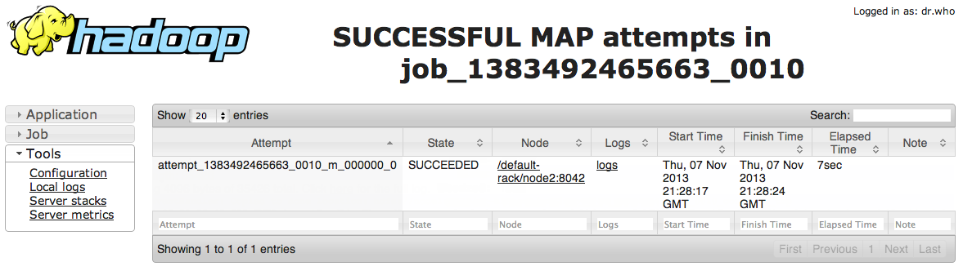
Notice the most recent job at the top of the list has a status of FAILED.
  - Click on Job ID of the failed IndexInverterJob. You should see the details page for this job:
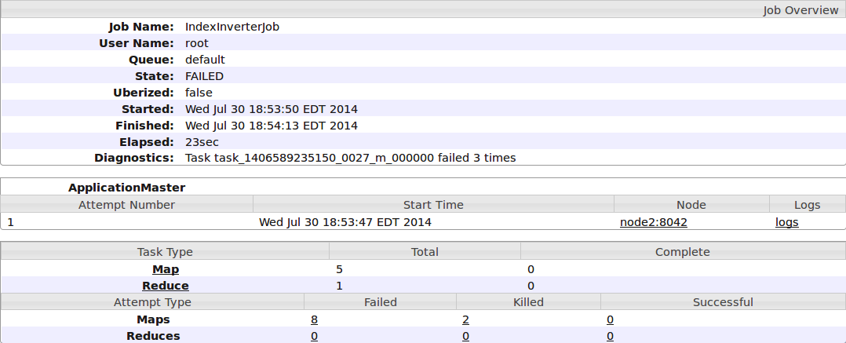
  - Notice this page contains useful details about the job, including the average map and reduce time, and how long it took to execute the entire job.
  - Also notice that 5 mappers and 1 reducer were started for this job. In the screen shot above, 8 map tasks failed, 2 were killed, and 0 were successful. Notice these numbers are links - click on your number of failed map tasks:
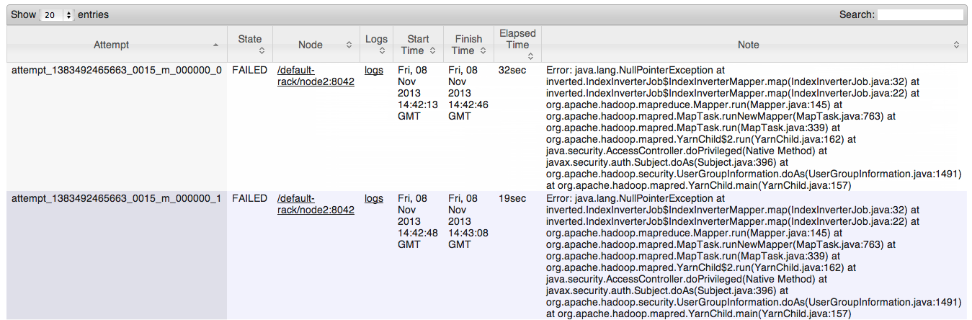
  - In the Logs column, click on the logs link of one of the failed map tasks to view the corresponding log file:
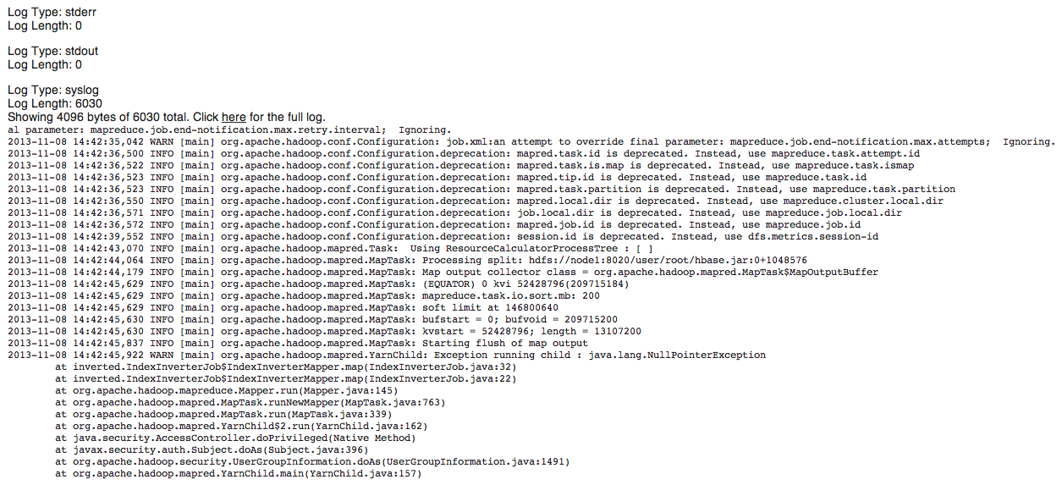
  - What happened in this job? Why did the mapper fail? ___________________
RESULT: You have executed a MapReduce job that failed for several different reasons. Being able to troubleshoot these types of issues is an important and handy skill for any Hadoop administrator.
ANSWERS:
2.2: The job fails because the input file for the job does not exist in HDFS.
3.3: 1 mapper and 1 reducer, as found in the Job Counters section of the output.
3.4: Look for the counter “Total time spent by all maps in occupied slots (ms)”
3.5: Similarly, look for “Total time spent by all reduces in occupied slots (ms)”
3.6: Bytes Read=1126, as found in the File Input Format Counters section.
3.7: Bytes Written=2997, as found in the File Output Format Counters section.
5.2: The output folder of a MapReduce job cannot exist. You should have gotten the following error message: “FileAlreadyExistsException: Output directory hdfs://node1:8020/user/root/index_output already exists”
7.3: You should see 10 launched map tasks. The number of failed and killed tasks will vary, but expect about 8 failed and 2 killed.
7.4: When a map task fails, the MapReduce framework launches the map task again. A map task has to fail 2 times (by default) before the entire job fails. The input file was split into 5 blocks, and each block generated a map task that failed 2 times, so 5x2=10.
8.6: A NullPointerException was thrown on line 32 of IndexInverterJob.java. Useful information for the Java developer!

Lab: Using Sqoop to Import Data

Objective: | Move data between HDFS and a RDBMS.
Successful Outcome: | You will have imported data from MySQL into folders in HDFS, and exported data from HDFS into a MySQL table.
Before You Begin: | Go into terminal on hadoop-master.

Perform the following steps:
- Install MySQL
  - If necessary, run the following commands to install MySQL on hadoop-master:
# yum -y install mysql mysql-server
  - Start the server with the following command:
# service mysqld start
- Create a Table in MySQL
  - As the root user, change directories to /root/materials:
  - View the contents of salaries.txt:
# cat salaries.txt
The comma-separated fields represent a gender, age, salary and zip code.
  - Notice there is a salaries.sql script that defines a new table in MySQL named salaries. For this script to work, you need to copy salaries.txt into the publicly-available /tmp folder:
# cp salaries.txt /tmp
  - Now run the salaries.sql script using the following command:
# mysql salaries < salaries.sql
- View the Table
  - To verify the table is populated in MySQL, open the mysql prompt:
# mysql
  - Switch to the test database, which is where the salaries table was created:
mysql> use test;
  - Run the show tables command and verify salaries is defined:
mysql> show tables;
+----------------+
| Tables_in_test |
+----------------+
| salaries |
+----------------+
1 row in set (0.00 sec)
  - Select 10 items from the table to verify it is populated:
mysql> select * from salaries limit 10;
+--------+------+--------+---------+----+
| gender | age | salary | zipcode | id |
+--------+------+--------+---------+----+
| F | 66 | 41000 | 95103 | 1 |
| M | 40 | 76000 | 95102 | 2 |
| F | 58 | 95000 | 95103 | 3 |
| F | 68 | 60000 | 95105 | 4 |
| M | 85 | 14000 | 95102 | 5 |
| M | 14 | 0 | 95105 | 6 |
| M | 52 | 2000 | 94040 | 7 |
| M | 67 | 99000 | 94040 | 8 |
| F | 43 | 11000 | 94041 | 9 |
| F | 37 | 65000 | 94040 | 10 |
+--------+------+--------+---------+----+

- Grant the Necessary Privileges
  - Enter the following command at the mysql prompt to grant access to node2 and node3 to connect to the mysql-server running on hadoop-master:
grant all privileges on *.* to 'root'@'%' with grant option;
  - Exit the mysql prompt:
mysql> exit
- Import the Table into HDFS
  - Enter the following Sqoop command (all on a single line), which imports the salaries table in the test database into HDFS:
# sqoop import
--connect jdbc:mysql://sandbox/test
--table salaries
--username root
  - A MapReduce job should start executing, and it may take a couple minutes for the job to complete.
- Verify the Import
  - View the contents of the salaries folder:
# hadoop fs -ls salaries
  - You should see a new folder named salaries. View its contents:
# hadoop fs -ls salaries
Found 4 items
-rw-r--r-- 1 root hdfs 272 part-m-00000
-rw-r--r-- 1 root hdfs 241 part-m-00001
-rw-r--r-- 1 root hdfs 238 part-m-00002
-rw-r--r-- 1 root hdfs 272 part-m-00003
  - Notice there are some new files in the salaries folder named part-m-0000x. Why are there this many of these files?
__________________________________________________________________
  - Use the cat command to view the contents of the files. For example:
# hadoop fs -cat salaries/part-m-00000
Notice the contents of these files are the rows from the salaries table in MySQL. You have now successfully imported data from a MySQL database into HDFS. Notice you imported the entire table with all of its columns. In the next step, you will import only specific columns of a table.
- Specify Columns to Import
  - Using the --columns argument, write a Sqoop command that imports the salary and age columns (in that order) of the salaries table into a directory in HDFS named salaries2. In addition, set the -m argument to 1 so that the result is a single file.
  - After the import, verify you only have one part-m fie in salaries2:
# hadoop fs -ls salaries2
Found 1 items
-rw-r--r-- 1 root hdfs 482 salaries2/part-m-00000
  - Verify the contents of part-m-00000 are only the 2 columns you specified:
# hadoop fs -cat salaries2/part-m-00000
The last few lines should look like the following:
69000.0,97
91000.0,48
0.0,1
48000.0,45
3000.0,39
14000.0,84
- Importing from a Query
  - Write a Sqoop import command that imports the rows from salaries in MySQL whose salary column is greater than 90,000.00. Use gender as the --split-by value, specify only 2 mappers, and import the data into the salaries3 folder in HDFS.
TIP: The Sqoop command will look similar to the ones you have been using throughout this lab, except you will use --query instead of --table. Recall that when you use a --query command you must also define a --split-by column, or define -m to be 1.

Also, do not forget to add $CONDITIONS to the WHERE clause of your query, as demonstrated earlier in this Unit.
  - To verify the result, view the contents of the files in salaries3. You should have only two output files.
  - View the contents of part-m-00000 and part-m-00001. Notice one file contains females, and the other file contains males. Why? ______________
______________________________________________________________
  - Verify the output files contain only records whose salary is greater than 90,000.00.
- Put the Export Data into HDFS
  - Now let’s export data from HDFS to the database. Start by viewing the contents of the data, which is in a file named salarydata.txt:
# tail salarydata.txt
M,49,29000,95103
M,44,34000,95102
M,99,25000,94041
F,93,96000,95105
F,75,9000,94040
F,14,0,95102
M,68,1000,94040
F,45,78000,94041
M,40,6000,95103
F,82,5000,95050
Notice the records in this file contain 4 values separated by commas, and the values represent a gender, age, salary and zip code, respectively.
  - Create a new directory in HDFS named salarydata.
  - Put salarydata.txt into the salarydata directory in HDFS.
- Create a Table in the Database
  - There is a script in the Lab3.2 folder that creates a table in MySQL that matches the records in salarydata.txt. View the SQL script:
# more salaries2.sql
  - Run this script using the following command:
# mysql test < salaries2.sql
  - Verify the table was created successfully in MySQL:
# mysql
mysql> use test;
mysql> describe salaries2;
+---------+------------+------+-----+---------+-------+
| Field | Type | Null | Key | Default | Extra |
+---------+------------+------+-----+---------+-------+
| gender | varchar(1) | YES | | NULL | |
| age | int(11) | YES | | NULL | |
| salary | double | YES | | NULL | |
| zipcode | int(11) | YES | | NULL | |
+---------+------------+------+-----+---------+-------+
  - Exit the mysql prompt:
mysql> exit
- Export the Data
  - Run a Sqoop command that exports the salarydata folder in HDFS into the salaries2 table in MySQL. At the end of the MapReduce output, you should see a log event stating that 10,000 records were exported.
  - Verify it worked by viewing the table’s contents from the mysql prompt. The output should look like the following:
mysql> use test;
mysql> select * from salaries2 limit 10;
+--------+------+--------+---------+
| gender | age | salary | zipcode |
+--------+------+--------+---------+
| M | 57 | 39000 | 95050 |
| F | 63 | 41000 | 95102 |
| M | 55 | 99000 | 94040 |
| M | 51 | 58000 | 95102 |
| M | 75 | 43000 | 95101 |
| M | 94 | 11000 | 95051 |
| M | 28 | 6000 | 94041 |
| M | 14 | 0 | 95102 |
| M | 3 | 0 | 95101 |
| M | 25 | 26000 | 94040 |
+--------+------+--------+---------+

RESULT: You have imported the data from MySQL to HDFS using the entire table, specific columns, and also using the result of a query. You have also exported a folder of data in HDFS into a table in MySQL.

SOLUTIONS:
Step 7.1 is the following command (entered on a single line):
# sqoop import --connect jdbc:mysql://hadoop-master/test
--table salaries
--columns salary,age
-m 1
--target-dir salaries2
--username root
Step 8.1:
sqoop import --connect jdbc:mysql://hadoop-master/test
--query "select * from salaries s where s.salary > 90000.00 and \$CONDITIONS"
--split-by gender
-m 2
--target-dir salaries3
--username root
Step 11
sqoop export
--connect jdbc:mysql://hadoop-master/test
--table salaries2
--export-dir salarydata
--input-fields-terminated-by ","
--username root

ANSWERS:
Step 6.3: The MapReduce job that executed the Sqoop command used four mappers, so there are four output files (one from each mapper).
Step 8.3: You used gender as the split-by column, so all records with the same gender are sent to the same mapper.

Lab: Using Flume to Export Data

Objective: | Install, configure and run Flume.
Successful Outcome: | A running Flume agent that reads data from a network connection and writes it to a folder in HDFS.
Before You Begin: | Go to terminal on sandbox.

Perform the following steps:
- Install Flume
  - On sandbox as root, confirm install of flume-ng:
# flume-ng
    - If needed install Flume using the following command:
# yum –y install flume
  - Verify Flume is installed by viewing the usage of the flume-ng command:
# flume-ng
- View the Flume Agent Configuration
  - Change directories to the ~/materials directory.
  - A Flume agent has been written for you in a file named flume-agent-1.conf. View the file:
# less flume-agent-1.conf
- Start a Flume agent
  - Start flume-ng using the following command (all on a single line):
flume-ng agent --conf conf --conf-file flume-agent-1.conf --name myagent -Dflume.root.logger=INFO,console &
NOTE that in a full deployment we would typically include one more option: --conf=<conf-dir>. The <conf-dir> directory would include a shell script flume-env.sh and potentially a log4j properties file. In this example, we pass a Java option to force Flume to log to the console and we go without a custom environment script.
  - View the output of the command. Make sure all sinks and sources started:
INFO sink.RollingFileSink: RollingFileSink sink1 started.
INFO instrumentation.MonitoredCounterGroup: Monitoried counter group for type: SOURCE, name: source1, registered successfully.
INFO instrumentation.MonitoredCounterGroup: Component type: SOURCE, name: source1 started
INFO source.AvroSource: Avro source source1 started.
- Test the Flume Agent
  - From a separate terminal (if possible), we can then telnet port 44444 and send Flume an event:
# telnet localhost 44444
Trying 127.0.0.1...
Connected to localhost.localdomain (127.0.0.1).
Escape character is '^]'.
Hello world! <ENTER>
OK

RESULT: You just ran a Flume agent that reads data from a network connection and streams it into a folder in HDFS.

LAB 7

Lab: Using Hive

Objective: | Understand how Hive table data is stored in HDFS.
Successful Outcome: | You will have created a couple of tables in Hive and learned how data gets associated with a Hive table.
Before you begin: | Go into terminal on the sandbox.

- Review the Data
  - As root, change directories to the /root/materials/data folder.
  - Notice there are part-m-0000x files, which are the result of a MapReduce job that formatted the data for use with Hive. View the contents of one of these files:
# more part-m-00000
Notice the data consists of information about visitors to the White House, including the name, date, person being visited, and a comment section.
- Define a Hive Table
  - In the data folder, there is a text file named wh_visits.sql. View its contents. Notice it defines a Hive table named wh_visits with a schema that matches the data in the part-m-0000x files:
# more wh_visits.sql
create table wh_visits (
lname string,
fname string,
time_of_arrival string,
appt_scheduled_time string,
meeting_location string,
info_comment string)
ROW FORMAT DELIMITED
FIELDS TERMINATED BY '\t' ;
NOTE: You cannot use comment or location as column names because those are reserved Hive keywords.
  - Run the script with the following command:
# hive -f wh_visits.hive
  - If successful, you should see “OK” in the output along with the time it took to run the query.
- Verify the Table Creation
  - Go into http://localhost:8000/beeswax/tables to view file you created
  - Start the Hive Shell:
# hive
hive>
  - From the hive> prompt, enter the “show tables” command:
hive> show tables;
You should see wh_visits in the list of tables.
  - Use the describe command to view the details of wh_visits:
hive> describe wh_visits;
OK
lname string None
fname string None
time_of_arrival string None
appt_scheduled_time string None
meeting_location string None
info_comment string None
  - Try running a query (even though the table is empty):
select * from wh_visits;
The query should execute fine, but no result appears.
- View the Hive Folder Structure
  - Exit the Hive shell:
hive> exit;
[root@sandbox data]#
  - View the contents of the Hive warehouse folder:
# hadoop fs -ls /apps/hive/warehouse
Found 1 items
drwxr-xr-x - root hdfs 0 /apps/hive/warehouse/wh_visits
Notice there is a folder named wh_visits. When did this folder get created? _________________________________________________________________
  - List the contents of the wh_visits folder:
# hadoop fs -ls /apps/hive/warehouse/wh_visits
Notice the folder is empty.
- Populate the Hive Table
  - Run the following command to put the local part-m-00000 file into the wh_visits folder:
# hadoop fs -put part-m-00000 /apps/hive/warehouse/wh_visits
  - From the Hive shell, run the following query:
hive> select * from wh_visits;
This time, you should see a couple thousand rows of data. Notice that by simply putting a file into the wh_visits folder, the table now contains data.
  - Notice no MapReduce job was executed to perform the select * query. Why not? ___________________________________________________________
- Drop the Table
  - Run the following query, which drops the wh_visits table:
hive> drop table wh_visits;
  - Exit the Hive shell and view the contents of the Hive warehouse folder:
# hadoop fs -ls /apps/hive/warehouse/
Notice that not only has the part-m-00000 file been deleted, but also the wh_visits folder no longer exists!
- Create the Table Again
  - Run wh_visits.hive again to recreate the wh_visits table:
# hive -f wh_visits.hive
- Use the Hive LOAD DATA Command
  - Create a new directory in HDFS named whitehouse:
# hadoop fs -mkdir whitehouse
  - Put all 5 part-m files into whitehouse:
# hadoop fs -put part-m-* whitehouse/
  - Verify the files are there:
# hadoop fs -ls whitehouse
  - From the Hive shell, run the following query:
hive> LOAD DATA INPATH '/user/root/whitehouse/' OVERWRITE INTO TABLE wh_visits;
  - Verify you have now have data in the table:
hive> select * from wh_visits limit 10;
You should ten rows of visitors, and no MapReduce is needed.
  - Try the following query. Make sure the output looks like first names:
hive> select fname from wh_visits limit 20;
This time a MapReduce job executed. Why? ____________________________
- View the Folder Structure
  - View the contents of the wh_visits folder:
# hadoop fs -ls /apps/hive/warehouse/wh_visits
Notice the five part-m files are located in wh_visits.
  - Try viewing the contents of the whitehouse folder:
# hadoop fs -ls whitehouse
Notice the folder is empty. The LOAD DATA command moved the files from their original HDFS folder into the Hive warehouse folder; it did not copy them.
IMPORTANT: Be careful when you drop a managed table in Hive. Make sure you either have the data backed up somewhere else, or that you no longer want the data.
- Count the Number of Rows in a Table
  - Enter the following Hive query, which outputs the number of rows in wh_visits:
hive> select count(*) from wh_visits;
  - How many rows are currently in wh_visits? _____________
- Define an External Table
  - Drop the wh_visits table again:
hive> drop table wh_visits;
  - View the contents of external_table.hive in the /root/labs/data folder:
# more external_table.hive
create external table wh_visits (
lname string,
fname string,
time_of_arrival string,
appt_scheduled_time string,
meeting_location string,
info_comment string)
ROW FORMAT DELIMITED
FIELDS TERMINATED BY '\t'
LOCATION '/user/root/whitehouse/' ;
  - Create the whitehouse folder in HDFS again, and put the five part-m files into whitehouse.
  - Verify that there is not a subfolder of /apps/hive/warehouse named wh_visits.
  - Run the query in external_table.hive to create the wh_visits table:
# hive –f external_table.hive
  - Run a query on wh_visits to verify that the table does actually contain records.
  - Drop wh_visits again, but this time notice that the files in the whitehouse folder are not deleted.

RESULT: As you just verified, the data for external tables is not deleted when the corresponding table is dropped. Aside from this behavior, managed tables and external tables in Hive are essentially the same.

Lab: Using WebHDFS
Objective: | To become familiar with the capabilities of WebHDFS and how to use it.
Successful Outcome: | You will have executed several WebHDFS file commands successfully, include upload, append, list a directory, and download.
Before You Begin: | Go into terminal on the sandbox.

- List a Directory
  - Using curl, view the contents of the /user/root directory in HDFS:
# curl -i "http://sandbox:50070/webhdfs/v1/user/root?op=LISTSTATUS"
  - You should see a 200 OK response, along with a JSON object containing the files and directories in your /user/root folder:
HTTP/1.1 200 OK
Cache-Control: no-cache
Expires: Thu, 14 Nov 2013 14:35:42 GMT
Date: Thu, 14 Nov 2013 14:35:42 GMT
Pragma: no-cache
Expires: Thu, 14 Nov 2013 14:35:42 GMT
Date: Thu, 14 Nov 2013 14:35:42 GMT
Pragma: no-cache
Content-Type: application/json
Transfer-Encoding: chunked
Server: Jetty(6.1.26)

{"FileStatuses":{"FileStatus":[
{"accessTime":0,"blockSize":0,"childrenNum":0,"fileId":17321,"group":"hadoop","length":0,"modificationTime":1384408800076,"owner":"root","pathSuffix":".Trash","permission":"700","replication":0,"type":"DIRECTORY"},
{"accessTime":1384219125588,"blockSize":134217728,"childrenNum":0,"fileId":17331,"group":"hadoop","length":861,"modificationTime":1384219125967,"owner":"root","pathSuffix":"constitution.txt","permission":"644","replication":3,"type":"FILE"},
...
]}}
- Make a New Directory
  - Use WebHDFS to make a new subdirectory of /user/root in HDFS named history:
# curl -i -X PUT "http://sandbox:50070/webhdfs/v1/user/root/history?op=MKDIRS"
Verify the file in Hue: http://localhost:8000/filebrowser/#/user/history
If you get an AccessControlException, you need to add the user.name property to the URL:
# curl -i -X PUT "http://sandbox:50070/webhdfs/v1/user/root/history?op=MKDIRS&user.name=root"
  - Verify the history directory was created successfully:
# hadoop fs -ls
- Upload a File
  - The first step to uploading a file is to create a path on the NameNode. As part of the REST contract, the NameNode will respond with a 307 TEMPORARY_REDIRECT to the actual DataNode that the blocks should go to:
# curl -i -X PUT "http://sandbox:50070/webhdfs/v1/user/root/history/constitution.txt?op=CREATE&blocksize=1048576"
  - Use the temporary redirect URL that the NameNode provides in the response above to submit the file to the DataNode. For example, the command shown here puts the file onto node4, but you should copy-and-paste the URL from the response of the previous step:

# curl -i -PUT -T constitution.txt "http://sandbox:50075/webhdfs/v1/user/root/history/constitution.txt?op=CREATE"
  - Verify the file was uploaded successfully:
# hadoop fs -lsr history
Found 1 items
-rwxr-xr-x 3 root hadoop 44841 history/constitution.txt
- Upload a Large File
  - In this step, you will upload a larger file, one that spans multiple blocks. Start by changing directories to /root/materials.
You should have a large file in materials. Pick one.
  - Ask the NameNode to create a file named big.txt in /user/root:
# curl -i -X PUT "http://sandbox:50070/webhdfs/v1/user/root/big.txt?op=CREATE&blocksize=1048576"
  - Using the URL provided by the previous command, upload test_data into HDFS, and then verify the upload worked successfully.
- Append to an Existing File
  - Appending a file is similar to creating a file - it is a two-step process. Using WebHDFS, append the local file constitution.txt to big.txt in HDFS.
- Retrieve a File
  - Use WebHDFS to retrieve the file constitution.txt.
  - Retrieve big.txt from the 1,000,000th byte offset and get 1048576 bytes (1MB). Pipe the result to a local file named big_partial.txt.

RESULT: You have seen how to use WebHDFS to execute a variety of HDFS commands over HTTP using RESTful web Services.

SOLUTION to 6.2:
curl -i -L "http://sandbox:50070/webhdfs/v1/user/root/big.txt?op=OPEN&offset=1000000&length=1048576" > big_partial.txt

