Introduction

|  |  |
| --- | --- |
| **Obejective** | Setup environment for developing. |
| **Outcome** | Verified development environment. |
| **Preparation** | Log into your online lab environment. |

**Login Info:**

During this class, you will be logging in and out. Please, pay careful attention to your login info and make note, as this information will only be given once, here:

[User-name] - training

[password] - hadoop

[root user-name] - root

[root password] - hadoop

[Amabri user-name] - admin

[Ambari password] - admin

[local-path] - /home/training/

[hdfs-path] - /user/training/

**Exploring our work environment:**

1. Once you’re in the lab environment log in with [user-name] and [password].
2. Now, let’s start with your first project. From the terminal window, cd to ~/workspace; check all directories there. Feel free to select one and take a look. You’ll see Eclipse exercise files there.
3. Import the project into Eclipse. Eclipse should be installed in your ~/workspacefolder. Start Eclipse to view the projects already installed.
   1. From the Eclipse menu, select File -‐> Import…
   2. Expand the Generalfolder and select from the dropdown menu:

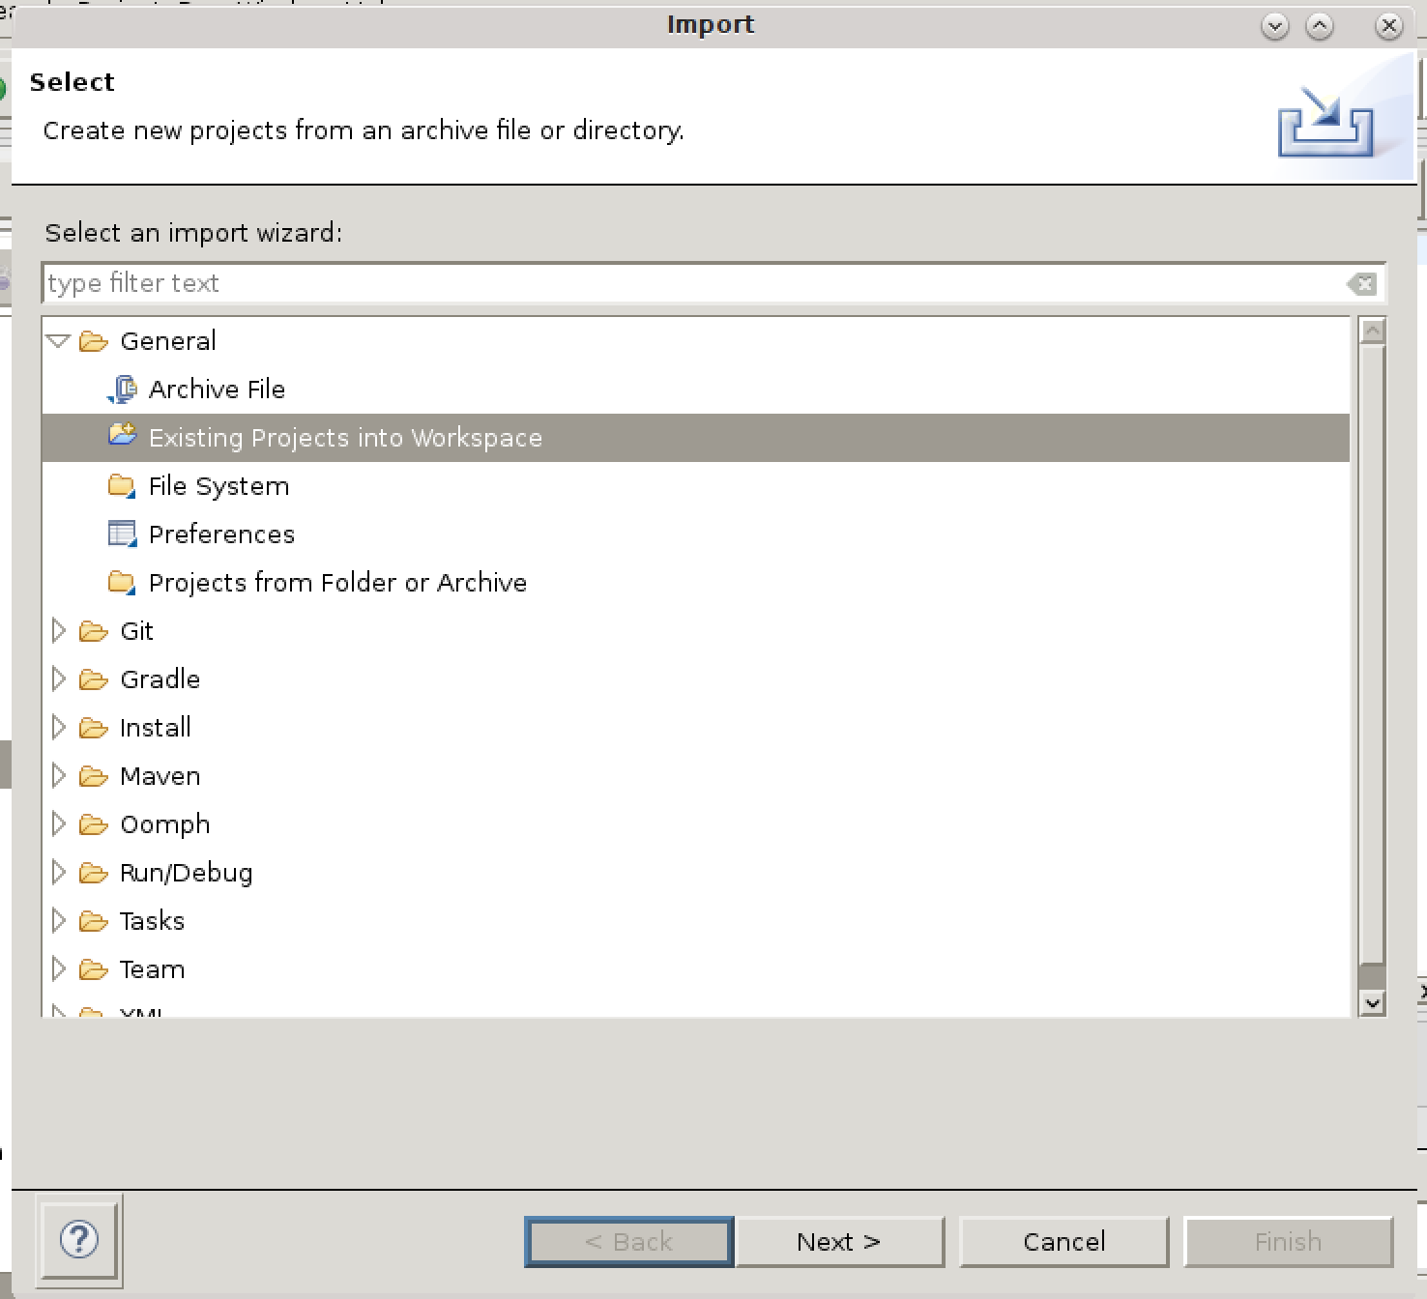

* 1. Once you have made your selection, click the Nextbutton, or double-click your selection.

# Click the Browse**…** button next to the “Select root directory:” text box and select your project’s folder.

# 

# Make sure “Copy projects into workspace” is selected in Options. Also, check your “Projects” area to make the appropriate projects are selected.

# 

1. Click the Finishbutton. Wait for the project to be imported into Eclipse.
2. You should now see your project in Eclipse Project Explorerwindow:

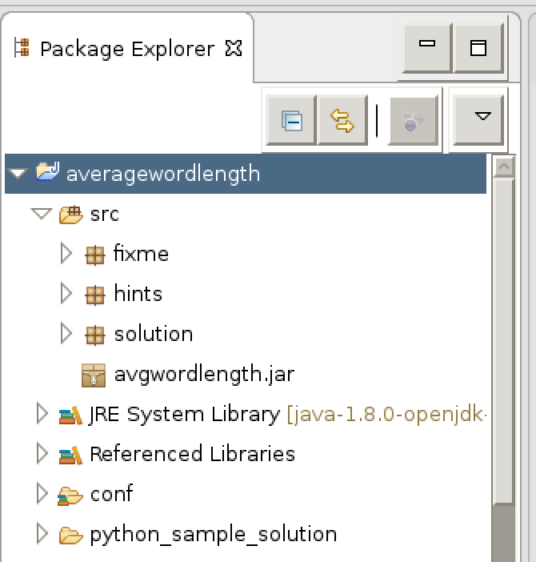

Your Eclipse is project is ready to go! You will use it in coming labs to develop Hadoop applications.

**Verify HDP is Running**

* 1. Open a terminal window. Switch to the rootuser (Password: hadoop).

$ su - root

* 1. Run the jpstool to verify which daemons are running:

$ jps

Results:

3494 JobHistoryServer

4075 RunJar

3120 QuorumPeerMain

…

[root@localhost ~]

NOTE: You may not see all of these processes, but will start them as we go.

1. Switch back to the [username]user by entering exit:
2. Define a directory in HDFS:
   1. View the contents in HDFS, by using the following command:

$ hdfs dfs -ls

* 1. You can also see ALL directories in HDFS:

$ hdfs dfs -ls –R

* 1. Define a new directory named ~/stocksin HDFS:

$ hdfs dfs -mkdir stocks

* 1. Verify the directory was created successfully:

1. In this step, you will upload into HDFS a group of files that contain dividend information from stocks traded on the NYSE. The files are currently on your local filesystem under ~/materials/data. You should see several *.csvfiles. Enter this to put these files into the /user/[user-name]/folder in HDFS:

$ hdfs dfs -put *.csv stocks/

1. Use Hadoop’s hdfs dfs -lscommand to verify the files are in HDFS.

**END**