Logging

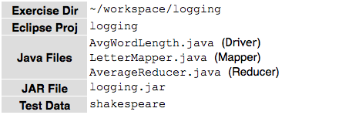

**In this Exercise, you will practice using log4j with MapReduce.**

Modify the Average Word Length program you built in the *Using ToolRunner and* *Passing Parameters* exercise so that the Mapper logs a debug message indicatingwhether it is comparing with or without case sensitivity.

**Enable Mapper Logging for the Job**

1. Before adding additional logging messages, try re-‐running the toolrunner

exercise solution with Mapper debug logging enabled by adding

-‐Dmapred.map.child.log.level=DEBUG to the command line.

$ *yarn jar toolrunner.jar solution.AvgWordLength*

*-Dmapred.map.child.log.level=DEBUG shakespeare outdir*

1. Take note of the Job ID in the terminal window or by using the maprep job command.
2. When the job is complete, view the logs. In a browser on your VM, visit the YARN Job Tracker UI: http://localhost:8088. Find the job you just ran in the Completed Jobs list and click its Job ID. E.g.:

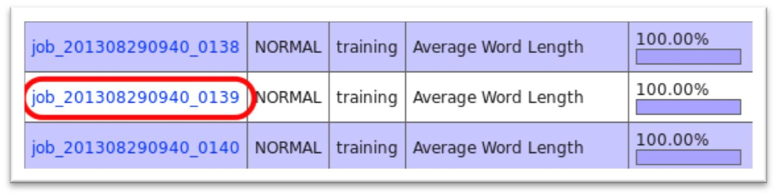

4. In the task summary, click map to view the map tasks.

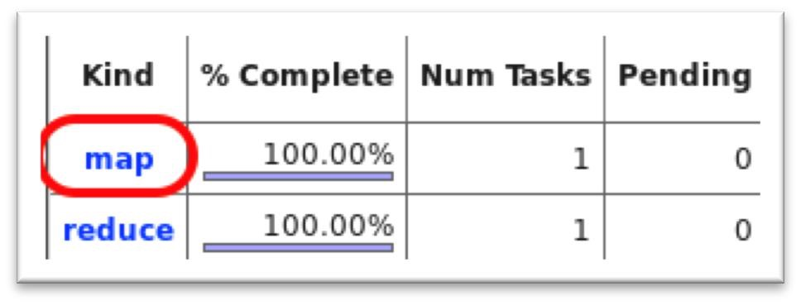

5. In the list of tasks, click on the map task to view the details of that task.

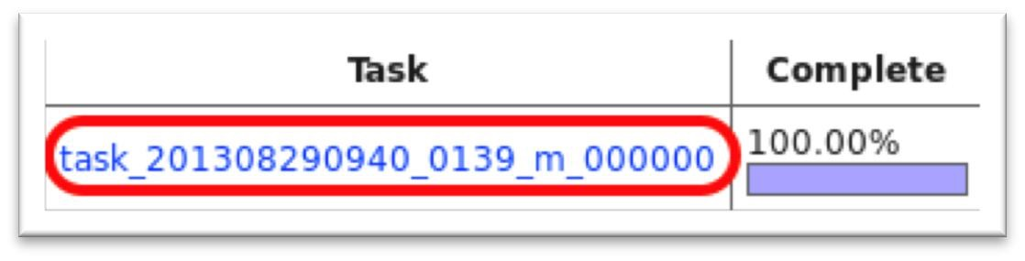

1. Under Task Logs, click “All”. The logs should include both INFO and DEBUG messages. E.g.:

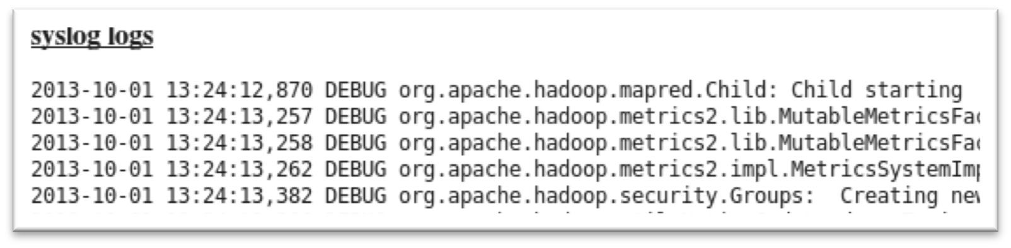

**Add Debug Logging Output to the Mapper**

1. Copy the code from the toolrunner project to the logging project fixme package. (You may either use your solution from the ToolRunner exercise, or the code in the solution package.)
2. Use log4j to output a debug log message indicating whether the Mapper is doing case sensitive or insensitive mapping.

**Build and Test Your Code**

1. Following the earlier steps, test your code with Mapper debug logging enabled. View the map task logs in the Job Tracker UI to confirm that your message is included in the log. (Hint: search for LetterMapper in the page to find your message.)

Optional: Try running map logging set to INFO (the default) or WARN instead of DEBUG and compare the log output.

**END**