Configure a Secure Wireless Network
Jesse Missaghian
University of Phoenix
CYB/360: Wireless Security
Jason Cupano
12/11/2023

In configuring our WLAN with the three Cisco Meraki MR62 wireless access points, I have focused on ensuring optimal coverage and connectivity. Each WAP has been strategically placed and configured to provide seamless internet access and intercommunication within our office space. Below is a breakdown of the configuration and associated vulnerabilities:

1. WAP1 - 10.0.1.12: Directional Beam Antenna
- Current Setup: Operating at 5 GHz
- Change Implemented: Switched to 2.4 GHz for broader coverage
- Vulnerability: The 2.4 GHz band, while offering extensive coverage, is more susceptible to interference from various common devices like microwaves and Bluetooth equipment. This could potentially lead to inconsistent connectivity and reduced network performance.

2. WAP2 - 10.0.1.14: High-Gain Patch Antenna
- Current Setup: Operating at 5 GHz
- Change Implemented: Adjusted to 2.4 GHz for enhanced reach
- Vulnerability: Utilizing the 2.4 GHz frequency increases the likelihood of overlapping channels with nearby networks, leading to potential co-channel interference and bandwidth issues.

3. WAP3 - 10.0.1.16: Omni-Directional Antennae
- Current Setup: Initially set at 5 GHz
- Change Implemented: Changed to 2.4 GHz for uniform performance
- Vulnerability: The shift to 2.4 GHz, despite ensuring consistent coverage, poses risks of network congestion, particularly in areas with many wireless networks, which might affect the network's throughput and latency.

The proximity of the WAPs, as depicted in the provided diagram, enables strong interconnectivity. This arrangement could lead to potential signal overlap, especially in areas where the coverage circles intersect. We need to carefully monitor these intersections to avoid performance degradation due to excessive signal strength.
While the chosen configurations aim to maximize coverage and ease of connectivity, we must remain vigilant about the potential vulnerabilities, particularly regarding interference and network congestion on the 2.4 GHz band. Regular network monitoring and adjustments will be essential to maintain an optimal balance between performance and security.
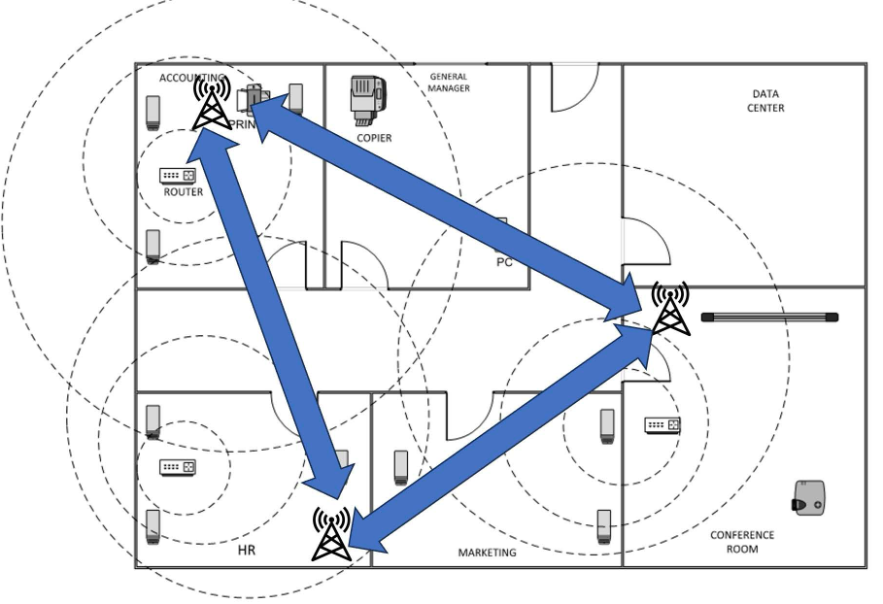
References
Coleman, D. D., & Westcott, D. A. (2021). CWNA Certified wireless network administrator study guide: Exam CWNA-108 (6th ed.). John Wiley & Sons, Inc.
MR - wireless LAN. Cisco Meraki. (2023, October 25). https://documentation.meraki.com/MR

