**Front-End Web Developer Project**

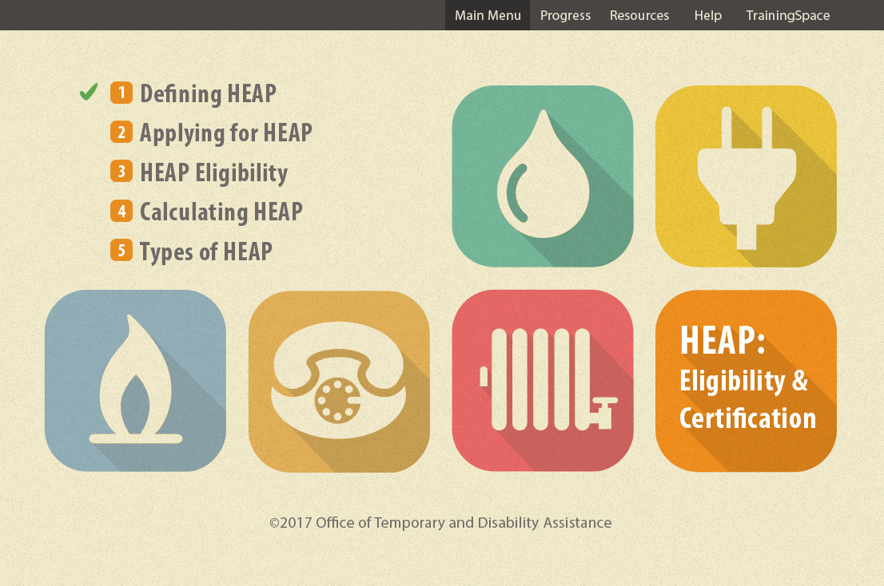

**The task:** Using HTML, CSS, and JavaScript, design and build four web pages for the course “HEAP: Eligibility & Certification.” Please adhere to the following specifications:

* Be sure your HTML is valid.
* The pages must be responsive.
* The pages should conform to Section 508 accessibility standards. See checklist here: <http://webaim.org/standards/508/checklist>
* Use the provided main menu graphic file (GUI-code-mainmenu.png) to design and build the main menu and three content pages as listed below.
* Each page must include:
  + Navigation buttons to move from page to page (BACK and NEXT buttons)
  + The top navigation bar, which includes the links: Main Menu, Progress, Resources, Help, and TrainingSpace
  + Design elements from the main menu design provided
  + Title of the page
  + Content for that page, as specified.
  + The page number
* Use the design theme of the main menu to design the content pages.

|  |  |  |  |
| --- | --- | --- | --- |
| # | Page Title | Content | Instructions |
| 1 | **Main Menu** | See screen design file: GUI-code-mainmenu.png | Please use the included png files to build the main menu in HTML, CSS, and JavaScript. |
| 2 | **Other Income Sources** | **Employed Under Contract**  If a client is employed under a contract, determine the time period the contract is intended to cover, and divide the total payment by that number of weeks or months, then calculate as appropriate.  **Lump Sums**  Retroactive lump sums which can be prorated over a specific time period, such as for SSI, Social Security, or Railroad Retirement, are considered income for HEAP purposes.  Non-recurring lump sum payments that are not for a specific period of time, such as a one-time sale of property, insurance settlements, Christmas bonuses, and income tax refunds are not considered income for HEAP purposes.  **Dividends and Interest**  Use a current statement to determine the monthly amount of any dividend or interest payment. Sometimes an annual statement or a quarterly statement covering three months must be used.  **IRA Income**  Use as *income* if the IRA is mature and the individual is or should be drawing from it. This includes instances where taking a mandatory withdrawal is *optional*.  NOTE: If the IRA is not mature, it is not counted as income, but *would be* considered a resource for Emergency HEAP applicants.  **Income Received by Children / Student Income**  Earned Income of dependent minors under 18 years old is exempt. Earned Income of full-time dependent students, student grants, loans, and scholarships, are all exempt.  **Strikers**  Count the current income of anyone on strike.  **Non-qualified Aliens Residing in Households with HEAP Applicants**  Income of non-qualified aliens is counted when determining eligibility and income tier. |  |
| 3 | **Activity: The Diaz Family** | Louise Diaz and her daughter, age 24, are applying for HEAP. Per an award letter, Ms. Diaz receives $761.00 monthly Code A SSI. Her daughter presents wage stubs indicating she works full time as a telemarketer earning $525 per week.  **What is the gross monthly income for this household?**  [numeric input]  *Text to display after user answer the question:*  The correct answer is $3,035. Because Ms. Diaz receives a monthly payment for Code A SSI, the Diaz household is categorically income eligible for HEAP. You should still calculate the family’s Gross Monthly Income, and then indicate the documentation supplied by the applicants. In this case, the daughter’s weekly wage is multiplied by 4.3333, and added to Ms. Diaz’s monthly payment. The Gross Monthly Income for the Diaz family is $3,035. | Please make this an activity. The correct answer is $3,035. |
| 4 | **Activity 2: Defining HEAP** | HEAP provides financial assistance to low income individuals and families for home energy costs.  **Households may be eligible for HEAP depending on their:**  *Please check all that apply.*   * Income (correct) * Family Size (correct) * Living Arrangement (correct) * Average age * Type of Heat (correct) * Region   *Text to display after user answer the question:*  Basic HEAP benefits depend on a household’s:   * Income * Family size * Living arrangement * Type of heat   Average age and region have no bearing on a family’s eligibility. | Please make this an activity. There are multiple correct answers. |

Please contact Edward Skawinski at [eskawinski@albany.edu](mailto:eskawinski@albany.edu) if you have any questions.