**WEEK-05**

**MODULE-08:MICROSERVICES WITH SPRINGBOOT 3 AND SPRING CLOUD**

**MANDATORY HANDSON**

**Creating Microservices for account and loan**

PRE-REQUISTE

1.Using SpringInitialzr to Create a Maven Project account and loan

2. Using the Dependencies such as Spring Web and Spring Boot DevTools

**For Account**

AccountController.java

package com.cognizant.account.controller;

import org.springframework.web.bind.annotation.*;

import java.util.Map;

@RestController

@RequestMapping("/accounts")

public class AccountController {

@GetMapping("/{number}")

public Map<String, Object> getAccountDetails(@PathVariable String number) {

return Map.of(

"number", number,

"type", "savings",

"balance", 234343 );

}}

**OUTPUT**

**BROSWER : http://localhost:8080**

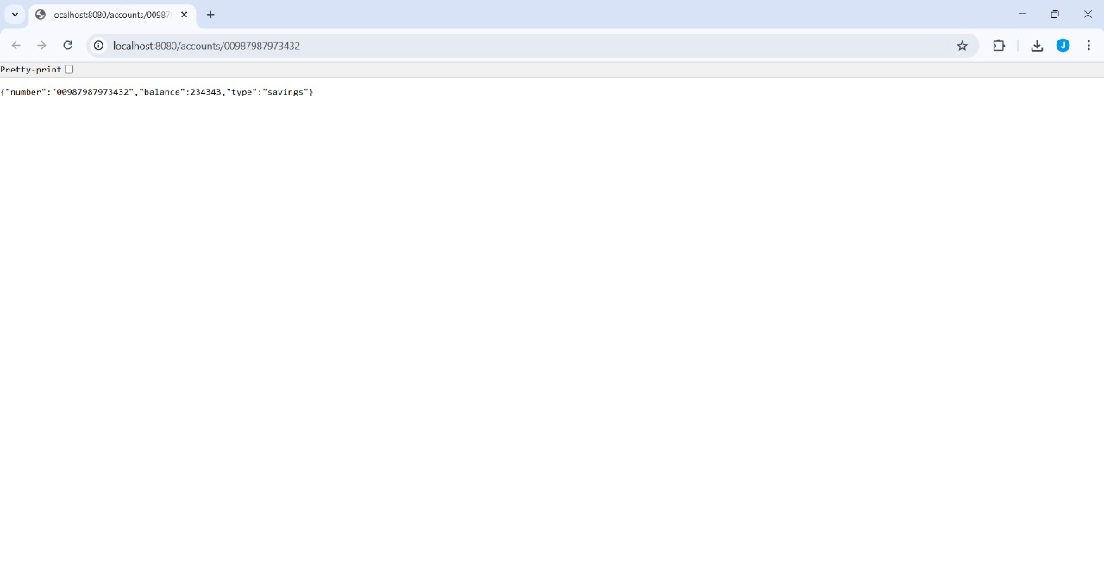

**FOR LOAN**

**LoanController.java**

package com.cognizant.loan.controller;

import org.springframework.web.bind.annotation.*;

import java.util.Map;

@RestController

@RequestMapping("/loans")

public class LoanController {

@GetMapping("/{number}")

public Map<String, Object> getLoanDetails(@PathVariable String number) {

return Map.of(

"number", number,

"type", "car",

"loan", 400000,

"email", 3258,

"tenure", 18

);

}

}

**OUTPUT**

**BROSWER :** [**http://localhost:8081**](http://localhost:8081)

