**WEEK-06**

**MODULE-10:SINGLE PAGE APPLICATION FRAMEWORK-REACT**

**MANDATORY HANDSON**

**1.REACTJS-HOL**

**.**

Step 1: Install Node.js and npm

* Go to the official Node.js website: <https://nodejs.org/en/download>
* Download and install the LTS version suitable for your operating system.
* After installation, open Command Prompt and verify installation:

**node -v**

Step 2: Install Create React App Tool

* Open Command Prompt.
* Run the following command to install Create React App globally:

**npm install -g create-react-app**

Step 3: Create a New React Application

* Run the following command to create a new React application named **myfirstreact**:

**npx create-react-app myfirstreact**

Step 4:Open the folder of myfirstreact in Visual Studio Code

Step 5: Open the App.js file in Src Folder of myfirstreact

Step 6: Remove the current content of “App.js**”**

function App() {

return (

<div>

<h1>Welcome to the first session of React</h1>

</div>

);

}

export default App**;**

Step 7:Run the React application

* In cmd:

**npm start**

**OUTPUT:**

BROSWER: <http://localhost:3000>

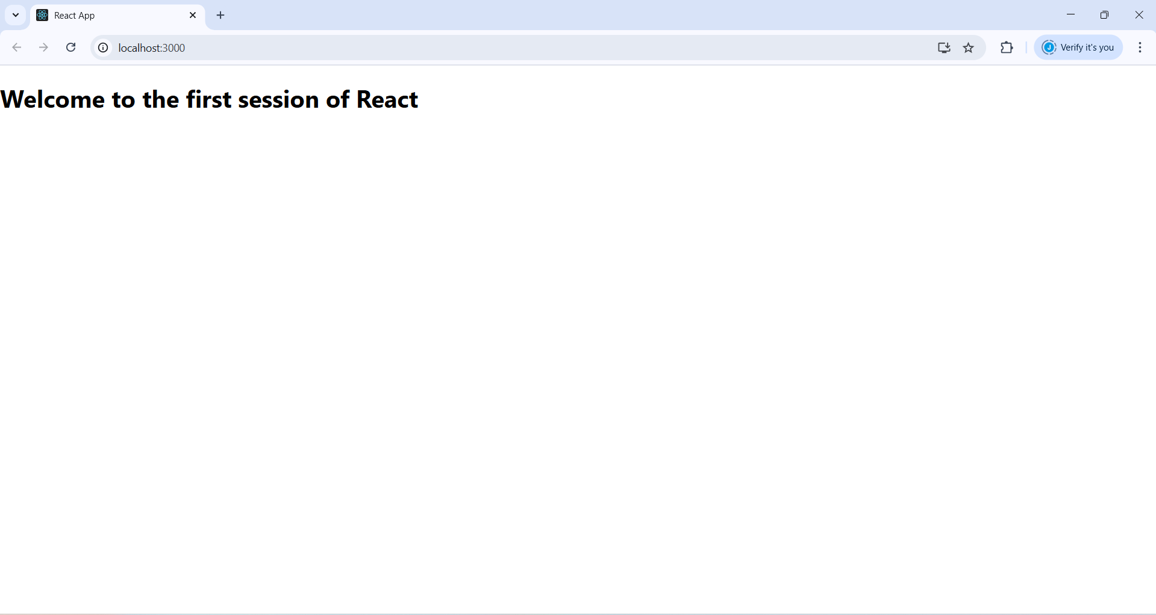

**2.REACTJS-HOL**

Step 1: Create a React Project Named studentapp

* Opening the Cmd or Terminal :

**npx create-react-app StudentApp**

Step 2: Open Project in Visual Studio Code

Step 3: Open studentapp folder

* Inside src folder create a new folder called Components
* Inside Components folder create three files namely:

Home.js

About.js

Contact.js

Step 4:

Home.js

import React from 'react';

function Home() {

return (

<div>

<h2>Welcome to the Home page of Student Management Portal</h2>

</div>

);

}

export default Home;

About.js

import React from 'react';

function About() {

return (

<div>

<h2>Welcome to the About page of the Student Management Portal</h2>

</div>

);

}

export default About;

Contact.js

import React from 'react';

function Contact() {

return (

<div>

<h2>Welcome to the Contact page of the Student Management Portal</h2>

</div>

);

}

export default Contact;

Step 5: Updating App.js

import React from 'react';

import Home from './Components/Home';

import About from './Components/About';

import Contact from './Components/Contact';

function App() {

return (

<div>

<Home />

<About />

<Contact />

</div>

);

}

export default App;

Step 6:run the application -npm start

**OUTPUT**

BROSWER : <http://localhost:3000>

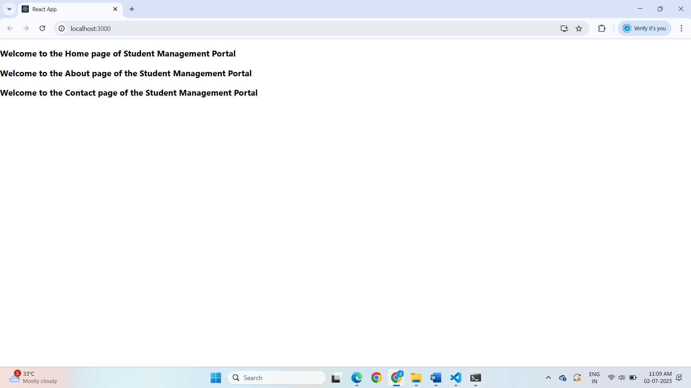

**3.REACTJS-HOL**

Step 1: Create React App

* Open command Prompt

**npx create-react-app scorecalculatorapp**

Step 2: Create Component Folder and File

* Create two folder named

**1.Componets**

**2.sheets**

* Creating two respective files in the folder

1.Compoents -CalculateScore.js

2.sheets -mystyle.css

CalculateScore.js

import "../sheets/mystyle.css";

const percentToDecimal = (decimal) => {

  return (decimal.toFixed(2) + "%")

};

const calcScore = (total, goal) => {

  return percentToDecimal(total / goal);

};

export const CalculateScore = ({ Name, School, total, goal }) => {

  return (

    <div className="formatstyle">

      <h1>

        <font color="Brown">Student Details:</font>

      </h1>

      <div className="Name">

        <b>

          <span>Name: </span>

        </b>

        <span>{Name}</span>

      </div>

      <div className="School">

        <b>

          <span>School: </span>

        </b>

        <span>{School}</span>

      </div>

      <div className="Total">

        <b>

          <span>Total: </span>

        </b>

        <span>{total}</span>

        <span> Marks</span>

      </div>

      <div className="Score">

        <b>Score: </b>

        <span>{calcScore(total, goal)}</span>

      </div>

    </div>

  );

};

mystyles.css

/* src/Stylesheets/mystyle.css */

.Name {

    font-weight: 300;

    color: blue;

  }

  .School {

    color: crimson;

  }

  .Total {

    color: darkmagenta;

  }

  .formatstyle {

    text-align: center;

    font-size: large;

    border: 1px solid #ccc;

    margin: 20px;

    padding: 15px;

    border-radius: 10px;

    background-color: #f9f9f9;

  }

    .Score {

    color: forestgreen;

  }

Step 4:Modifying App.js

import React from "react";

import { CalculateScore } from "./Components/CalculateScore";

function App() {

  return (

    <div>

      <CalculateScore

        Name="Steeve"

        School="DNV Public School"

        total={284}

        goal={3}

      />

    </div>

  );

}

export default App;

Step 5: Running the Project

* Open the terminal in vscode

**npm start**

**OUTPUT:**

**BROSWER :** [**http://localhost:3000**](http://localhost:3000)

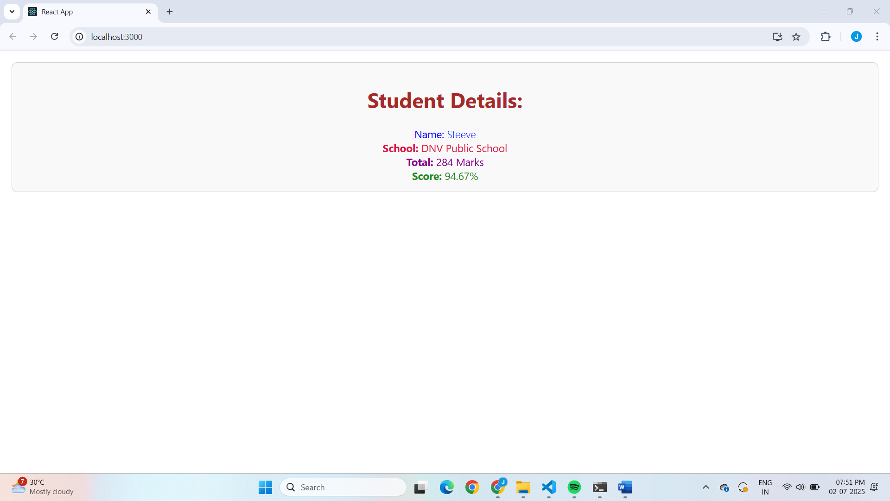

**4.REACTJS-HOL**

Step 1: Create React App

* Open the terminal in vs code or the cmd
* Run the following cmd:

**npx create-react-app blogapp**

Step 2: Create Post.js

* In src folder ,creating a file named

Post.js

class Post {

    constructor(id, title, body) {

      this.id = id;

      this.title = title;

      this.body = body;

    }

  }

  export default Post;

Step 3: Create Posts.js

* Creating a file in src named Posts.js with following methods:

1.loadPosts()

2. componentDidMount()

3.render()

Posts.js

import React from "react";

import Post from "./Post";

class Posts extends React.Component {

  constructor(props) {

    super(props);

    this.state = {

      posts: [],

    };

  }

 loadPosts() {

    fetch("https://jsonplaceholder.typicode.com/posts")

      .then((response) => {

        if (!response.ok) {

          throw new Error("Failed to fetch posts");

        }

        return response.json();

      })

      .then((data) => {

        const postList = data.map((item) => new Post(item.id, item.title, item.body));

        this.setState({ posts: postList });

      })

      .catch((error) => {

        alert("Error fetching posts: " + error.message);

      });

  }

 componentDidMount() {

    this.loadPosts();

  }

 componentDidCatch(error, info) {

    alert("An error occurred: " + error.message);

  }

render() {

    return (

      <div style={{ padding: "20px" }}>

        <h2>Blog Posts</h2>

        {this.state.posts.map((post) => (

          <div key={post.id} style={{ marginBottom: "20px" }}>

            <h3>{post.title}</h3>

            <p>{post.body}</p>

            <hr />

          </div>

        ))}

      </div>

    );

  }

}

export default Posts;

Step 4: Modify App.js

import React from "react";

import Posts from "./Posts";

function App() {

  return (

    <div className="App">

      <Posts />

    </div>

  );

}

export default App;

Step 11: Run the App

* Open the terminal in vscode:

**npm start**

OUTPUT:

BROSWER : <http://localhost:3000>

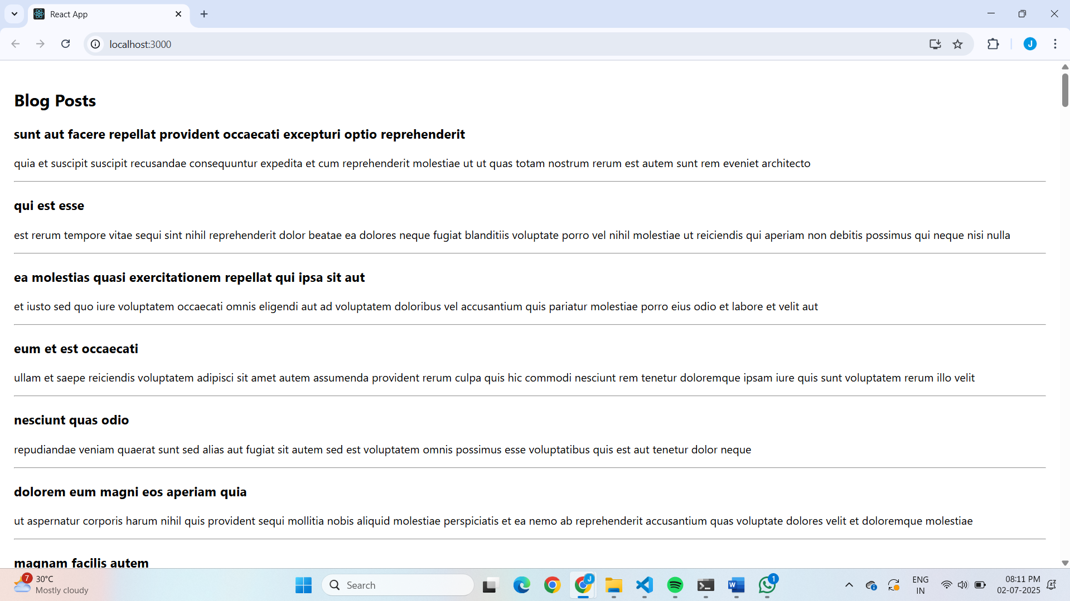

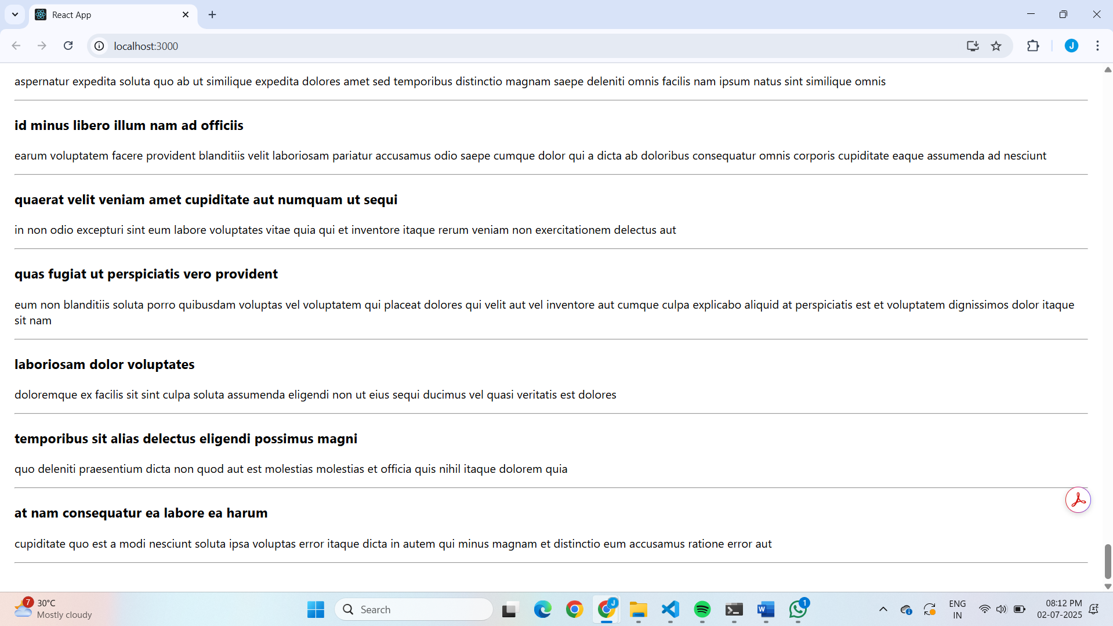

**5.REACTJS-HOL**

1. Unzip the React App

2. Install Node Packages

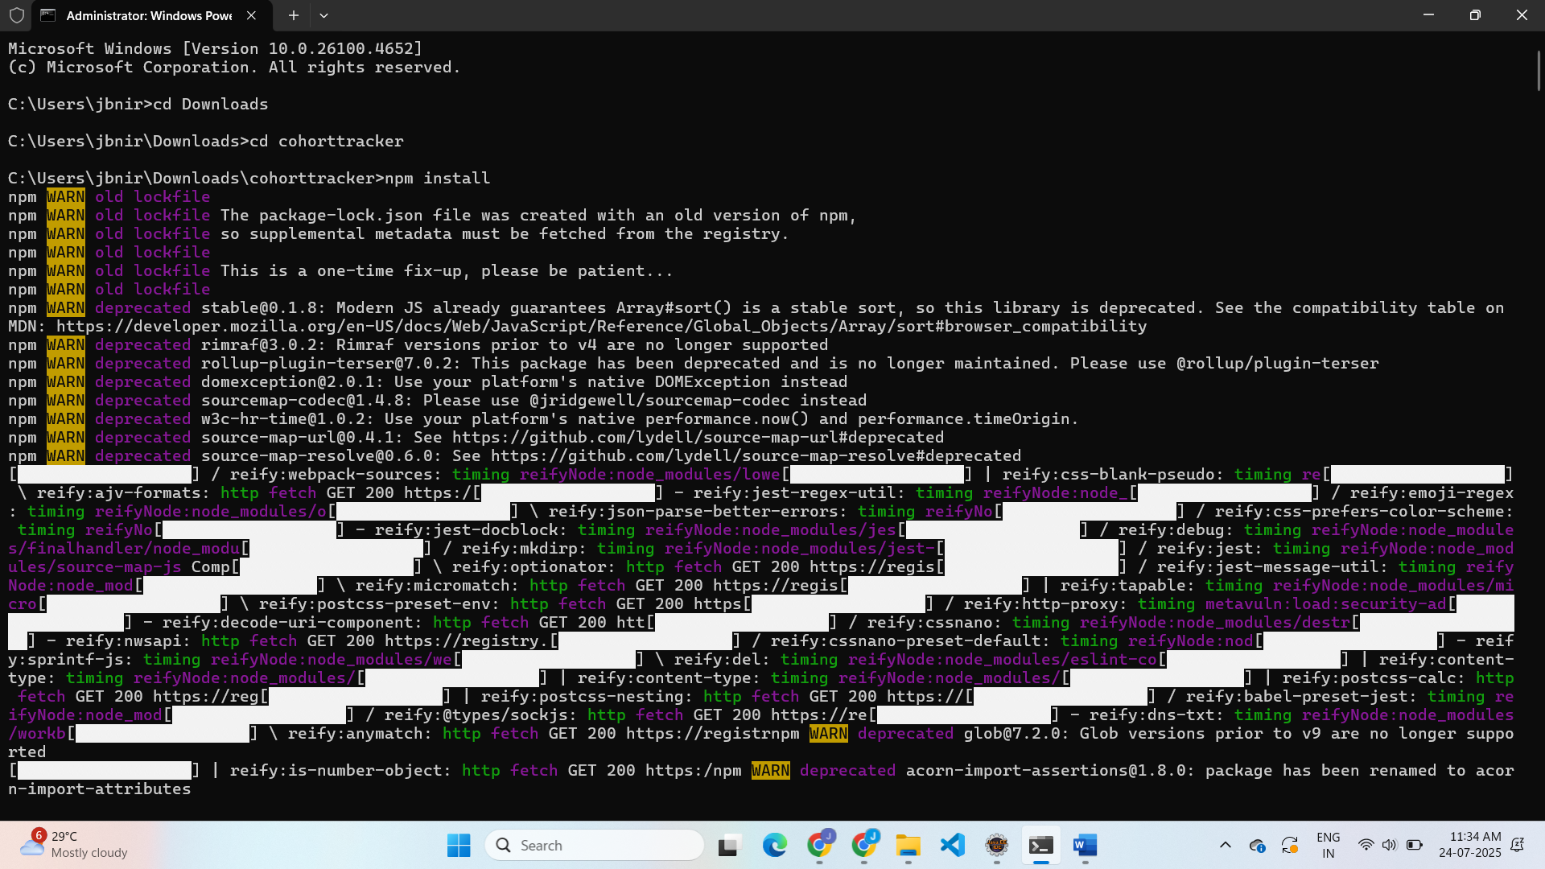

3.Create CSS Module File

.box {

width: 300px;

display: inline-block;

margin: 10px;

padding: 10px 20px;

border: 1px solid black;

border-radius: 10px;

}

dt {

font-weight: 500;

}

4.Opening the cohort details component and import the CSS Module

5. Define the style for <h3> element to use “green” color font when cohort status is “ongoing” and “blue” color in all other scenarios

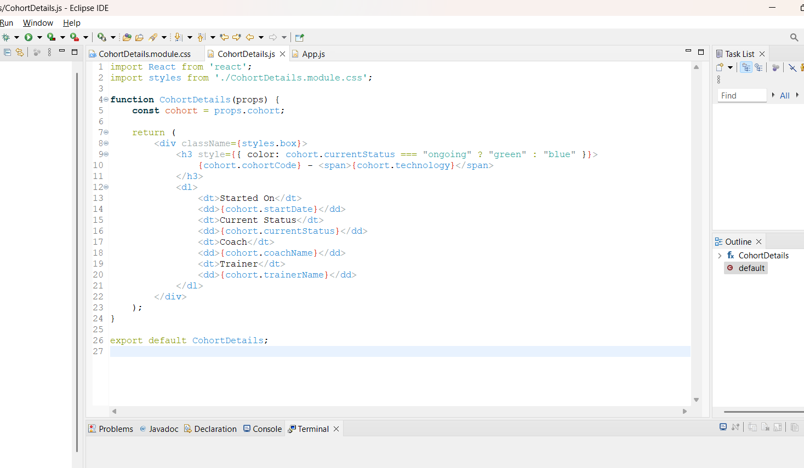

6.Run the Project

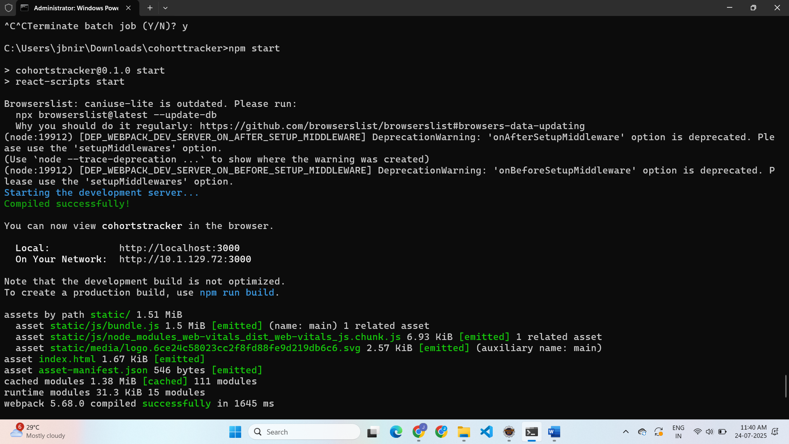

**OUTPUT**

