**WEEK-07**

**MODULE-10:SINGLE PAGE APPLICATION FRAMEWORK-REACT**

**MANDATORY HANDSON**

**9.REACTJS-HOL**

Step 1: Open Terminal and Create the App

**npx create-react-app cricketapp**

Step 2:Create the needed files

* Create the following files under the src folder

ListofPlayers.js

ScoreBelow70.js

IndianPlayers.js

OddPlayers.js

EvenPlayers.js

MergedPlayers.js

Step 3:Implement the following codes in respective files

ListofPlayers.js

import React from 'react';

const ListofPlayers = ({ players }) => {

  return (

    <div>

      <h1>List of All Players</h1>

      <ul>

        {players.map((player, index) => (

          <li key={index}>{player.name} - {player.score}</li>

        ))}

      </ul>

    </div>

  );

};

export default ListofPlayers;

ScoreBelow70.js

import React from 'react';

const ScoreBelow70 = ({ players }) => {

  const below70 = players.filter(player => player.score < 70);

  return (

    <div>

      <h1>Players having Scores Less than 70</h1>

      <ul>

        {below70.map((player, index) => (

          <li key={index}>{player.name} - {player.score}</li>

        ))}

      </ul>

    </div>

  );

};

export default ScoreBelow70;

IndianPlayers.js

import React from 'react';

import OddPlayers from './OddPlayers';

import EvenPlayers from './EvenPlayers';

import MergedPlayers from './MergedPlayers';

const IndianPlayers = () => {

  const indianTeam = ['Virat', 'Rohit', 'Dhoni', 'Jadeja', 'Rahul', 'Bumrah', 'Gill', 'Pandya'];

  const T20players = ['Virat', 'Rohit', 'Gill'];

  const RanjiPlayers = ['Pujara', 'Rahane', 'Saha'];

const merged = [...T20players, ...RanjiPlayers];

return (

    <div>

      <h1>Indian Team</h1>

      <h2>Odd Players</h2>

      <OddPlayers team={indianTeam} />

      <hr />

      <h2>Even Players</h2>

      <EvenPlayers team={indianTeam} />

      <hr />

      <h2>List of Indian Players Merged</h2>

      <MergedPlayers players={merged} />

    </div>

  );

};

export default IndianPlayers;

OddPlayers.js

import React from 'react';

const ordinalWords = [

  '', 'first', 'second', 'third', 'fourth', 'fifth',

  'sixth', 'seventh', 'eighth', 'ninth', 'tenth', 'eleventh'

];

const OddPlayers = ({ team }) => {

  const oddPlayers = team.filter((_, index) => index % 2 === 0);

  return (

    <ul>

      {oddPlayers.map((player, i) => {

        const originalIndex = i * 2 + 1; // 1-based position

        const positionWord = ordinalWords[originalIndex];

        return <li key={i}>{positionWord} - {player}</li>;

      })}

    </ul>

  );

};

export default OddPlayers;

EvenPlayers.js

import React from 'react';

const ordinalWords = [

  '', 'first', 'second', 'third', 'fourth', 'fifth',

  'sixth', 'seventh', 'eighth', 'ninth', 'tenth', 'eleventh'

];

const EvenPlayers = ({ team }) => {

  const evenPlayers = team.filter((_, index) => index % 2 !== 0);

  return (

    <ul>

      {evenPlayers.map((player, i) => {

        const originalIndex = i * 2 + 2; // 2-based position

        const positionWord = ordinalWords[originalIndex];

        return <li key={i}>{positionWord} - {player}</li>;

      })}

    </ul>

  );

};

export default EvenPlayers;

MergedPlayers.js

import React from 'react';

const MergedPlayers = ({ players }) => {

  return (

    <ul>

      {players.map((player, index) => (

        <li key={index}>{player}</li>

      ))}

    </ul>

  );

};

export default MergedPlayers;

Step 4:Modifying App.js

import React from 'react';

import ListofPlayers from './ListofPlayers';

import ScoreBelow70 from './ScoreBelow70';

import IndianPlayers from './IndianPlayers';

function App() {

  const flag = false; // const flag = true

  const players = [

    { name: 'Virat Kohli', score: 90 },

    { name: 'Rohit Sharma', score: 80 },

    { name: 'MS Dhoni', score: 95 },

    { name: 'Jadeja', score: 60 },

    { name: 'Shubman Gill', score: 50 },

    { name: 'KL Rahul', score: 70 },

    { name: 'Shreyas Iyer', score: 40 },

    { name: 'Hardik Pandya', score: 88 },

    { name: 'Bumrah', score: 45 },

    { name: 'Kuldeep Yadav', score: 66 },

    { name: 'Ashwin', score: 78 },

  ];

 return (

    <div className="App">

      {flag ? (

        <div>

          <ListofPlayers players={players} />

          <hr />

          <ScoreBelow70 players={players} />

        </div>

      ) : (

        <IndianPlayers />

      )}

    </div>

  );

}

export default App;

Step 5: Run the Application

* Open the cmd or teminal in vs code and run the following command

npm start

**OUTPUT:**

**WHEN flag = false**

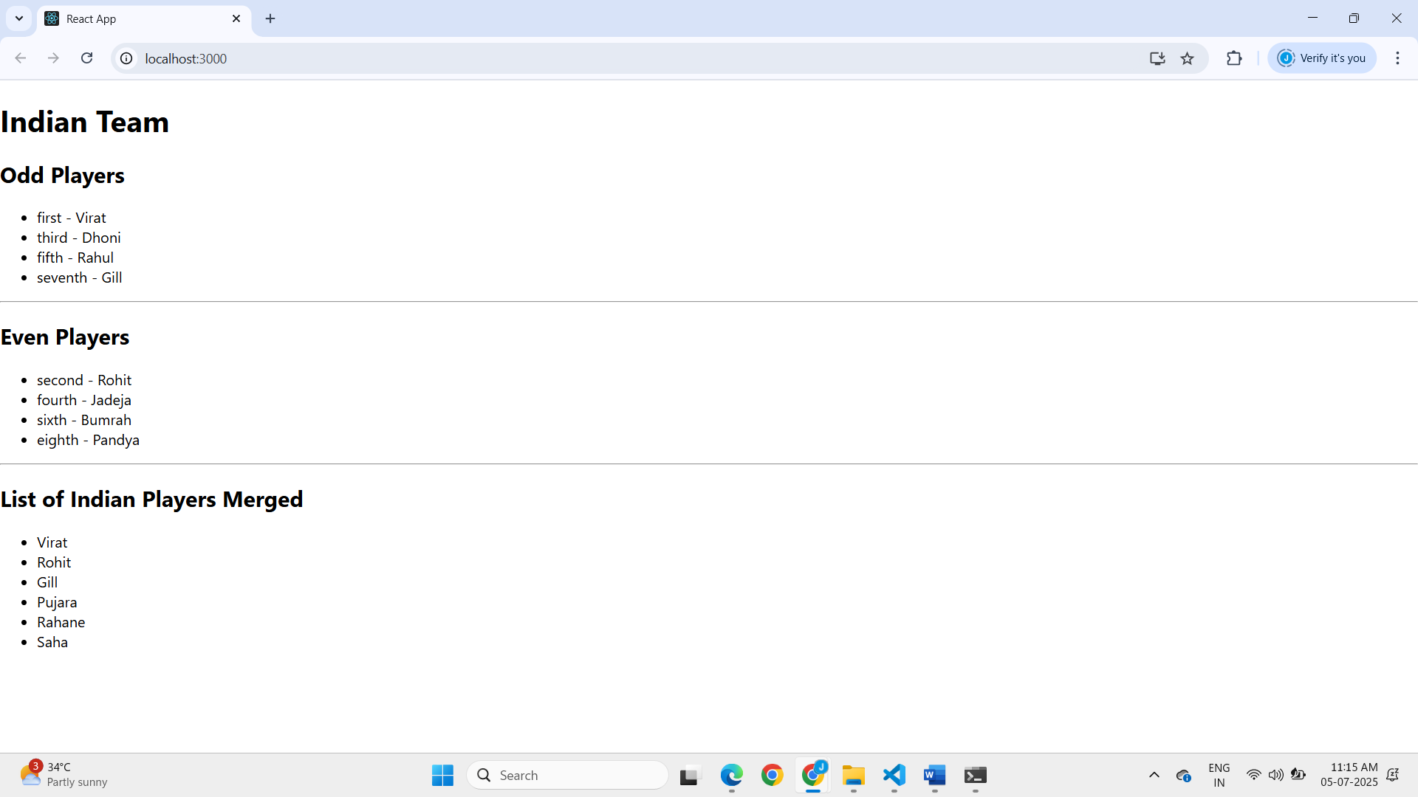

**When flag =true**

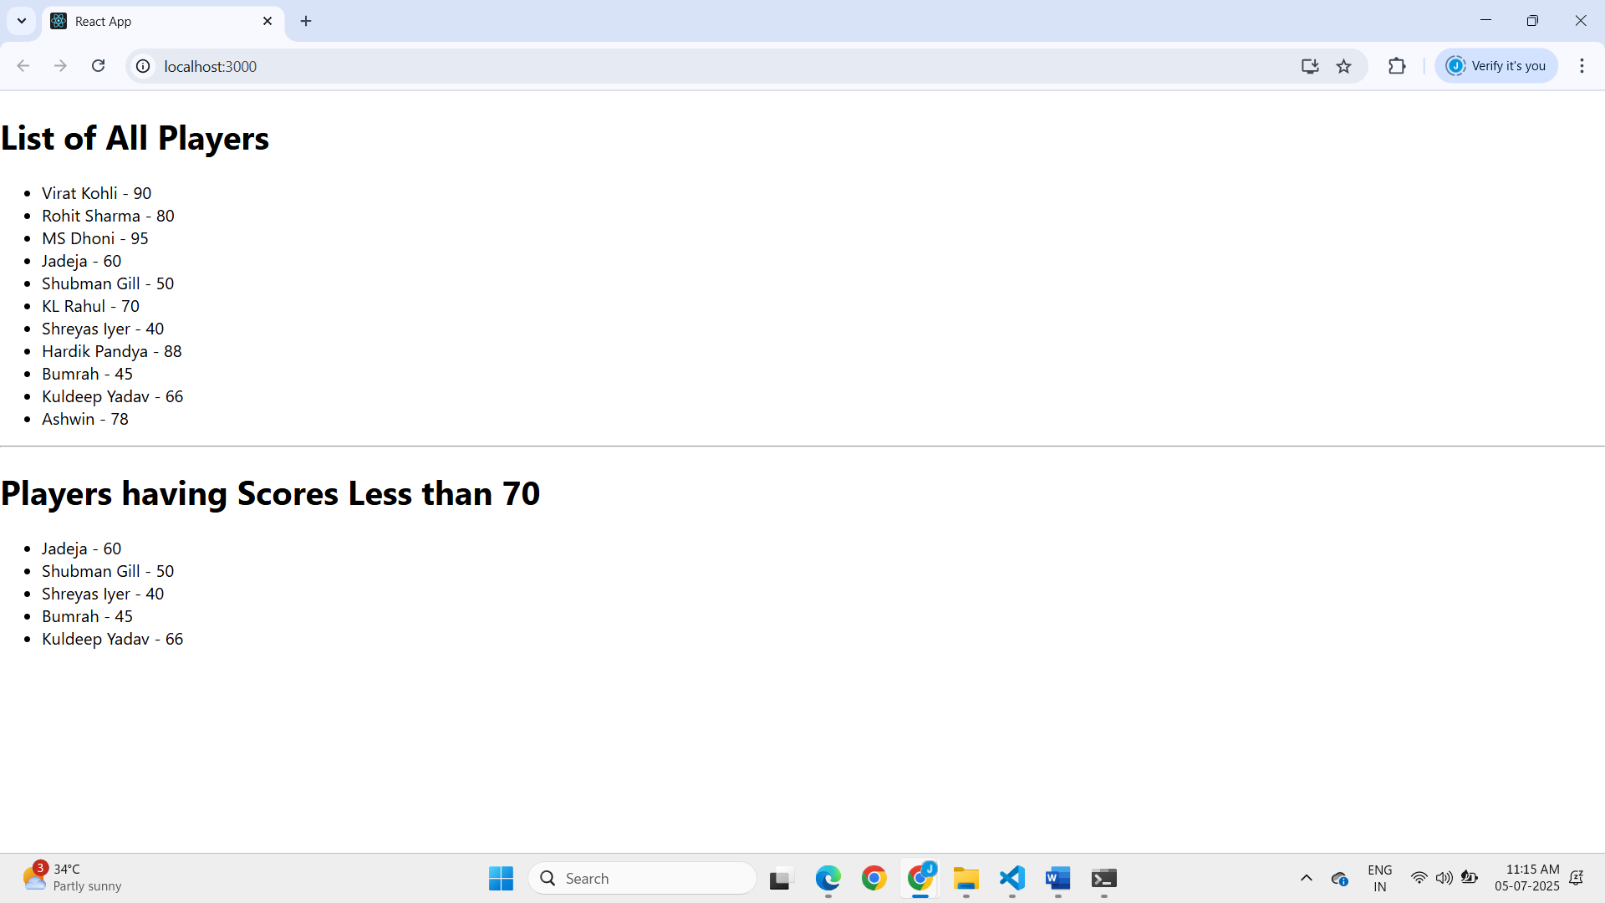

**10.REACTJS-HOL**

Step 1: Open Terminal and Create the App

**npx create-react-app officespacerentalapp**

Step 2:Create the needed files

* Under /src folder ,create a new folder called /components
* Inside /components folder,create two files namely

1.OfficeCard.js

2.OfficeCard.css

Step 3:

OfficeCard.js

import React from 'react';

import './OfficeCard.css';

const OfficeCard = () => {

  const element = "Office Space";

  const sr = "https://ezeebiz.com/themes/custom/ezeebiz/images/Office-space-v2.jpg";

  const ItemName = {

    Name: "DBS",

    Rent: 50000,

    Address: 'Chennai'

  };

  let colors = [];

  if (ItemName.Rent <= 60000) {

    colors.push('textRed');

  } else {

    colors.push('textGreen');

  }

  const jsxatt = <img src={sr} width="25%" height="25%" alt="Office Space" />;

  return (

    <div>

      <h1>{element}, at Affordable Range</h1>

      {jsxatt}

      <h1>Name: {ItemName.Name}</h1>

      <h3 className={colors.join(' ')}>Rent: Rs. {ItemName.Rent}</h3>

      <h3>Address: {ItemName.Address}</h3>

    </div>

  );

};

export default OfficeCard;

OfficeCard.css

.textRed {

    color: red;

  }

    .textGreen {

    color: green;

  }

App.js

import React from 'react';

import './App.css';

import OfficeCard from './components/OfficeCard';

function App() {

  return (

    <div className="App">

      <OfficeCard />

    </div>

  );

}

export default App;

Step 4: Run the Application

* Open the cmd or teminal in vs code and run the following command

**npm start**

**OUTPUT:**

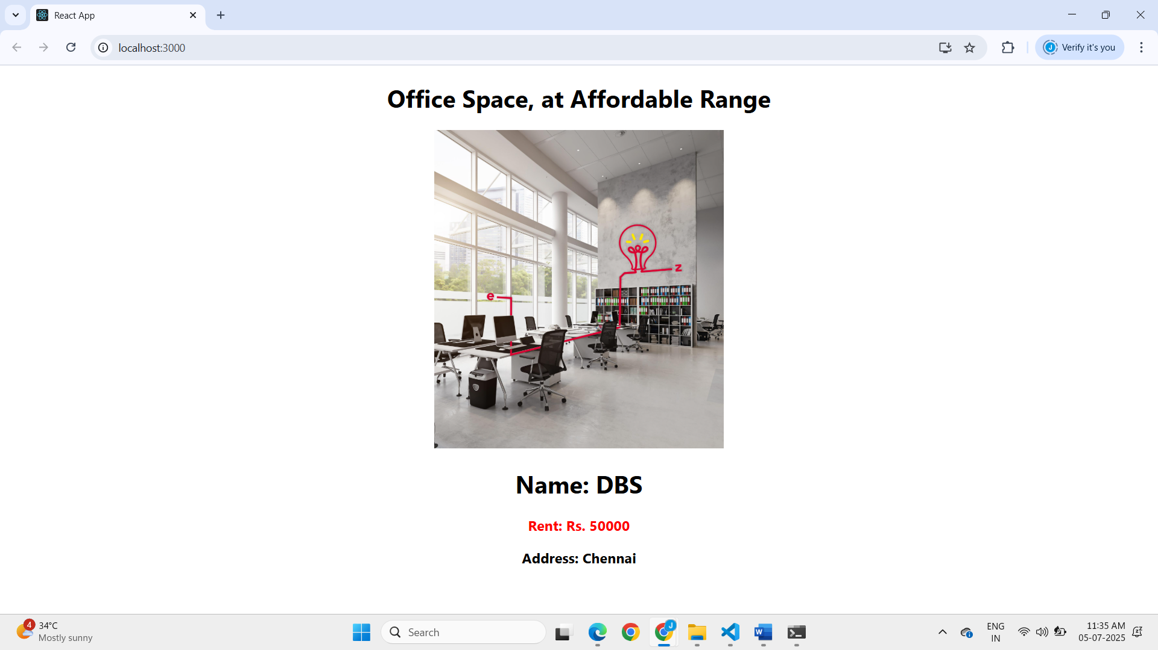

**11.REACTJS-HOL**

Step 1: Open Terminal and Create the App

**npx create-react-app eventexamplesapp**

Step 2:Create the needed files

* Create the following files under the src folder

1.Counter.js

2.SayWelcome.js

3.SyntheticEvent.js

4.CurrecyCounter.js

Step 3:Implement the following codes in respective files

Counter.js

import React, { useState } from 'react';

const Counter = () => {

  const [count, setCount] = useState(1);

  const sayHello = () => {

    console.log("Hello! This is a static message.");

  };

  const increment = () => {

    setCount(count + 1);

    sayHello();

  };

  const decrement = () => {

    setCount(count - 1);

  };

  return (

    <div>

      <div>{count}</div>

      <button onClick={increment}>Increment</button>

      <button onClick={decrement}>Decrement</button>

    </div>

  );

};

export default Counter;

SayWelcome.js

import React from 'react';

const SayWelcome = () => {

  const sayMessage = (msg) => {

    alert(msg);

  };

return (

    <div>

      <button onClick={() => sayMessage('welcome')}>Say welcome</button>

    </div>

  );

};

export default SayWelcome;

SyntheticEvent.js

import React from 'react';

const SyntheticEvent = () => {

  const handleClick = () => {

    alert("I was clicked");

  };

  return (

    <div>

      <button onClick={handleClick}>Click on me</button>

    </div>

  );

};

export default SyntheticEvent;

CurrencyCounter.js

import React, { useState } from 'react';

const CurrencyConvertor = () => {

  const [rupees, setRupees] = useState('');

  const handleSubmit = (e) => {

    e.preventDefault();

    const euroAmount = parseFloat(rupees) * 80;

    alert(`Converting to Euro Amount is ${euroAmount}`);

  };

  return (

    <div>

      <h2 style={{ color: 'green', fontSize: '28px' }}>Currency Convertor!!!</h2>

      <form onSubmit={handleSubmit}>

        <div>

          <label>Amount: </label>

          <input

            type="number"

            value={rupees}

            onChange={(e) => setRupees(e.target.value)}

            required

          />

        </div>

        <div>

          <label>Currency: </label>

          <select>

            <option>Euro</option>

          </select>

        </div>

        <button type="submit">Submit</button>

      </form>

    </div>

  );

};

export default CurrencyConvertor;

Step 4:Modifying App.js

import React from 'react';

import Counter from './Counter';

import SayWelcome from './SayWelcome';

import SyntheticEvent from './SyntheticEvent';

import CurrencyConvertor from './CurrencyConvertor';

function App() {

  return (

    <div className="App">

      <Counter />

      <SayWelcome />

      <SyntheticEvent />

      <CurrencyConvertor />

    </div>

  );

}

export default App;

Step 5: Run the Application

* Open the cmd or teminal in vs code and run the following command

**npm start**

**OUTPUT**

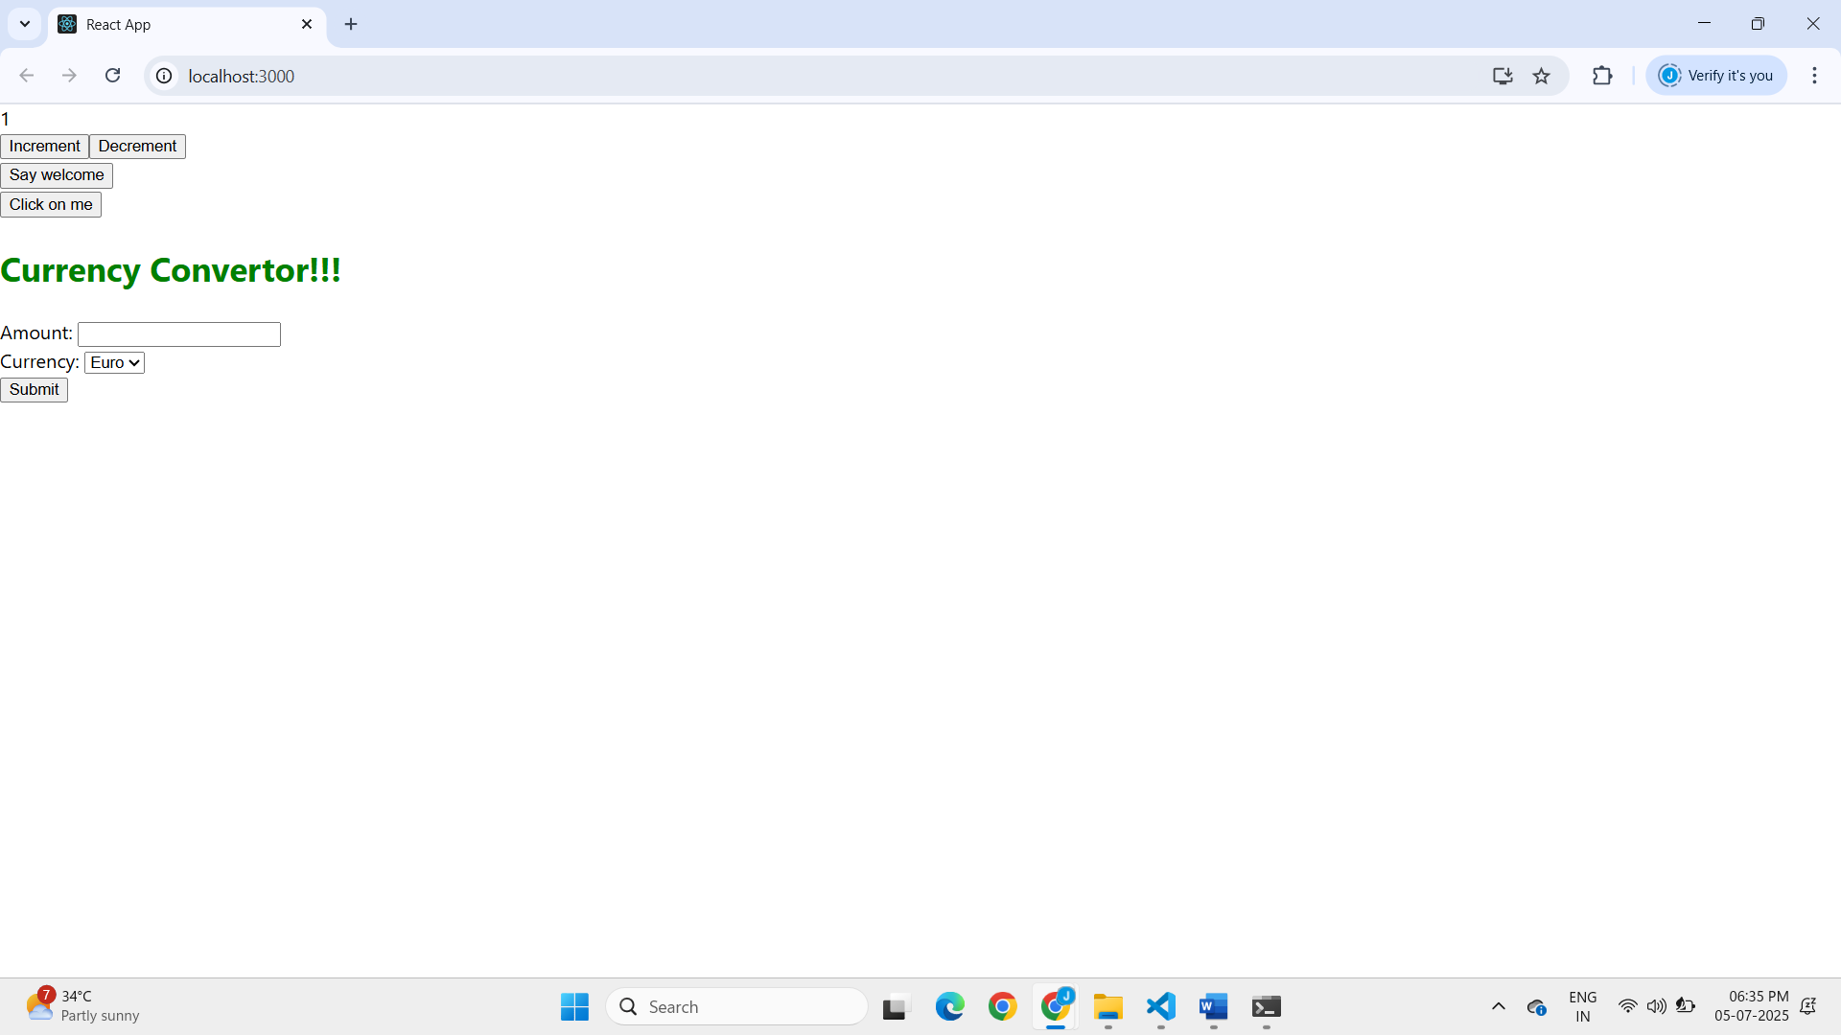

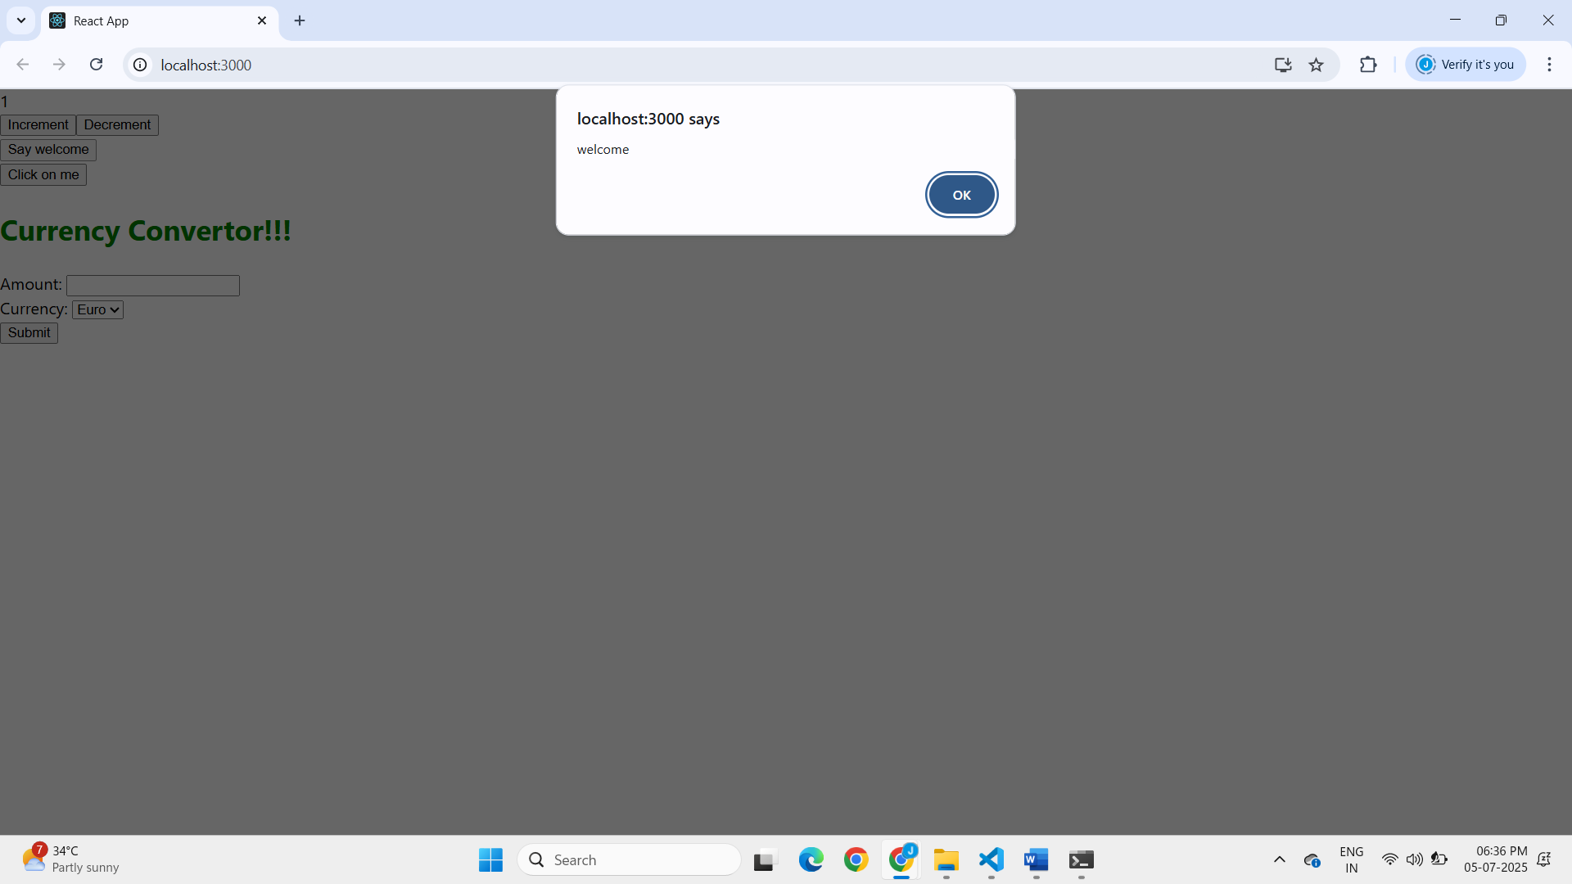

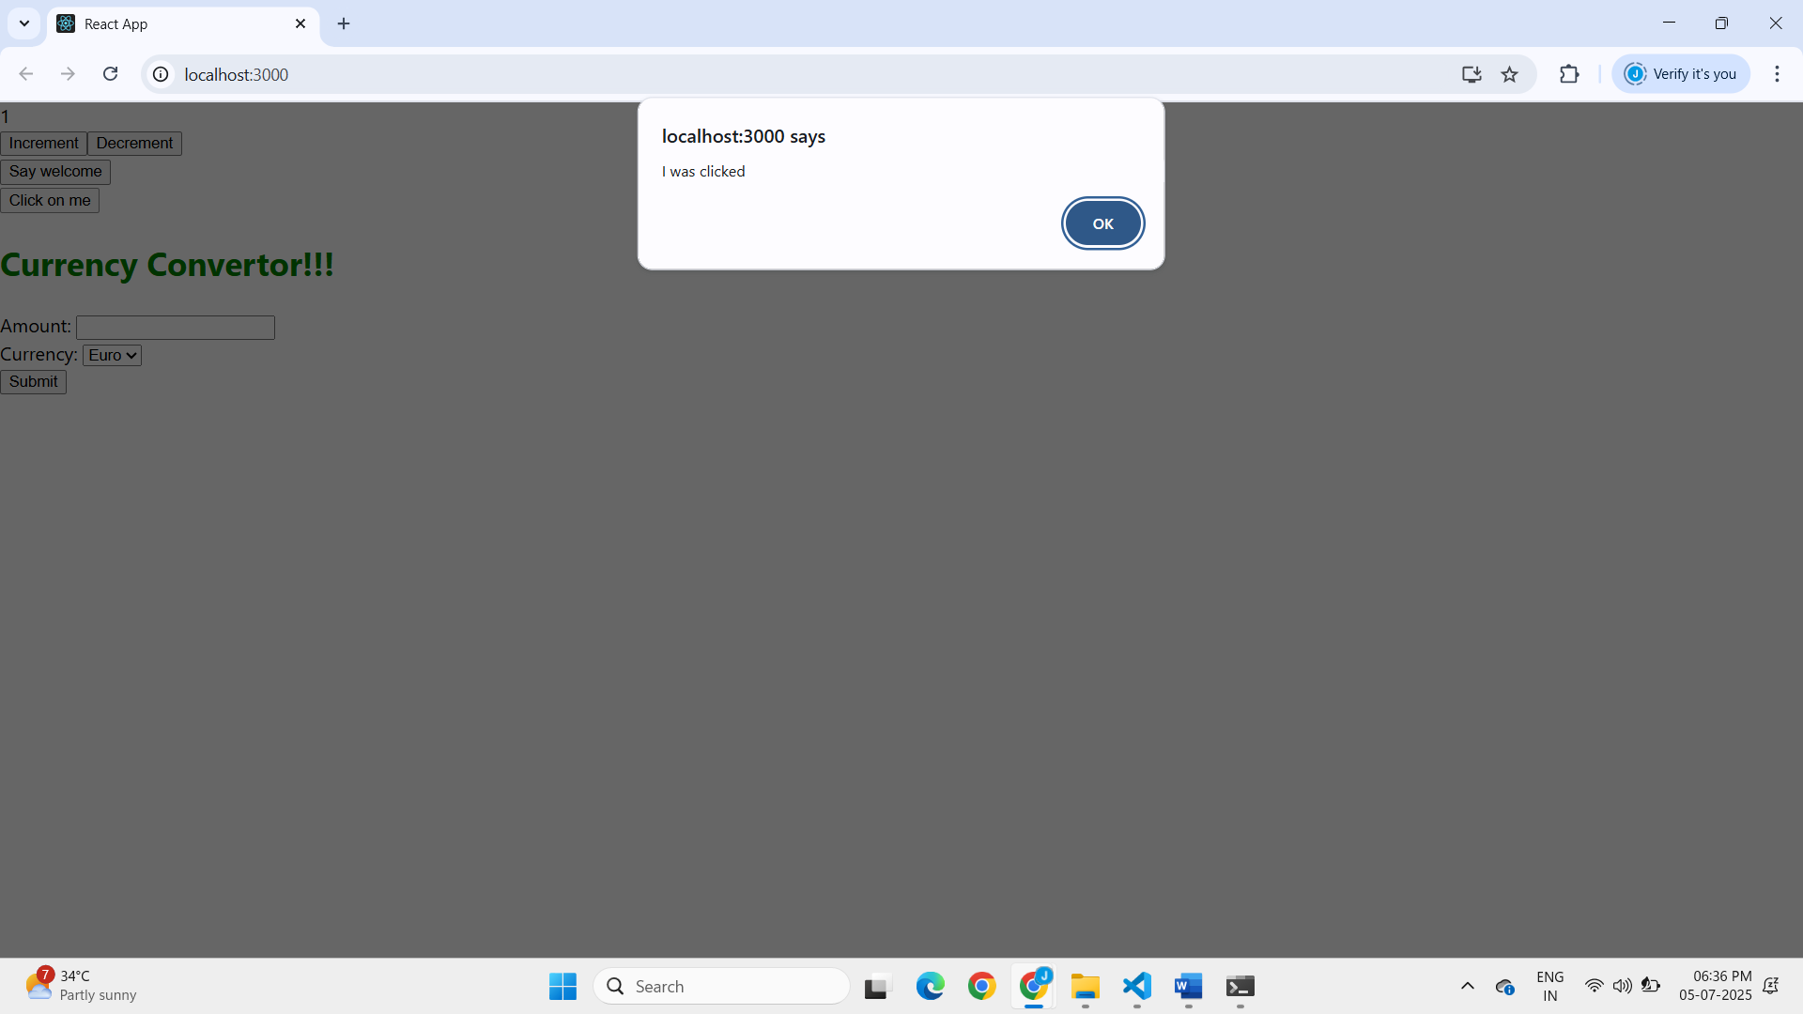

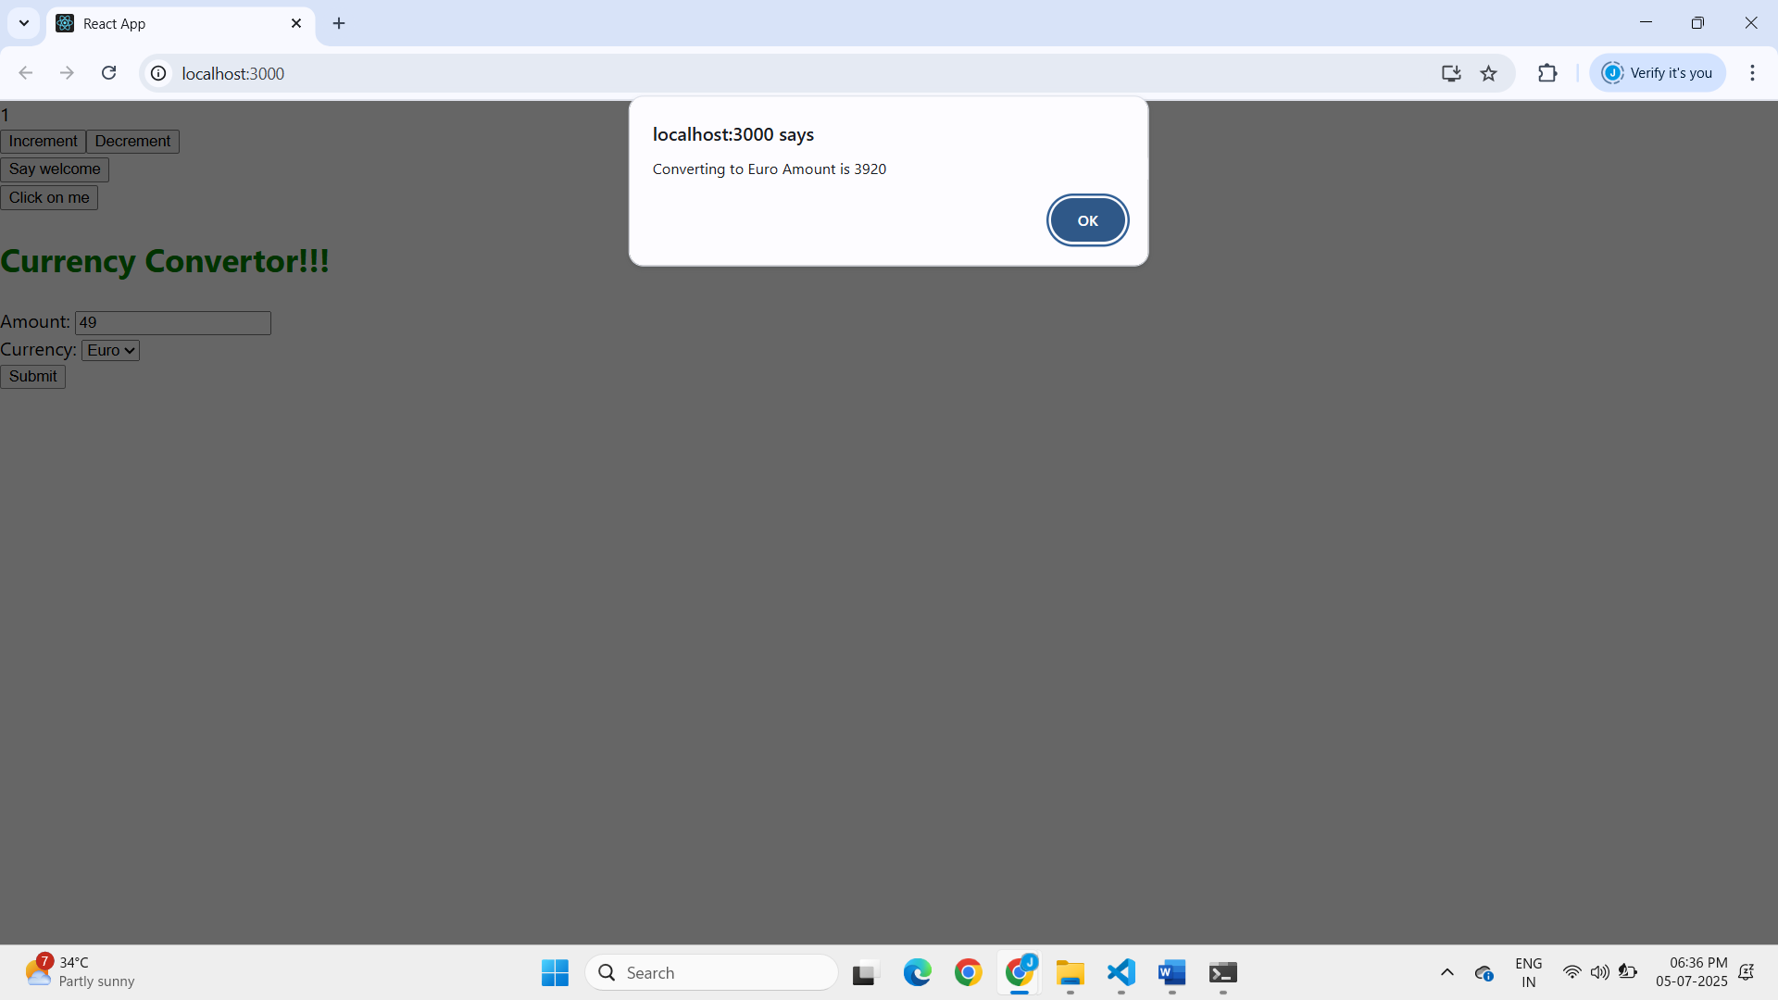

**12.REACTJS-HOL**

Step 1: Open Terminal and Create the App

**npx create-react-app ticketbookingapp**

Step 2:Writing the App.js

import React, { useState } from 'react';

// Guest Greeting Component

function GuestGreeting() {

  return (

    <div>

      <h2>Welcome, Guest!</h2>

      <p>Explore available flights below (Login to book):</p>

      <ul>

        <li>Flight 101 - Chennai to Delhi</li>

        <li>Flight 202 - Mumbai to Bangalore</li>

        <li>Flight 303 - Hyderabad to Kolkata</li>

      </ul>

    </div>

  );

}

// User Greeting Component

function UserGreeting() {

  return (

    <div>

      <h2>Welcome, User!</h2>

      <p>You can now book your tickets:</p>

      <ul>

        <li>✅ Book Flight 101 - Chennai to Delhi</li>

        <li>✅ Book Flight 202 - Mumbai to Bangalore</li>

        <li>✅ Book Flight 303 - Hyderabad to Kolkata</li>

      </ul>

    </div>

  );

}

// Greeting Component (Conditional)

function Greeting(props) {

  const isLoggedIn = props.isLoggedIn;

  if (isLoggedIn) {

    return <UserGreeting />;

  }

  return <GuestGreeting />;

}

// Login Button

function LoginButton(props) {

  return (

    <button onClick={props.onClick}>Login</button>

  );

}

// Logout Button

function LogoutButton(props) {

  return (

    <button onClick={props.onClick}>Logout</button>

  );}

// Main App Component

function App() {

  const [isLoggedIn, setIsLoggedIn] = useState(false);

  const handleLoginClick = () => setIsLoggedIn(true);

  const handleLogoutClick = () => setIsLoggedIn(false);

  return (

    <div style={{ padding: '20px', fontFamily: 'Arial' }}>

      <h1>✈️ Ticket Booking App</h1>

      {/* Conditionally render button */}

      {isLoggedIn ? (

        <LogoutButton onClick={handleLogoutClick} />

      ) : (

        <LoginButton onClick={handleLoginClick} />

      )}

      {/* Greeting view */}

      <Greeting isLoggedIn={isLoggedIn} />

    </div>

  );

}

export default App;

Step 3: Run the Application

* Open the cmd or teminal in vs code and run the following command

**npm start**

**OUTPUT**

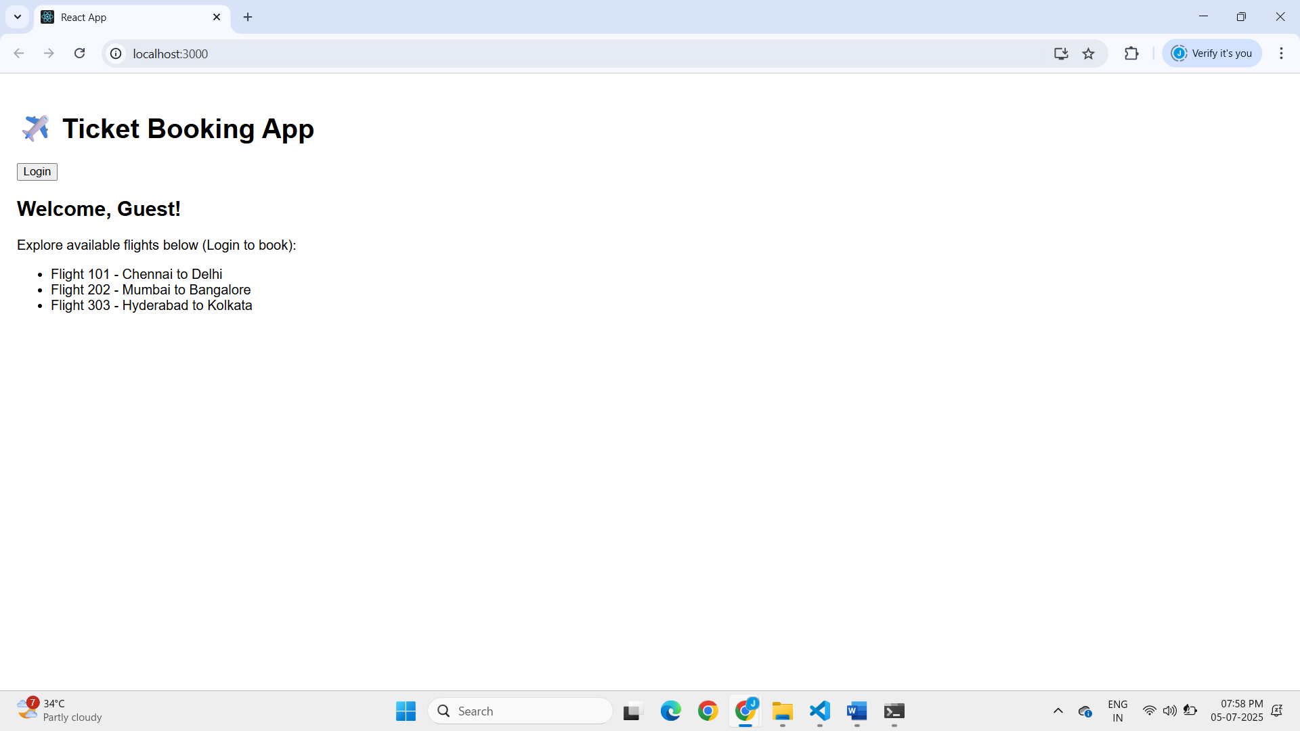

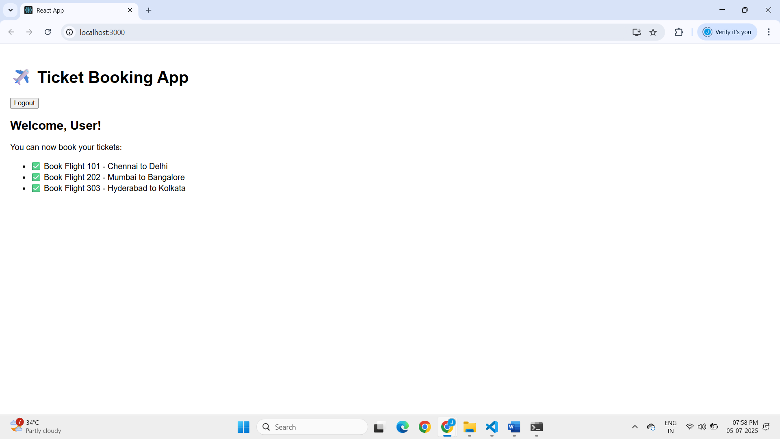

**13.REACTJS-HOL**

Step 1: Open Terminal and Create the App

**npx create-react-app ticketbookingapp**

Step 2:Create the needed files

* Create the following files under the src folder

BookDetails.js

CourseDeatils.js

BlogDeatils.js

Step 3:Implement the following codes in respective files

BookDetails.js

import React from 'react';

const BookDetails = ({ books }) => {

  return (

    <div>

      {books.map((book) => (

        <div key={book.id}>

          <h3>{book.bname}</h3>

          <p>{book.price}</p>

        </div>

      ))}

    </div>

  );

};

export default BookDetails;

BlogDetails.js

import React from 'react';

const BlogDetails = ({ blogs }) => {

  return (

    <div>

      {blogs.map((blog, index) => (

        <div key={index}>

          <h3>{blog.title}</h3>

          <strong>{blog.author}</strong>

          <p>{blog.content}</p>

        </div>

      ))}

    </div>

  );

};

export default BlogDetails;

CourseDetails.js

import React from 'react';

const CourseDetails = ({ courses }) => {

  return (

    <div>

      {courses.map((course) => (

        <div key={course.id}>

          <h2>{course.cname}</h2>

          <p>{course.date}</p>

        </div>

      ))}

    </div>

  );

};

export default CourseDetails;

App.js

import React from 'react';

import './App.css';

import CourseDetails from './components/CourseDetails';

import BookDetails from './components/BookDetails';

import BlogDetails from './components/BlogDetails';

function App() {

  const books = [

    { id: 101, bname: 'Master React', price: 670 },

    { id: 102, bname: 'Deep Dive into Angular 11', price: 800 },

    { id: 103, bname: 'Mongo Essentials', price: 450 },

  ];

  const courses = [

    { id: 1, cname: 'Angular', date: '4/5/2021' },

    { id: 2, cname: 'React', date: '6/3/20201' },

  ];

  const blogs = [

    {

      title: 'React Learning',

      author: 'Stephen Biz',

      content: 'Welcome to learning React!',

    },

    {

      title: 'Installation',

      author: 'Schewzdenier',

      content: 'You can install React from npm.',

    },

  ];

return (

    <div className="container">

      <div className="column">

        <h1>Course Details</h1>

        <CourseDetails courses={courses} />

      </div>

<div className="column with-border">

        <h1>Book Details</h1>

        <BookDetails books={books} />

      </div>

<div className="column with-border">

        <h1>Blog Details</h1>

        <BlogDetails blogs={blogs} />

      </div>

    </div>

  );

}

export default App;

App.css

.container {

  display: flex;

  justify-content: center;

  padding: 20px;

  font-family: Arial, sans-serif;

}

.column {

  flex: 1;

  padding: 20px;

}

.with-border {

  border-left: 4px solid green;

}

Step 3: Run the Application

* Open the cmd or teminal in vs code and run the following command

**npm start**

**OUTPUT**

