Jeff Porter

OSU CS 290

Project Proposal

2/17/2020

My project will be a personal portfolio type of website. This website will be used to congregate my computer science projects and show the progress of my web development skills. I plan to make it all-encompassing to also include some of my personal interests and side pursuits. It will contain of 4 pages: a home page, a project page, personal interests, and a page dedicated to my podcast pursuits.

**Home Page**

The home page will be a landing page with an introduction to the page and me. Each page will have the same design/background as the landing page but will include different content/features. This will keep the site feeling cohesive and professional. This page will contain a carousel of a few pictures of me that kind of encompass the whole webpage. Images will include professional setting, hobbies, personal life to give a small photo biography. I’m thinking the layout will be similar to below (color palette is not decided on yet):

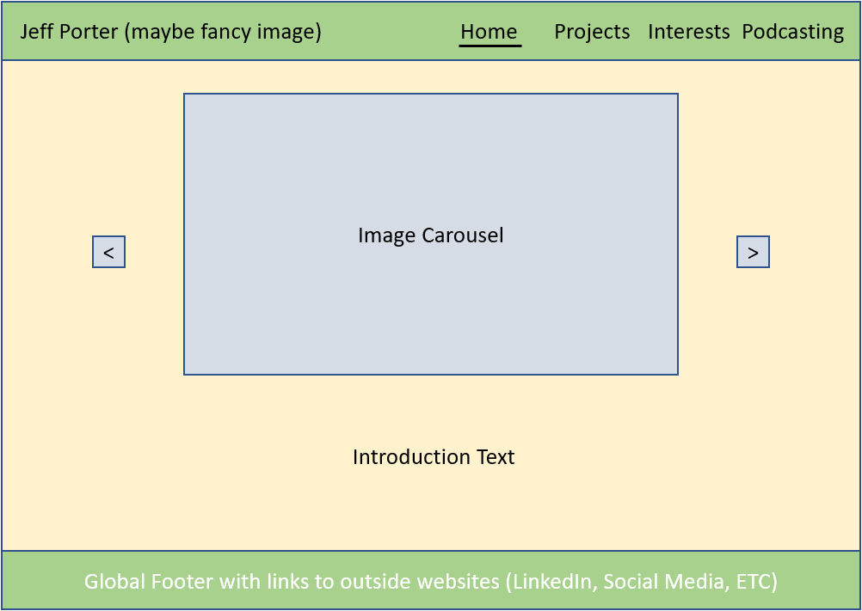

**Project Page**

This is the page where I’d put images/descriptions of personal projects and then download buttons for some of my source code. For now, this will just hold easy examples from this class, and I will populate it with more robust projects as I progress my skills. Layout below:

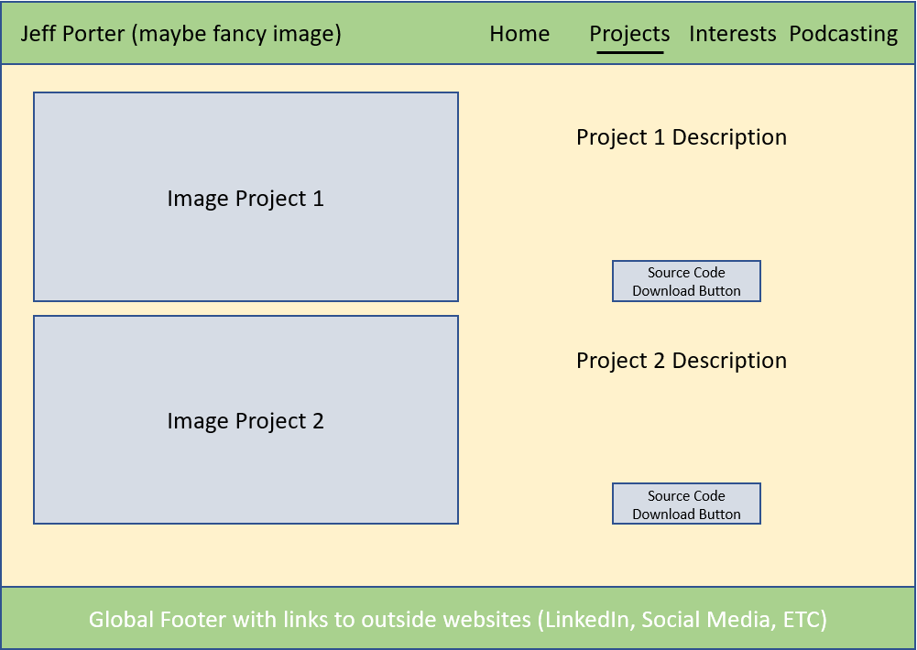

**Interests Page**

This will be a fairly basic page with an unordered list of interests on one side and images on the other. I will probably implement some links into this page somehow to take the user to youtube videos of my interests. Layout below:

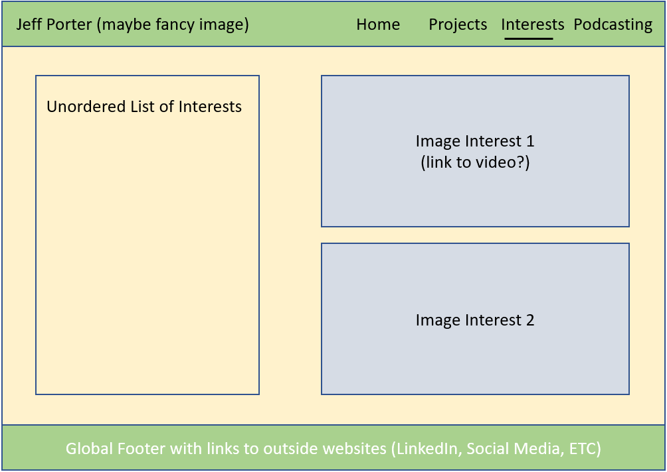

**Podcasting Page**

This page will contain the last two requirements: A scroll box and a form. It will submit via post most likely. The page will contain a small description of my two podcasts and an email signup form for notifications (will not currently actually sign anyone up). On the other side of the page will be a scroll box of links to random episodes of podcasts that I enjoy and draw inspiration from. Layout below:

