Joshua Ramsey

11/26/2023

CSD-310 Database Development and Use

Module 7.2

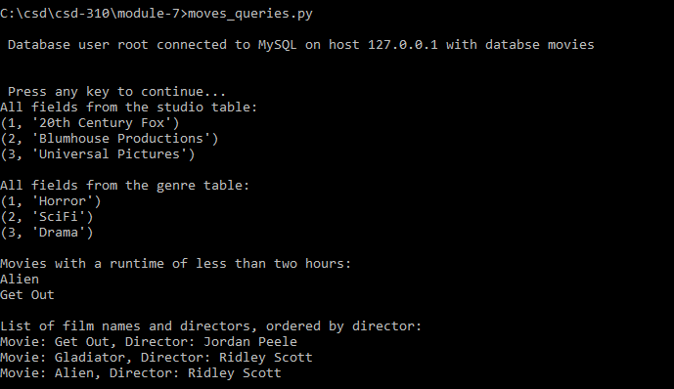

https://github.com/JBRamsey/csd-310