WardLink PQ
Lightweight, quantum-safe monitoring for India’s municipal water tanks
Project report for supervisor review
Domain | Security in Futuristic Technologies
Problem statement | Lightweight Post-Quantum Messaging (DSCI)
Prepared by | CB
Date | 5 October 2026
Status | Working software prototype with live dashboard; 40 of 40 field scenarios passing

The project in one line
Sensors on ward water tanks send sealed, quantum-safe readings to the section office, which checks each reading against the Indian drinking-water standard (IS 10500) and the tank’s physics, and tells the field crew exactly what to do.

Contents
1. Executive summary
2. Background and problem
3. What WardLink PQ is
4. Applications
5. Advantages
6. How it works
7. Security analysis
8. Results
9. Implementation
10. Hardware for the field version
11. How we proceed
12. Limitations and risks
13. Conclusion
References
Appendix A. Running the prototype and a five-minute demonstration

1. Executive summary
WardLink PQ is a monitoring link between a sensor on a ward water tank and the section office. Readings travel through a channel that stays confidential and authentic even against future quantum computers, yet it is light enough for low-cost, battery-powered hardware and narrow long-range radios. At the office, each reading is checked against the Indian drinking-water standard (IS 10500:2012) and against what the tank can physically do, and turned into a clear work order: send a tanker, hold the safe-water notice and take a sample, walk the outlet main for a leak, or inspect a faulty sensor.
The project answers the DSCI problem statement “Lightweight Post-Quantum Messaging” with a concrete, India-specific use: securing the telemetry of intermittent piped-water supply.
Key results, measured on the prototype
• Quantum-safe connection set-up (handshake) of 4,544 bytes: 49% smaller than the usual signature-based post-quantum design (8,978 bytes) and 78% smaller than fully post-quantum TLS 1.3 (20,767 bytes), with quantum-safe secrecy and identity.
• Each reading travels as a 40-byte sealed capsule with its own key: a single LoRa radio frame, and a stolen device cannot decrypt anything it sent earlier.
• 40 of 40 real-life scenarios pass: NIST conformance, power cuts, stolen and cloned boards, faulty sensors and 20 tanks at once. 2,400 corrupted messages caused no crash, and no reading was lost through outages or restarts.
• Two real reliability bugs were found by deliberately attacking the gateway, and fixed.

Status and next step. The complete software prototype runs on a laptop with a live, animated dashboard. The next step is to port the sensor firmware to ESP32-S3 hardware and pilot the system on one ward tank with the municipal water department.

2. Background and problem

2.1 The DSCI problem statement
The Data Security Council of India (DSCI) problem statement “Lightweight Post-Quantum Messaging” (domain: Security in Futuristic Technologies) asks for messaging that remains confidential and forward-secret in the quantum era and is light enough for mobile and IoT devices. Its deliverables are a prototype using NIST post-quantum algorithms (Kyber, now standardised as ML-KEM, and Dilithium, now ML-DSA), a key exchange optimised for constrained devices, benchmarks against classical TLS, and a demonstration on constrained devices.

2.2 Why quantum safety matters now
Today’s secure connections agree on keys using elliptic-curve cryptography, which a sufficiently large quantum computer running Shor’s algorithm could break. Traffic recorded today can be stored and decrypted later, an attack known as “harvest now, decrypt later”. In August 2024 NIST published the first post-quantum standards: FIPS 203 (ML-KEM) for key agreement and FIPS 204 (ML-DSA) for signatures. Field devices installed now may stay in service for many years, often without anyone visiting to update their keys, so they need protection that will still hold when quantum computers arrive.

2.3 The ground reality in India’s water supply
Many Indian towns and villages receive piped water for only a few hours a day. It is stored in overhead tanks and drawn down by households in between. Tank levels and quality alerts often travel by phone call, SMS, WhatsApp groups or open internet dashboards. Such messages can be faked (“tank full, water safe”), read by anyone, and are usually trusted without checking whether the number is even physically possible. AI tools have also made it cheaper to find and exploit exposed IoT devices.

2.4 Our problem statement
Build a low-cost monitoring link for ward water tanks that:
- keeps readings secret and authentic against today’s attackers and future quantum computers;
- runs on battery-powered hardware and narrow long-range radios;
- never loses a reading during outages, restarts or attacks;
- turns readings into correct, explainable actions for the field crew.

3. What WardLink PQ is
The system has three parts:
- Sensor unit (tank roof). An ESP32-S3 microcontroller with an ultrasonic level sensor, turbidity, TDS (total dissolved solids) and pH probes, temperature sensors, a solar-charged battery and a radio (Wi-Fi in the prototype; LoRa or NB-IoT in the field).
- Gateway (section office). Verifies, stores and evaluates every reading. A laptop today; a Raspberry Pi or office PC in the field.
- Engineer dashboard. A web page that also opens on a phone. It shows a live, animated cutaway of the system, the current work order, and tools to demonstrate attacks and run test scenarios.
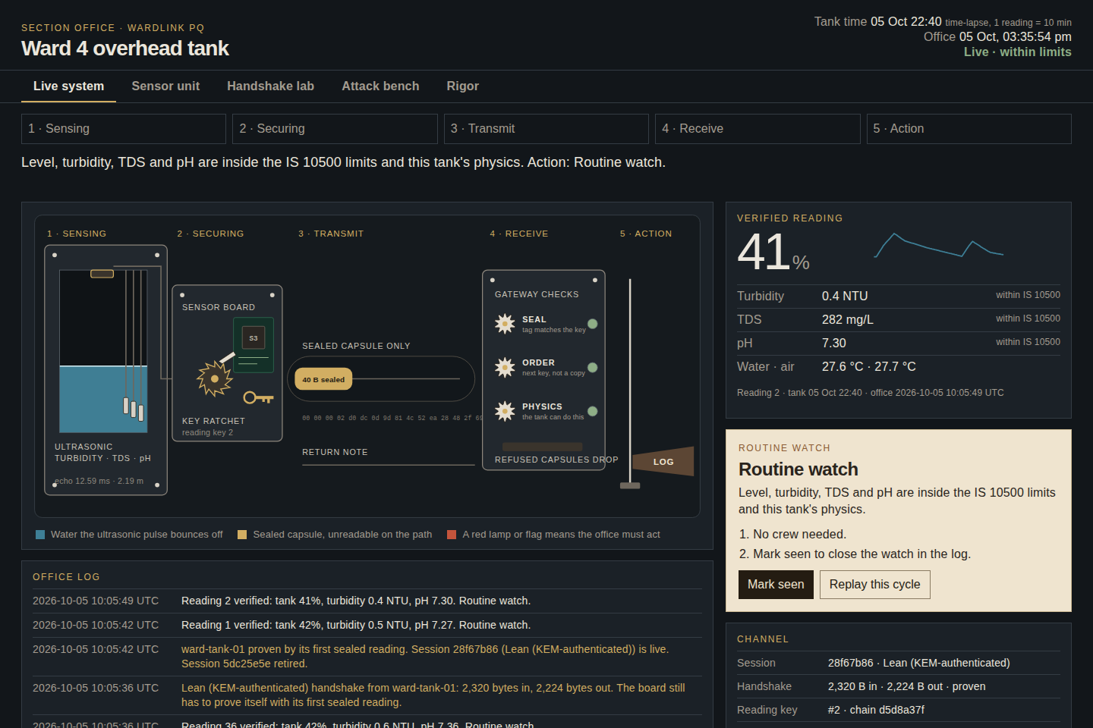
Figure 1. Live system view. Each verified reading animates through five stations: sensing, securing, transmission, the gateway’s three checks, and the action flag. The right side shows the reading, the work order and the channel status.

4. Applications
Application | What WardLink PQ provides
Ward overhead tanks and elevated service reservoirs | Live level, refill tracking, and a tanker forecast before the tank runs dry.
Drinking-water quality surveillance | Turbidity, TDS and pH checked against IS 10500, with “hold the safe-water notice” and sampling instructions.
Leak and theft detection | A night-flow test flags leaks and unauthorised connections on the outlet side.
Rural piped-water schemes (for example, villages under the Jal Jeevan Mission) | The same unit monitors village tanks over long-range radio on solar power.
Dams and reservoirs (read-only) | Trusted level telemetry; gate and pump control stay on separate systems.
Other critical telemetry | The same secure channel suits any small sensor in smart-city, industrial or agricultural settings.

5. Advantages

5.1 Security
- Quantum-safe secrecy and identity. ML-KEM-768 (FIPS 203) is combined with classical X25519, so an attacker must break both.
- A new key for every reading. A stolen board cannot decrypt anything it sent before the theft.
- Defence in depth. Cryptography proves who sent a reading; the physics and IS 10500 checks decide whether to believe it and how to act.
- Stolen-device handling. Clone detection, revocation and on-site re-enrolment.

5.2 Lightweight
- 4,544-byte handshake, half the signature-based design. No certificates or PKI are needed, because devices are enrolled in person.
- 20-byte reading, 40 bytes sealed: one LoRa frame, against four frames for the same reading as text.
- About 1.3 ms of computation for both sides of a handshake on a laptop, and no signature code on the sensor.

5.3 Reliability
- No lost readings. Each reading stays on the board until the office confirms it.
- Survives power cuts, dead links, gateway restarts and connection floods (each one tested).
- A watchdog flags a tank that goes silent.

5.4 Practical and verified
- Low-cost, commonly available components, solar powered.
- Actions follow the Indian standard and the realities of intermittent supply.
- An explainable dashboard that engineers and supervisors can follow without a cryptography background.
- Verified: 40 field scenarios and 35 unit tests, all passing; official NIST test vectors; 2,400 fuzzed messages.

6. How it works

6.1 One reading, end to end
Stage | What happens | Key detail
1. Sensing | The ultrasonic sensor times its echo from the water surface; the probes read turbidity, TDS, pH and temperature. | Distance = speed of sound × echo time ÷ 2, corrected for air temperature.
2. Securing | The reading is packed into 20 bytes and sealed with ChaCha20-Poly1305 under a key used only once. | 40-byte sealed capsule.
3. Transmission | The capsule waits in the board’s outbox and is sent over the radio. | It stays until the office’s receipt arrives.
4. Receiving | The gateway checks the seal, that the key is the next in line (not a replay), and that the tank could physically do this. | Stored once in the database; a sealed receipt goes back.
5. Action | Rules turn the reading into a work order; the engineer marks it seen. | A sealed “seen” note returns to the board.

6.2 The sensor unit
The sensor unit sits on the tank roof in an IP65 enclosure. The ultrasonic transducer is fixed under the roof and never touches the water; the water-quality probes hang into the tank. Every ten minutes in the field (faster in the time-lapsed demo) the board runs one sampling cycle: wake, measure air temperature, send an ultrasonic ping, read turbidity, TDS, pH and water temperature, pack the 20-byte record, seal it, send it over the radio, and sleep.
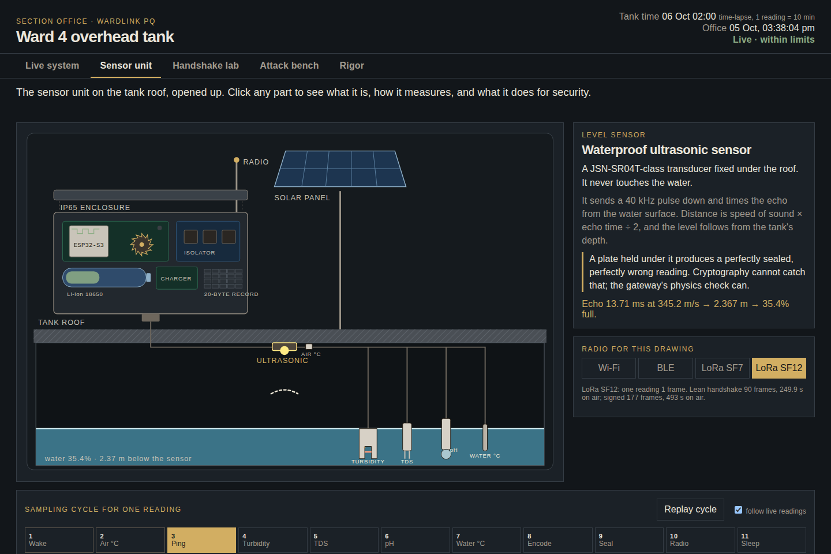
Figure 2. Sensor unit view: an exploded drawing of the roof unit. Every part is clickable and explains what it measures and what it does for security; the sampling cycle below animates with live values.

6.3 The lean quantum-safe handshake
Before sending readings, the board and the gateway agree on a fresh session key. Because the board was enrolled in person at the ward office, each side already holds the other’s long-term public keys. A conventional design would have each side sign the handshake with ML-DSA-65, at 3,309 bytes per signature, which is three-quarters of all handshake bytes. WardLink PQ instead lets each side prove its identity by opening ML-KEM capsules addressed to its enrolled key, the idea behind KEMTLS and Post-Quantum Noise in the research literature. Six shared secrets, from ML-KEM-768 and X25519, are mixed into the session key, and the temporary keys are deleted afterwards.
Message | Sent by | Contents | Size
Hello | Sensor | Device id; temporary X25519 and ML-KEM keys; a capsule for the gateway’s enrolled key | 2,320 B
Welcome | Gateway | Temporary X25519 key; a capsule for the sensor’s temporary key; a capsule for its enrolled key; a confirmation tag | 2,224 B

- The gateway proves itself: its confirmation tag can only be computed with the gateway’s enrolled keys.
- The sensor proves itself: its first sealed reading can only be produced with the sensor’s enrolled keys.
- Hybrid: reading or impersonating needs both ML-KEM and X25519 broken.
- Forward secrecy: the temporary keys are deleted, so a later key theft cannot open recorded sessions.

6.4 A new key for every reading
After the handshake, each reading is sealed with its own key, taken from a one-way chain. Once used, a key is deleted and cannot be recomputed from later keys. A thief who steals the board and reads its memory can therefore read nothing sent earlier, and a fresh handshake (every 36 readings, about six hours, or on demand) locks the thief out of later readings too.

6.5 No lost readings
Every reading goes into an outbox on the board and leaves it only when the gateway’s sealed receipt arrives. During an outage the board keeps measuring and marks readings as buffered, keeping their original time; on reconnection it sends them in order. If a receipt is lost, the board resends and the gateway recognises the copy by its time and stores it once. All readings and events go into a database, so a gateway restart loses neither data nor the context the rules need.

6.6 Decision rules
Check | Rule | Action
Turbidity | IS 10500: 1 NTU acceptable, 5 NTU permissible | Above 5 NTU: hold the safe-water notice and take a sample. A single spike waits one reading for confirmation unless it is above 15 NTU.
pH | 6.5 to 8.5, no relaxation | Outside the range: lab sample before the next supply.
TDS | 500 mg/L acceptable, 2,000 mg/L permissible | Above 2,000 mg/L: reject the supply for drinking.
Tank physics | The level cannot exceed the overflow pipe, rise faster than the inlet, rise with the main closed, or fall faster than any draw | Treat the level as untrusted and inspect the sensor.
Leak | Night draw between 01:00 and 04:00 above 2.4% per hour (homes use under 1%) | Walk the outlet main; look for unauthorised taps.
Tanker | Projected level below 10% before the next supply window | Book a tanker before the predicted time.
Sensor faults | No echo, object in the blind zone, frozen reading, probes out of the water, impossible values | Name the fault; do not act on that reading.

Water-quality limits are taken from IS 10500:2012, Table 1.

6.7 Device lifecycle
- Enrolment in person: keys are created at the ward office; the gateway roster stores public keys only.
- Periodic re-key: a fresh handshake every 36 readings, or on demand.
- Clone alarm: two boards with the same keys are detected by their overlapping sessions; the tank is quarantined and the overlapping readings are marked suspect.
- Revoke and re-enrol on site: new keys are issued; stolen keys stop working.
- Watchdog and rate limit: a silent tank is flagged; at most six handshakes per minute per tank.

7. Security analysis
Threat | Example | Defence | Verified by
Future quantum decryption | Traffic recorded today is decrypted later | ML-KEM-768 + X25519 hybrid handshake | Handshake and NIST vector scenarios
Tampering | One bit changed in transit | Poly1305 seal on every capsule | Bit-flip scenario
Replay | An old “tank full” sent again | One-time keys in strict order | Replay scenario
Impostor device | A board with its own keys claims the tank’s id | Enrolled keys | Impostor scenario
Unknown device | A board that was never enrolled | Gateway roster | Unlisted-board scenario
Fake gateway | An attacker pretends to be the office | Gateway’s confirmation tag | Fake-gateway scenario
Stolen device | Memory dumped to read old traffic | Per-reading keys; re-key; re-enrolment | Stolen-board scenario
Cloned device | A second board built from stolen keys | Clone alarm, quarantine, re-enrolment | Clone and re-enrol scenarios
Physical spoofing | A plate held under the level sensor | Tank-physics check | Plate-under-sensor scenario
Faulty instruments | Frozen sensor, no echo, bubble on a probe | Fault rules and confirmation | Sensor-fault scenarios
Network abuse | Stalled or flooding connections | Threads, timeouts, connection cap, rate limit | Transport-fault scenarios

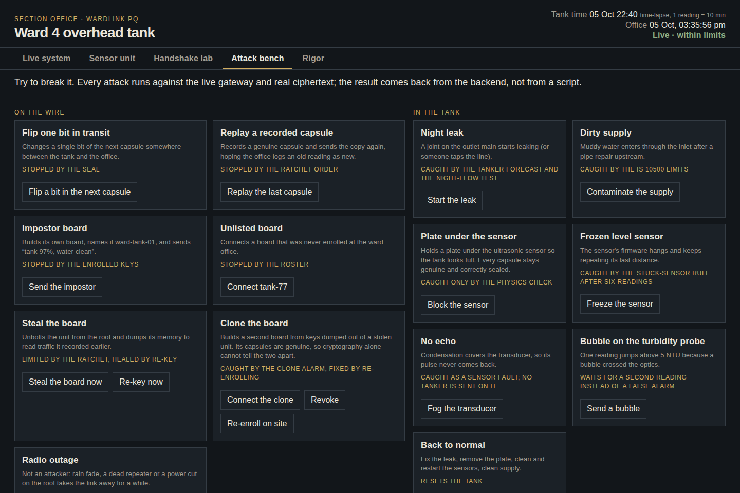
Figure 3. Attack bench. Each button runs a real attack or fault against the live gateway and shows the gateway’s response; the table at the bottom maps every attack to the layer that stops it.

8. Results

8.1 Handshake benchmark
All five handshakes were measured on the same laptop with mutual authentication: TLS through OpenSSL 3.5.5, and WardLink through the project’s own code.
Handshake | Secrecy | Identity | Bytes | Time | SF12 frames | SF12 airtime
TLS 1.3 classical | classical | classical | 1,685 | ≈1.1 ms | 34 | 93 s
TLS 1.3 hybrid | quantum-safe | classical | 4,010 | ≈2.3 ms | 80 | 221 s
WardLink lean | quantum-safe | quantum-safe | 4,544 | ≈1.3 ms | 90 | 250 s
WardLink signed | quantum-safe | quantum-safe | 8,978 | ≈3.3 ms | 177 | 493 s
TLS 1.3 post-quantum | quantum-safe | quantum-safe | 20,767 | ≈5.0 ms | 408 | 1,139 s

Bytes are exact. Times are medians for both sides together and vary between runs. Radio cost uses LoRaWAN IN865 at its slowest setting (SF12, 51-byte frames) and the Semtech time-on-air formula. TLS uses one self-signed certificate per side; a real certificate chain would add more.
The lean handshake gives quantum-safe identity for 13% more bytes than today’s hybrid TLS, which still uses classical identity, and at less than a quarter of the size of fully post-quantum TLS. On LoRa at its slowest setting a handshake still takes about four minutes of airtime, so the board re-keys rarely and uses the per-reading key chain in between; each reading is a single frame.
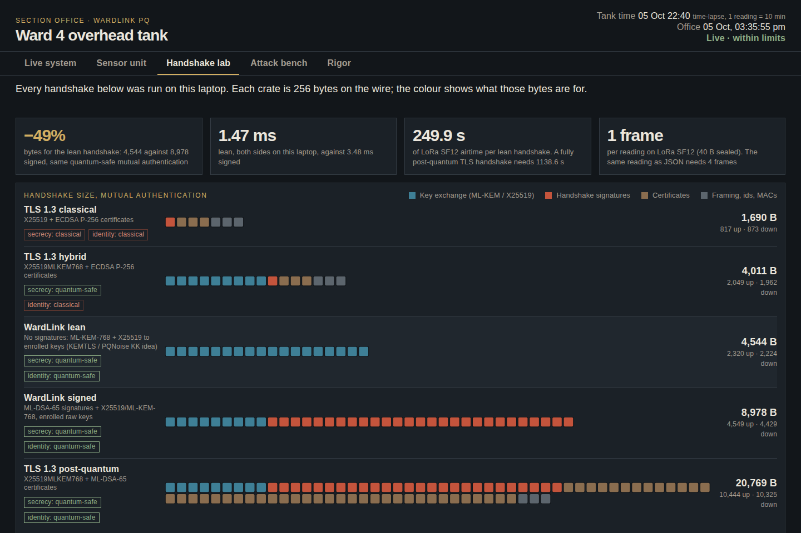
Figure 4. Handshake lab. Each crate is 256 bytes on the wire; red crates are signatures and brown ones certificates. The lean row has neither.

8.2 Field-rigor suite
The suite drives the real gateway through 40 scenarios in eight categories. Each scenario builds its own gateway on a temporary network port, so it never disturbs the live system. Latest run: 40 of 40 passed in 17.4 s.
Category | Scenarios | Examples | Result
Standards | 5 | NIST ACVP key-generation vectors (25 + 25), handshake round trips, fake gateway | 5/5
Protocol attacks | 7 | Bit flip, replay, impostor, stolen board, 2,400 fuzzed messages | 7/7
Transport faults | 6 | Stalled sender, power cut, silent connection, connection flood, 10 MB frame | 6/6
Delivery | 4 | Outage with reconnect, lost receipt, gateway restart, full buffer | 4/4
Lifecycle | 6 | Clone alarm, revoke, re-enrol, rate limit, watchdog, re-key without false alarm | 6/6
Sensor faults | 6 | Frozen sensor, no echo, blind zone, dry probes, impossible pH, turbidity bubble | 6/6
Physics and water | 5 | Plate under the sensor, rise with the main closed, IS 10500 bands, night leak, tanker forecast | 5/5
Load | 1 | Twenty tanks reporting at once, 160 readings | 1/1

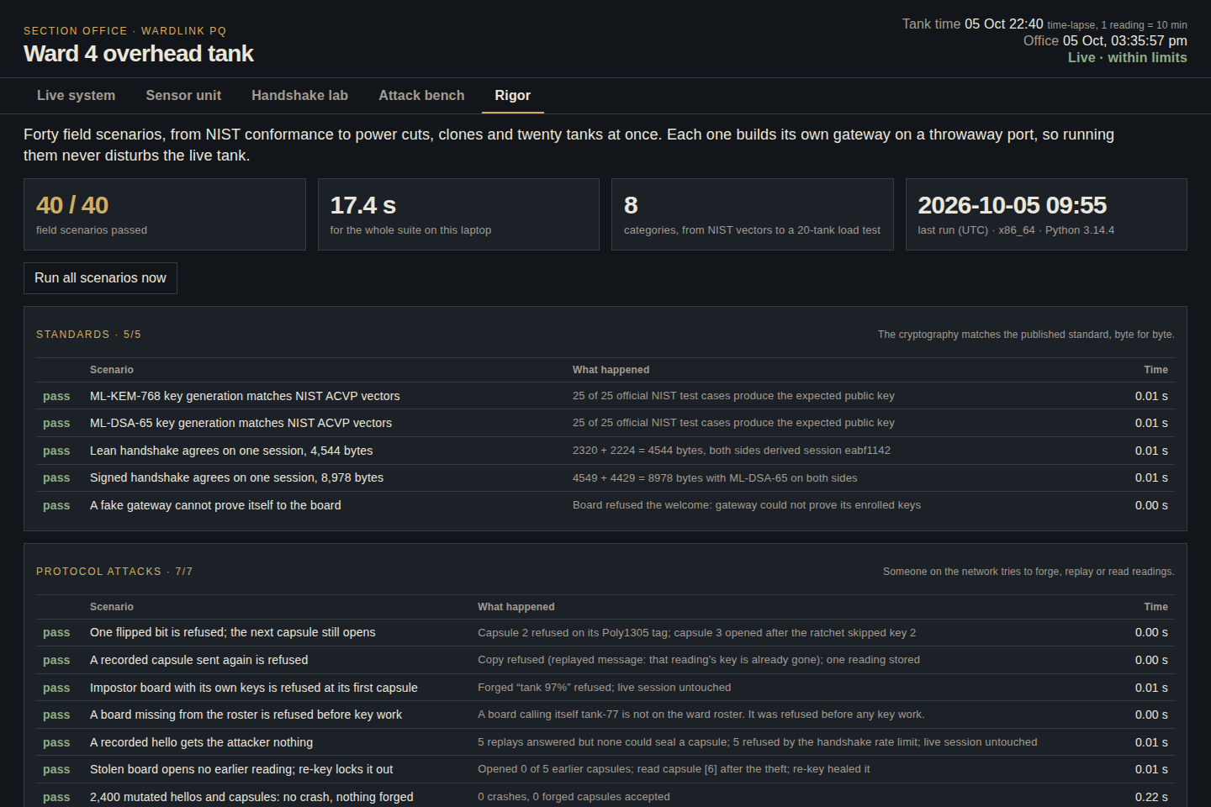
Figure 5. Rigor tab. The whole suite can be run from the dashboard; results are grouped by category with what happened in each scenario.

8.3 Problems found and fixed
- A half-sent message froze the whole gateway. A connection that sent part of a message and stopped blocked every tank. Fixed with one thread per connection and time limits; in the test the real sensor was served in 0.3 s while the stalled connection was dropped.
- A power cut locked the board out. A board that lost power right after connecting could not get back in, because the gateway kept waiting on the dead connection. Fixed the same way; the rebooted board now reconnects within 0.2 s.

9. Implementation
Part | Technology
Language | Python 3.14
Cryptography | PyCA cryptography 50 (OpenSSL-backed): ML-KEM-768, ML-DSA-65, X25519, ChaCha20-Poly1305, HKDF
Storage | SQLite in write-ahead-log mode
Gateway network | TCP with length-prefixed frames; one thread per connection
Dashboard | Standard-library web server; HTML, CSS and JavaScript with animated SVG; no external frameworks
Testing | 35 unit tests and the 40-scenario field suite

Module | Responsibility
crypto.py · channel.py | Key generation, both handshakes, session keys and the per-reading key chain
record.py | The 20-byte reading and the sealed receipts
office.py · store.py | Gateway state for every tank, clone alarm, attack bench, database
rules.py · world.py | IS 10500, physics, leak, tanker and sensor-fault rules; the simulated tank
service.py · web.py | Gateway network service, sensor loop with outbox, dashboard API
bench.py · rigor.py | Handshake benchmark against TLS 1.3; the field-scenario suite

10. Hardware for the field version
Component | Purpose
ESP32-S3 board | Reads the probes, runs ML-KEM-768 and the sealing; Secure Boot and flash encryption protect its keys
Waterproof ultrasonic sensor (JSN-SR04T class) | Measures the distance to the water surface from under the roof
Air and water thermometers (DS18B20) | Correct the speed of sound and the TDS reading
Turbidity probe (optical) | Detects dirty water by scattered infrared light
TDS probe (conductivity) | Measures dissolved solids in mg/L
pH probe (glass electrode) | Measures acidity; needs periodic calibration
Analog signal isolator | Stops the TDS and pH probes disturbing each other
Li-ion cell, solar charger and 6 V panel | Power without mains on the roof
LoRa (IN865) or NB-IoT module | Long-range radio for the field
IP65 enclosure and cable glands | Weather protection
Raspberry Pi 4 (gateway) | Section-office gateway and dashboard

All components are low-cost and commonly available in India; the final selection follows the bench trials in Phase 3.

11. How we proceed
Phase | Goal | Deliverables | Duration
1. Software prototype | Prove the protocol, rules and dashboard | Gateway, tank simulator, dashboard, benchmark, 40-scenario suite | Completed
2. Hardware port | Run the sensor side on an ESP32-S3 | Firmware with ML-KEM-768, outbox in flash, Secure Boot and flash encryption; measured cycles, memory and energy | 6–8 weeks
3. Bench and radio trials | Validate on real links | LoRa (IN865) and NB-IoT trials, 24-hour soak test with injected loss, clock-drift check, NIST encapsulation and signing vectors, formal model of the handshake | 4–6 weeks
4. Pilot | One ward tank with the municipal water department | Installed unit and office gateway, crew procedures, real data to tune thresholds, response-time measurement | 8–12 weeks
5. Scale-up and handover | Many tanks, robust operation | Multi-tank roster tools, second gateway with fail-over, signed firmware updates, documentation, external security review | After the pilot

Durations are indicative and depend on hardware availability and pilot-site access.

11.1 Resources needed
- A hardware kit: sensor-unit components, a Raspberry Pi gateway and LoRa modules.
- Access to one municipal tank for the pilot, with a contact in the water department.
- A reference turbidity meter and pH buffer solutions for calibration.

11.2 Decisions requested from supervisors
- Approval to procure the hardware kit for Phase 2.
- Help identifying a pilot site and a water-department contact.
- Guidance on the DSCI submission, publication and any intellectual-property filing.

12. Limitations and risks
Limitation | Impact | Mitigation
Laptop timings and a simulated tank | Real radio loss, flash wear and battery behaviour are untested | Hardware port (Phase 2) and pilot (Phase 4)
The handshake’s security argument is informal | No machine-checked proof yet | Formal model in Tamarin or ProVerif (Phase 3)
A sustained connection flood can delay a real board | The gateway is protected, but the link is not | The board retries with backoff; flood connections time out
The board buffer holds one day of readings | A longer outage drops the oldest readings | Every drop is counted and reported; a larger flash buffer in the field build
Clone detection needs both boards transmitting | A thief holding the only board leaves no overlap | Silence watchdog plus the stolen-board procedure: re-key, then re-enrol
Confirmation delays a real turbidity alarm by one reading | Ten minutes later, unless above 15 NTU | A deliberate trade-off against false alarms from bubbles
Low-cost turbidity probes cannot resolve 1 NTU precisely | Small exceedances may be missed | Lab confirmation and a reference meter for calibration
The board clock is trusted for reading times | A drifting clock could reorder readings | Clock-drift check against the gateway (Phase 3)

13. Conclusion
WardLink PQ shows that post-quantum security does not have to be heavy. By using the fact that tank sensors are enrolled in person, it halves the size of a quantum-safe handshake, seals every reading with its own key, and delivers every reading even through outages and attacks. Combined with IS 10500 and tank-physics checks, it turns raw sensor data into trustworthy, actionable decisions for India’s water supply. The software prototype is complete and verified; the next step is the hardware port and a field pilot.

References
1. DSCI. Problem statement “Lightweight Post-Quantum Messaging”, Security in Futuristic Technologies, December 2025.
2. NIST. FIPS 203: Module-Lattice-Based Key-Encapsulation Mechanism Standard (ML-KEM), August 2024.
3. NIST. FIPS 204: Module-Lattice-Based Digital Signature Standard (ML-DSA), August 2024.
4. P. Schwabe, D. Stebila, T. Wiggers. Post-Quantum TLS Without Handshake Signatures. ACM CCS 2020.
5. P. Schwabe, D. Stebila, T. Wiggers. More Efficient Post-Quantum KEMTLS with Pre-Distributed Public Keys. ESORICS 2021.
6. Y. Angel, B. Dowling, A. Hülsing, P. Schwabe, F. Weber. Post Quantum Noise. ACM CCS 2022.
7. Bureau of Indian Standards. IS 10500:2012 Drinking Water — Specification (Second Revision).
8. LoRa Alliance. RP002 LoRaWAN Regional Parameters, IN865-867 band.
9. Semtech. SX1276/77/78/79 datasheet: LoRa time-on-air formula.
10. NIST. ACVP-Server test vectors for ML-KEM and ML-DSA key generation.
11. T. Perrin, M. Marlinspike. The Double Ratchet Algorithm (Signal specification).

Appendix A. Running the prototype and a five-minute demonstration
From the project folder, with the Python environment active:
Command | What it does
python -m wardlink demo | Starts the gateway, the simulated tank sensor and the dashboard at http://127.0.0.1:8765
python -m wardlink rigor | Runs the 40 field scenarios and saves data/rigor.json
python -m wardlink bench | Measures the five handshakes and their radio cost
python -m wardlink check | Quick handshake and refusal checks without the network

A suggested five-minute demonstration for reviewers:
1. Live system: click stages 1 to 5 to walk one reading from the ultrasonic ping to the action flag.
2. Sensor unit: click the ultrasonic sensor and the ESP32-S3; let the sampling cycle play.
3. Handshake lab: point to the red signature crates, which disappear in the lean row.
4. Attack bench: block the sensor with a plate (caught by physics), cut the radio link (nothing lost), clone the board (clone alarm).
5. Rigor: run all scenarios and show the result.

