Defect Report
Odoo Purchase Module – Functional Testing
Joinab Binte Siraj Asifa
SQALOGY
26th September 2026

Table of Contents
1 Document Control 3
2 Executive Summary 3
3 Test Environment 3
4 Defect Metrics 3
5 Defect Summary 3
6 Detailed Defect Description 3
6.1 BUG-01: Product creation allows saving without product name 3
6.2 BUG-02: Duplicate vendor warning not displayed 4
6.3 BUG-03: RFQ line does not auto-populate unit/price 4
6.4 BUG-04: RFQ allows quantity value 0 without validation 4
6.5 BUG-05: Purchase order report preview not generated 4
7 Jira Evidence 5
8 Recommendation 6
9 Conclusion 6

1 Document Control
Version | Date | Author | Description
1.0 | 26-09-2026 | Joinab Binte Siraj Asifa | Initial defect report submission

2 Executive Summary
This document provides a detailed overview of the defects identified during manual functional testing of the Odoo Purchase Module (Version 18.0). Defects were logged and tracked using the Jira issue tracking system.
The objective of this report is to summarize the discovered issues, classify their severity, and provide recommendations for improvement.

3 Test Environment
- Application: Odoo Purchase Module
- Version: 18.0
- URL: https://runbot.odoo.com/
- Testing Type: Manual Functional Testing
- Issue Tracking Tool: Jira

4 Defect Metrics
Metric | Count
Total Test Cases Executed | 33
Total Defects Identified | 5
Critical Defects | 0
Major Defects | 5
Minor Defects | 0

5 Defect Summary
Bug ID | Title | Severity | Status
BUG-01 | Product creation allows saving without a product name | Major | Open
BUG-02 | Duplicate vendor names can be saved with no warning shown | Major | Open
BUG-03 | RFQ product line does not auto-populate unit/price after product selection | Major | Open
BUG-04 | RFQ accepts a quantity of 0 with no validation message | Major | Open
BUG-05 | Purchase order report preview does not open after clicking Print | Major | Open

6 Detailed Defect Description

6.1 BUG-01: Product creation allows saving without product name
Module: Product Management
Steps to Reproduce
1. Navigate to Product creation page
2. Leave the Product Name field empty
3. Enter a price value
4. Click Save
Expected Result
System should prevent saving a product without a product name.
Actual Result
The product is saved even though the Product Name field is empty; no blocking validation error is shown.
Severity: Major

6.2 BUG-02: Duplicate vendor warning not displayed
Module: Vendor Management
Steps to Reproduce
1. Create a vendor, e.g. "ABC Supplier Ltd"
2. Save the vendor
3. Create another vendor with the same name
4. Save
Expected Result
System should display a duplicate-vendor warning.
Actual Result
The duplicate vendor is saved successfully with no warning shown.
Severity: Major

6.3 BUG-03: RFQ line does not auto-populate unit/price
Module: RFQ Management
Steps to Reproduce
1. Create a new RFQ
2. Select a vendor
3. Add a product line and select a product
Expected Result
The product's unit and price should auto-populate on the RFQ line.
Actual Result
The unit shows but price does not auto-populate on the line.
Severity: Major

6.4 BUG-04: RFQ allows quantity value 0 without validation
Module: RFQ Management
Steps to Reproduce
1. Create an RFQ
2. Add a product line
3. Enter quantity = 0
4. Save the RFQ
Expected Result
System should show a validation message for an invalid quantity.
Actual Result
The RFQ is saved successfully with quantity 0 and no validation message.
Severity: Major

6.5 BUG-05: Purchase order report preview not generated
Module: Purchase Order
Steps to Reproduce
1. Confirm the RFQ into a Purchase Order
2. Click Print → Purchase Order
Expected Result
The report preview should open.
Actual Result
The report preview does not open.
Severity: Major

7 Jira Evidence

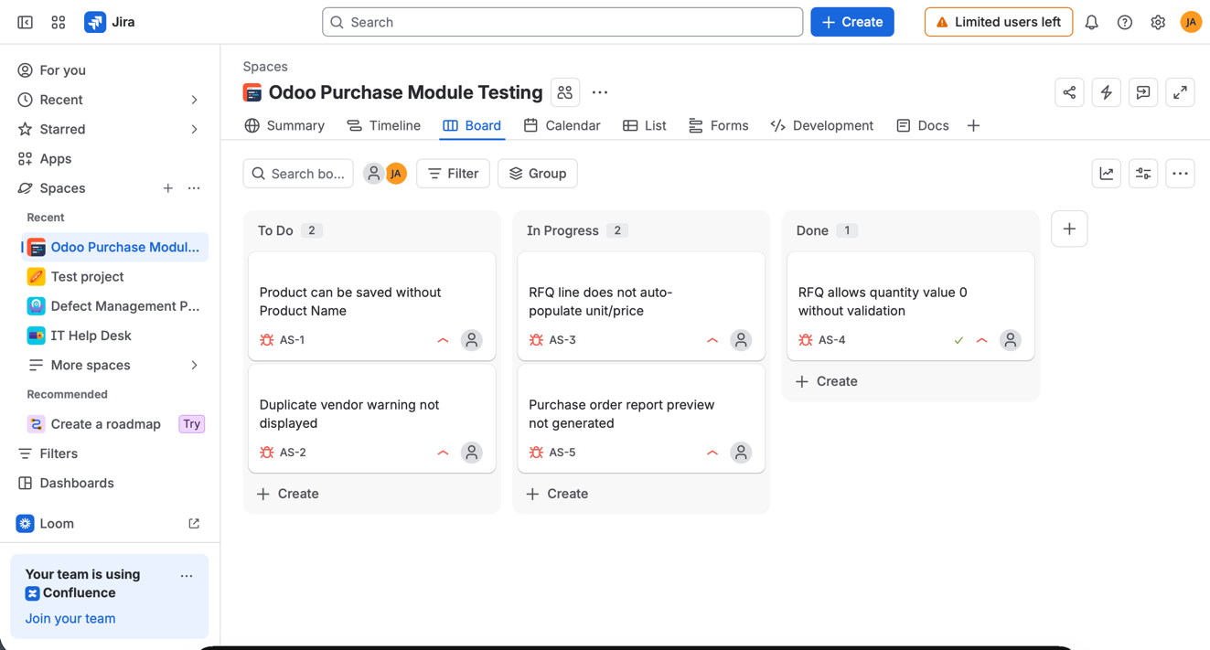
Figure 1: Jira defect board showing logged issues

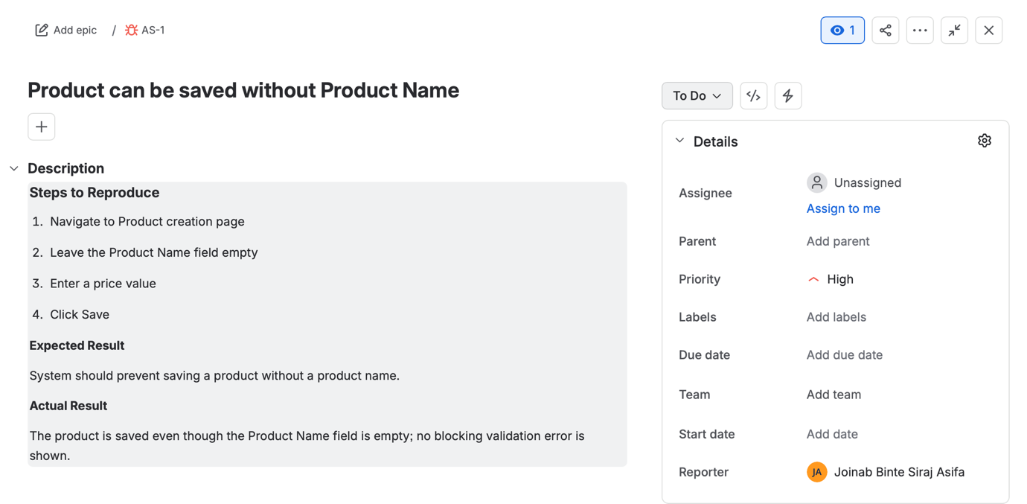Figure 2: Example defect detail view in Jira

8 Recommendation
Based on the identified defects, improvements are recommended in the following areas:
- Input validation for mandatory fields (Product Name)
- Duplicate-vendor detection mechanism
- Auto-population of unit and price on RFQ product lines
- Quantity validation on RFQ lines (reject or flag zero values)
- Reliable purchase order report generation and preview

9 Conclusion
The functional testing process identified 5 validation and usability defects within the Odoo Purchase Module, all of Major severity. Core workflows — login, product/vendor creation, RFQ creation, and PO confirmation — function correctly end to end, but the identified gaps in field validation and report generation should be addressed to improve data integrity and user experience.

