Divvy Bikes Dataset (2013) Analysis using R

Data Analysis Report
Naimish Viradia
4/24/2016

Visualize the complete dataset

- Hour of Day Trips
- Day of Week
- Top Stations
  - Top 5 Stations
  - Bottom 5 Stations
- User Type Graph
- Gender Graph
- Month
- Month & Season

Hour of Day trips
Find number of trips based on hour of the day.

Scripts to find Hour of Day:
# get Hour from startTime field
> hourOfDay<-format(as.POSIXct(dtrips$starttime) ,format = "%H")
# do group using table command
> groupByHour<-table(hourOfDay)

Command:
> barplot((groupByHour), beside = TRUE, col = c("green", "black"),main="Hour of Day",ylab="Freq")
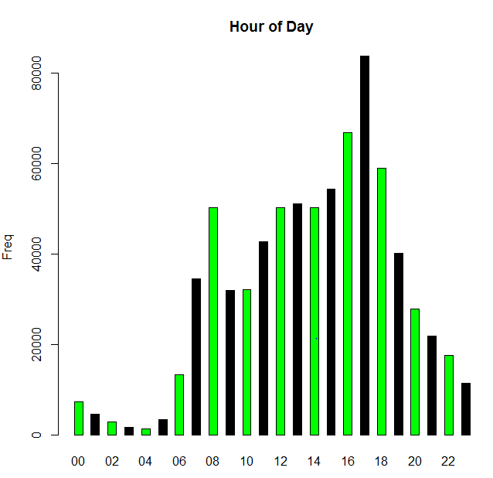
Day Of Week:
Number of trips for day of week.

Script:
# Get Day name form date
> dayOfWeek<-(weekdays(as.Date(dateOfTrip,'%d-%m-%Y')))
# Use data frame to convert vector
> d<-data.frame(dayOfWeek)
# Provide Order
> d$dayOfWeek<-factor(d$dayOfWeek,levels=c("Sunday", "Monday","Tuesday", "Wednesday", "Thursday", "Friday", "Saturday"))
# Create Group by variable
> groupByDayOfWeek<-table(d[order(d$dayOfWeek),])

Command:
> barplot(groupByDayOfWeek,main="Day Of Week",ylab="Freq")

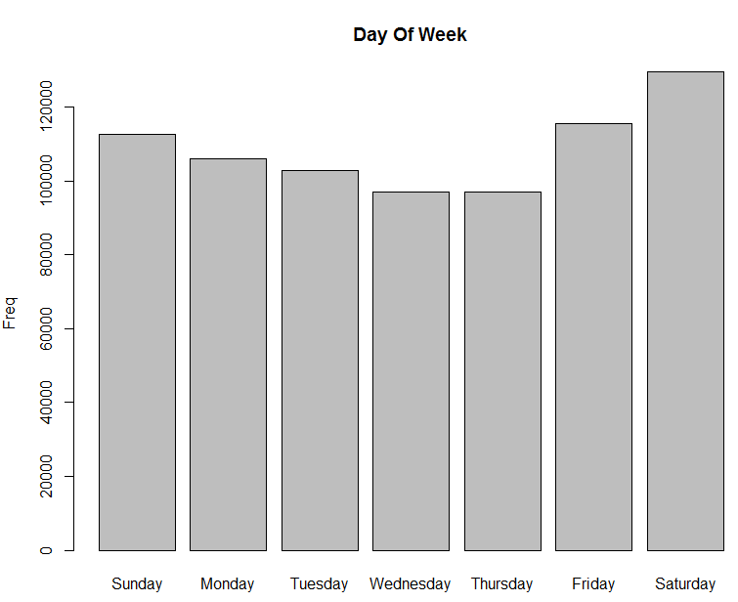
Top Station trips
Find Stations who had highest and lowest number of trips.

Scripts To Find Top 5 City:

Top 5 Name of Station | No of Trips
Streeter Dr & Illinois St | 18544
Millennium Park | 18395
Lake Shore Dr & Monroe St | 15457
Michigan Ave & Oak St | 14342
Clinton St & Washington Blvd | 13898

# Get Grouped values for all stations.
> groupByStation←table(dtrips$to_station_name)

# Preapre Descending Order Vector
> orderByFreqDesc=order(-groupByStation)

# Apply Desc Order Function to our Stations.
> View(groupByStation[orderByFreqDesc])
> top5City <- c(groupByStation[orderByFreq][1:5])

Command:
> barplot(top5City,main="Top 5 City Trips",ylab="Freq",ylim=c(0,20000))
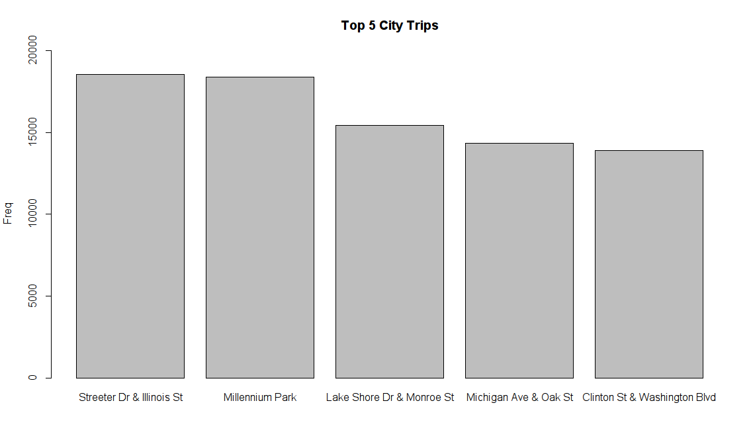
Scripts To Find Bottom 5 City:

Bottom 5 Name of Station | No of Trips
Cottage Grove Ave & 47th St | 30
Calumet Ave & 35th St | 33
Western Ave & 24th St | 51
Cottage Grove Ave & 43rd St | 58
Halsted St & 37th St | 94

# Get Grouped values for all stations.
> groupByStation←table(dtrips$to_station_name)

# Make Order Vector
> orderByFreq=order(groupByStation)

# Apply Order Function to our Stations.
> View(groupByStation[orderByFreq])
> bottom5City <- c(groupByStation[orderByFreq][1:5])

Command:
> barplot(bottom5City,main="Bottom 5 City Trips",ylab="Freq",ylim=c(0,100))

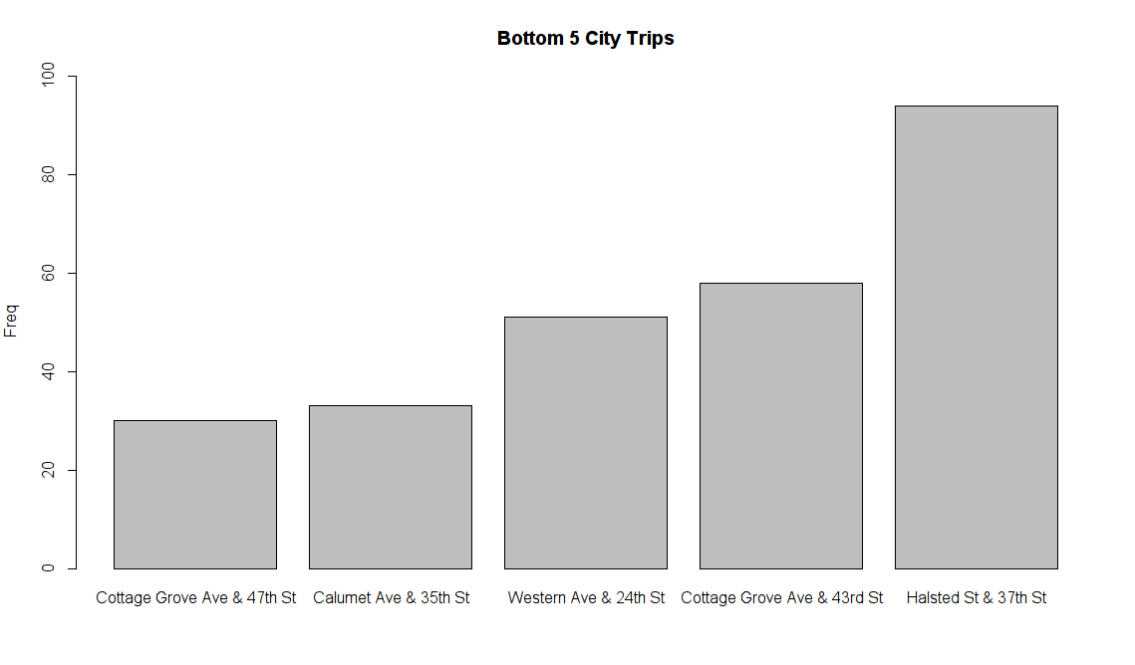
Trips Per Station:
Graph shows number of trips per stations.

Command:
> barplot(table(dtrips$to_station_name),ylab="Frequency",main="Frequency Per Station",xla="Station Name",ylim=c(0,20000))
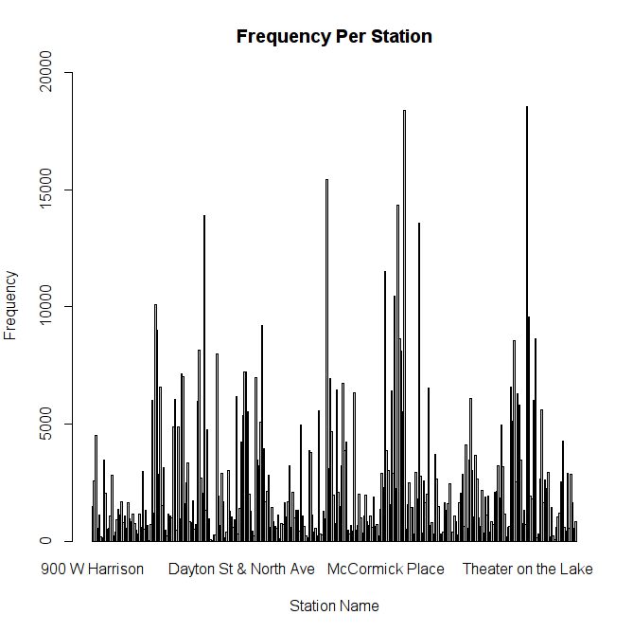

User Type Graph:
Graph shows Roughly more number of Subscribers then Customers.

Command:
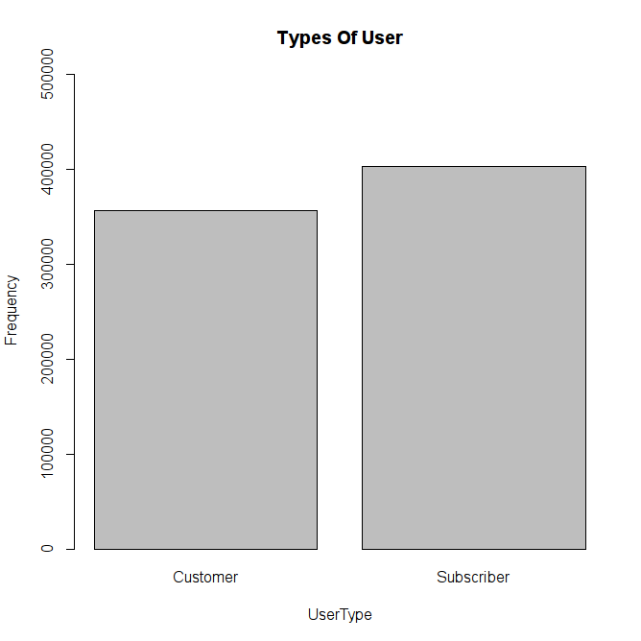
> barplot(table(dtrips$usertype),ylab="Frequency",main="Types Of User",xla="UserType",ylim=c(0,500000))

Gender Graph:
Almost half of the user do not provide their Gender information.

Command:
> barplot(table(dtrips$gender),ylab="Frequency",main="Gender Of People",xla="Gender",ylim=c(0,500000))
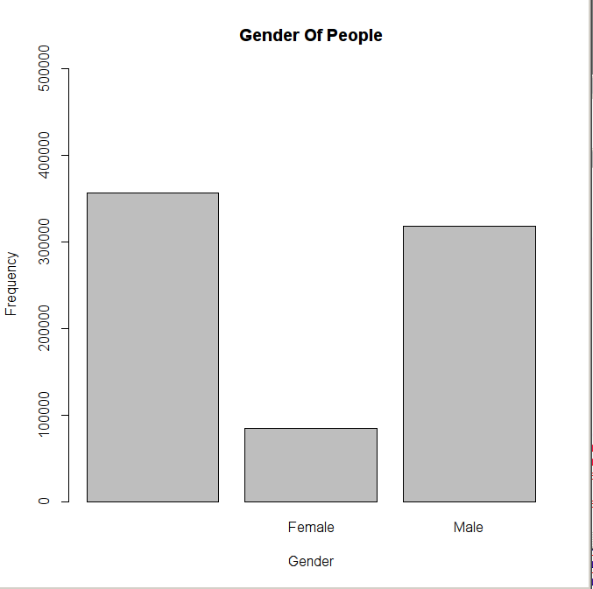
Month:
Number of trips in Month. In month of September we have highest number of trips.

Script:
> month <- format(as.POSIXct(dtrips$starttime) ,format = "%m")
> View(month)
> groupByMonth<-table(month)

Command:
> barplot(groupByMonth,main="Month Trips",ylab="Freq")

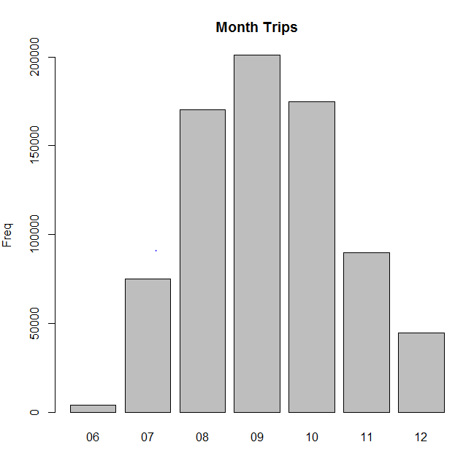
Month & Seasons:
From Graph We can say that Most number of trips in Fall.

Script:
# Find Month
dtrips$month<-months(as.Date(dtrips$starttime))

# Find Season
dtirps$season[dtrips$month=="January"] <- "Winter"
dtrips$season[dtrips$month=="February"] <- "Winter"
dtrips$season[dtrips$month=="March"] <- "Spring"
dtrips$season[dtrips$month=="April"] <- "Spring"
dtrips$season[dtrips$month=="May"] <- "Spring"
dtrips$season[dtrips$month=="June"] <- "Summer"
dtrips$season[dtrips$month=="July"] <- "Summer"
dtrips$season[dtrips$month=="August"] <- "Summer"
dtrips$season[dtrips$month=="September"] <- "Fall"
dtrips$season[dtrips$month=="October"] <- "Fall"
dtrips$season[dtrips$month=="November"] <- "Fall"
dtrips$season[dtrips$month=="December"] <- "Winter"

Command:
barplot(table(dtrips$season), main="Season")

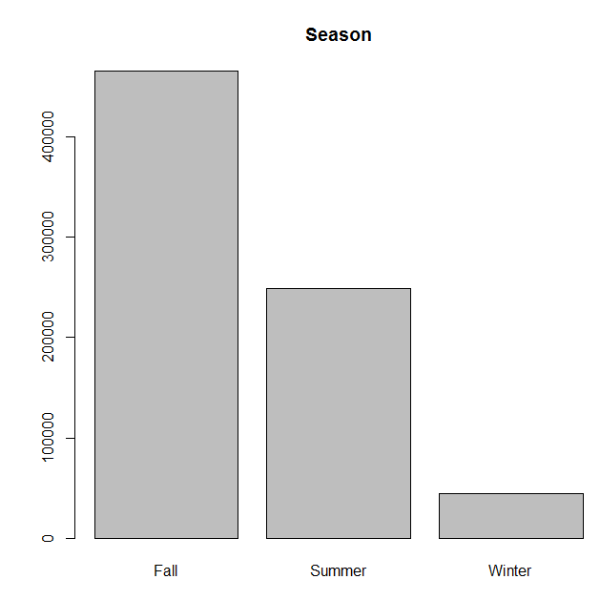
Cross Table Reports

- Hour X Day of Week
- Station Pair X Hour of Day
- Station Pair X Day of Week
- User Type X Day of Week
- User Type X Season

Hour X Day of Week:
From Chart we can say that Saturday is busiest day of week and also hours have most number of trips than any other day.

Scripts:
> barplot(table(hourOfDay, dayOfWeek), beside=T, col=heat.colors(99), xlab="Weekday", ylab="Number of Trips", main="Hour x Day of Week")

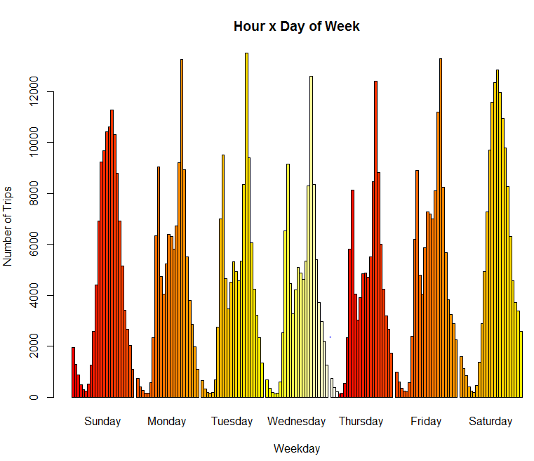
Station Pair X Hour of Day

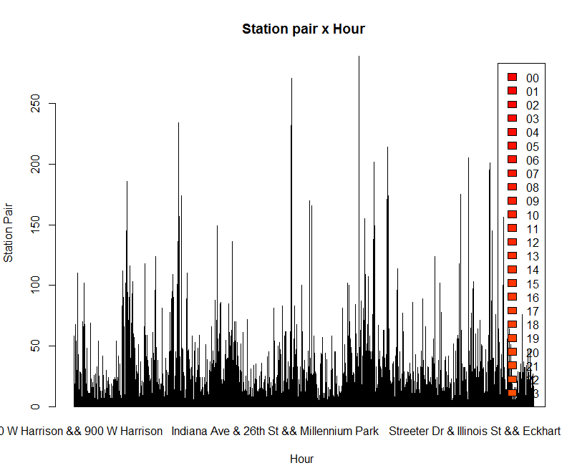
Station Pair X Day of Week

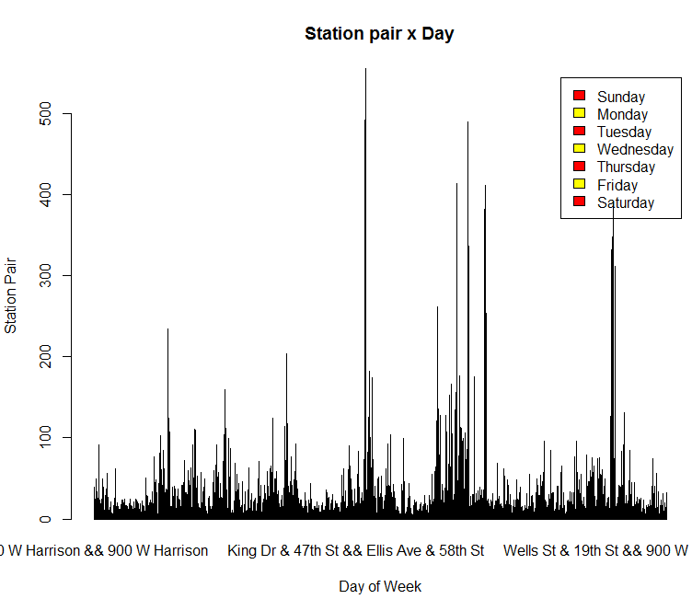
User Type X Day of Week
From This Graph we can say that Subcirbers are more frequent users during Monday to Friday and Customers are more frequent users on Sunday and Staurday.

Script:
> (table(dtrips$usertype, dayOfWeek), beside=T, col=heat.colors(2), xlab="Weekdays", ylab="User Type", legend=T)

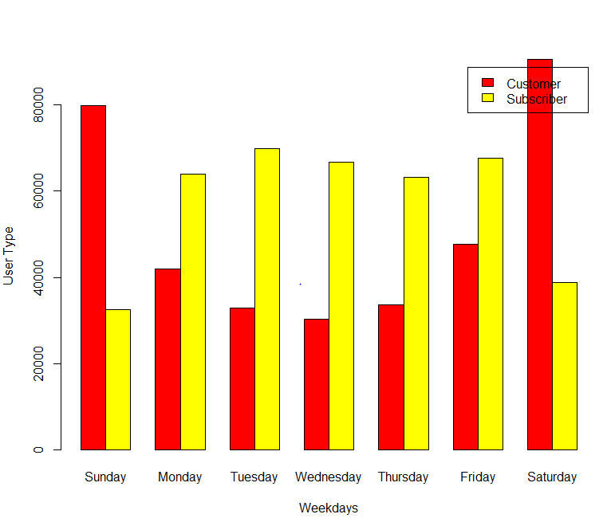

Season X User Type
From Graph we can say that Subscribers are more in Fall and Winter. Where Customers are more in Summer.

Command:
> barplot(table(dtrips$usertype, dtrips$season), beside=T, xlab="Season", ylab="User Type", legend=T, main="User x Season", col=c("blue", "red"))

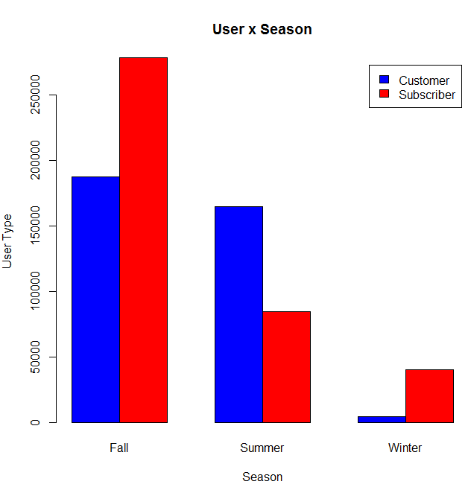
Extra Commands Used:
timeOfTrip <- format(as.POSIXct(dtrips$starttime) ,format = "%H:%M")
dateOfTrip <- as.Date(dtrips$starttime)

Following Command is used to remove exponential Number Format
> options(scipen = 999)

