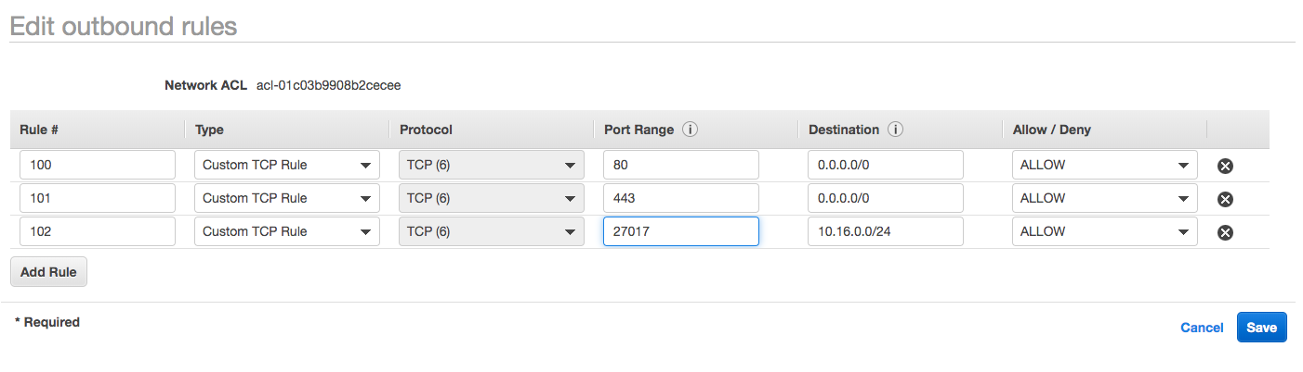

100 – Allows outbound http traffic from the subnet to the internet

101 – Allows outbound https traffic from the subnet to the internet

102 – Allows outbound responses to clients on the internet from socket 27017 (mongo db)

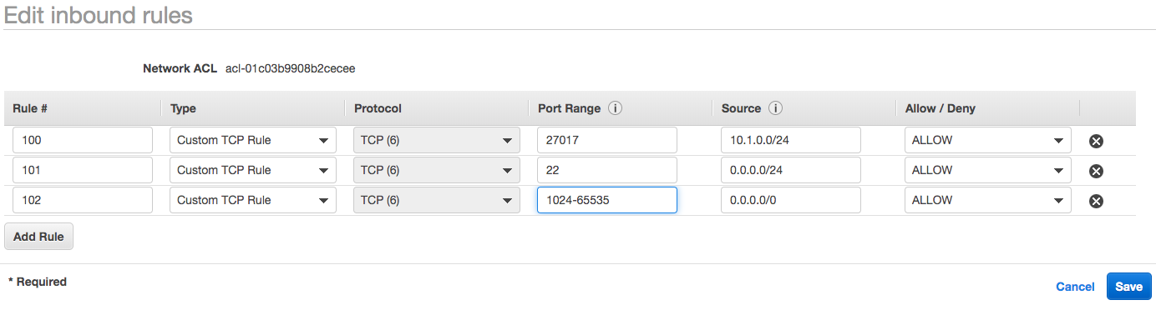

100 – Allows public subnet to read and write to mongo DB

101 – Allows inbound SSH traffic from the public subnet

102 – Allows inbound traffic from NAT gateway in the public subnet