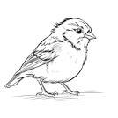
Said the Robin to the Sparrow,
“I should really like to know
Why these anxious human beings
Rush about and worry so!”

Said the Sparrow to the Robin,
“Friend, I think that it must be
That they have no heavenly Father
Such as cares for you and me!”
-Elizabeth Cheney

